REDINGTON FROGNAL
NEIGHBOURHOOD FORUM

23 February 2021
Dear Mr. Yeung,

Application 2021/0188/P: 10 Ferncroft Avenue - objection

Thank you for forwarding this application to the Neighbourhood Forum for comment.

The Forum objects to the proposal to install automated metal sliding gates to front boundary. Metal gates are not a traditional feature of the Redington Frognal Conservation Area. Together with the replacement of front gardens by car parks, they are causing very serious cumulative harm to the Conservation Area, as has been noted in both the 2003 and 2020 Conservation Area appraisals.

The Conservation Area character is based on garden suburbs, so that landscape infrastructure is of fundamental importance to the special architectural or historic interest and character and appearance of the area: in particular mature trees and hedges. Similarly. in the application of Section 72 of the Planning (Listed Buildings and Conservation Areas) Act 1990, as Amended, it is important to understand the central contribution of the amalgam of both front and rear gardens.

The existing car park has space for three cars only (not four) and we suspect that the application is an attempt to increase the area for off-street parking, in order to accommodate four cars, which is not compliant with Camden Local Plan policy T2.

Moreover, the Redington Frognal Conservation Area Statement notes the positive contribution of low brick walls and hedges to most properties in this part of the Conservation Area. The low brick wall and hedge at number 10 is shown below, long with adjacent front boundary treatments forming a positive contribution to Ferncroft Avenue.

Existing hedge and low brick wall
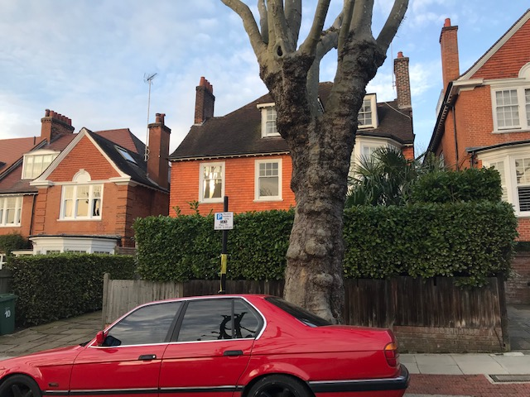

Streetscape and front boundary treatments to right and left of 10 Ferncroft
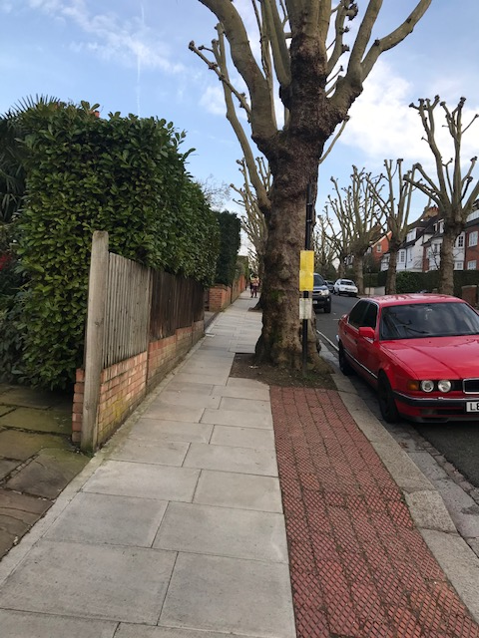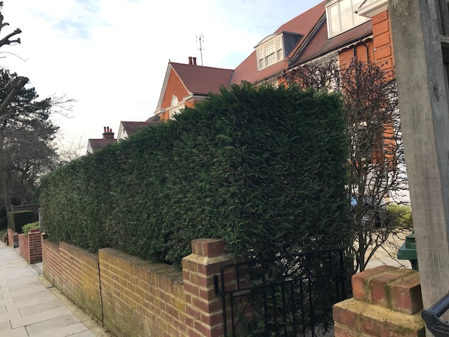

We would also draw your attention to similar applications which have been refused:

- 2020/2471/P (24 Ferncroft Avenue), where the planning officer required the new gates to be constructed from timber, rather than metal, and sought to retain as much of the greenery as possible.
- 2020/1399/P (49 Redington Road), where the applicant was advised that metal fencing would be unacceptable for the Conservation Area and, as a result of this advice, an application for brickwork boundary was submitted and the existing privet hedge was retained and extended.

With regard to the proposals to install a timber decking area, shed and various hard and soft landscaping works to front and rear gardens, we would note that the application is not compliant with the following Redington Frognal Neighbourhood Plan policies:

BGI 1:
Open/unbuilt areas within development sites should be designed to enhance their ecological, wildlife and residential amenity values. This includes:

- Retaining, providing and reinstating trees, hedgerows and other planting using species, especially those of high value to biodiversity, as set out in the 6.2 Planting Guidance to Enhance Biodiversity and Conservation Area Character.
- Achieving an urban greening score in excess of the London Plan target.
iii. Maximising the area of soft landscaping and using planting with high value to pollinators and insects, as set out in the 6.2 Planting Guidance to Enhance Biodiversity and Conservation Area Character.
iv. Minimising hard surface areas to those necessary for the functioning of the site, such as footpaths to doors, and ensuring they are permeable to allow drainage of surface water.
- Retaining hedges and walls and taking opportunities to use hedges as boundary treatments, instead of or in addition to walls and fences.

Other relevant policies are:

- Redington Frognal Conservation Area Character and Management Appraisal: Guidelines RF 1 and RF 8
- Camden Local Plan policy: CC2
- London Plan policy: G5.

Yours sincerely,

Nancy Mayo

Secretary
Redington Frognal Neighbourhood Forum
https://www.redfrogforum.org
https://twitter.com/RedfrogNF

REDINGTON FROGNAL
NEIGHBOURHOOD FORUM

