# LONDON BOROUGH OF CAMDEN

# MEMORANDUM

|  |  |
| --- | --- |
| Date: | **Tuesday 15th October 2019** |
| To: | **Insurance Section** |
| Ref: | **18TR000049** |
| From: | **Jake Camilleri** |
| Our Ref: | **17214 - 23351** |

## ALLEGED TREE ROOT DAMAGE REPORT

|  |  |
| --- | --- |
| Address of Property: | **20 Churchill Road, NW5 1AN** |
| Department/s Responsible for Tree/s: | **Camden Borough London, 18 Churchill Road** |
| Date of inspection and Officer: | **15th October 2019** |
| Maintenance History: |  |
| Camden Tree SEQ 81 (T1) Platanus x hispanica    **Completion Date Item**  **06/03/2015 Crown reduction 40% & Reshape - Large**  **Specific branch/limb removal (150mm)**  **General Prune (GP.3 ) Re-reduction - Large**  **Remove self sowns in pit**  **19/03/2018 General Prune (GP.3) - Medium**  Camden Tree SEQ 80 (T2) Platanus x hispanica    **Completion Date Item**  **06/03/2015 Crown reduction 40% & Reshape - Large**  **Specific branch/limb removal (150mm)**  **General Prune (GP.3 ) Re-reduction - Large**  **Remove self sowns in pit**  **19/03/2018 General Prune (GP.3) - Medium**  Camden Tree SEQ 79 (T3) Platanus x hispanica    **Completion Date Item**  **06/03/2015 Crown reduction 40% & Reshape - Large**  **Specific branch/limb removal (150mm)**  **General Prune (GP.3 ) Re-reduction - Large**  **Remove self sowns in pit**  **19/03/2018 General Prune (GP.3) - Medium**  Camden Tree SEQ 78 (T4) Platanus x hispanica  **Completion Date Item**  **06/03/2015 Crown reduction 40% & Reshape - Large**  **Specific branch/limb removal (150mm)**  **General Prune (GP.3 ) Re-reduction - Large**  **Remove self sowns in pit**  **19/03/2018 General Prune (GP.3) - Medium**  Camden Tree SEQ 77 (T5) Platanus x hispanica  **Completion Date Item**  **06/03/2015 Crown reduction 40% & Reshape - Large**  **Specific branch/limb removal (150mm)**  **General Prune (GP.3 ) Re-reduction - Large**  **Remove self sowns in pit**  **19/03/2018 General Prune (GP.3) - Medium**  Camden Tree SEQ 76 (T6) Platanus x hispanica  **Completion Date Item**  **06/03/2015 Crown reduction 40% & Reshape - Large**  **Specific branch/limb removal (150mm)**  **General Prune (GP.3 ) Re-reduction - Large**  **Remove self sowns in pit**  **19/03/2018 General Prune (GP.3) – Medium**  Camden Tree SEQ 75 (T7) Platanus x hispanica  **Completion Date Item**  **06/03/2015 Crown reduction 40% & Reshape - Large**  **Specific branch/limb removal (100mm)**  **General Prune (GP.3 ) Re-reduction - Large**  **Remove self sowns in pit**  **19/03/2018 General Prune (GP.3) - Medium**  Camden Tree SEQ 74 (T8) Platanus x hispanica  **Completion Date Item**  **06/03/2015 Crown reduction 40% & Reshape - Large**  **Specific branch/limb removal (100mm)**  **General Prune (GP.3 ) Re-reduction - Large**  **Remove self sowns in pit**  **Inspect Possible fungal bracket at 7m going towards the west**  **Provide specified climbing inspection report - Large**  **19/03/2018 General Prune (GP.3) – Medium**  Camden Tree SEQ 73 (T9) Acer pseudoplatanus    **Item**  **06/03/2015 General Prune (GP.1) – Medium**  **Specific branch/limb removal (100mm)**  **Remove self sowns in pit**  **19/03/2018 General Prune (GP.1) - Medium** | |
| Cyclical inspection and maintenance programme.  Trees, **T1,T2,T3,T4,T5,T6,T7** and **T8** are all inspected once every three years and re-reduced once every three years.  **T9** is inspected is inspected once every three years with work being raised appropriately.  **ST1, ST2,ST3** are not officially listed on our maps, They are small, self-sown trees which have arisen via succession. | |

|  |  |
| --- | --- |
| Claims Ref: **19TR000002** | Address: St. Georges Terrace |

|  |  |  |  |  |  |  |  |  |  |  |
| --- | --- | --- | --- | --- | --- | --- | --- | --- | --- | --- |
| Tree No. | Ownership | Species | Height (m) approximate | Crown Spread (m) | DBH (cm) | Vitality | Water Demand | Distance to Boundary (m) | Distance to Property (m) | CAVAT Value |
|  |  |  |  |  |  |  |  |  |  |  |
| **T1** | **London Borough Camden** | **Platanus x hispanica** | **5** | **4** | **144cm** | **Good** | **Moderate** | **10** | **12** | **£12531.41** |
| **T2** | **London Borough Camden** | **Platanus x hispanica** | **6** | **4** | **84cm** | **Good** | **Moderate** | **12** | **14** | **£4375.64** |
| **T3** | **London Borough Camden** | **Platanus x hispanica** | **6** | **3** | **157cm** | **Good** | **Moderate** | **10** | **12** | **£16182.09** |
| **T4** | **London Borough Camden** | **Platanus x hispanica** | **6** | **4** | **176cm** | **Good** | **Moderate** | **9** | **11** | **£16182.09** |
| **T5** | **London Borough Camden** | **Platanus x hispanica** | **5** | **6** | **56cm** | **Good** | **Moderate** | **9** | **11** | **£10356.53** |
| **T6** | **London Borough Camden** | **Platanus x hispanica** | **5** | **5** | **49cm** | **Good** | **Moderate** | **12** | **14** | **£16182.09** |
| **T7** | **London Borough Camden** | **Platanus x hispanica** | **5** | **5** | **180cm** | **Good** | **Moderate** | **14** | **16** | **£23302.21** |
| **T8** | **London Borough Camden** | **Platanus x hispanica** | **5** | **6** | **214cm** | **Good** | **Moderate** | **16** | **18** | **NA** |
| **T9** | **London Borough Camden** | **Acer pseudoplatanus** | **6** | **4** | **110cm** | **Good** | **Moderate** | **17** | **19** | **£3452.18** |
| **T10** | **NA** | **Fraxinus excelsior** | **7** | **4** | **NA** | **Good** | **Moderate** | **16** | **18** | **NA** |
| **H1** | **18 Churchill Road** | **Privet Spp.** | **2** | **NA** | **NA** | **Good** | **NA** | **5** | **6** | **NA** |
| **C1** | **18 Churchill Road** | **Wisteria sinensis** | **3.5** | **4** | **NA** | **Good** | **NA** | **5** | **5** | **NA** |
| **ST1** | **London Borough Camden** | **Acer spp.** | **0.5** | **NA** | **NA** | **Good** | **Moderate** | **9** | **11** | **NA** |
| **ST2** | **London Borough Camden** | **Prunus padus** | **NA** | **NA** | **NA** | **NA** | **Moderate** | **9** | **11** | **NA** |
| **ST3** | **London Borough Camden** | **Fraxinus excelsior** | **1.5m** | **N/A** | **5** | **Good** | **Moderate** | **12** | **14** | **NA** |

TG.1

|  |  |  |  |  |  |  |  |  |  |  |
| --- | --- | --- | --- | --- | --- | --- | --- | --- | --- | --- |
| **T11** | **NA** | **Acer pseudoplatanus** | **15m** | **6m** | **80cm** | **Good** | **Moderate** | **16** | **18** | **NA** |

In the original Arb report the area ‘TG1.’ Was listed as ‘Mixed Species Group’. This area holds a sub-station, which is surrounded by some land and a fence. It has some mature trees and small shrubs none of which appear to have cyclical pruning regimes in place. The area was not directly accessible due to the large fence, so some details are estimated or missing altogether. I specifically looked at the biggest tree in that area, T11.

Data taken from Confirm database and/ or onsite inspection

|  |
| --- |
| **TREE/VEGETATION ISSUES:**   * Trees **T1, T2, T3 ,T4,T5,T6,T7** and **T8** are all rated as good in health. No trees had any significant health or structural defects at point of inspection. Each one of these trees is inspected and re-reduced once every three years. * **T9** had no significant health or structural defects at point of inspection, this tree is inspected once every three years with work being raised appropriately. * **T10** was in good health at the time of inspection with no major structural defects noted. * **H1** was in good health at time of inspection with no major structural defects noted. * **C1** was in good health at time of inspection with no major structural defects noted. * **ST1** and **ST3** was in fair health at time of inspection with no structural defects. * **ST2** had been felled at time of inspected. * **T11 (TG1)** is an area approximately 10m x 10m with some mature trees and small shrubs. It cannot be ruled out that this area is not having an effect on soil moisture levels. |
| **STRUCTURE ISSUES:**  Data gathered from Structural engineers report dated: 24th January 2019 Ref:QG1T1074537   * Externally, we noted severe crack damage to the left hand splay of the two storey   bay with crack widths up to 30 mm.   * The left hand splay was also distorted. * A separation crack was viewed between the left hand central pier of the bay and the   sash window frame of 10 mm.   * Cracking was also noted to the lower ground floor window cill and onto the brickwork   below to all sections of the bay.   * The brick built bin store had pulled away from the wall and was close to collapse. * The front retaining wall opposite the bay was out of plumb. * Internally, cracking was noted to the painted timber panel below the left hand splay of * The bay 5-6 mm in width and the left hand window frame was distorted with a gap * Between the glazing and the timber – lounge of the lower ground floor flat. * The external entrance door to the lower ground floor flat was difficult to open   **The damage would be described as Category 4-5 using the BRE 251 Classification**. |
| **TECHNICAL INVESTIGATIONS:**  Data gathered from Structural engineers report dated: 24th January 2019 Ref:QG1T1074537  **Trial Hole 1**   * A trial hole was excavated adjacent to the front bay and that revealed a shallow   Concrete footing with the underside 200 mm below ground level seated on stiff brown  slightly sandy clay.   * A trial hole extended by hand auger revealed this material to continue to a depth of   3000 mm where the trial hole was terminated.  **Laboratory Analysis**   * Analysis of soil samples taken from Trial Hole 1 revealed clay of very high plasticity   that would be subject to volumetric change with changes in moisture content.   * Evidence of desiccation was noted below foundation level. * Roots found below the foundation level were identified as Plane and shrubs.   **Trial Hole 2**   * A trial hole was excavated adjacent to the front wall close to the entrance to the lower   ground floor flat and that revealed a brick footing with the underside 150 mm below  ground level seated on stiff brown slightly sandy clay.   * A trial hole extended by hand auger revealed this material to continue to a depth of   3000 mm where the trial hole was terminated.  **Laboratory Analysis**   * Analysis of soil samples taken from Trial Hole 2 revealed clay of high to very high   plasticity that would be subject to volumetric change with changes in moisture  content.   * Evidence of desiccation was noted below foundation level. * One root found below foundation level was identified as plane.   **Drainage Survey**   * The underground drainage system was surveyed and no defects identified. |
| **COMMENTS:**   * Plane tree roots and ‘shrub’ roots have been found under the foundations of 20 Churchill Road. * The closest plane trees are 11 meters from the foundation of 20 Churchill Road. * The Plane trees are managed on a triennial re-reduction regime. * The closest shrubs are 5 meters from the foundation of the house. The maintenance record of the wisteria and hedge is unclear. Though they have had maintenance. * Around the base of the Plane trees is a lot of unmanaged vegetation. * The substation is approx. 18 – 20 meters from 20 Churchill Road, there appears to be no ongoing maintenance regime of these trees. |
| **RECOMMENDATIONS:**   * Increase the re-reduction regimes of T4 and T5 from triennial to biennial * Strip all vegetation surrounding the tree pits from T1, T2, T3, T4, T5, T6,T7, T8 and T9 * Remove ST1 and ST3 and poison stumps * Poison the stump of ST2 to make sure it does not grow back or sprout suckers from elsewhere * Review the pruning regime for TG1 (T11) and do not allow for vegetation levels to dramatically increase. |

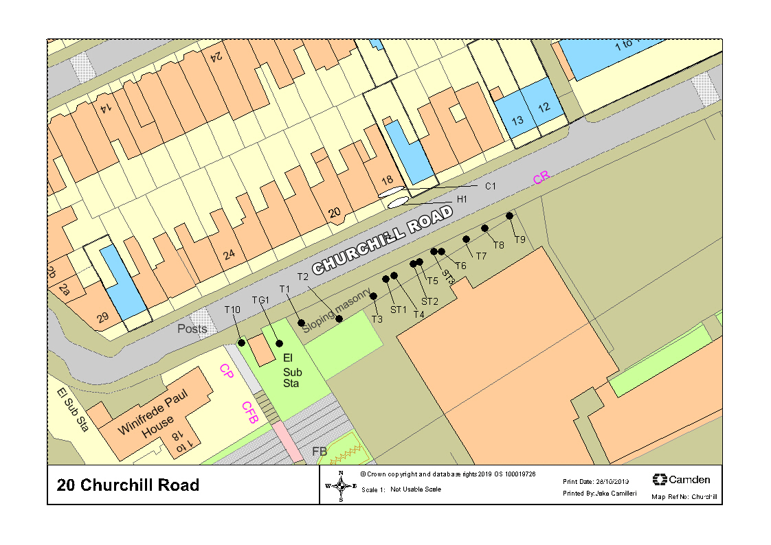

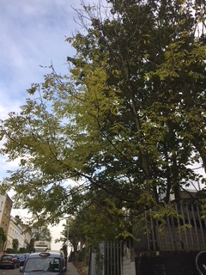

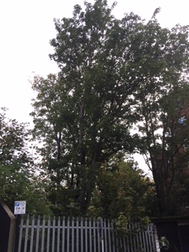

T11

T10

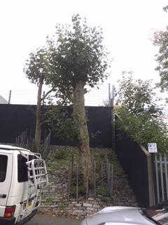

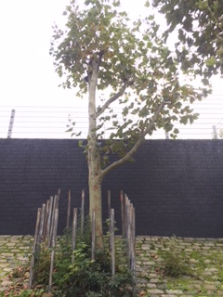

T1 T2

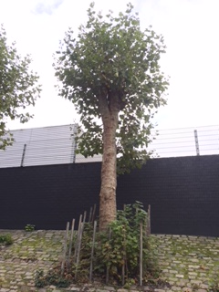

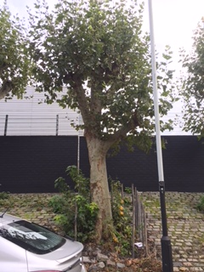

T3 T4

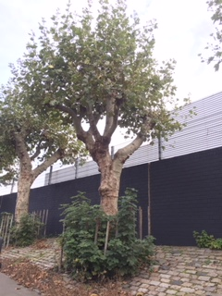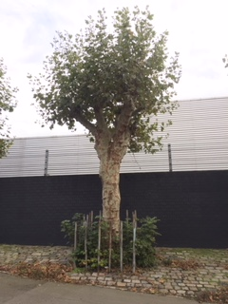

T5 T6

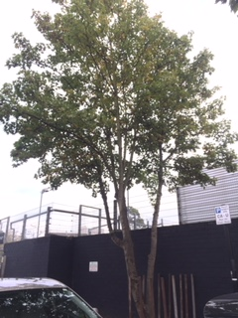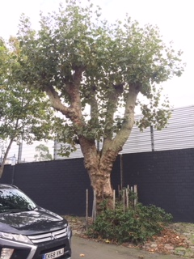

T7 T8

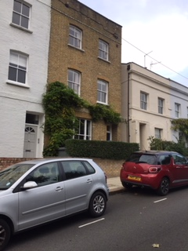

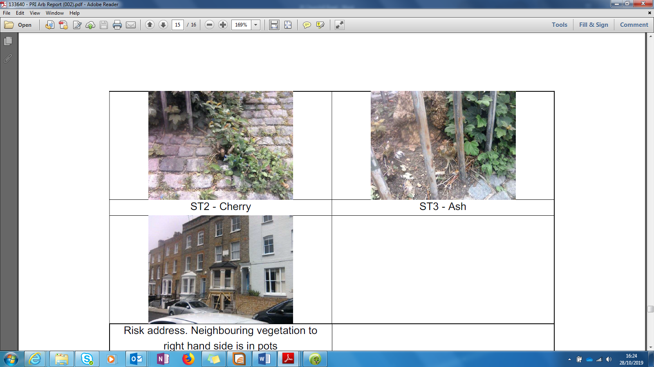C1 & H1 ST3

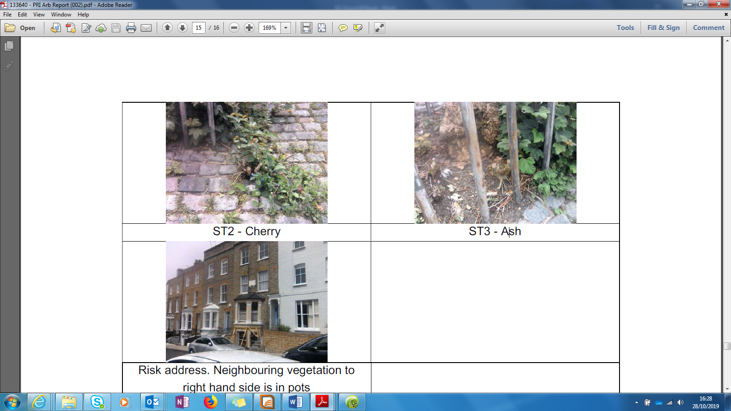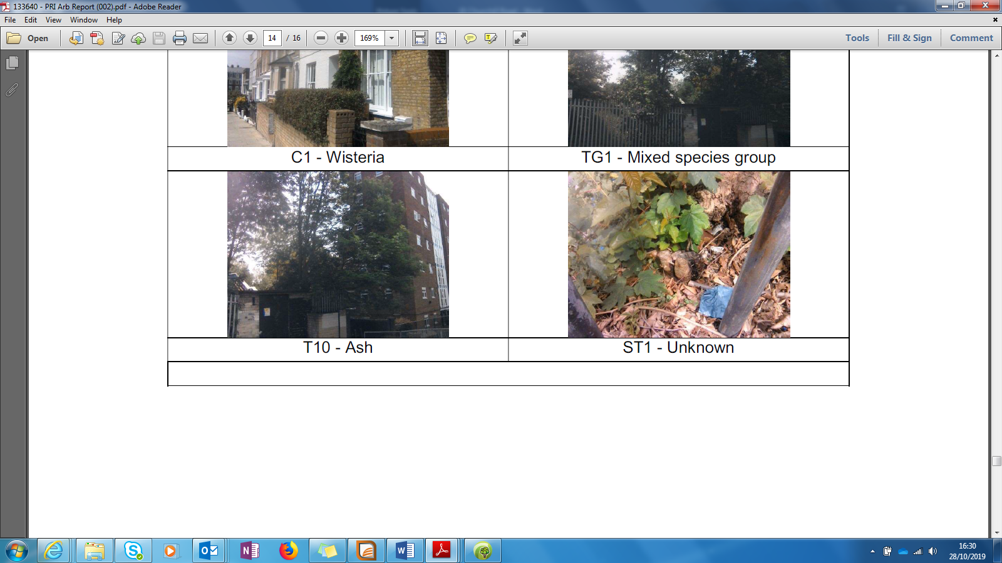

ST2 ST1