Planning application for tree works:

17 Rochester Terrace London NW1 9JN

Claire Elliott

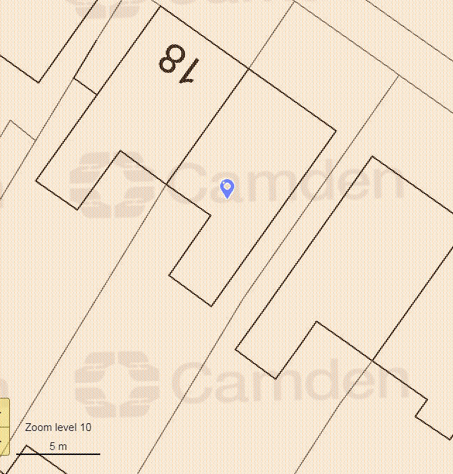

Rochester Terrace

**17**

T1

T2

T3