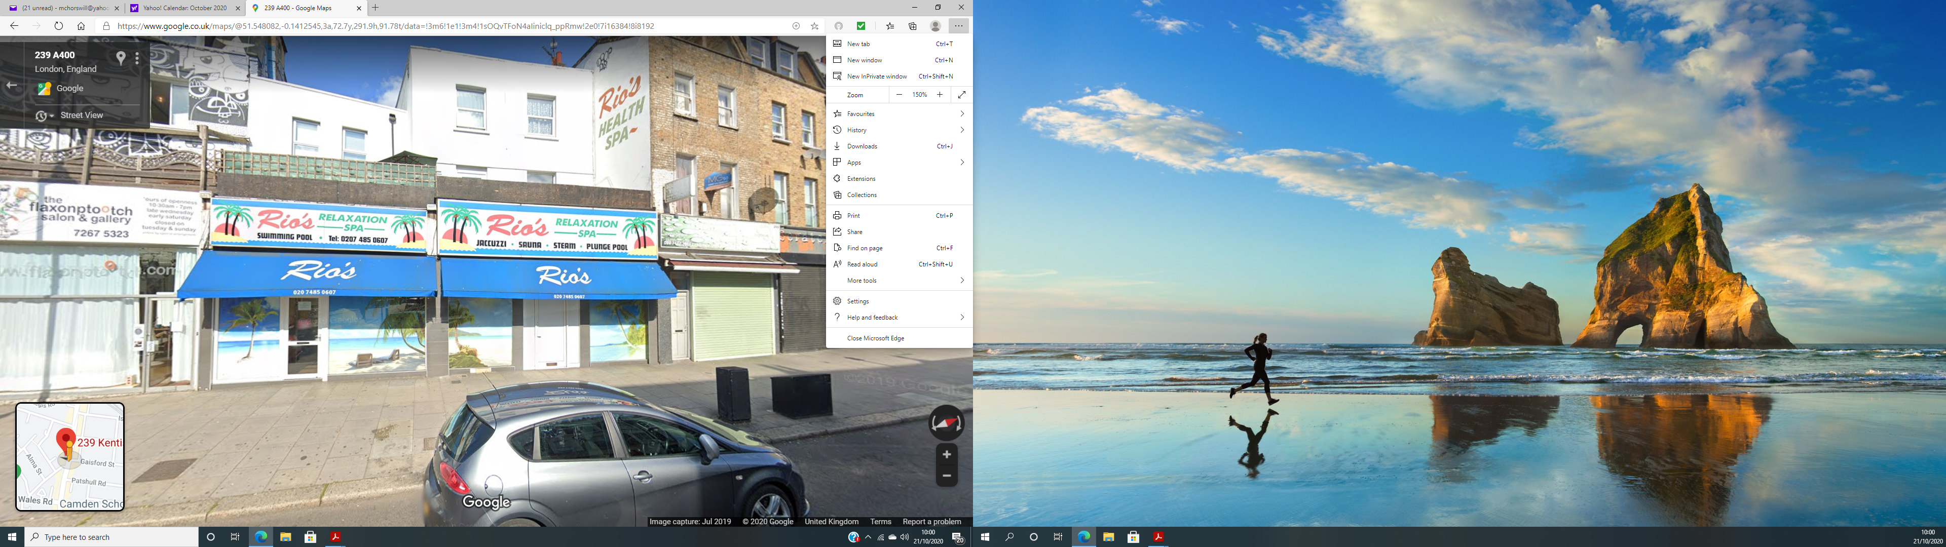

**239 KENTISH TOWN ROAD. EXISTING SHOPFRONT AND SIGNAGE**