## OFFICE OFFICE

KITCHEN

HOOK STASSIS KITCHEN

STUDIO

INTERIOR DESIGN ARCHITECTURE URBAN DESIGN

OROSI DESIGN

07718377879 _ info@orosidesign,com

Salad Bar Existing door for access flat above

Client: Samuel Haim

# EXISTING FLOOR PLAN

(HOOK)

Folding door

Entrance door

Folding door Entrance door

AMENDED FLOOR PLAN

Project:

63-65 PARKWAY, CAMDEN, NW1 7PP, LONDON

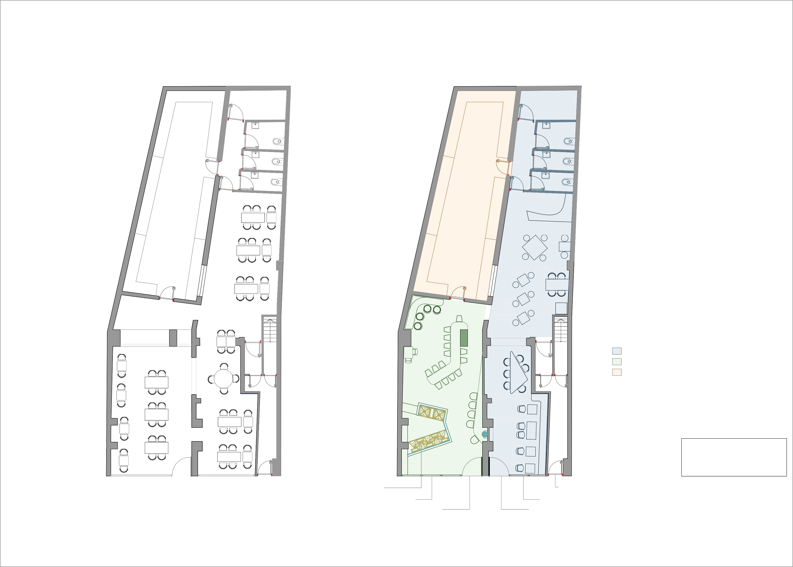

|  |  |  |  |
| --- | --- | --- | --- |
| Scale | Drawing No | Date | Drawing By |
| 1/100 @A3 | HO-48-17 | JUN 2017 | SamSalehi |