TOTAL No. OF COVERS: -

Internal: 52

Feature fixed booth seating

(Type A)

1200

4938

1200

2400

Feature fixed booth seating (Type B)

High

|  |  |  |  |  |  |
| --- | --- | --- | --- | --- | --- |
| AREAS SQ M & SQ FT | | | | | |
| LOCATION | SALES AREA | | BOH AREAS | TOTAL | |
| GROUND FLOOR | 1463.9 | sq ft | 170.1 sq ft | 1634.0 | sq ft |
| 136.0 sq m | | 15.8 sq m | 151.8 sq m | |
| FIRST FLOOR | 1142 | sq ft | 318.6 sq ft | 1460.6 | sq ft |
| 106.1 sq m | | 29.6 sq m | 135.7 sq m | |

Table with

Optional Screen

1850

2400

1096

5824

250

Decorative Wall

Panel

Feature 3D

6389

2400

4586

boiler position flue

800mm H ledge

MAN HOLE

cleaners cupboard unit with sink - 500 x 700mm

BABYCHANGE

baby change

High Table with Optional Screen

1210

1600

2400

2180

Graphic wall

panel

metal framed display unit with Lightbox graphics to stairs

3293

roof light over

2180

250

Balustrade to mezzanine level and staircase

front loading dumbwaiter

push through dishwasher

DUMB WAITER - SHAFT DIMS - 900W x 750D

1860

dirties

3590

900

1480

wc

2041

1950

1470

900

2041

# wc

SHELF

shelf unit

angled low wall

DUMB WAITER - SHAFT DIMS - 900W x 750D

3205

795

990

5100

1140

5100

double volume void

clean

2041

1170

1000 x 400 DRY GOODS

2041

1200 x 400 DRY GOODS

built in vanity unit with cupboard storage below

new dumbwaiter

/ hoist (by specialist)

Ceiling rafts over

bar

1251

1050

16338

NO WORKS

sink and hadwash

1800

storage racking

4890

# Kitchen/

2no Tv's back to back on

3496

1600

basin

# Prep

2041

form new

ceiling mounted

pole.

807

1. All drawings to be read in conjunction with Structural Engineer's details & any relevant

sub-contractor's details. All works to comply with current Building Regulations, British Standards & Codes of Practice.

1. All dimensions to be checked on site before commencement of any work or shop drawings.

form new cupboard/ shelving within alcove for manager

New emergency escape ladder,

welded in

place

2850

cold

2140 room

STEEL ACCESS HATCH

2041

4000

1990

cupboard housing to distribution boards (approx 1800mm wide)

area used for storage of waste /bins

door with digi lock

Provide new bar servery, back bar &

Gelato counter:

Illuminated star hung over front of

counter

6821

2678

3205

32mm DIA.

Water feed

1600

1600

3no decorative wall panels / feature lightbox

Figured dimensions to take precedence over those scaled. Contractor to visit site to asses site conditions.

1. For any discrepancies in the drawings, the contractor is to inform the designer.
2. This drawing is to be read in conjunction with the specification when existing.
3. Contractor to ensure that all work meets the requirements of the EHO, Building Control, Fire Authority and all other statutory bodies.

D NB 10.11.20 BASEMENT PLAN UPDATED FOLLOWING

SITE VISIT & CLIENT REVIEW C NB 03.11.20 AREAS & COVERS NOTED

B NB 30.10.20 LAYOUT UPDATED A NB 28.10.20 LAYOUT UPDATED

managers desk and safe

gas main

600

4890

# office/ store

Ceiling raft

3496

1562

matting

1319

NO WORKS

2261

# Store

1600

2261

# Store

1600

low level

racking within vaulted store

new bi-fold doors to shopfront

2937

900

low level

racking within vaulted store

1500 x 600

2221

1500 x 600

2220

# Ground Floor

Scale 1:50

steel hatch

New window manifestation by Signage

# First Floor

Scale 1:50

Creams

327 Grays Inn Road, London

DRY GOODS

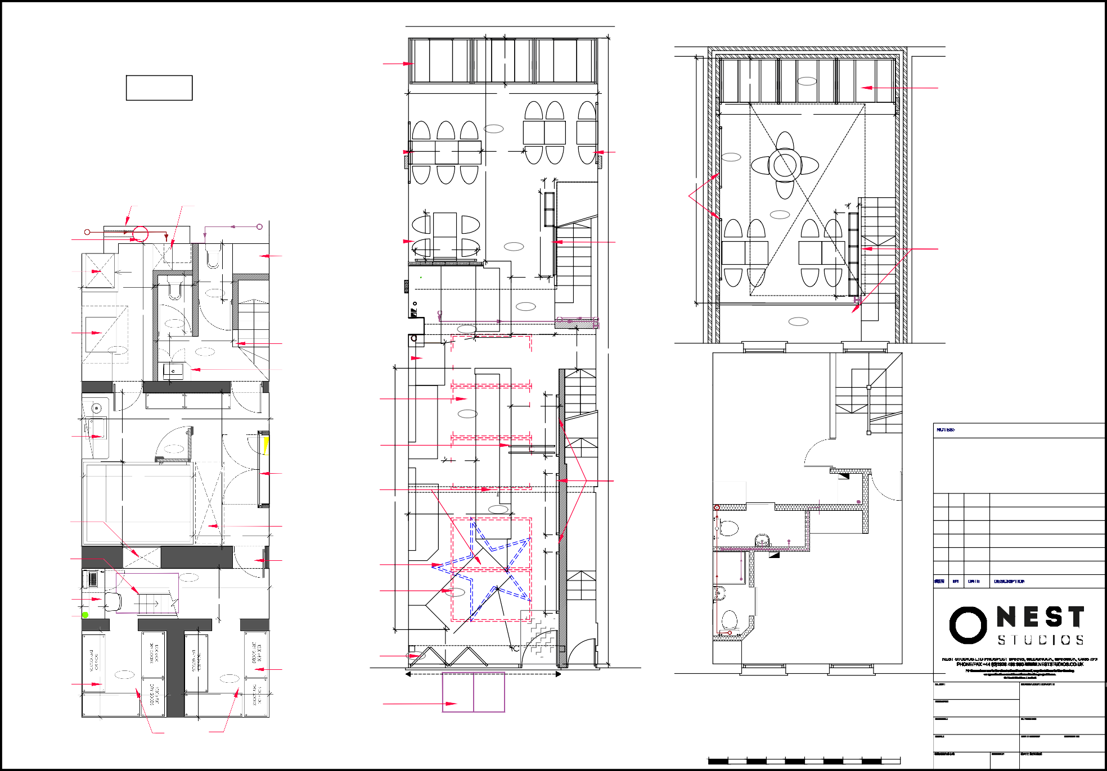

# Basement Plan

Scale 1:50

DRY GOODS

vaulted ceilings within store areas

steel access hatch

Contractor

Scale Bar

## scale 1:50

1 2

## 3 4 5m

Kings Cross Proposed Plan 1:100@A2

20-02-101 D

WC1X 8PX

N/A

14.09.20 NB 1. 0.11.20