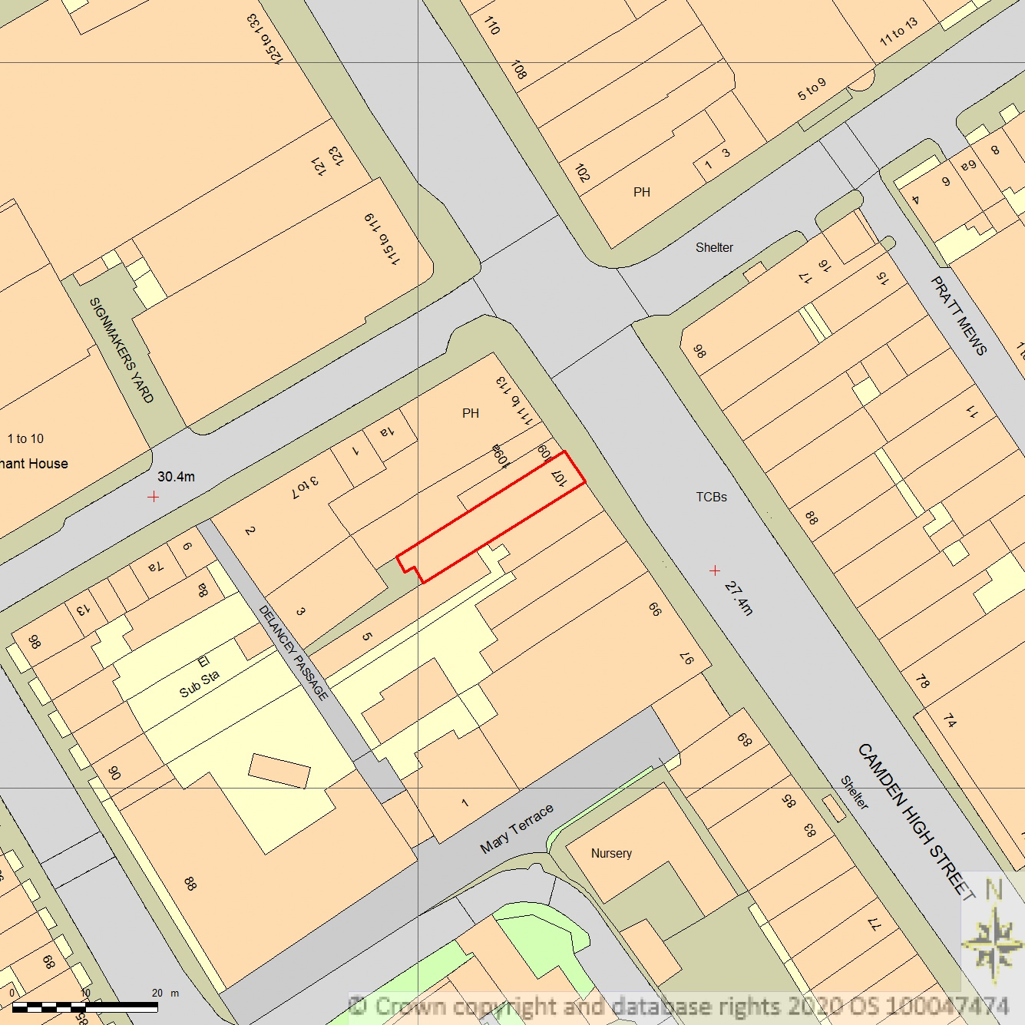
SITE LOCATION PLAN
AREA 2 HA
SCALE 1:1250 on A4
CENTRE COORDINATES: 529013, 183638



Supplied by Streetwise Maps Ltd
www.streetwise.net
Licence No: 100047474
30/07/2026 15:36

