37 PARKWAY NW1 7PN - HERITAGE STATEMENT
Prepared by Esme Rothwell BA (Hons) Arch, MArch, RIBA

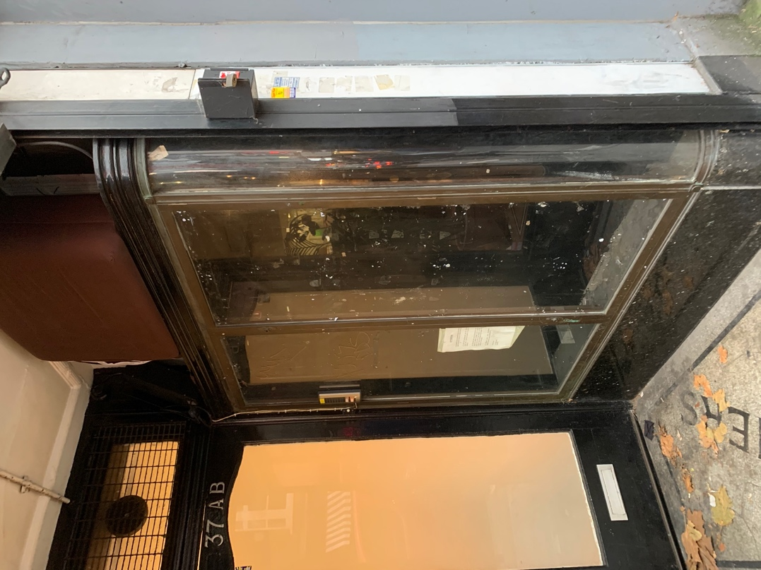

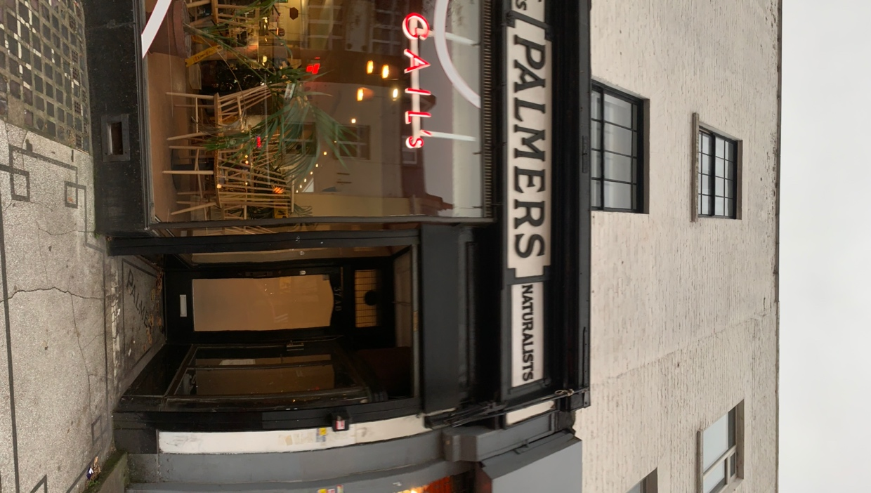
ANALYSIS OF SIGNIFICANT ARCHAEOLOGY, HISTORY, CHARACTER OF LISTED BUILDING, OR STRUCTURE

Palmers pet stores, 35-7, parkway is a Grade II listed, pet shop c1938 on the ground floor of two nineteenth century (1820s) terraced flats in the London Borough district of Camden.

The listing reads:
EXTERIOR: the shop front runs across the ground floor of a pair of three-storey 1820s houses, each of a single bay and part of a larger terrace. The shop front is symmetrical with three large display windows flanked by two doors which have smaller, curved display cabinets inside the porches. The shop front is of wood, painted black, with brass surrounds to the curved display windows in the corners. There is mosaic tiling along the pavement outside and in the porches, the latter spelling out 'PALMERS'. The upper horizontal elements of the window surrounds are scored with triglyph-style grooves and classical paterae adorn the four corners of the timber surrounds. Above this, the fascia has carved wood lettering on a white background. These announce 'PALMERS' in the centres of the two halves of the front, each flanked with smaller panels describing the shop and its wares in further detail. From the left they read 'MONKEYS' 'TALKING PARROTS' 'REGENT PET STORES' and 'NATURALISTS'. Above the shop, the single window openings retain their sash windows. Those to the first floor were once much larger and there is evidence that the longer sash windows were cut down to size when the openings were reduced in height, most probably when the shop front was inserted. The brickwork to the front is largely intact.
INTERIOR: The shop fittings have been removed but a large rectangular skylight, designed to light the rear of the shop and dating from the early C20, survives. Such features have tended to be removed from shops in the post-war period and its survival is of interest. Otherwise, the upper floors retain a good degree of 1820s joinery. The stair of No. 37 survives, though the balusters have been replaced but for the final few at the top of the flight. There are several door cases with elegant fluted pilasters and architraves surviving from the 1820s. A few cornices, skirting boards, some plank panelling and two alcoves either side of what was a fireplace add up to a good survival of original joinery in what would only ever have been a humble dwelling place with simple features. There are C19 horned sash windows to the rear. The rear elevation is not visible, as extensions have been built in what were the gardens of the houses. These extensions date from the early C20 and, particularly the section with the skylight, are likely to be connected with the conversion of the ground floor to commercial use.
HISTORY: Records indicate the building was unoccupied in 1918 but by 1921 'Mrs Palmer (Florence), bird dealer' was trading from 83 Park Street, what is now 35 Parkway (the numbering and the street name changed during WWII). In 1924, the business was taken over by Mr George Palmer, presumably a nephew or son of Mrs Florence Palmer. Under George, the shop expanded one house westwards: in between 1937 and 1941 the shop began to be registered at Nos. 35 and 37 Parkway. It was at this time that the new shop front was designed and installed as a single composition, spanning the two premises owned by George Palmer. The panel which reads 'Regents Pet Stores' may have been added in 1954 or, more plausibly, it was included in the late 1930s makeover and only selected as the main trading name after 1954.
Palmers Pet Stories is situated on one of the main thoroughfares leading to London Zoo, the world's first scientific zoo which opened to the public in 1847. The Zoo opened the first children's zoo in 1938, at about the same time that the Palmer's business expanded into No. 37 and the shop front was installed. It is no surprise that the shop prospered in its chosen location, expanding from bird dealership into more exotic pets such as the monkeys advertised on the fascia. The decision to name the shop 'Regent Pet Stores', as evidenced in the lettering on the shop front, makes the link between the exotic animals in the Zoo and those for purchase at Palmer's even stronger.
When Mrs Florence Palmer arrived at 83 Park Street in c1921, she moved into a building of some antiquity. The street, leading up to Regent's Park which had been laid out from 1818, dates from the 1820s and 1830s and represents one of the earliest phases of development in the Camden area. Park Street is shown as lined with buildings on Christopher and John Greenwood's map of 1830, which clearly shows the terrace which was later inhabited by Palmer's. On the north side of Parkway, a pair of houses in their original state survives at Nos. 98 & 100, but the remainder of properties, like Palmer's, were converted to retail uses at ground level from the mid C19 onwards. The modest scale of the original development survives in most part in the western portion of the street; the best preserved terrace is the section containing Palmer's (on the south side between Arlington Road and Albert Street) where the absence of roof extensions has retained original building heights.
SUMMARY OF IMPORTANCE: 35-37 Parkway are a pair of early C19 terraced houses which in c1921 were converted to retail use by Palmers Pet Stores. The shop front, dating from around 1938, is of special historic interest as a rare survival of a pet shop advertising exotic pets in the distinctive sign panels which read 'MONKEYS' and 'TALKING PARROTS'. The shop front's significance is enhanced by its proximity to London Zoo, also articulated in the shop front lettering 'REGENT PET STORES'. The building is also of special architectural interest. Firstly, the elegant 1930s shop front has good points of detail including brass surrounds to the curved glass side windows and circular paterae marking each corner of the panels; secondly there is good survival of late Georgian features, including sash windows and door cases with fluted surrounds, which relate to the first phase of the building's development as a pair of terraced houses.

PROPOSED WORKS
The proposed works involve addition of a new entrance door flat 37AB following the line of the shop front with an updated security system.

PHYSICAL FEATURES RELEVANT TO THE WORKS
Features mentioned in the listing that will be impacted by the works are the symmetry of the black painted wood shop front, mosaic tiling along the pavement outside and in the porches, spelling out 'PALMERS' and the curved display cabinets with brass surrounds these cabinets are currently empty and not in use.

JUSTIFICATION OF PROPOSED WORKS TO LISTED BUILDING AND IMPACT
Presently, the entrance to flats 37AB is being used in a manner that is disruptive to the residents, who describe the situation as ’unacceptable’. In some instances, they have not been able to access the property for a period of time due to the disruption. Defecation and urine have been found within the porches on the mosaic and there is a lack of good quality security. Cigarette butts, beer bottles and homeless people using it as a place of shelter have been reported in addition to graffiti to the glass cabinets with brass surrounds. There are various examples of updated entrances to flats along Parkway similar to the proposal. The mosaic, mentioned in the listing, is cracked and in poor condition therefore the additional door to the entrance will prevent further damage and misuse to this feature.

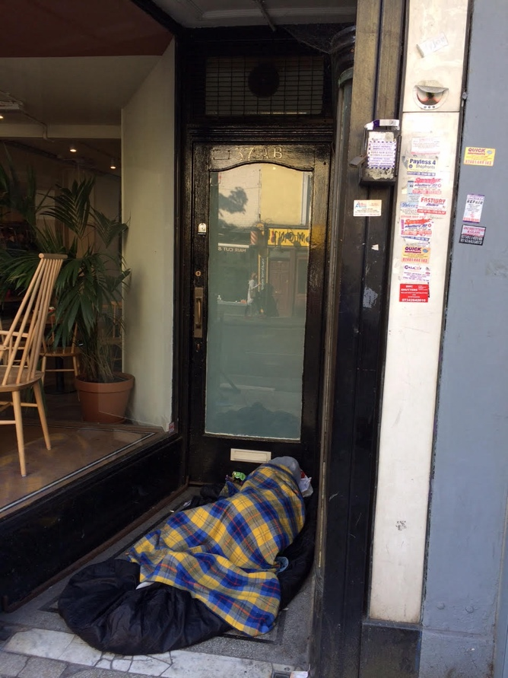
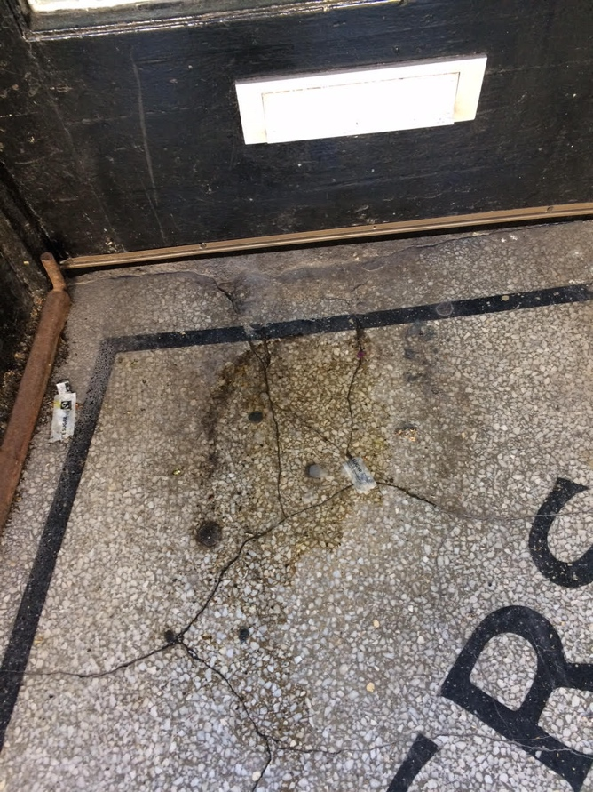

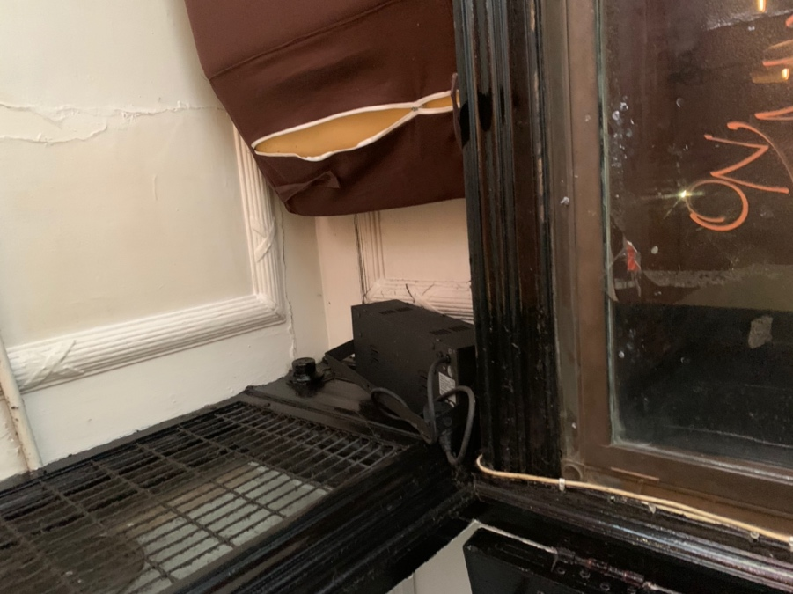
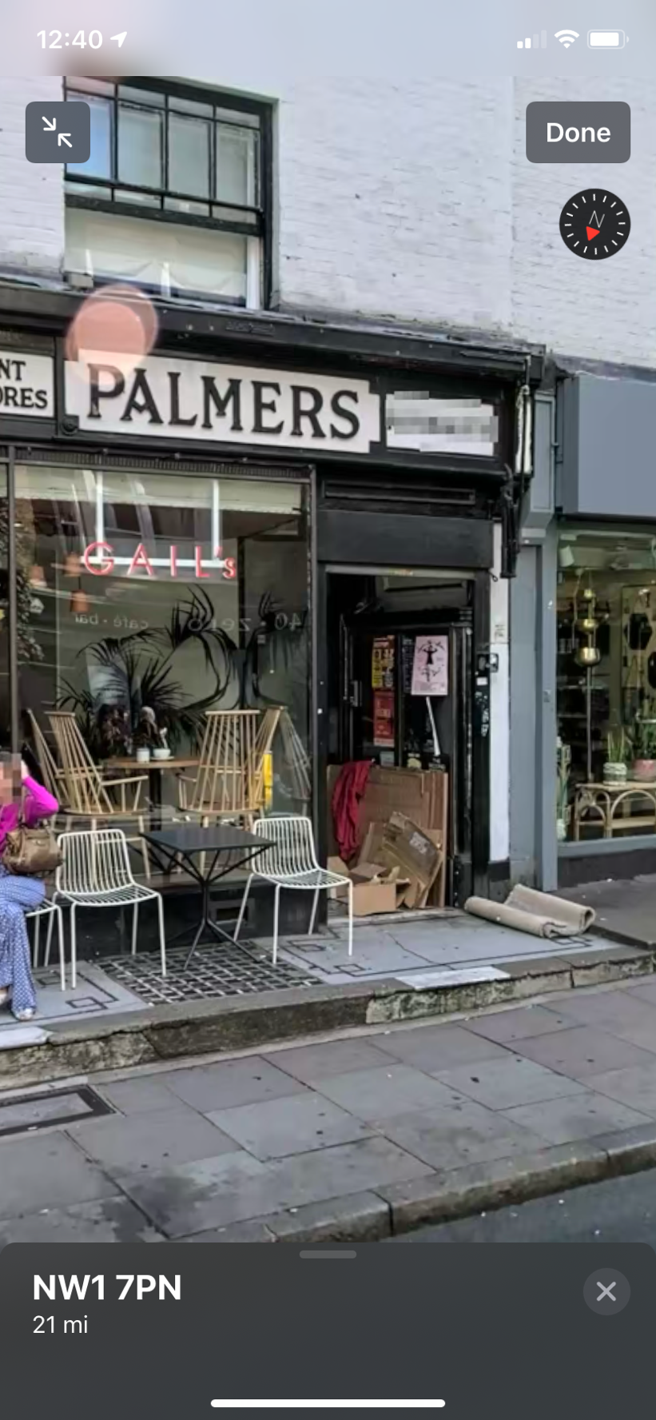
Examples of the entrance being blocked by garbage, a homeless person using the porch as a shelter, damage to the mosaic and graffiti to the curved glass cabinets.

SCHEDULE OF WORKS

Carefully remove existing shop front facing the porch and replace with internal partition. Remove existing shutter case above the porch entrance. Install front black painted timber door with security glass glazed panels at the top, steel beading on the inside. The door is to have 3 stainless steel butt hinges with caps.
Install an entry phone system with a door lock control, ASSA dead locks with thumb turns on the inside.

