37 PARKWAY NW1 7PN - HERITAGE STATEMENT
Prepared by Esme Rothwell BA (Hons) Arch, MArch, RIBA

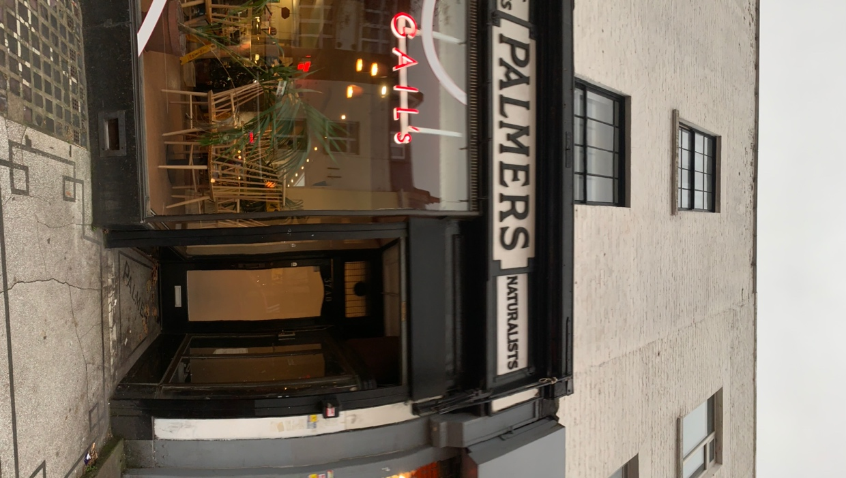

SITE

Palmers pet stores, 35-7, parkway is a Grade II listed, pet shop c1938 on the ground floor of two nineteenth century (1820s) terraced flats in the London Borough district of Camden.

DESIGN

The existing property has good examples of nineteenth century physical features. The Grade II listed pet shop front c1938 is unique in design and has a is a positive contribution to the Camden town conservation area in which it resides. Unfortunately, the present condition of listed features including the curved cabinets with brass surrounds and mosaic tiling on the porch floor spelling ‘PALMERS’ is poor. Damage misuse and vandalism to the features have been recorded. The proposal of a black timber door to the entrance protects the listed elements from further damage.

ACCESS

Access to the flats above is via a communal staircase and not impacted by the addition of a new door.

SECURITY

The door is to be fitted with security glazed panels at the top with steel beading on the inside and is to have 3 stainless steel butt hinges with caps. The entry phone system will have door lock control, ASSA dead locks with thumb turns on the inside. For increased security and safety for the residents.

SUMMARY

The proposed development will preserve and enhance what is currently the beginning of degeneration of a unique listed building. It will increase the safety and security of the residents to the upper flats and prevent further misuse to the porches.

Planning policies considered in the design of this proposal are as follows:
Camden Town conservation area appraisal

