Shops And Premises, Regency Parade, Finchley Road, London, NW3 5EQ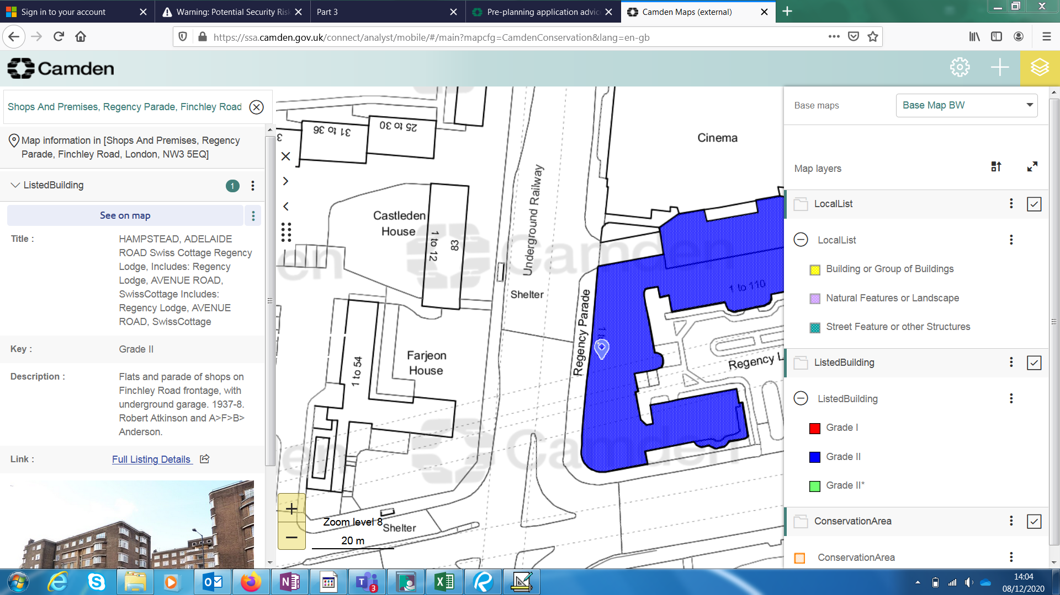. Grade II listed