APR/JW

29th July 2020

Amir Abdul
DAR
74 Wigmore Street
London
W1U 2SQ

Dear Amir

150 high holborn – planning note

I refer to your request for the marketing history for the commercial section of the above property.

As a practice, Jackson Criss are UK wide with offices in Central London, Leeds and Edinburgh, having a comprehensive geographic spread of instructions including some 60 shopping centres and circa 250 High Street disposal instructions across the UK.

Jackson Criss were appointed by DAR in April 2018, on a sole agency basis to commence a marketing campaign.

In late 2018, early 2019 Jackson Criss produced a bespoke marketing brochure and a further direct and indirect marketing campaign commenced. The campaign was based on the demise of the commercial units as per the original planning approval.

The instructions from the client were to approach a range of use classes on a leasehold basis, either to lease the units as a whole or subject to sub division to meet individual retailer requirements.

At no point have Jackson Criss been tested with a proposal from an occupier for all of the space including the basement. We exhausted leasing the basement space separately, however this proved too difficult as producing vertical circulation into the basement affected the letting prospects of the ground floor units.

It was therefore decided that leasing the basement space was an unviable option due to the lack of interest. We have kept the soft spots where the vertical circulation space could be installed for any future use.

However, what was clear early on was that the ability to split the units did appeal to operators. This produced leasehold offers based on splitting the units into smaller ground floor lock ups.

The potential to split the units has had a positive effect on leasing them, as it is in line with modern day demand and reduces the occupier’s property costs, as smaller units benefits them in reduced service charge.

Kind Regards,

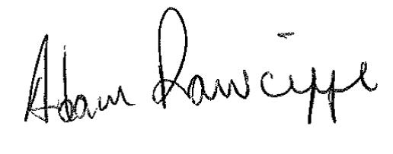

A RAWCLIFFE

E-Mail: arawcliffe@jacksoncriss.co.uk

