52 Holmes Road

London Borough of Camden

Doc Ref: Waste Management Plan

Revision: Final

**Waste Management Strategy 2020**

# Introduction

This waste management plan has been prepared on behalf of Holmes Assets Ltd (as developer) as part of the redevelopment of 52 Holmes Road in the London Borough of Camden under planning permission 2018/3318/P. This planning permission relates to the demolition of existing building and replacement with a new build mixed use development of 6 storeys (plus basement) comprising of 9 residential units and 377sq.m of industrial employment space (B1c).

A location plan showing the site in relation to the surrounding streets shown in figure 1.1 and in 1.2 you can see a layout plan indicating the entrances to the residential and commercial units accessible from Holmes Road only.

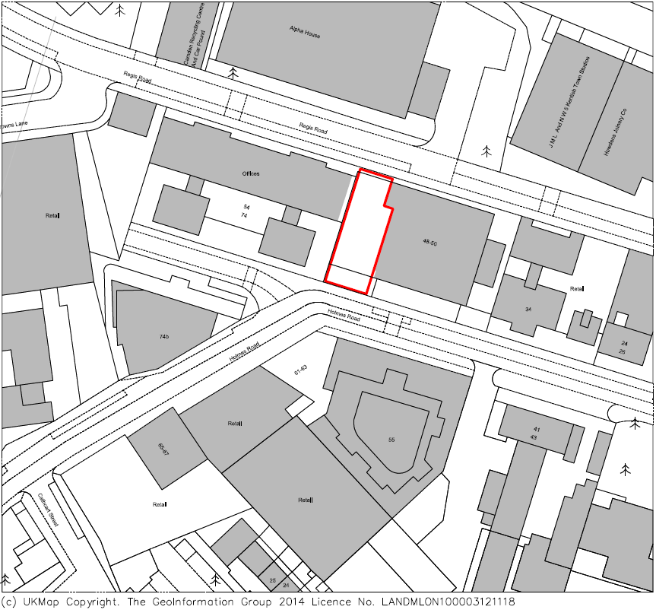

Figure 1.1 : 52 Holmes Road Location

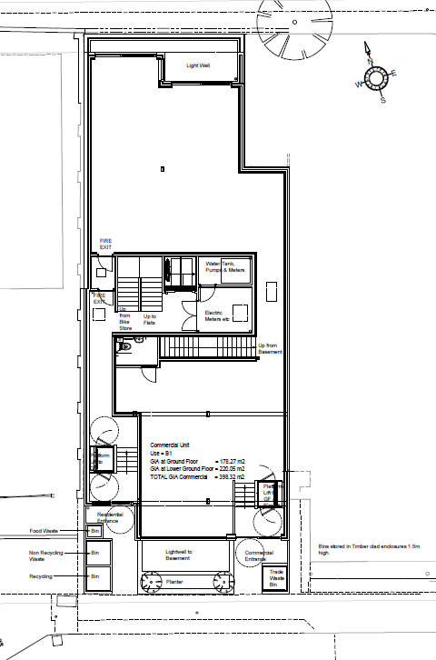

Figure 1.2 Ground floor layout highlighting commercial and residential entrances as well as bin store location.

This waste management plan has been prepared in order to discharge condition 21 of approval 2016/1986/P which says:

*“Prior to occupation of the hereby approved development, details of the location, design and method of waste storage and removal including recycled materials, shall be submitted to and approved by the local planning authority in writing. The facility as approved shall be provided prior to the first occupation of any of the new units and permanently retained thereafter.”*

This waste management strategy is to be shared with all relevant stakeholders (residential and commercial) including Camden officers. Any change of build or agreed arrangement for waste removal will be subject to a change management application.

# Waste Storage Provision

The provision for waste storage for the internal residential areas is for 9x 2 bedroom flats. In this instance, provided in each flat is a general waste allocation for 60L and a 23L caddy for food waste. The development is limited in available space for communal bins and so Veolia have been consulted on this. It was deemed acceptable by Veolia to provide 2x 1100L bins for general waste and mixed recycling as well as a 240L bin for food waste. Space has even been considered for small ancillary sack provision, including nappies, textiles, HH batteries and small WEEE. Collection services for this will be provided by Veolia.

Veolia were also consulted as an advisory on bin provision for the commercial aspect of the development. The commercial unit is use class B1. Such business operations under B1 include offices, research and development and light industrial use. Examples of waste that can be expected to be produced from commercial activity under this class include paper, card and light plastics. The commercial provision for bins and the strategy for waste collection and removal is to be assessed upon a commercial business taking occupation of the units. However, there is provision for a 660 L bin. Bulky waste collection can be booked in as required. Alternatively, the tenant can drop off bulky waste at Regis Road Reuse & Recycling Centre. The tenant will be reminded that they have a duty of care to manage their waste and ensure they are set up with an EA approved collection provider. Requirements for waste management will be included within the tenancy agreement.

# Waste Collection

It is intended for collection to be provided by Veolia once per week for the residential aspect. Additional collections such as ancillary sacks are to be arranged as additional to this arrangement as well as combined residential and commercial collection in order to minimise the number of roadside trips as much as possible. The target is to keep trips to a minimum of 3-4 times in a week with no more than 7 occurring in a single week. Bulky waste collection is to be provided 4 times per calendar year. Collection times will be between 8am-3pm. Any bins presented will not be left by the roadside and will be returned to the bin stores once emptied. Details for securing the bin enclosures will be shared with Veolia and any other EA approved collection provider. Details & Schedules to this effect will be shared with residents/tenants to ensure that processes for waste management is followed and understood. Letters and information will be sent to new and leaving residents or included in tenancy agreements. Additional information holds will be located on the bin enclosures to help aid residents & tenants.

Regarding RCV vehicles stopping for collection there are traffic restrictions outside of 52 Holmes Road due to a zebra crossing adjacent to the outside of the building. Control measures are to reduce stopping and collection to as short a time as possible. The bin stores are located at the front of the property directly adjacent to the footpath and well within 10 meters of the dropped kerb in front of the development (see figures 1.2 and 2.1). Bins will be presented prior to collection and then any refuse vehicle will only be pausing for a few minutes to empty the bins before returning them and moving on. Whilst stationary, vehicle hazard lights should be displayed, and the vehicle should be stopped clear of the zebra crossing. No vehicle is permitted to overtake in this area so for crossing pedestrians they would be able to observe traffic before crossing safely.

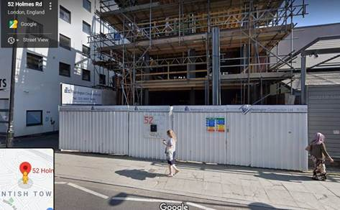

Figure 2.1 Street view of 52 Holmes Road showing dropped kerb.

# Details of the bin enclosures

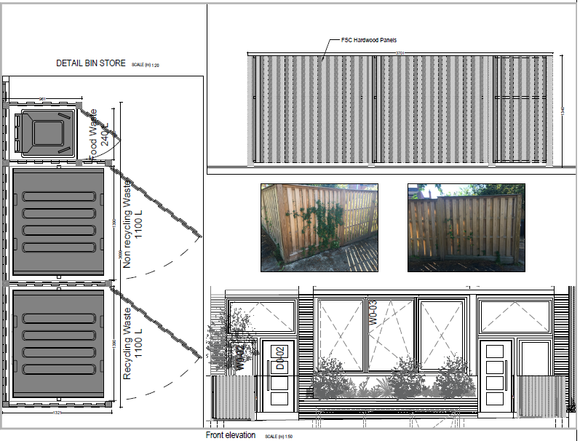

Figure 3.1 Details of the size and scale of the bin stores.

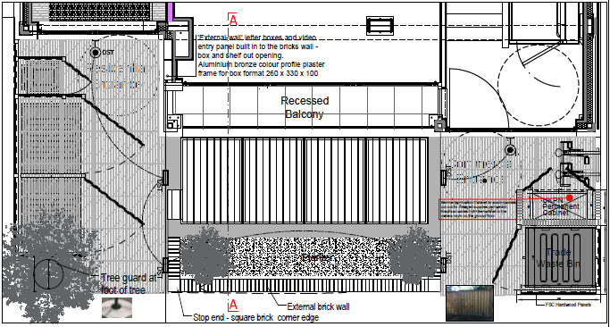

Figure 3.2 layout plan of the front courtyard and bin stores.

# Additional information to be shared

The relevant links and additional information is to be shared with residents and tenants of 52 Holmes Road:

* What Goes In My bin? <https://www.camden.gov.uk/what-goes-in-bins>
* Right Waste Right Place (Commercial) <http://www.rightwasterightplace.com/#intro>
* Camden Regis Road RRC <https://www.nlwa.gov.uk/places-to-recycle/camden-regis-road>
* Clean Camden App <https://www.camden.gov.uk/clean-camden#dfmo>