REDINGTON FROGNAL
NEIGHBOURHOOD FORUM

23 November 2020

Dear Ms Fieldsend,

6 Chesterford Gardens: 2020/4540/P – objection

Chesterford Gardens was laid out in the Victorian era. Numbers 2-30 and 1-21 are considered to make a positive contribution to the Conservation Area and their settings are therefore of particular importance.

Page 5 of the Design and Access Statement submitted by the applicant refers to “The traditional black wrought iron gate and railings”. This is incorrect: metal railings are not and never have been a characteristic feature of the Redington Frognal area and, indeed, are causing significant harm. This harm is noted in the current (draft) Conservation Appraisal for Redington Frognal.

Traditional boundary treatments are detailed on page 45 of the attached Heritage and Character Assessment and a photograph of an appropriate boundary treatment is shown below.

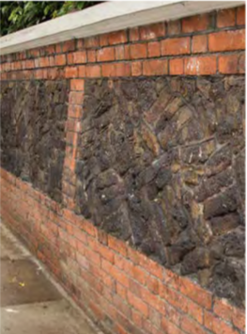

The introduction of metal railings would be highly damaging to the building’s setting and to the streetscape.

Although the Neighbourhood Forum objects to the proposal to install metal railings, a traditional brick wall incorporating lava bricks with a wooden gate would be in keeping with the Conservation Area. A planted front garden would also be encouraged.

Yours sincerely,

Nancy Mayo

Secretary

Redington Frognal Neighbourhood Forum
http://www.redfrogforum.org/

