DECISION

Planning (Listed Building and Conservation Areas) Act 1990

Approval of Details (Listed Building) Granted

Address:
36-37 Chester Terrace
London
NW1 4ND

Proposal:
Discharge of Condition 4d (full details of replacement fire places) of Listed Building Consent ref: 2017/3280/L) for alterations to grade I listed building.
Drawing Nos:
CHT-PL-06 B;
CHT-PL-08 B;
Photo sheets of existing and proposed fire surrounds.

The Council has considered your application and decided to grant Approval of Details (Listed Building) subject to the following condition(s):

Conditions And Reasons:

Informative(s):

Reasons for granting approval of details (listed building):

This application is to clear Condition 4 (d) of Listed Building Consent ref 2017/3280/L which requires full details of replacement fireplaces.

It is noted that the existing fireplaces are non original and have no architectural or historic interest in their current context. The replacement fireplaces are considered appropriate in design, scale, location and materials.

The proposed works are not considered to harm the special interest of the grade I listed building and as such the proposal is supported.

No responses were received as a result of the public consultation through a press notice and a site notice. Historic England were not required to be consulted in this instance as this application relates to an approval of details for a listed building. The site's planning history has been taken into account in making this decision.

Special attention has been paid to the desirability of preserving the special interest of the listed building, under s.16 of the Listed Buildings and Conservation Areas Act 1990 as amended by the Enterprise and Regulatory Reform Act (ERR) 2013

As such, the proposal is in general accordance with policy D2 of the Camden Local Plan 2017. The proposed development also accords with the London Plan 2016 and the NPPF.

In dealing with the application, the Council has sought to work with the applicant in a positive and proactive way in accordance with paragraph 38 of the National Planning Policy Framework 2019.

In dealing with the application, the Council has sought to work with the applicant in a positive and proactive way in accordance with paragraph 38 of the National Planning Policy Framework 2019.

You can find advice about your rights of appeal at:

http://www.planningportal.gov.uk/planning/appeals/guidance/guidancecontent

Yours faithfully

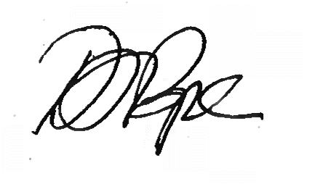
Daniel Pope
Chief Planning Officer

