**MINOR ALTERATIONS TO EXTERNAL ENVELOPE AT GROUND FLOOR LEVEL AT SIENNA BUILDINGS, 47 HATTON GARDEN, LONDON, EC1N 8EX**

We are submitting via the Planning Portal an application in respect of planning approval for minor alterations to the existing front entrance area for the above residential building.

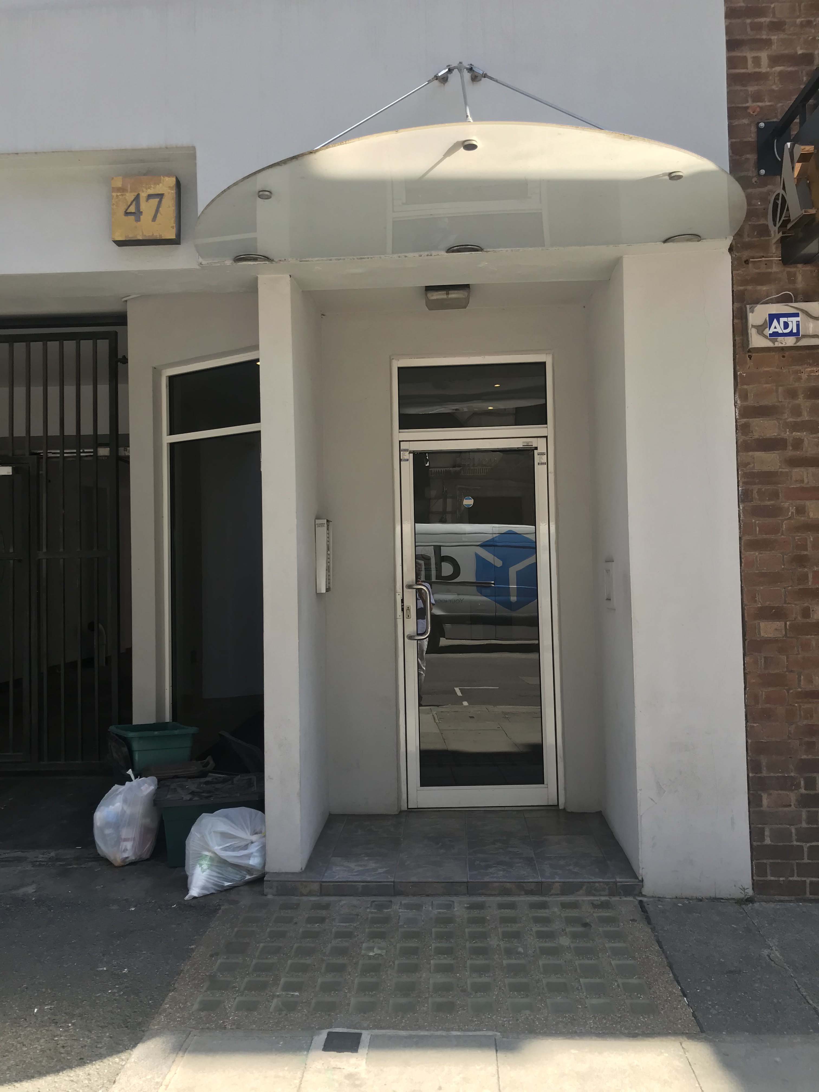

**CONSERVATION AREA**

The building is situated at the Northern end of Hatton Garden and sits within the Hatton Garden Conservation area. The designation of a conservation area provides the basis for policies designed to preserve or enhance those aspects which define the special interest of such an area. 47 Hatton Garden although within the Hatton Garden Conservation Area the building is not noted as having any positive or Negative impact on the area.

The seven storey concrete framed building was converted from offices to eleven residential apartments in 1987 with the provision of some car parking at ground floor level

**PROPOSED WORKS.**

The works proposed are to remove the current recessed entrance door and fully glaze the entrance frontage as the current recessed porch area has proved to be a security risk and by repositioning the door it will allow the formation of an external letterbox and parcel delivery secure box for the use of the existing apartments.

The new framing will be formed of bronze anodised aluminium with double glazed units.

**PLANNING HISTORY**

*PS9704370 – 28/04/1997*

*Conversion of existing offices into 13 residential apartments with ancillary car parking and retention of part ground floor retail space. Approved*

*PS9705075 – 08/10/1997*

*Conversion and change of use of the basement and ground floor retail unit (Class A1) to a health and fitness studio (Class D2). Approved*

*2009/2665/P – 03/08/2009*

*Replacement of existing pavement light and relocation of entrance door. Refused*

*2010/4308/P – 12/08/2010*

*Installation of front lightwell, alterations to front elevation. Approved*

*2011/1746/P – 14/04/2011*

*Change of use from porter rest area to bedsit at basement level (Class C3). Refused*

*2014/1627/P – 20-03-2014*

*Erection of projecting balconies to rear elevation. Approved*

**PLANNING POLICY**

Planning Policy is set out at National and Local level. Sources of guidance relevant to present proposals are:

National Planning Policy Framework (NPPF)

The London Plan 2016

Camden Local Plan 2017

Camden Planning Guidance 2017

National Planning Policy Framework sets out the national standards which require to be considered by individual authorities when producing Local Planning guidance. It contains a set of principles which must be applied to all planning situations. The NPPF contains the outline within which Local Policy must sit.

With regard to the current small scale proposal the works to the external fabric of the building will enhance the appearance of the building and provide a safer environment.

The Council Local Plan requires that a high quality of design is achieved and should respect the local character and preserve or enhance the historic environment.

The proposal uses high quality materials and offers a sustainable design.

**CONCLUSION**

The proposal outlined above and in the accompanying drawings are in our view sensitive to the existing building and the wider context of the Hatton Garden Conservation Area and offer a more attractive and safer environment for the occupants of the building.