# Design and Access Statement for a new shop-front at 218 Tottenham Court Road, London

# For

# Carpet-Right

## July 18th 2020

## Introduction

* 1. 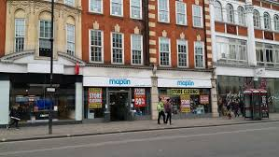Carpet Right have taken a leaser on 218 Tottenham Court Road London to operate the premises as a new carpet shop specialising in exclusive and bespoke designed carpets. The premises they are seeking to occupy is part of the ground floor of the former Maples furniture building which was an historic feature of this part of London’s shopping scene and key in establishing Tottenham Court road as a furniture shopping destination. Since it was vacated by Maples the store was occupied by Maplins. They ceased trading in 2015. Since the liquidation of Maplins the premises have remained vacant for a number of years. The former Maplins shop front is shown below.
  2. Whilst the owners have been seeking to let the property they have installed a temporary shopfront (pictured below).

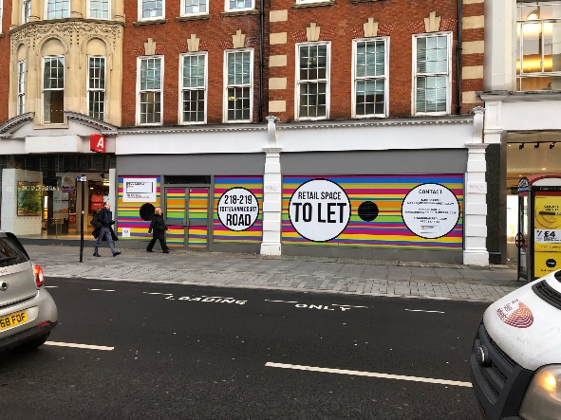

* 1. Our clients are seeking to reinstate a facia and shopfront more in keeping with the lines of the original shopfront by reducing the facia depth from both Maplins and the temporary shopfront and increasing the vertical window heights with seamless glazing from the limited stall risers to the base of the fascia board. This will reflect what Argos have attempted on the adjacent premises at 218 (see below) and provide a cleaner simpler overall design.

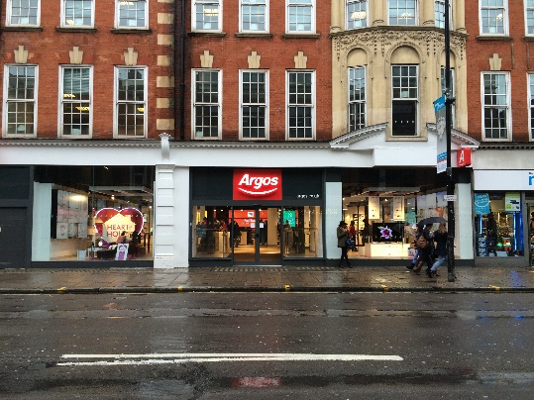

## Design

1. The new shopfront will provide a simple modern solution for the frontage whilst respecting the scale and proportions that the buildings rhythm and openings suggest. The right-hand panel will include the new store entrance (replicating the temporary shopfront) whilst the left-hand panel will be entirely glazed with only vertical breaks in the glazing and no horizontal banding.

2.1 The current backboard at the top of the windows will be replaced with glazing

2.2 The materials for the shopfront are glazing with powder-coated aluminium vertical glazing bars and frame in RAL7024 Graphite Grey. The door frame is made using the same matching materials.

## Access

2.3 The central door in the right-hand unit will have a flat level threshold and a shallow ramp up into the shop to overcome differences in levels between the street and shop floor. This difference is no more than 300mm and will be overcome by a shallow ramp over 2m in length. This is shown on plan TCR290520 enclosed with the application.

2.4 No shutters, rollers or blinds are proposed in order to maintain visual interest in the shop-front and a modern clean public display allowing passers-by to view activity within the unit.

## Summary

2.5 In-keeping with it’s location this is to be a flagship store for Carpetright in their new Design Studio format where the emphasis will be placed on bespoke carpets and flooring and customer led design.

Additional photographs of the existing unit are included below:

