LDC (Proposed) Report |  | Application number | 2020/4567/P
Officer |  | Expiry date
Raymond Yeung |  | 30/11/2020
Application Address |  | Authorised Officer Signature
35 Achilles Road
London
NW6 1DZ
Conservation Area |  | Article 4
N/A |  | Basements

Proposal
Erection of a roof dormer to the rear roof plane of the main house, installation of two rooflights to the front roof plane, and alteration of rear elevation windows to the rear outrigger of the dwenllinghouse (Use class C3).
Recommendation: | Grant approval

The property is a two-storey brick-built mid-terrace dwellinghouse which benefits from an original rear outrigger and single storey rear extension. It is not within a conservation area nor is the property statutory listed.

The proposal involves erection of a roof dormer to the main house measuring 27.3 m3 , the installation of two rooflights to the front roof slope and enlargement of rear windows of the rear outrigger at first and ground floor levels.

The latter is considered under class A as it is a minor alteration to the original
Dwellinghouse, the enlargement to the existing windows on the rear outrigger would allow light into the bedrooms (Overlaid the existing and proposed on the screenshot below). The windows will be timber sash to match the existing house.

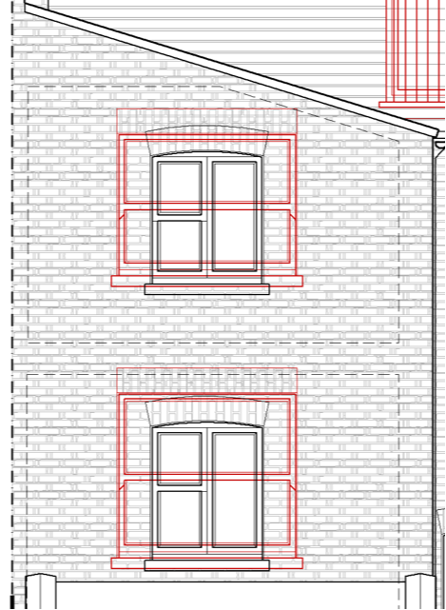

Class A The enlargement, improvement or other alteration of a dwellinghouse

If yes to any of the questions below the proposal is not permitted development |  | Yes/no
A.1 (a) | Permission to use the dwellinghouse as a dwellinghouse has been granted only by virtue of Class M, N, P, PA or Q of Part 3 of this Schedule (changes of use) | No
Comments:
A.1 (b) | As a result of the works, will the total area of ground covered by buildings within the curtilage of the dwellinghouse (other than the original dwellinghouse) exceed 50% of the total area of the curtilage (excluding the ground area of the original dwellinghouse)? | No
A.1 (c) | Will the height of the part of the dwellinghouse enlarged, improved or altered exceed the height of the highest part of the roof of the existing dwellinghouse? | No
A.1 (d) | Will the height of the eaves of the part of the dwellinghouse enlarged, improved or altered exceed the height of the eaves of the existing dwellinghouse? | No
A.1 (e) | Will the enlarged part of the dwellinghouse extend beyond a wall which:  - forms the principal elevation of the original dwellinghouse; or  - fronts a highway and forms a side elevation of the original dwellinghouse? | No
A.1 (f)  (subject to A.1 (g)) | Will the enlarged part of the dwellinghouse have a single storey and:  - extend beyond the rear wall of the original dwellinghouse by more than 4 metres in the case of a detached dwellinghouse, or 3 metres in the case of any other dwellinghouse, or  - exceed 4 metres in height? | No
A.1 (g)  (until 30th May 2019) | For a dwellinghouse not on article 2(3) land* nor on a site of special scientific interest, will the enlarged part of the dwellinghouse have more than one storey and—  - extend beyond the rear wall of the original dwellinghouse by more than 8 metres in the case of a detached dwellinghouse, or 6 metres in the case of any other dwellinghouse; or  - exceed 4 metres in height? | No
A.1 (h) | Will the enlarged part of the dwellinghouse have more than a single storey and  - extend beyond the rear wall of the original dwellinghouse by more than 3 metres, or  - be within 7 metres of any boundary of the curtilage of the dwellinghouse opposite the rear wall the dwellinghouse? | No
A.1 (i) | Will the enlarged part of the dwellinghouse be within 2 metres of the boundary of the curtilage of the dwellinghouse, and the height of the eaves of the enlarged part exceed 3 metres? | No
A.1 (j) | Will the enlarged part of the dwellinghouse extend beyond a wall forming a side elevation of the original dwellinghouse, and either  - exceed 4 metres in height,  - have more than one storey, or  - have a width greater than half the width of the original dwellinghouse? | No
A.1(ja) | Will any total enlargement (being the enlarged part together with any existing enlargement of the original dwellinghouse to which it will be joined) exceed the limits set out in A.1(e) to A.1(j)? | No
A.1(k) | Would it consist of or include either:  - the construction or provision of a veranda, balcony or raised platform,  - the installation, alteration or replacement of a microwave antenna,  - the installation, alteration or replacement of a chimney, flue or soil and vent pipe, or  - an alteration to any part of the roof of the dwellinghouse? | No
Is the property in a conservation area (article 2(3) land)? If yes to any of the questions below then the proposal is not permitted development

A.2(a) | Would it consist of or include the cladding of any part of the exterior of the dwellinghouse with stone, artificial stone, pebble dash, render, timber, plastic or tiles? | No
A.2(b) | Would the enlarged part of the dwellinghouse extend beyond a wall forming a side elevation of the original dwellinghouse? | No
A.2(c) | Would the enlarged part of the dwellinghouse have more than a single storey and extend beyond the rear wall of the original dwellinghouse? | No
A.2(d) | Would any total enlargement (being the enlarged part together with any existing enlargement of the original dwellinghouse to which it will be joined) exceed the limits set out in sub-paragraphs A.2(b) and A.2(c)? | No
Conditions. If no to any of the below then the proposal is not permitted development

A.3(a) | Would the materials used in any exterior work (other than materials used in the construction of a conservatory) be of a similar appearance to those used in the construction of the exterior of the existing dwellinghouse? | Yes
A.3(b) | Would any upper-floor window located in a wall or roof slope forming a side elevation of the dwellinghouse be—  - obscure-glazed, and  - non-opening unless the parts of the window which can be opened are more than 1.7 metres above the floor of the room in which the window is installed? | n/a
A.3(c) | Where the enlarged part of the dwellinghouse has more than a single storey, or forms an upper storey on an existing enlargement of the original dwellinghouse, would the roof pitch of the enlarged part, so far as practicable, be the same as the roof pitch of the original dwellinghouse? | n/a
* The land referred to as article 2(3) land is the land described in Part 1 of Schedule 1 to Town and Country Planning (General Permitted Development) (England) Order 2015/596 (National Parks, areas of outstanding natural beauty and conservation areas etc).

Class B
The enlargement of a dwellinghouse consisting of an addition or alteration to its roof

If yes to any of the questions below the proposal is not permitted development

As a result of the works, would any part of the dwellinghouse exceed the height of the highest part of the existing roof? |  | No
As a result of the works, would any part of the dwellinghouse extend beyond the plane of any existing roof slope which forms the principal elevation of the dwellinghouse and fronts a highway? |  | No
As a result of the works, would the cubic content of the resulting roof space exceed the cubic content of the original roof space by more than—  (i) 40 cubic metres in the case of a terrace house, or  (ii) 50 cubic metres in any other case? | 27.3 m3 | No
would it consist of or include—  - the construction or provision of a veranda, balcony or raised platform, or  - the installation, alteration or replacement of a chimney, flue or soil and vent pipe? | Only Juliet balcony on dormer | No
Is the dwellinghouse on article 1(5) land? |  | No
Would the materials used in any exterior work be of a similar appearance to those used in the construction of the exterior of the existing dwellinghouse? |  | Yes
Other than in the case of a hip-to-gable enlargement, would the edge of the enlargement closest to the eaves of the original roof be less than 20 centimetres from the eaves of the original roof, so far as practicable? |  | Yes
Would any windows inserted on a wall or roof slope forming a side elevation be obscured-glazed and non-opening unless the opening part is higher than 1.7 metres above the floor of the room in which the window is installed? |  | n/a

Class C:
Class C – other alterations to the roof of a dwellinghouse.

Class C. Any other alteration to the roof of a dwellinghouse.

C.1 | Development is not permitted by Class C if—
C.1 (a) | permission to use the dwellinghouse as a dwellinghouse has been granted only by virtue of Class M, N, P or Q of Part 3 of this Schedule (changes of use); | No
C.1 (b) | the alteration would protrude more than 0.15 metres beyond the plane of the slope of the original roof when measured from the perpendicular with the external surface of the original roof; | No
C.1 (c) | it would result in the highest part of the alteration being higher than the highest part of the original roof; or | No
C.1 (d) | it would consist of or include—
C.1 (d i) | the installation, alteration or replacement of a chimney, flue or soil and vent pipe, or | No
C.1 (d ii) | the installation, alteration or replacement of solar photovoltaics or solar thermal equipment. | No
Conditions:
C.2 | Development is permitted by Class C subject to the condition that any window located on a roof slope forming a side elevation of the dwellinghouse must be—
C.2 (a) | obscure-glazed; and
C.2 (b) | non-opening unless the parts of the window which can be opened are more than 1.7 metres above the floor of the room in which the window is installed. | No
Assessment: Recommended approval

