

The Society examines all Planning Applications relating to Hampstead and Hampstead Heath Fringes, and assesses them for their impact on conservation and on the local environment.

**To London Borough of Camden, Development Control Team**

**Planning Ref:** 2019/5835/P **Address:** 4B Hampstead Hill Gardens

**Case Officer:**  Rachel English **Date**: 7th October 2020

I have been investigating the causes of subsidence in Hampstead, and in this capacity have recently been alerted to this application which shows inaccuracies and omissions in the Basement Impact Assessment: either ignorance of the tendency of parts of Hampstead to be susceptible to landslide or deliberate ignoring of known risks. This property is sited on the Claygate Beds/Unit D of the London Clay Formation transition zone that is highly laminated, a short distance below the Spring line, and highly susceptible to landslip. The boreholes samples themselves show the ground to be silty clay with sandy and silt partings. These facts are ignored and also misrepresented throughout the BIA.

**From the BIA**

**Screening questions 3 Land Stability:**

4. While Figure 16 of the Arup Camden Geological, Hydrogeological and Hydrological Study may show that 4B Hampstead Hill Gardens is not on a slope of more than 7 degrees, this is based on surface slopes, whereas the slope of the clay beneath the superficial deposit ‘Head’ solifluction is likely to be more than 7 degrees. The superficial deposit is approximately 1 metre thick here (TP1/BH1 800mm; TP2 980mm with water strike; ), being erroneously described as Made Ground and gives reason to assume the slope angle of the top of the Claygate Beds/Unit D of the London Clay Formation transition zone beneath is greater and should have been assessed. This also fails to acknowledge that clay *does* slide at angles of much less than this based on Weeks AG (1969) 'The stability of natural slopes in south-east England as affected by periglacial activity' *Quarterly Journal of Engineering Geology* 2, 49-61. This showed that landslide has been reported at angles of 4 degrees or less where related to superficial quaternary deposits such as the Head here. Where this part of London is concerned, Head solifluction on slopes with groundwater present should consider slopes of less than 7 degrees for their tendency to instability. Arup’s study was printed in 2010 and so should in any case be updated.

Land Stability is completely ignored. Figure 17 of Arup’s Camden Geological, Hydrogeological and Hydrological Study, which is the British Geological Survey (BGS) 'Areas for Greatest Potential for Slope Instability' <http://www.largeimages.bgs.ac.uk/iip/mapsportal.html?id=1001750> – and see extract at end of this document, shows 4B HHG to be right over an area of High/Very High risk for slope instability as calculated by Forster A, Wildman G & Poulton C. (2003) Landslide potential modelling of North London. British Geological Survey Internal Report, IR/03/122R. This ‘crimson line’ is now being recognised in my study of subsidence in Hampstead as highly significant for a large proportion of cases of subsidence and landslide in the Hampstead area.

**5.1.2**

**“**Water was struck in TP2 at 0.98m bgl at the base of the Made Ground and was standing a 1.14m bgl upon completion of the pit, which was terminated at 1.18m bgl. It is considered that this is localised perched water within the Made Ground.”

This is evidence of the aquifer at the base of the Head superficial deposit: *during dry weather conditions*, TP2 had a water strike at 980mm which is at the base of the Head – they referred to this as ‘Made Ground’. While there are fragments of brick etc within the ground here, it is actually an unstable and semi-permeable solifluction. This has been completely missed.

**5.1.4** The arb report is no different from the vast majority of subsidence reports seen in the Hampstead area and elsewhere: do inappropriate tests for the ground conditions, misunderstand the data, blame the trees and ignore all other potential causes of subsidence. In this area, only when expert arboriculturalists and engineers who work outside the subsidence and insurance industries and appropriately investigate and evaluate what is happening do the true causes emerge, along with the solutions.

**5.2.**

“The CET investigation was undertaken for the purposes of investigating subsidence related damage arising due to the presence of existing trees and vegetation. As such, in-situ testing and moisture content results have been excluded from further consideration as they are deemed to be un-representative, as the trees thought to have caused the original subsidence have now been removed/limited, as discussed above.”

This completely misses the point that soil investigation performed at one time point for an insurance company aiming to clear up a subsidence claim as fast and as cheaply as possible some years ago is totally inappropriate as a basis for demonstrating the effect of digging out a deep basement on an attached neighbour, and assessing the project’s likelihood of causing landslide or the severity of damage to the neighbouring building.

“As such, strata boundaries from the investigation and the Atterberg Limit tests results (which are a

fundamental soil property) are considered representative.“

This could hardly be further from the truth. It is typical of the level of knowledge of engineers in the subsidence industry; an adequately trained geo-technical engineer who keeps up to date will know that using merely representative tests (with inappropriately gathered samples due to using the wrong boring methods for, for example, obtaining non-disturbed samples and determining groundwater). Loughborough University’s Frost & Gray 2019 publication investigation into Atterberg limits stated:

“It is concluded that a more appropriate analysis should be based on a wider overall assessment of all the available soil/site information, in conjunction with a simple assessment of plasticity.”

We would suggest that this applies to the entire BIA. At every step the ground is referred to as London Clay, and the references for this give Patel DC (2015) 15. ’*Interpretation of results of pile tests in London Clay – Victoria Station*.’ The clay beneath Victoria Station could not be further from that beneath this site. The proportion of silt and sand, the permeability, the soil cohesion, the geological historical method of laying down the ground here are totally totally different.

Standard Penetration Tests (SPT) were used, though understandably, only on the ‘London Clay Formation’ (LCF) i.e. the Unit D of the LCF beneath the Head, but this is a crude test with very wide margins of error and importantly does not evaluate the ground’s propensity to landslip or to cohesion in the wider sense. The attached neighbour is sitting on the superficial deposit Head on a slope. This was not tested but is known to be complex, highly laminated and susceptible to landslide, and is relatively much more permeable than clay alone. Since it is the effect on the stability of *neighbouring properties - and the adjacent public roadway -* that the BIA should be concerned about, this is disgraceful.

The BIA acknowledges that the Mackintosh Probe and hand shear vane tests performed on the surface to assess subsidence in 2015 do not yield reliable results in relation to the geotechnical behaviour of the soils, yet instead of doing tests that do, they rely on those performed at 1 Hampstead Hill Gardens by RPS in July 2017. Since this is the same company one would assume it could have made the same errors of test choice and interpretation as are evident here. The first obvious error is to use a limited number of boreholes and at such a distance. The ground here is known to vary considerably, in many areas within a foot, as described in Ellison RA et al (2004) 'Geology of London: memoir of the British Geological Survey, Sheets 256 (North London), 257 (Romford), 270 (South London) and 271 (Dartford)'.

The BIA also states:

“Approximate undrained shear strengths were calculated from SPT results using the correlation Cu = f1 x N9, where a value for f1 = 4.5 has been adopted based on Plasticity Index results. The SPT results correspond approximately to undrained shear strength values ranging from 50kN/m2 to 86kN/m2, which is indicative of a medium, ranging to a high strength, cohesive material.”

The comment that the results were “considered to be conservative for the stratum when compared to published data contained within Patel (2015)” beggers belief. One cannot consider a comparison between two geologically and structurally totally different materials.

Thus, one has SPT with its wide margin of error, using f1 values based on an inappropriate test for the plasticity of laminated ground, to ‘correspond’ to shear strength values and come up with the statement that the ground is a *medium ranging to a high* strength cohesive material. Of course the ground is stiff at depth; that’s not the point. Are Camden, Campbell Davis, the contractors *and the neighbours* supposed to feel comforted that other shallower properties around are secure from ground movement, and that no more than Burland Scale 1 movement can be expected on ground officially designated as high to very high risk of landslide?

The figures given in Table 5: Geotechnical Design Parameters are described as “considered to be ‘moderately

conservative’ design values.” Such a bald statement is not good enough.

**6.2. Groundwater Conditions** states “Groundwater was not encountered during the investigation by CET or in the investigation by RPS at 1 Hampstead Hill Gardens.” It was *prevented from being encountered* by the method of testing yet still was encountered at 1 HHG and in the earlier subsidence study. Naming it ‘Perched water’ doesn’t prevent its presence – and certainly not its effect, particularly if there is a storm causing groundwater surging as occurs in Hampstead during the underpinning method process and basement dig-out, and on construction if temporary works don’t take account of it. All surrounding properties and trees to the side, up-stream and downstream need to be considered after this huge block to groundwater is finally in place. Problems that have been encountered elsewhere in Hampstead of some geological similarity have shown that landslide lubricated and eroded by such groundwater continues for around 20 years until it finally comes to a stop until the next assault on it e.g. 254 and 268 Finchley Road, and most probably Camden Arts Centre which continues its alarming move downhill yet the Subsidence Industry engineers are still blaming a small cherry, rowan and birch trees, buddleia and pampas grass, so deep is their conviction that only vegetation can cause subsidence.

**7.4 Ground Movements Arising from Basement Excavation and Construction**

This section tells us that they have used OASYS Limited PDisp analysis software. Although the results are presented, none of the data that was entered has been as is usual so that it can be checked. In any case, this is a soil settlement calculation & displacement analysis. Both OASYS P-Disp and OASYS X-Disp are reliant on the ground being stable to start with. Figure 17 of Arup’s ‘Camden Geological, Hydrogeological and Hydrological Study’ says otherwise. If ground is suspected of being unstable – as here – then neither analyses can be used.

Oasys cannot cope with dynamic conditions; the analyses represent ideal circumstances - they do not cater for vibrations from construction, landslides that are creeping as a result of excavation, groundwater storm surges and consolidation from the reduction of pore water pressures. Finite Element Analyses (FEA) are needed for that. It may be assumed that conditions are reasonable BEFORE excavation commences, but these will change with time to conditions that would not produce predictions of displacements that are acceptable. Conditions such as this are far far far from present here.

The work of Burland, Wroth, Standing, Boscardin and Cordin are quoted, yet this fundamental requirement for using OASYS, developed as a result of and using these authors’ work, is ignored.

**Subsidence Evidence presented in Appendices**

Four hornbeams and plenty of other trees have been removed yet it is acknowledged that cracking still reappeared and extended.

Other properties close by in Daleham Gardens who have suffered subsidence have had their’s more adequately investigated which were found to be leaking drains, and in one case ground settlement from basement excavation. Fixing the leaking drains stopped further movement in these cases. Here, leaking drains were found but as is unfortunately usual with the loss adjusters Crawfords involved, these were ignored and the trees were all taken out instead. The vibration from piling at various times, ground pressure changes during digging out for extensions and other alterations over the years has not even been considered as responsible for causing local ground movement and landslip as is happening elsewhere in Hampstead, though particularly on the ‘crimson line’ of the BGS ‘Areas for Greatest Potential for Slope Instability’. My experience of subsidence and landslip as a result of basement excavation along Finchley Road, in the Netherhall Gardens area, South Hill Park and elsewhere demonstrates that this is likely to occur. The BIA gives no comfort at all that the authors, the contractors or Campbell Reith understand the local geology and its implications at all.

In view of all the potential risk to the other neighbouring – some listed - buildings from landslip, subsidence, silt erosion by groundwater constraint, and flooding and tree drowning from groundwater damming up, please refuse this inaccurate and inadequate application that fails to conform to Camden Planning Guidelines and the Hampstead Neighbourhood Plan.

Dr Vicki Harding, Society Tree Officer, Planning Sub-Committee of the Heath & Hampstead Society

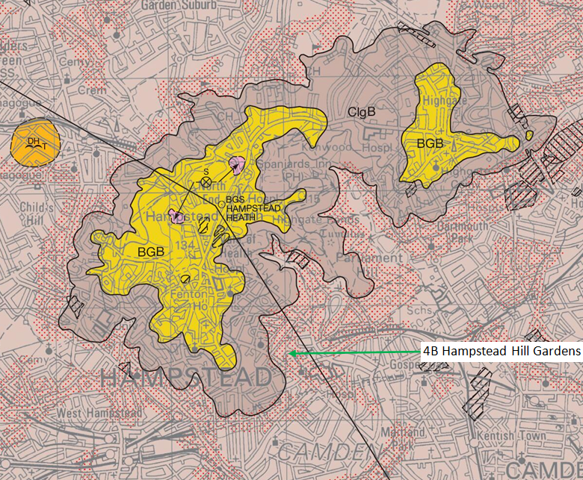

**British Geological Survey 1 : 50 000 series North London Sheet 256 Bedrock and Superficial Deposits**

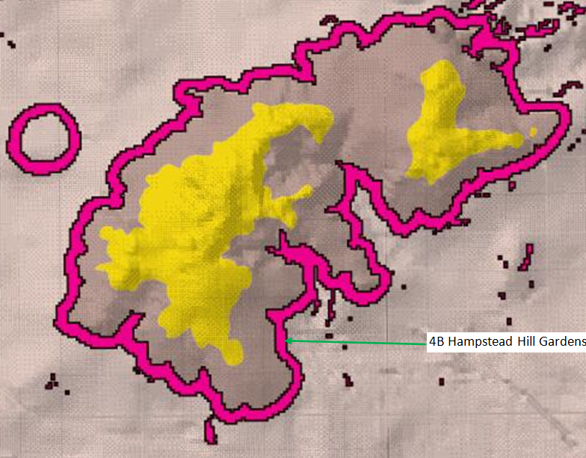

**British Geological Survey Areas for Greatest Potential for Slope Instability**

http://www.largeimages.bgs.ac.uk/iip/mapsportal.html?id=1001750

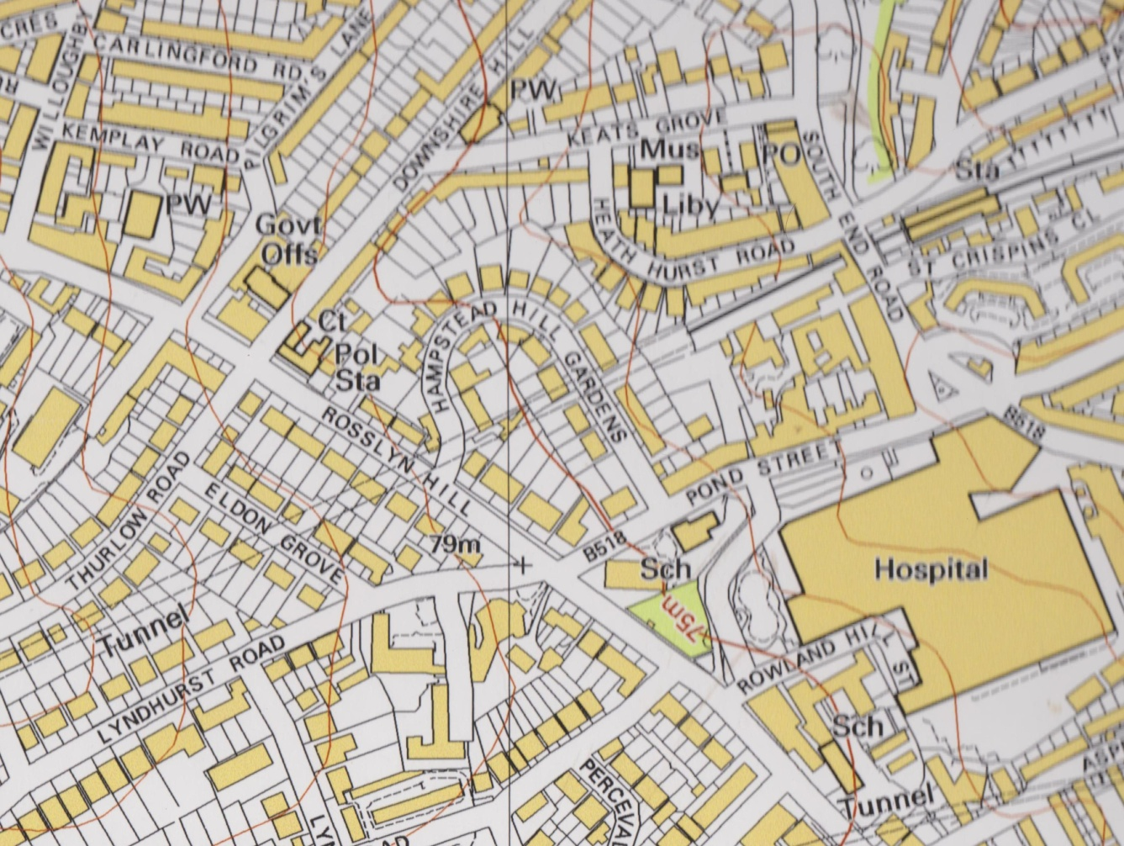

**1:5000 OS map showing close contour lines immediately to the WNW of the property with groundwater flow in a westerly direction indicating ponding will occur beneath 4A HHG, as well as the effects of GW constraint**