SITE SPECIFIC SUPPLEMENTARY INFORMATION

- Site Details

Site Name: | Torrington Place | Site Address: | Torrington Place  1-19 Torrington Place  Tottenham Court Road  London  WC1E 7HB
NGR: | E: 529515, N: 181988
Site Ref Number: | 98117 | Site Type: Macro | Upgrade

- Pre Application Check List

Site Selection

Was an LPA mast register used to check for suitable sites by the operator or the LPA? |  | No
If no explain why:

After a phone call to the LPA it was felt that the industry database was a more up to date source of information.

Was the industry site database checked for suitable sites by the operator: | Yes
If no explain why:

N/A

Pre-application consultation with LPA

Date of written offer of pre-application consultation: | 9th January 2019
Was there pre-application contact: |  | No
Date of pre-application contact: | N/A
Name of contact: | The Director of Planning
Summary of outcome/Main issues raised:

No comments have been received in respect to the proposal.

Ten Commitments Consultation

Rating of Site under Traffic Light Model: | Green
Prior to the submission of this application the applicant initiate pre-consultation discussions with the local planning authority. This provides an opportunity for the LPA to discuss development proposals and identify site specific issues.

Summary of outcome/Main issues raised:

No responses had been received at the time of submission.

School/College

Location of site in relation to school/college:

There are no schools in close proximity that overlook the site.

Outline of consultation carried out with school/college:

N/A

Summary of outcome/Main issues raised:

N/A

Civil Aviation Authority/Secretary of State for Defence/Aerodrome Operator consultation (only required for an application for prior approval)

Will the structure be within 3km of an aerodrome or airfield? |  | No
Has the Civil Aviation Authority/Secretary of State for Defence/Aerodrome Operator been notified? |  | No
Details of response:

N/A

Developer’s Notice

Copy of Developer’s Notice enclosed? |  | Yes
Date served: | 11th July 2020

- Proposed Development

The proposed site:
PLEASE NOTE THIS IS A RESUBMISSION OF APPLICATION REF: 2019/0448/P

The current roof equipment at Torrington Place, 1-19 Torrington Place, Tottenham Court Road
London, WC1E 7HB is being upgraded with minimal visual impact, indeed the visual implications of this upgrade are negligible. The applicant appreciates that the site is within a Conservation Area and thus the equipment has been kept to an absolute minimum whilst retaining the key coverage requirements. The sharing of base stations between multiple operators is one of the key strategic policy principles contained within the NPPF. H3G and EE have a network sharing agreement and thus these installations are fully compliant with the NPPF.

In keeping with the National Planning Policy Framework (NPPF). guidelines of using: “high quality communications infrastructure”, the proposed design has been selected to minimise visual impact upon the street scene by integrating with the existing built environment. The presence of the roof top equipment sets a clear precedent for telecommunications development in this location and indicates that the principle of this proposal is acceptable in terms of siting. As stated above the National Planning Policy Framework advocates site sharing, and as such we believe that there are no sequentially preferable locations within the defined site search area.

The design of the proposed equipment is considered to be the least visually intrusive option available. Although it is accepted that there will be very marginally intensification in the amount of equipment it is felt that such a minor increase would not detract from the Article 2 (3) land character of the area in which the proposal sits. The Conservation Area will be both preserved and enhanced with this upgrade with improved connectivity.

Any other proposal to satisfy the identified requirement would result in the addition of a separate ground based column elsewhere in close proximity to the existing structure. In our opinion, such a proposal would, in this instance, unnecessarily add to the clutter in the street scene and result in a greater visual impact.

Application Ref 2019/0448/P Refusal

Prior to submission of this application, application ref 2019/0448/P was refused on 26th April 2019. The reason for refusal is as follows: -

“The proposal, by reason of location, scale, height and design would result in visual rooftop clutter which would cause harm to the character and appearance of the property, local views and the Bloomsbury Conservation Area, contrary to policies D1 (Design) and D2 (Heritage) of the London Borough of Camden Local Plan 2017.”

The proposal has since been revised in order to reduce the scale, height and density of the proposal in order to reduce the ‘rooftop clutter’ and work to maintain the character and appearance of the property and surrounding Bloomsbury Conservation Area. Figure 1 show the existing rooftop which currently houses existing telecoms equipment.

Figure 1:

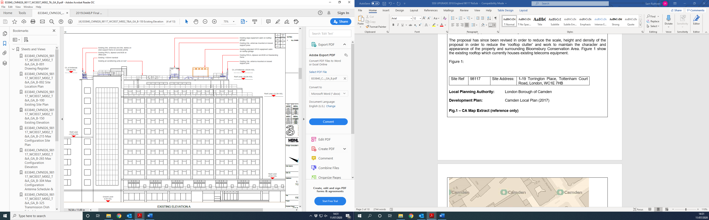

The refused design for application 2019/0448/P is shown below in Figure 2 for comparison purposes with the revised design which has been submitted with this application, which is shown on the new application drawings.

Figure 2:

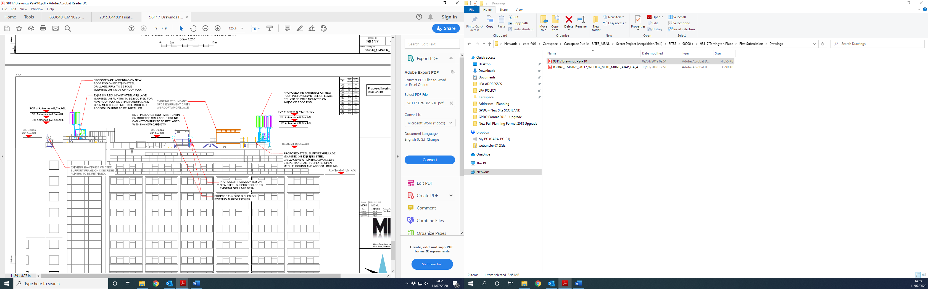

As the drawing shows, the revised scheme in Figure 3 has been scaled down significantly from the previous proposals and allow for a development which is reduced in both scale and density. The number of Apertures on the rooftop has been halved, allowing for more consideration to be had for the existing rooftop and surrounding areas. The colours and materials used have been designed to reflect the character of the existing impact and sought to reduce the impact on the existing skyline.

Site Ref | 98117 | Site Address: | 1-19 Torrington Place, Tottenham Court Road, London, WC1E 7HB

Local Planning Authority: London Borough of Camden

Development Plan: Camden Local Plan (2017)

Fig.1 – CA Map Extract (reference only)

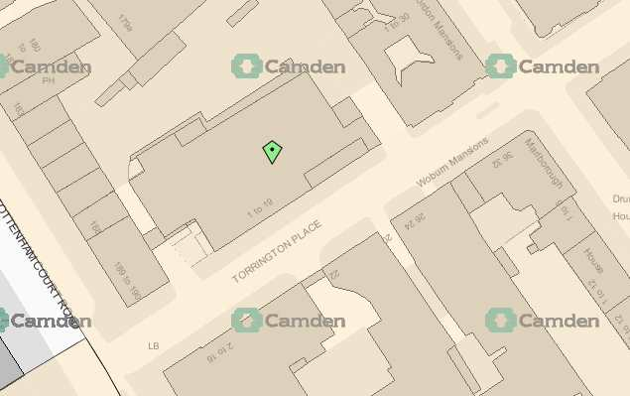

Site and its surrounds

Policy Relevant to the Development Site:

The site is designated as being in the settlement boundary, with urban uses to the north, east, south and west. The site is in the Bloomsbury Conservation Area. The land designation that this site is located in is a material consideration.

The London Borough of Camden does not have a specific telecoms policy. Therefore the NPPF is of relevance. The National Planning Policy section of this supporting statement goes into detailed analysis of why this site is in compliance with the NPPF.

Policy Analysis:

Policy D2 states:

Conservation areas are designated heritage assets and this section should be read in conjunction with the section above headed ‘designated heritage assets’. In order to maintain the character of Camden’s conservation areas, the Council will take account of conservation area statements, appraisals and management strategies when assessing applications within conservation areas.

The Council will:

e. require that development within conservation areas preserves or, where possible, enhances the character or appearance of the area;
f. resist the total or substantial demolition of an unlisted building that makes a positive contribution to the character or appearance of a conservation area;
g. resist development outside of a conservation area that causes harm to the character or appearance of that conservation area; and
h. preserve trees and garden spaces which contribute to the character and appearance of a conservation area or which provide a setting for Camden’s architectural heritage.

The proposed works on this site would are suitably distant and diminutive in scale and design (when seen in context) as to not be to the detriment of the surrounding area or its character (the visual change would be limited), and yet would provide the requisite coverage needed in the area as well as facilitate site sharing, so according with the principles of the policy.

It accords with the requirements of the NPPF and the objectives of the London Plan (Policy 4.11 Encouraging a Connected Economy (March 2015)).

Enclose map showing the cell centre and adjoining cells:
This can be emailed to the LPA on request

Type of Structure
Description:

Roof top upgrade and associated works.

Overall Height: N/A
Height of existing building |  | 36.0m AGL
Equipment Housing:
Length: |  | See drawings
Width: |  | See drawings
Height: |  | See drawings
Materials
Tower/mast etc – type of material and external colour: | See drawings
Equipment housing – type of material and external colour: | See drawings

Reasons for choice of design:
The sharing of base stations between multiple operators is one of the key strategic policy principles contained within the NPPF. EE Ltd is the new operating company which used to be T Mobile and Orange.

In keeping with the National Planning Policy Framework (NPPF). guidelines of using “high quality communications infrastructure”, the proposed design has been selected to minimise visual impact upon the street scene

- Technical Information

ICNIRP Declaration attached  ICNIRP public compliance is determined by mathematical calculation and implemented by careful location of antennas, access restrictions and/or barriers and signage as necessary. Members of the public cannot unknowingly enter areas close to the antennas where exposure may exceed the relevant guidelines.  When determining compliance the emissions from all mobile phone network operators on the site are taken into account. | Yes

Frequency: | This information can be emailed to the LPA on request
Modulation characteristics | As above
Power output (expressed in EIRP in dBW per carrier)  In order to minimise interference within its own network and with other radio networks, (EE Ltd) operates its network in such a way the radio frequency power outputs are kept to the lowest levels commensurate with effective service provision  As part of (EE Ltd)’s network, the radio base station that is the subject of this application will be configured to operate in this way. | As above
Height of antenna (m above ground level) | See drawings

- Technical Justification

Reason(s) why site required
The National Planning Policy Framework clearly states that authorities should not question the need for the service, nor seek to prevent competition between operators. Notwithstanding this fact, the Applicant considers it to be important to explain the technical justification for the site and how the facility fits into the overall network.

The site is required to provide enhanced coverage for EE Ltd, ESN and H3G LTE.

- Site Selection Process – alternative sites considered and not chosen

Discounted Options
In accordance with the sequential approach outlined in the National Planning Policy Framework (NPPF) following search criteria have been utilised. Firstly consideration is always given to sharing any existing telecommunication structures in the area, secondly consideration is then given to utilising any suitable existing structures or buildings and thirdly sites for freestanding ground based installations are investigated.

This sequential approach is outlined below:

- Mast and Site Sharing
- Existing Buildings Structures
- Ground Bases Installations

In compliance with its licence and the sequential approach outlined in the NPPF all attempts to utilise any existing telecommunication structures where they represent the optimum environmental solution have been employed. The Ofcom Site Finder mast register is always examined prior to the submission of an application.

If no alternative site options have been investigated, please explain why:

This is an upgrade to existing sites thus no other standalone new facilities have been investigated. A new additional mast to facilitate the upgrade would not be in line with NPPF by upgrading the current facility the most sequentially preferable option has been progressed.

- Additional Relevant Information

Background to the Proposal
Mobile phone base stations operate on a low power and accordingly base stations therefore need to be located in the areas they are required to serve. Increasingly, people are also using their mobiles in their homes and this means we need to position base stations in, or close to, residential areas.

A further limiting factor is that the position has to be one that fits in with the existing network. Sites have to form a patchwork of coverage cells with each cell overlapping to a limited degree with the surrounding base stations to provide continuous network cover as users move from one cell to the other. However if this overlap is too great unacceptable interference is created between the two cells.

DEVELOPMENT PLAN POLICY.

Development plan considerations have a special significance in law. Section 54A of the Town and Country Planning Act 1990 (The Act), and re-iterated in Section 38 of the Planning and Compensation Act 2004, it is stated that:

“Where in making any determination under the Planning Acts regard is to be had to the Development Plan, determination shall be made in accordance with the Development Plan unless material considerations indicate otherwise.”

NATIONAL PLANNING POLICY

The Government remain committed to promoting telecommunications and place emphasis on the importance of telecommunications to the wider economy. The National Planning Policy Framework (NPPF Feb 2019) sets out the Government’s planning policies for England and how these are expected to be applied at the Local level. It provides a framework within which local people and their accountable Councils can produce their own distinctive local and neighbourhood plans, which reflect the needs and priorities of their communities.
The purpose of the planning system is to contribute to the achievement of sustainable development. There are three dimensions of sustainable development, each of which give rise to the need for the planning systems to perform a number of roles including;

- Economic Role – contributing to building strong, responsive and competitive economy;
- Social Role – Supporting strong vibrant and healthy communities; and
- Environmental Role – Contributing to protecting and enhancing our natural, built and historic environment.
The NPPF contains at its core a presumption in favour of sustainable development which runs through both plan-making and decision-making processes. The NPPF recognises the vital importance of high quality telecommunications and dedicates a whole chapter to this. Chapter 10 of the NPPF outlines the Governments support for high quality communications. The paragraphs below clearly outline the overarching support from Central Government for telecommunications and how Local Planning Authorities should embrace this vital infrastructure:

Paragraph 112 states:

“Advanced, high quality and reliable communications infrastructure is essential for economic growth and social well-being. Planning policies and decisions should support the expansion of electronic communications networks, including next generation mobile technology (such as 5G) and full fibre broadband connections. Policies should set out how high quality digital infrastructure, providing access to services from a range of providers, is expected to be delivered and upgraded over time; and should prioritise full fibre connections to existing and new developments (as these connections will, in almost all cases, provide the optimum solution).”

It continues in Paragraph 113

“The number of radio and electronic communications masts, and the sites for such installations, should be kept to a minimum consistent with the needs of consumers, the efficient operation of the network and providing reasonable capacity for future expansion. Use of existing masts, buildings and other structures for new electronic communications capability (including wireless) should be encouraged. Where new sites are required (such as for new 5G networks, or for connected transport and smart city applications), equipment should be sympathetically designed and camouflaged where appropriate.” Operators always follow the sequential site selection process. Where an existing site can be shared or upgraded this will always adhered to before a new proposal is put forward for consideration.

The support for telecoms and the need not to constrain Operators is laid out in Paragraph 116

“Local planning authorities must determine applications on planning grounds only. They should not seek to prevent competition between different operators, question the need for an electronic communications system, or set health safeguards different from the International Commission guidelines for public exposure.”

Conclusion

We consider that the development is complaint with the council’s policy and that in accordance with Section 38 (6) of the Planning and Compensation Act 2004 permission should be granted for the installation.

We consider the development complies with both central government and local planning policy guidance where the underlying aim is to provide an efficient and competitive telecommunication system for the benefit of the community while minimising visual impact.

Taking into account the factors of technical constraints, available sites and planning constraints we consider that this site and design clearly represents the optimum environmental solution.

On the basis of a recognised need to expand and promote telecommunications networks across the region, it is considered that the proposal fully accords with the requirements of the National Planning Policy Framework and Local Plan Policies.

Damian Hosker BA(Hons) MA MRTPI
d.hosker@whptelecoms.com

07771 527 070

Contact Details

Name: (Agent) | Damian Hosker BA(Hons) MA MRTPI | Telephone: | 07771 527 070
Operator: | EE Ltd & H3G | Fax no: | N/A
Address: | WHP  Helena House  Troy Mills  Troy Road  Leeds  LS18 5SF | Email Address: | d.hosker@whptelecoms.com
Signed: |  | Date: | 12th July 2020
Position: | Planning Manager | Company:  (on behalf of above operator) | WHP

The modulation method employed in GSM is GMSK (Gaussian Minimum Shift Keying) which is a form of Phase modulation The modulation method employed in UMTS is QPSK (Quad Phase Shift Keying) which is another form of Phase Modulation

