**Heritage Statement**

For

**The Roebuck PH, 15 Pond Street, London NW3 2PN**

The Roebuck is a Grade II Listed Building with the following listing description.

*TQ2785SW POND STREET 798-1/39/1325 (North side) 14/05/74 No.15 Roebuck Public House*

*Public house & hotel. Late 1860s. Stucco with channelled stucco ground floor. 3 storeys and cellars. Symmetrical facade of 5 windows plus 1-window extension over left hand carriage entrance. Public house openings round-arched with keystones and linked by impost bands; doorways, in outer bays, with fanlights and panelled doors. Upper floor sashes in round-arched openings with architraved heads, 1st floor with keystones, linked by impost bands; pilasters articulate bays, 1st floor with rusticated bands supporting an entablature with projecting modillion cornice, 2nd floor plain pilasters with enriched heads supporting entablature (inscribed Roebuck Hotel) and dentil and modillion pediment having a painted sculpture roebuck in the tympanum. Extension has architraved tripartite sashes; 1st floor with console bracketed cornice, 2nd floor with mask keystone. Entablature with dentil and modillion cornice. INTERIOR: now converted to a single bar, retains massively overscaled cornices with modillion decoration.*

*Listing NGR: TQ2713885475*

The property is currently used a public house with bars and customer toilets on the ground floor and basement level with further beer cellars to the basement. The trade kitchen is located on the first floor with the managers accommodation with the second floor previously used a staff accommodation now mostly used. There is a beer garden located to the rear of the property accessed through the pub and with a means of escape via the rear yard into an access road to the side of the property which leads back to the main road.

The application seeks approval for two bin store area constructed of a timber structure with vertical posts to all corners supported off the floor to prevent excessive bolting to the existing structure. This will be clad in plywood for the roof with a GRP covering and the walls will be constructed of 150 x 25mm timber boarding with 10mm ventilation gaps between. The location of the structure is concealed from the public view being down a private access road and behind timber gates.

We believe therefore that the works proposed will have little detrimental effect on the fabric of the existing Listed Building.

**Existing Photographs**

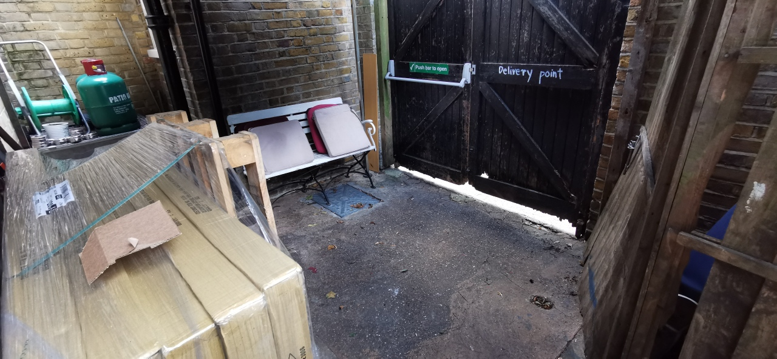

Photo in rear yard looking at gates into side access road.

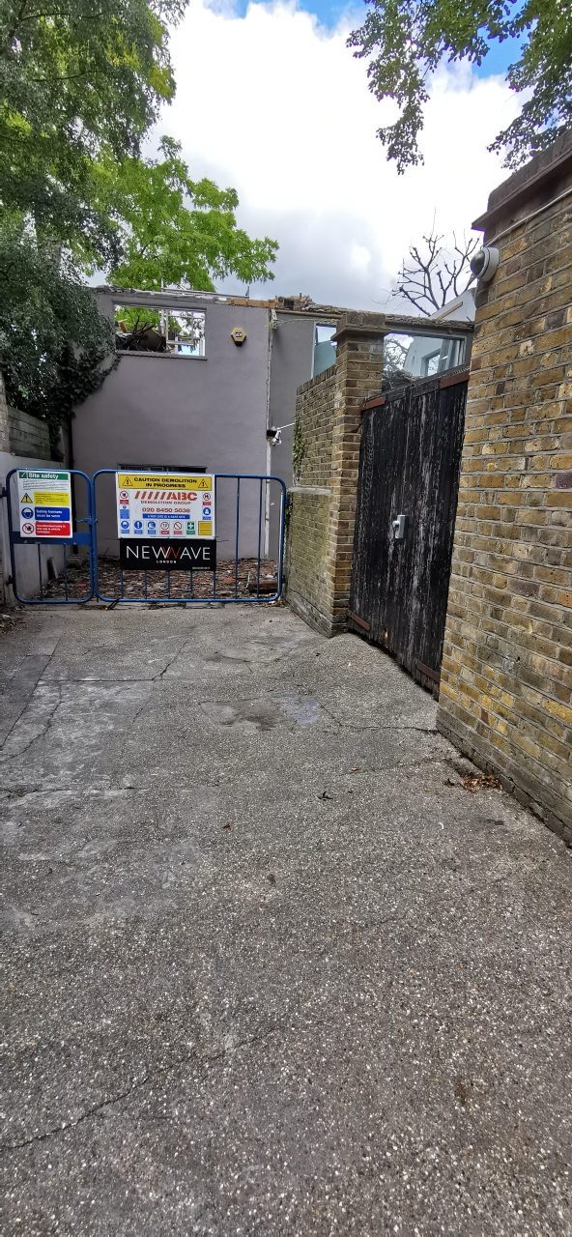 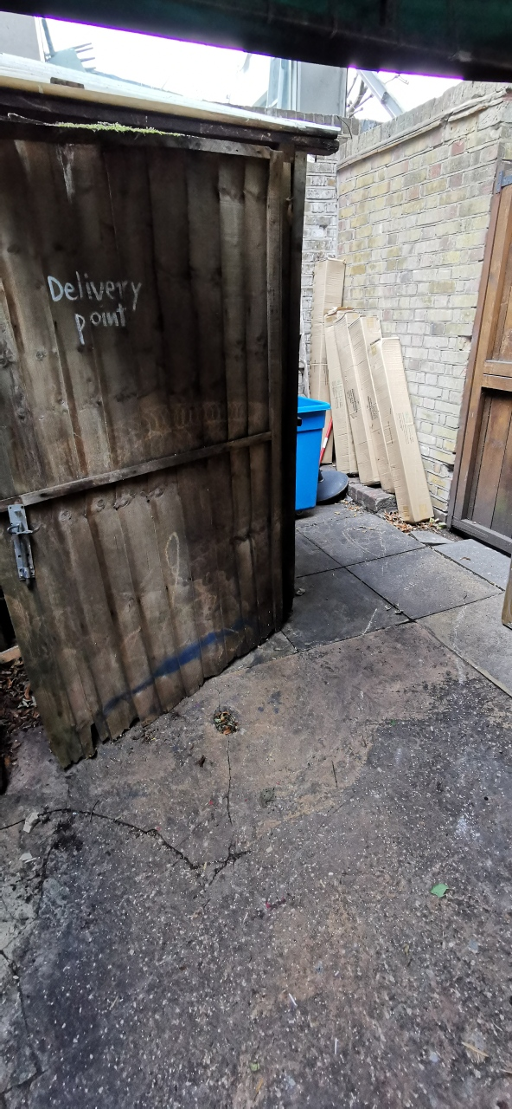

Photo of gates from side access road Photo of existing store

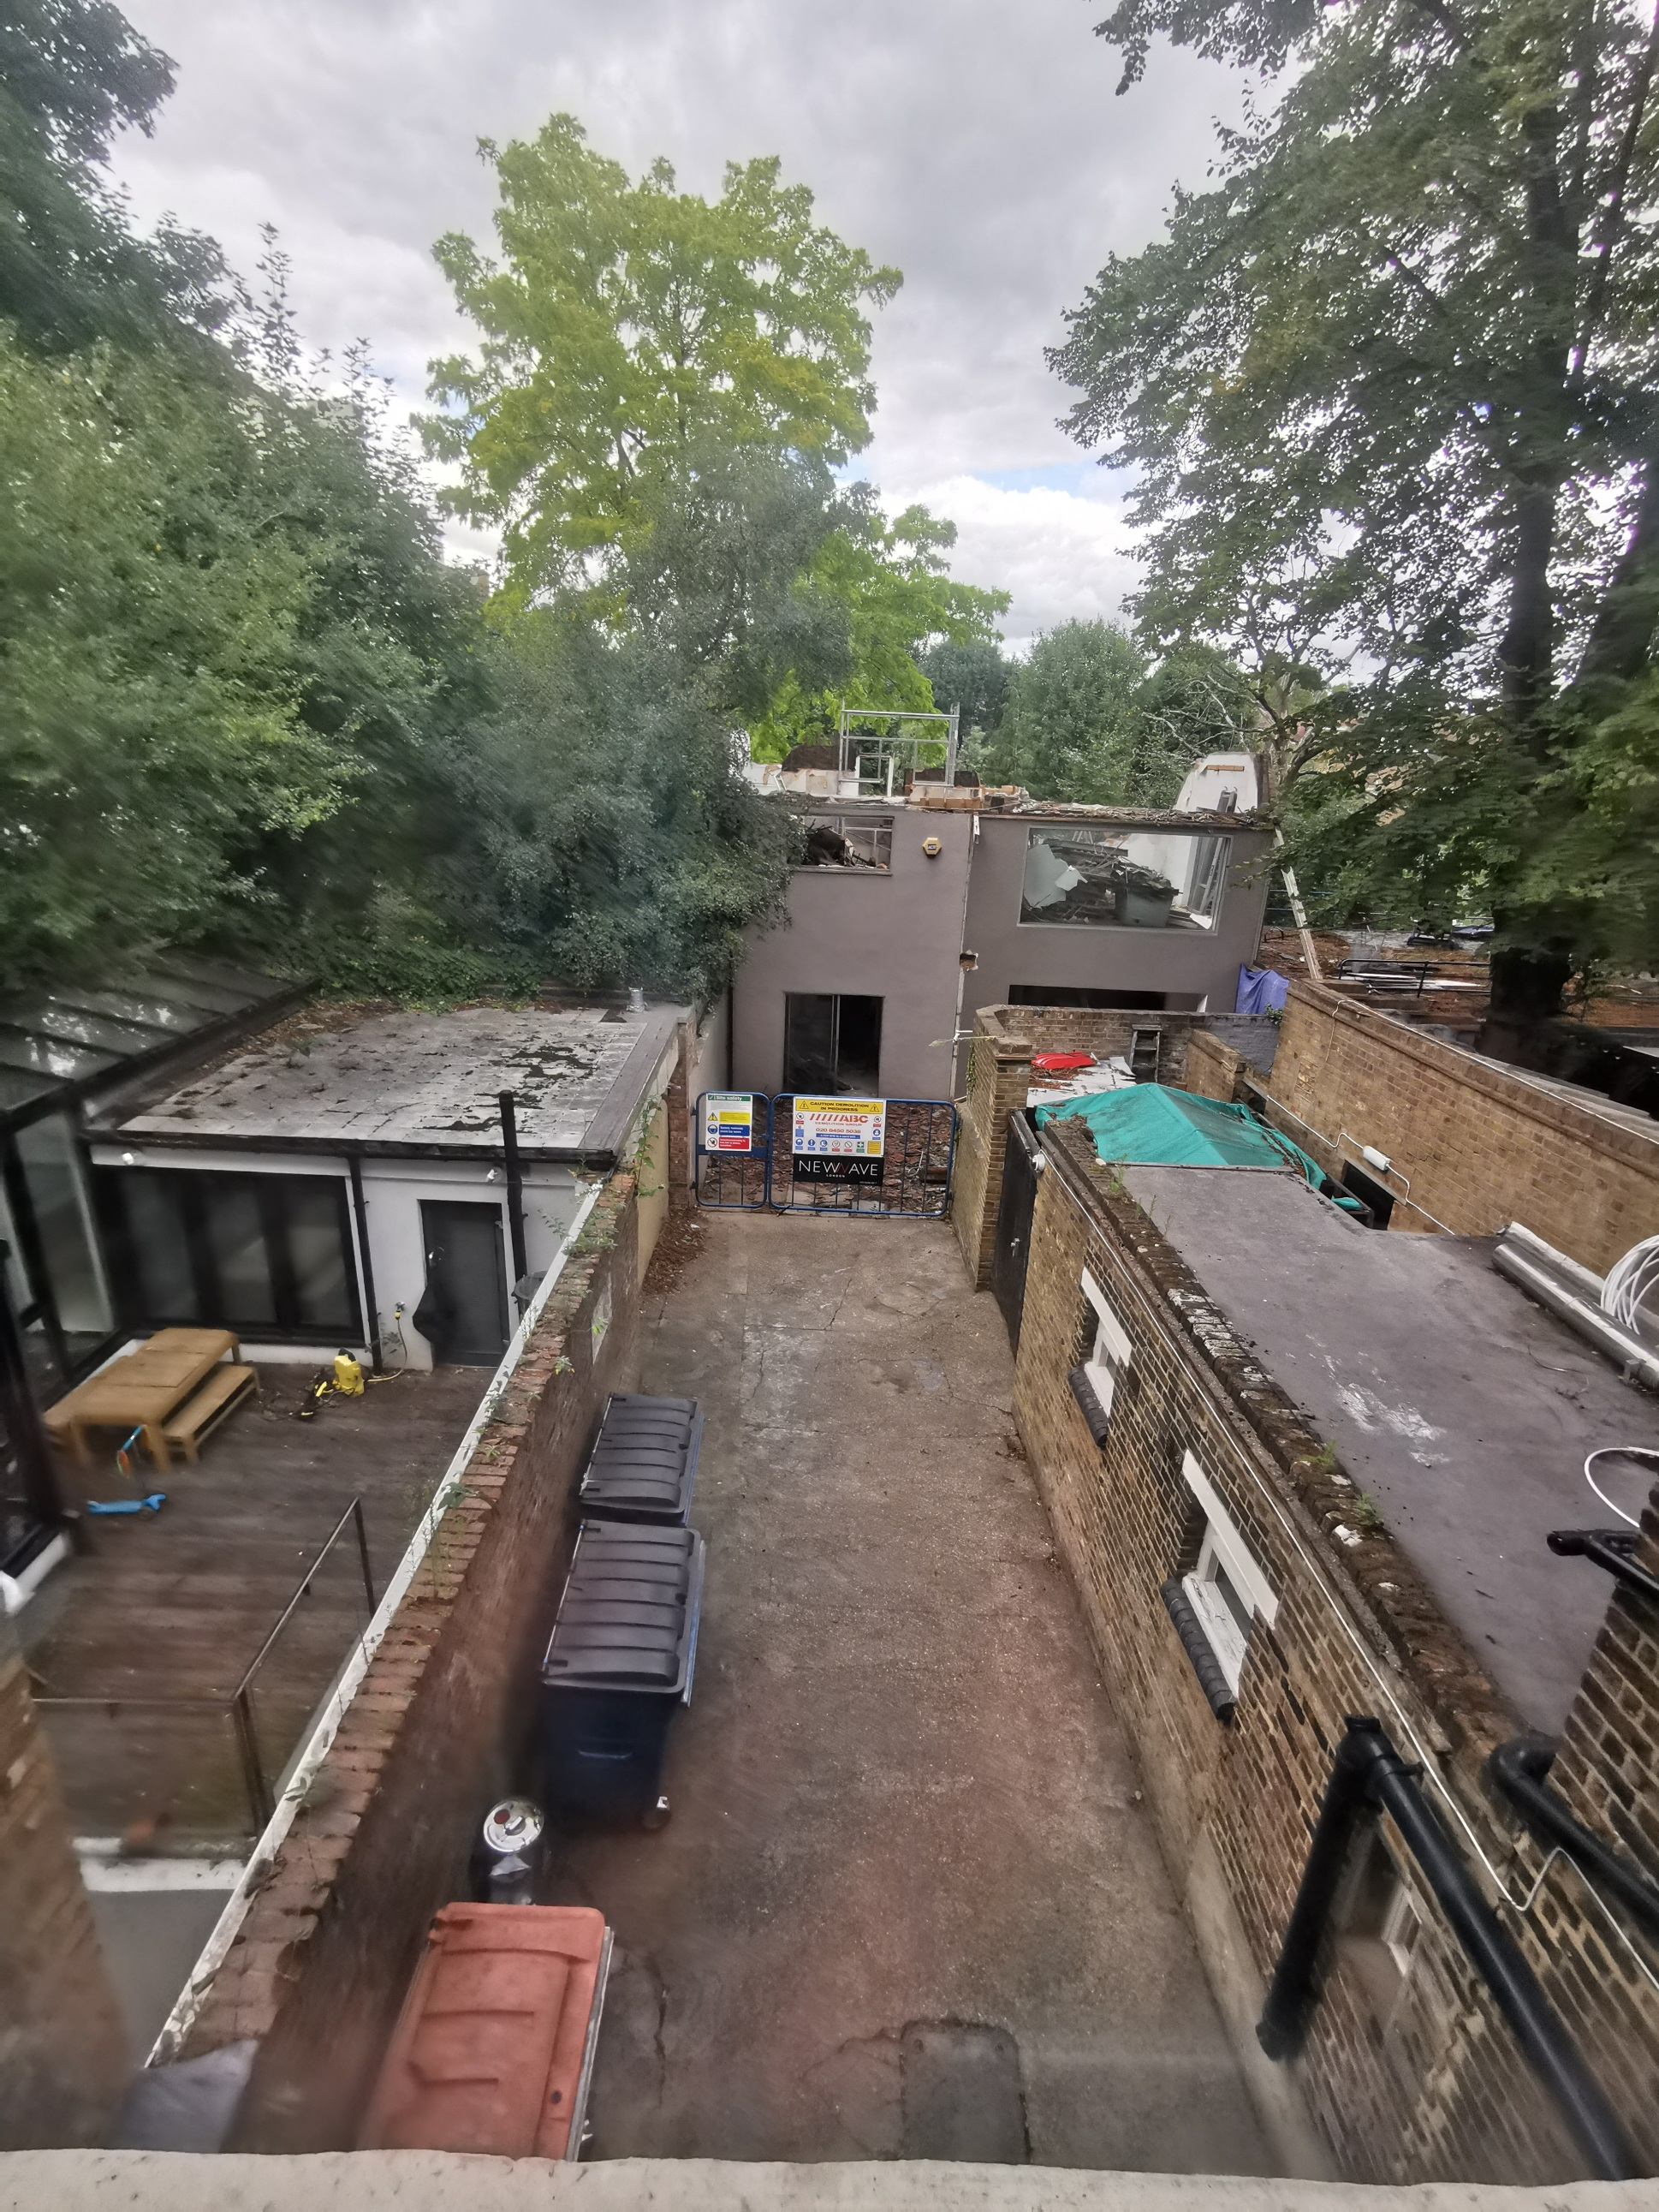

Photo taken from first floor, existing store area shown with green tarpaulin over and existing bins along boundary wall

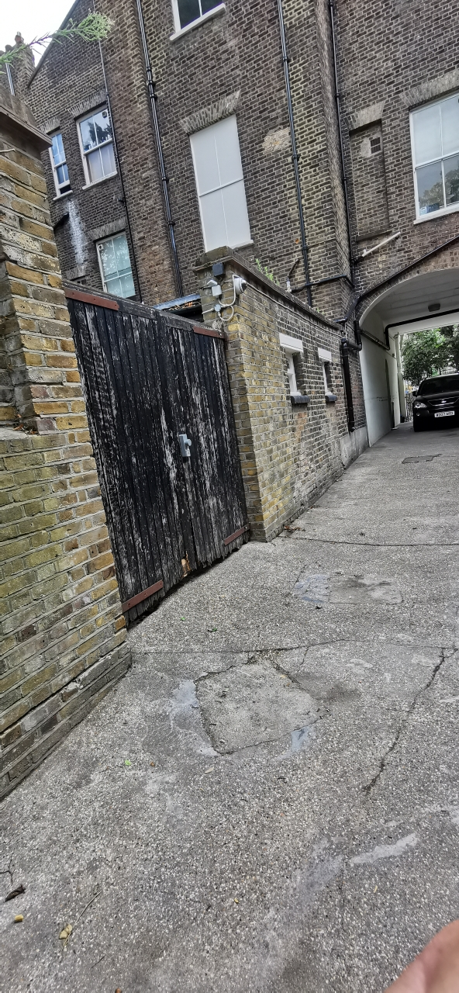

Photo of gates in access road looking toward rear of elevation of building