# **Roof Hatch at 59 Gloucester Crescent NW1 7EG: Design and Access Statement**

This design and access statement has been prepared to support an application for permission to replace a roof hatch at 59 Gloucester Crescent, a building that is listed Grade II.

**Context**

59 Gloucester Crescent was constructed in the late 1840s and has the appearance of being semi-detached with 58, but is in fact joined at the side to 60 to form a terrace. The entrance door and hall are located on the left side of the dwelling outside the main structure. A bathroom extension was built above the entrance door around 1900 and extended to the full depth of the building around 1956, creating two bathrooms next to each other on the first floor. The roof hatch to be replaced is accessed from the rear bathroom. Occasional access to the side roof is necessary to keep it clear of leaves as the gutter for the main roof discharges rainwater onto the side roof.

The side roof was re-covered with lead in 1985 and is water-tight. The side roof has a slight slope from the front of the house to the back, though the section where the hatch is located is virtually flat.

**Proposal**

The roof hatch itself has developed a leak and needs to be replaced, so that the bathroom can be redecorated. The existing roof hatch is also lead-covered, heavy and difficult to remove when access is required to the roof. Accordingly, a lighter, hinged roof hatch is required that is water-tight and energy efficient.

The intention is to install a flat roof access window in the same location and of roughly the same size as the existing roof hatch (77 cms by 77). The window will be opaque, double glazed, hinged and will be opened manually.

**Appearance**

The bathroom extension roof has a small parapet all round so that the existing roof hatch is not visible from the front or rear of the house or from the street. 59 Gloucester Crescent faces Inverness Street, as shown on the location plan, so the roof hatch is not visible from houses across the street. Nor is it overlooked from next door, 60 Gloucester Crescent. The new roof hatch is in the same position, is approximately the same size (75 cms by 75) and will also not be visible.

The picture below taken from the front of the bathroom extension shows the position of the roof hatch towards the rear of the bathroom extension roof.

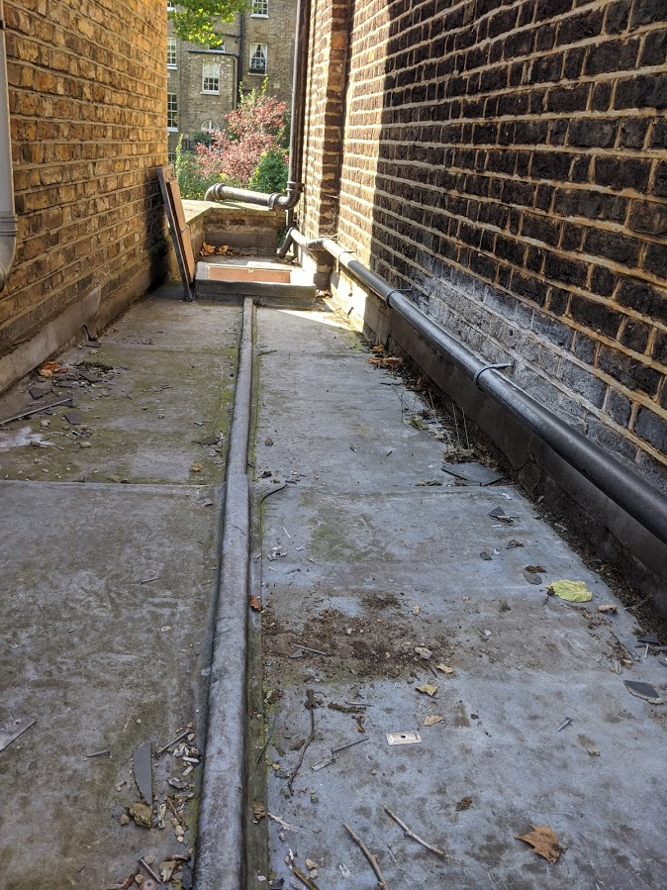

The picture below shows the bathroom extension and parapet above it from across the road in Inverness Street, confirming that the roof hatch is not visible from the street.

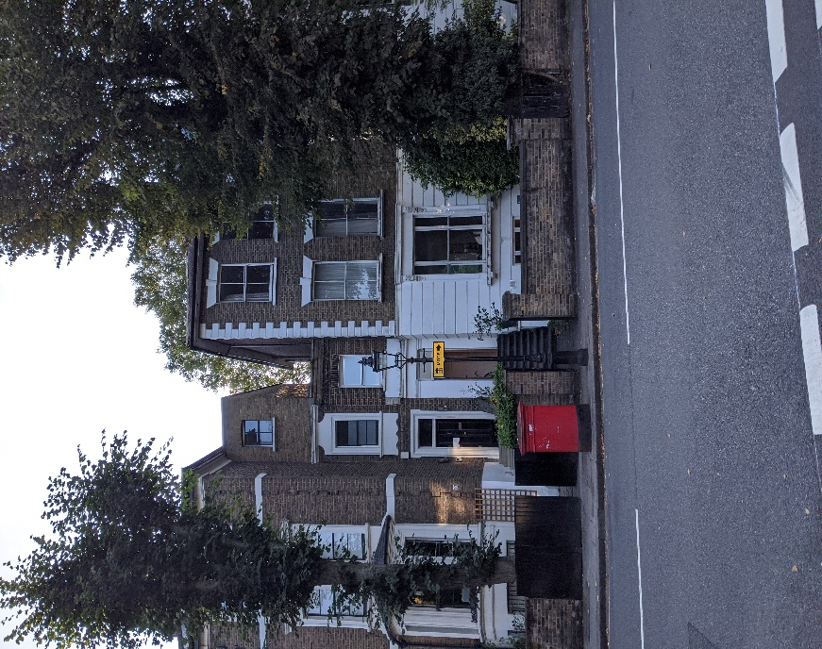

The roof hatch it is proposed to install is shown below:

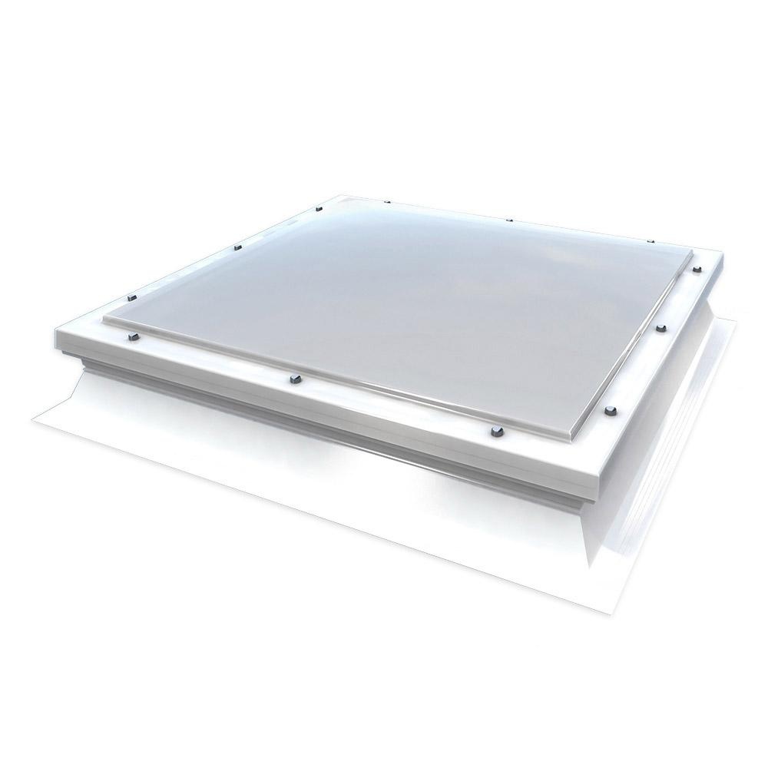

The design selected is a Mardome Trade Access Hatch, 750mmx750mm, double-skinned, opaque.

**Access**

Access to the roof will continue to be by step ladder from the bathroom.