Dear Ms Meynell

I am writing to comment on the application 2020/3157/P. I am the long leasehold owner of flat 3, 33 Betterton Street. The application is to extend my flat, but I did not received notice of the application on the date specified on the original application form, and I have not sanctioned any application to make changes to the flat. The plan would require entry to my home and permanently remove walls and ceilings, my roof windows, immersion cupboard, kitchen store cupboard and involves material reconfiguration.

Had I not been informed by the Council’s email alert, I would have not known that the application had been submitted. Only once the council were informed of the omission did the applicant send notice by email, losing nearly a week of the available time for comments. The applicant has subsequently amended their application and supporting documents, with less than a week until the deadline for comment.

The current configuration of flat 3 is that of a spacious studio flat, with separate kitchen. This is our permanent home, and it is relatively quiet; benefiting from sunlight though the roof windows and an elegant open eaves ceiling in the main studio room. The main room also has a mezzanine which is used as a sleeping deck. I understand that the mezzanine was used for sleeping in the 1960’s, and going back further in time, I have been told that the mezzanine was a grain store.

The planning drawings are similar to those received by me in 2016 which proposed an additional unit at 33 Betterton Street. Once constructed it might be difficult for the planning department to oppose use separate from flat 3, and as a result, this submission will include the effect of the plans for flat 3 and the building of both an extension and an additional unit.

The proposed extension is unacceptable in its entirety for both size and structure, visibility at street level, loss of historic fabric, use of inappropriate materials and unsympathetic treatment of the interior and exterior of the building.

1. The Heritage Statement supplied by the applicant contains the listed building entry, which states that the building is included for its interior, and in particular focuses on the staircase, newels and balusters which are noted to reach the top of the house. However, no mention is made in the Heritage Statement of the potential effect of the development on these key heritage features, or the interior more generally. The heritage consultant has not requested, or been given, access to flat 3 for the preparation of their submission.
2. Currently, the banisters noted in the listing reach the top of the stairs and then turn to form what would previously have been an open landing. In forming the exiting smoke lobby at flat 3, the wall of flat 3 was placed directly behind these heritage features in order to conserve them. Extending the stairs up to the additional floor will result in the permanent loss of this original feature which previously consented works had gone to some lengths to conserve. Picture 1 in the appendix to this letter illustrates this configuration.
3. The submitted drawing of the current stairs at third floor level appear to show the banisters ending at a landing outside the smoke lobby of the 3rd floor. The stairs and banisters fully extend to the smoke lobby and contrary to the drawing there is no landing at third floor level external to the lobby. Again, this can be seen in picture 1 in the appendix to this letter. The proposed wall will remove an additional length of banisters. As there is no landing outside the third floor, to construct this area as planned the existing last flight of stairs, and even more banisters, will require removal. The proposed configuration may also restrict furniture access to flat 3, and considerably changes the experience of the historic stairwell which is currently light and spacious, by constructing the bulkhead of the new stairs across the window.
4. The more recent Heritage Statement submitted by the applicant, dated 3rd September, in contrast to the previous Heritage Statement dated 15th July, claims that an earlier roof would have existed that was of habitable height as a separate floor. The statement gives no indication of how this floor might have been accessed given that there is clearly no staircase at present.
5. The proposed staircase extension would appear to be formed of open bannisters to the communal stairwell, which, if the case, would not be consistent with the construction of an extension of the 3rd floor flat, but that of an additional unit. The only section of additional wall to box in the new stairs runs along the edge of the new landing and no further. An open arrangement of stairs would also be unacceptable in terms of fire risk, and none of the stair doors look to have been included in the plan which would be required if this was an extension of the 3rd floor flat. The plan as proposed removes the outer wall of flat 3 which faces onto the communal stairs. Any visitor, when approaching the flat via the stairs, would be able to see into the flat interior via the proposed open banisters, and possibly gain access, by simply climbing over the banisters.
6. Whilst the aerial plan drawings shows the stairs build through the existing immersion cupboard, the cross-section plan shows the foot of the new flight of the stairs as external to flat 3, from the new landing. In considering the proposal it may be of benefit to view the interior of 33 Betterton Street, to understand how difficult future access to the flat will be, and the extent to which the drawings differ from the actual configuration.
7. Although the applicant’s Heritage Statement refers to the roof variously as being ‘*absent*’ and ‘*redundant*’, the roof is very much still here, and the front portion is being used on a daily basis to sleep in. The proposal contains the wholesale loss of this historic fabric.
8. The back section of the roof currently houses the water tanks for the flats. The plan contains no details of where these will be re-sited, or where any other of the new flat’s utilities will be located, having removed the existing immersion cupboard for the new stairs.
9. The Heritage Statement provides questionable evidence for the comment that *‘it is understood that the roofline at no 33 has seen some fundamental changes in its character since it was listed in 1974’p40,* or for the contention that the roof is a later design. The roof is a traditional double pitched valley roof design, located behind a parapet, often found on Georgian period houses in London. There are many examples in the local area, including one in Shelton Street diagonally behind 33 Betterton Street, and several in Great Queen Street. That this is the last one on Betterton Street, makes this all the more worth saving as an example of the original style.
10. Picture 4 in the appendix to this letter is a screenshot from Britain from Above, taken in 1937, with a red circle to show the roofline at no 33. The buildings location can be ascertained from its position relative to the old stained glass factory sited opposite. The roofline is exactly the same as it is today. Moreover, as this photograph was taken before the bomb damage to the Eastern end of Shelton Street, other similar roof shapes can be seen. Clearly an M shaped double pitch roof, with a raised parapet encircling the entire roof was common to the area. The roofs are not built to the top of the parapet line.
11. The Heritage Statement identifies the roof as a W shaped roof. The Statement then includes comparison to 51-55 Shelton Street and refers to these as ‘better examples of W-shaped roofs’. 51-53 have butterfly roofs as shown in the picture on page 29 of the Heritage Statement. 33 Betterton Street has an M shaped double pitched roof, as does 55 Shelton Street. The misidentification of the current roof configuration of the building should impact the credibility of the remaining report.
12. Because 51-53 is a listed building, a planning application for 53 made in 2015-16, 2015/3713/L, helpfully contains a Heritage Statement covering some of the history of the street and the building. This identifies 53 Shelton Street as a replacement building, and not to the Thomas Neale plan. The Shelton Street Heritage statement also contains the survey of the WW2 bomb damage to the street showing the buildings which have roofs to match 33 Betterton Street as ‘seriously damaged’. This damage would explain their replacement since the 1937 photograph included below at image 4. 33 Betterton Street is fortunately not marked as bomb damaged.
13. The Heritage Statement, on page 28, takes the omission of any entry regarding the roof, and the statement in the list entry of a rebuilt parapet, to mean that the roof is more modern. The list entry for 51-53 Shelton Street also makes no mention of the roof line. As is the case with the parapet, it might be expected that the list entry would make mention of the roof if it had been replaced, but no such observation is made. Parapets often fail due to the guttering behind them. Typically, when the parapet fails it does not take the entire roof with it.
14. The Heritage Statement and proposal take their exterior references from 31 Betterton Street and Betterton House, and states that the uniformity of these two buildings give the street its distinctive character (p40). It is not clear that there is significant uniformity between Betterton House and 31 Betterton Street, or that this is what gives the street its character.
15. The Heritage Statement also includes ‘*The position of No 33 appears quietly and unannounced as the viewer turns in from Endell Street. There is no obvious demarcation against no 31 and its elevation blends in with the character of Betterton House’*(p25). 31 Betterton Street is built of different brick, it is of a different colour, is of different proportions and has different style windows, it generally looks more modern. There are also clear differences between the townhouse design of 33 and the large residential block of Betterton House, built in the 1920s, further along the street. The Heritage Statement makes no attempt to explain why the listed building at 33 Betterton Street should take its design cues to align with a relatively modern building of no obvious architectural interest. Pictures 2 & 3 in the appendix to this letter illustrate this.
16. The Heritage Statement focuses on the claim that the proposal will reunify the terrace at the front of the building and the plan diagrams describe the rebuilding of the front parapet to match 31 Betterton Street. 31 Betterton Street had a flat roof prior to an extension and has no noticeable front parapet. P 40 of the Heritage Statement states that ‘*the proportions of the windows will be smaller in size and the position within the roof slope will be lowered to be partially hidden behind the existing parapet wall’.* Given that the plan seems to be to remove the front parapet wall, it is not clear which existing parapet is referred to here.
17. The application states that the proposed mansard will be clad in ‘*tiles to match existing (ie grey slate)’*. The existing roof tiles are terracotta clay.
18. The Heritage Statement notes ‘*The decision to use natural grey slate tiles has a strong conservation ethic and is a positive response to the tiles found on the roofs of all buildings in the terrace. This helps the extension adopt a more traditional form thus, respecting the setting of the Conservation Area whilst also bearing a strong semblance to the front roof developments on* adjoining buildings.’ The photograph on page 28 of the Heritage Statement shows both 31 and Betterton House as having terracotta clay tiled roofs, not slate.
19. The Georgian Group Guide, No 10, roofs, notes that slates were not introduced into the capital and other major cities until the mid-18th century - later than our building.
20. The proposed dormer windows are to be constructed in lead and timber (page 34 para 3, of the Heritage Statement), but by paragraph 7 of page 34 have the tiled cheeks shown in the elevation drawings.
21. Claims that the proposal will unify the terrace are not supported with evidence of why this would be a desirable aim when the building is listed to preserve its individual character. This claim also ignores the existence of the 20 Endell Street, which has a roof line comparable to 33 Betterton Street when viewed at street level, the northern side of which forms the start of Betterton Street. The roof at 20 Endell Street is not flat as stated (p18) and also has a low-pitched roof form hidden behind a parapet.
22. Whilst the executive summary in the Heritage Statement states that the proposal will have no impact on the principle elevation of the building, and that ‘*’Due to the scale, views of the roofline are limited to the parapet and glimpses of the front slope’*, the extension at 31 Betterton Street is clearly visible at street level. The photographs used on both the cover of the site plans and Heritage Statement were taken before the extension at no31 was built. The use of up to date photographs would have made this apparent. The close proximity of 33 Betterton Street to the junction with Endell Street means that longer distance views from the western side of the street will make any roof alterations and new flank wall highly visible.
23. The working chimney positioned between 33 Betterton Street and 20 Endell Street are not of a height or shape to accommodate the proposed roof and no details as to how these should be retained and extended has been given. The existing configuration can be seen in the photographs in the appendix to the Heritage Statement.
24. The plan contains a Juliet balcony, with ‘*balconies a feature of the host building’* included in the Heritage Statement. There are not multiple balconies at 33 Betterton Street. The proposed balcony could encourage overlooking from the rear of the building.
25. The drawing of the rear of 31 Betterton Street contained in the planning drawings is out of date. The first floor has a full balcony with a brick retaining wall. The top floor terrace is set back from the edge of the building, having no aerial symmetry with the Juliet balcony proposed at 33.
26. The elevation drawing of 33 Betterton Street does not fully represent the existing features. The main entrance door is panelled, there are no half height modern window boxes, and there is a panelled timber frontage with corbels. The drawing makes the building look more modern than it is. Picture 2 & 3 in the appendix illustrate this.
27. The Heritage Statement claims that ‘*the retention of the surviving architectural features (parapet and eaves,) will embrace the integrity and style of the original design intentions of the house’* p4. The design removes the front parapet and aside from one interior section, the proposal destroys the existing eaves. The one remaining eaves section is described in the application drawings as ‘*consistent with existing*’ which could be seen to imply that this too is being removed. Again, the proposal results in considerable loss of historic fabric.
28. The Heritage Statement notes the proposed designs’ replication of the roof line at 31 Betterton Street. The proposed sectional drawing looks to be significantly bulkier that the form at 31, where the roof tiles sit well below the side parapets, and contains no details of roof height, in particular for the newly created kitchen and bathroom which will have oddly sloping floors. These rooms have a proposed floor height well above the floor height of that of 31 Betterton Street, yet have a matching ceiling height. Whilst the plan is clearly not to scale, there is no reassurance that the proposed rooms have an acceptable ceiling height.
29. The September Heritage Statement contains additional photographs in an appendix. These photographs are, again, not contemporaneous, as illustrated by the flat roof still at 31 Betterton Street. The updated Heritage Statement at page 29 para 3, seems to imply that the current roof cannot be original as the chimney stacks on the west side are towards the front of the roof slope and not at the apex. The use of out of date photographs may have added to the confusion here. The chimneys that are to the front of the roof slope are those of 31 Betterton Street and are on the east side. They are at the front of the building as they are above the fireplaces in 31 Betterton Street. The chimneys at the west side of the roof, along the wall with 20 Endell Street, are at the apex of the front portion of the roof, directly above my fireplace.
30. Endell Street was redeveloped in the C19th after the Street Improvement Act of 1842. This is over 100 years after the construction of 33 Betterton Street. There is no reason to expect the roofline of an older building to mirror that of a later one. Where the roof to have been originally higher to match the side parapet at 31, it would not marry with 20 Endell Street and vice versa.
31. The claim that the roof form would have been build to the height of the side parapets is not evidenced by the other double pitched roofs in picture 4 of this letter. Numerous roofs on Shelton Street show the M roof shape with a higher side and front parapet to stop fire spread.
32. The section plan clearly shows the proposed fire escape being adjacent to a sloping section of the roof of 31 Betterton Street. In contrast, the proposed site plan places the fire escape egress adjacent to the rear balcony of 31, giving the impression that the escape route is to a flat section of 31 Betterton Street’s roof. The rear of 31 Betterton Street is relatively closely aligned to 33 Betterton Street, as can be seen on the aerial photograph on page 28 of the Heritage Statement, and bears little resemblance to the plan as drawn in the application. The siting of the roof fire escape as proposed therefore gives no access to the adjacent flat roof of 31, and loses the existing roof top fire escape access to 20 Endell Street.
33. If the extension is used as an additional unit, flat 3 will lose access to the new fire escape.
34. The new kitchen is backed by a solid wall, making no use of the light that enters through the newly created dormers, to enable separation from the existing structure of the third floor. The structure is therefore more consistent with a self-contained additional unit, rather than an extension of the third floor. The proposed kitchen will also have little light, with no windows, and the raised floor level blocking much of the light coming in from the Juliet balcony.
35. If the structure were to be used as an additional unit, the problem of noise travel and room stacking arises. The stairs to the raised kitchen and bathroom level are directly above the mezzanine sleeping area, which without comment has been removed from the third floor in the proposal. The existing mezzanine is not of standing height, and the plan has no details of sound proofing measures. Foot traffic and toilet flushing would be just a few feet away from pillow level. Current Camden planning guidance states that due to noise and vibration rooms should be stacked like for like.
36. The loss of the two existing roof windows to flat 3 is not compensated for by the addition of two dormer windows. These windows are essentially ‘blind’, and face into a solid wall giving the third floor an unusual shape which is not harmonious, and bears no relation to the traditional room shape in this historic building or others in the area. Facing a blank wall, the proposed windows would bring in little light and being above openable height, no ventilation. No light report has been submitted with the application.
37. The existing Victorian mezzanine, which has been removed from the proposed plans, forms the roof to the bathroom and part of the ceiling of the space underneath. The plan contains no detail of how these new spaces would be managed, for example as a flat roof to the bathroom or extending to the pitch. The existing or proposed plans also make no reference to the historic cross bracing which protects the structure of the roof and walls of flat 3.
38. Looking at the structure as a whole there is nothing to indicate the engineering solutions needed to create an additional floor, which has living accommodation placed above the sloped roof structure. The current roof structure is not a flat roof designed to take weight. The application does not contain details of any steel work required in order that the slope of the eaves does not collapse under the weight of a new kitchen, bathroom and inhabitants.
39. The building has had significant recent redevelopment of the ground floor and basement, with the building being further excavated at basement level. The application includes no consideration of whether the building can support an extra floor without structural damage.
40. Due to the recent re-development what was previously a building of three one-bedroom flats, now has four flats with a total of six bedrooms – potentially doubling the occupancy. An addition of another bedroom, or an additional unit, will increase this number further and overdevelops the building. There is already no provision for waste or cycle storage.
41. In building the extension, partially demolishing the ceilings of flat 3, and altering the stairs if an additional landing is created, considerable dust, noise and access problems will arise.
42. The revised application form states that the proposal includes no interior changes. The existing kitchen walk-in cupboard is removed, a new flight of stairs is proposed removing historic fabric, the immersion cupboard is removed and the mezzanine is removed. Additional partition walls and doors are proposed. The application lacks the relevant documents to address these changes.
43. The application proposes replacing the existing window in the third floor kitchen with a smaller window. There is no clear benefit to reducing the window scale and it may be simply a retained detail from the initially filed application which included the extension of the outrigger. The reduction in widow size will require replacement brick. Replacement bricks rarely truly match, and an unsightly line may be left marking the old window shape.
44. The loss of the outrigger extension in the updated proposal, results in the loss of access to a full bathroom for the second bedroom without entering the first bedroom. This would appear to be contrary to the aim to create quality accommodation.

Given my concern that an application has been made to alter my flat, and the less than clear contents of the Heritage Statement, I have commissioned my own heritage report from Donald Insall Associates, and this is attached for your reference.

Overall, I would urge you to consider the importance of preserving the heritage value of 33 Betterton Street, both internally and externally, and the wider streetscape, particularly when viewed from Endell Street. The flat as it stands has ample space, and has been our home for over 14 years. Its existing form and use are evidence of how historic buildings can provide a quality home without losing the link to its past. The proposal destroys this link.

John Strype’s Survey of London in 1720 described our street as ‘well inhabited and built’. The application is insensitive to both the history of the street, the building and its current and future inhabitants. The design is less of the *‘hat’* referred to by the heritage consultant, and more akin to an ill-fitting toupee.

Yours sincerely

Katherine Dee

Appendix

Picture 1 – the stairs and banister configuration to the front door of flat 3. No landing is external to the door.

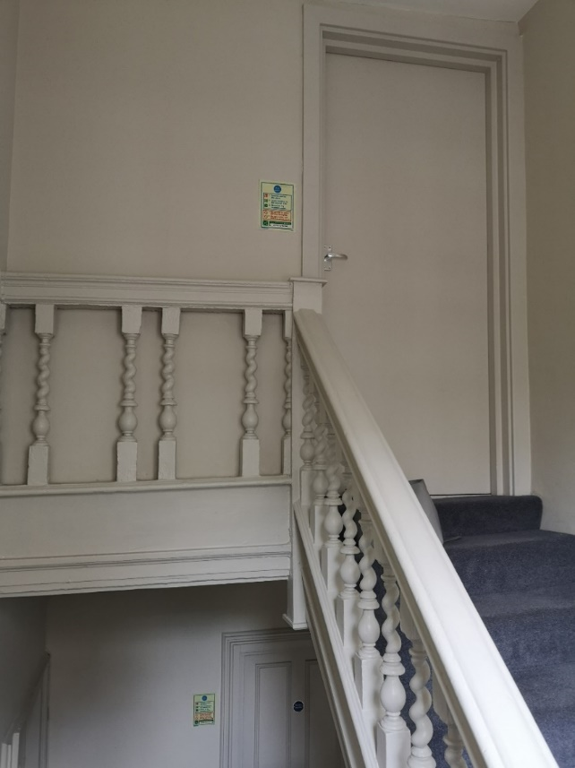

Pictures 2 & 3

Different street views of 33 Betterton Street., with 31 Betterton Street to the left.

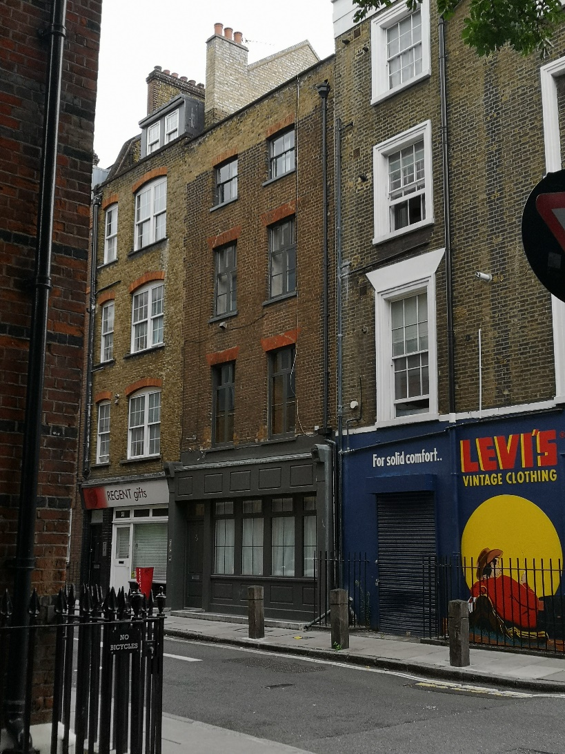

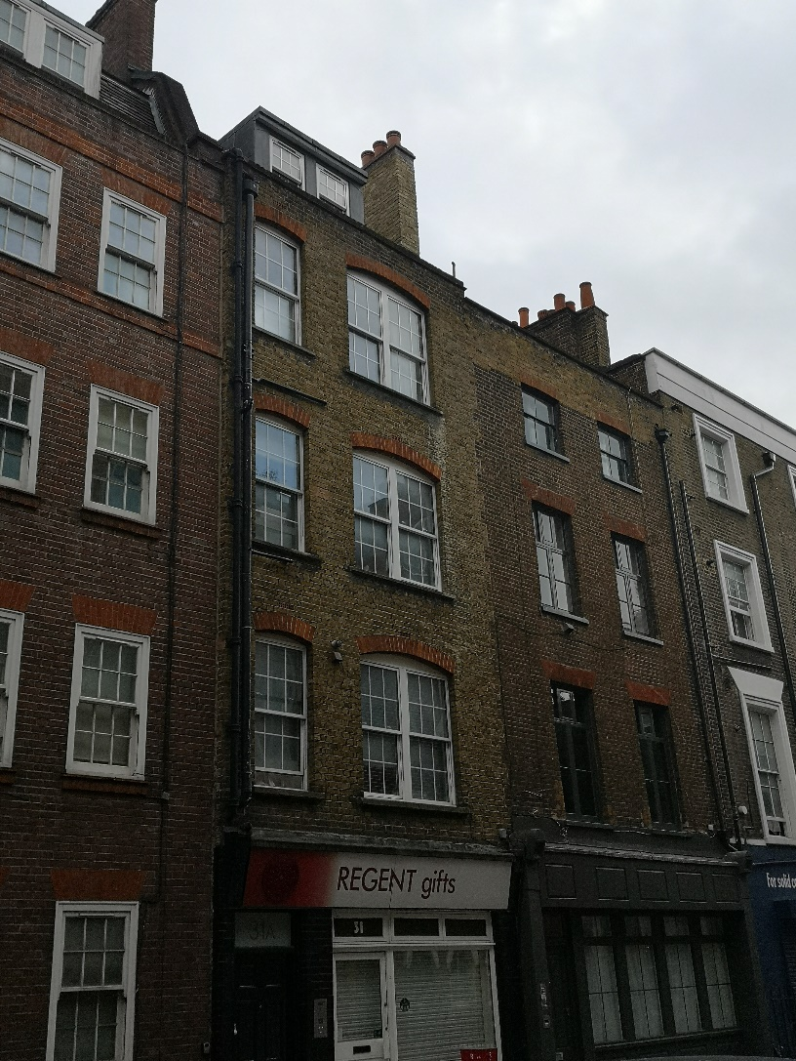

Picture 4

