**Coronavirus: Public transport systems face an uncertain future**



[Tom Edwards](https://www.bbc.co.uk/news/correspondents/tomedwards)Transport correspondent, London[@BBCTomEdwardson Twitter](https://www.twitter.com/BBCTomEdwards)

* 30 June 2020

* comments
* [Share this with Facebook](https://www.bbc.co.uk/news/uk-england-london-53220111)

* [Share this with Messenger](https://www.bbc.co.uk/news/uk-england-london-53220111)

* [Share this with Twitter](https://www.bbc.co.uk/news/uk-england-london-53220111)

* [Share this with Email](mailto:?subject=Shared%20from%20BBC%20News&body=https%3A%2F%2Fwww.bbc.co.uk%2Fnews%2Fuk-england-london-53220111)

* [Share](https://www.bbc.co.uk/news/uk-england-london-53220111#share-tools)

Related Topics

* [**Coronavirus pandemic**](https://www.bbc.co.uk/news/topics/cyz0z8w0ydwt/coronavirus-pandemic)

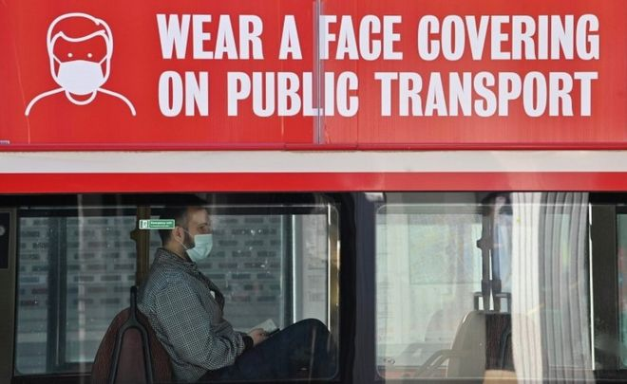Image copyrightAFPImage captionFace coverings are mandatory for everyone using public transport

**How can mass transit survive when it can't carry high numbers of passengers? That is the question vexing the authorities.**

Most of the time trains and buses are operating with social distancing and sometimes they seem to be running very empty. Those who are travelling on them wear masks and some are still reticent to use public transport.

That doesn't look like changing very much and it's very much what the authorities want to see in the short to medium term.

The messaging hasn't changed from "avoid public transport unless absolutely necessary". Arguably the language has softened a little from only "essential" journeys to "necessary".

Already car journeys are rising.

In the congestion charging zone, the number of cars is already what it was before lockdown - 100,000 a day.

[**The congestion charge zone fee has increased**](https://www.bbc.co.uk/news/uk-england-london-53127019) to try and combat that. The fear is that in London that will continue to grow and any recovery will be car-led with the associated pollution.

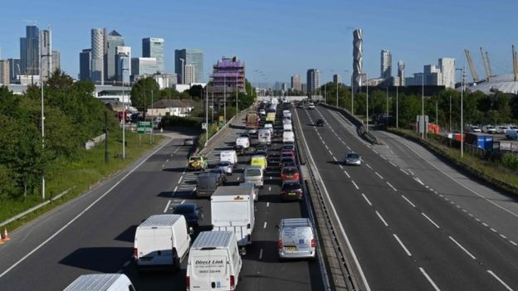Image copyrightAFPImage captionThe congestion charge fee has been increased to try to cut the number of vehicles in central London

But the number of people cycling and walking has also jumped in the capital leading to some councils to start low traffic neighbourhoods and school streets to further restrict motor vehicles.

In Brixton, Lambeth Council has stopped traffic going through areas around Railton Road, where 5,000 vehicles a day were passing along one residential road. And while many local residents like the idea, there is a sizeable number who are against the restrictions.

What is also interesting is the funding for these emergency interventions are part of [**the government's bailout of Transport for London (TfL)**](https://www.bbc.co.uk/news/uk-england-london-52670539).

A condition of the bailout is the money which is being given to councils via TfL, can only be used on this type of cycling and walking scheme.

You can expect to see more of this trend. Perhaps the number of e-scooters will continue to increase.

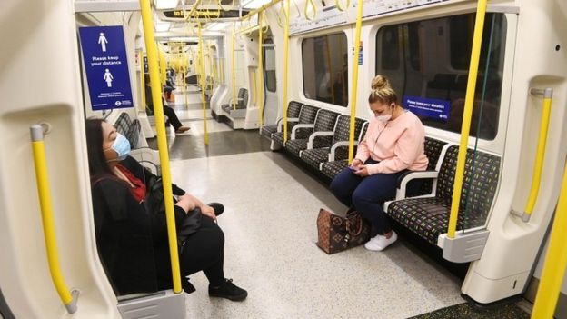Image copyrightEPAImage captionA Tube train can normally carry more than 800 people without social distancing rules in place

Figures showed 50% of Londoners used public transport to get around before the lockdown began. And the concern is running Tubes and trains which are only partially full is not sustainable.

[**What has also changed is the social distancing**](https://www.bbc.co.uk/news/uk-53152416) and that will help with capacity a little. According to TfL's modelling, going from 2m to 1m will increase capacity to 25%, from 15%.

While a normal Tube train can normally carry 800 people (or even more), at 2m that reduces to 93, while at 1m plus a train can carry 208, the figures show.

A double-decker bus can carry 87 passengers. At 2m social distancing it can carry 20, at 1m plus it can carry 30. There will also be an impact on queues, making them shorter.

But all the transport unions have concerns about reducing social distancing.

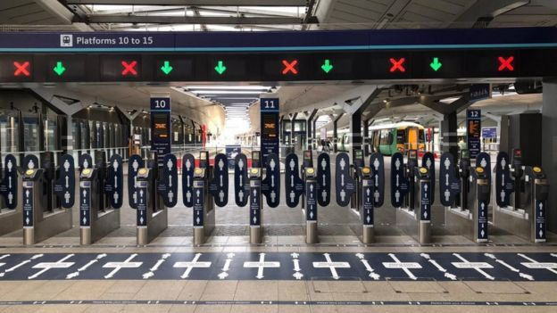Image captionRail companies have welcomed the relaxation of social distancing rules

Rail companies have welcomed the news that social distancing will be cut to 1m plus. But they have warned the capacity will be full even at 1m by late November. After that you would have to manage and suppress the excess demand through messaging or pricing.