**Appendix 20**

**Report on the presence of significant amount of very toxic particulates – on site study conducted on the pavement in front of the Hampstead Station April – June 2019**

As stated in # 2.1 of the [Camden Planning Guidance - Air Quality- March 2019](https://www.camden.gov.uk/documents/20142/35992328/Air+Quality+CPG.pdf/63222d5c-a5b7-0b54-0724-cd0065169886) , “it is widely accepted that there is no safe level for particulates (PM10 and smaller). Air quality is particularly severe along major roads through the borough”.

Below is a summary table of particulate measurements conducted onsite in front of the pavement of the Hampstead police station from 8.30 to 9.am between 24th April and the 24th June 2019.

|  |  |  |  |  |  |  |  |  |  |  |  |  |
| --- | --- | --- | --- | --- | --- | --- | --- | --- | --- | --- | --- | --- |
| date | Time: am | Pm 1  range | Pm1  average | Pm1  peak | Pm 10ange | Pm 10 average | Pm 10  peak | WHO limits for PM 10: 12.5 ug/m3 | Pm 2.5  range | Pm 2.5  average | Pm 2.5  peak | WHO limits for PM 10 ug/m3 and 25 ug/m3 hourly . |
| 24th April 2019 | 8.34 to 8.41 am | 30 |  |  | 66-70 | 68 | 75 |  |  |  |  |  |
| 24 | 8.45 to 8.55 | 30-33 |  |  | 66-72 |  |  |  | 39- |  |  |  |
| 29 | 8.44 to 8.51 | 7-12 |  |  | 15-32 |  |  |  | 10-19 |  |  |  |
| 29 | 8.51 to 8.57 | 7-16 |  |  | 16-30 |  |  |  | 12-20 |  |  |  |
| 30 | 8.32 to 9.00 | 19-20 |  |  | 37-41 |  |  |  | 24-25 |  |  |  |
| 1-May | 8.39 to 8.43 | 14-17 |  |  | 30-33 |  |  |  | 21-22 |  |  |  |
| 1 | 8.49 to 8.58 | 16-18 |  |  | 31-36 |  |  |  | 21-23 |  |  |  |
| 2 | 8.35 to 8.48 | 3-7 |  |  | 6-13 |  |  |  | 5-7 |  |  |  |
| 3 | 8.33 to 9.00 | 7-65 | 14 | 130 | 15-122 | 22 | 274 |  | 10-65 | 10 | 129 |  |
| 6 - May **Bank Holiday** | 8.39 to 8.57 |  | 1 | 3 |  | 4 | 8 |  |  | 3 | 6 |  |
| 7 | 8.29-9.00 |  | 11 | 14 |  | 21 | 32 |  |  | 14 | 21 |  |
| 8 | 8.34-9.00 |  | 4 | 22 |  | 9 | 51 |  |  | 7 | 23 |  |
| 9 | 8.33 – 9.00 |  | 3 | 9 |  | 9 | 19 |  |  | 6 | 12 |  |
| 10 | 8.33 9.00 |  | 12 | 22 |  | 23 | 49 |  |  | 16 | 29 |  |
| 13 | 8.33-9.00 |  | 6 | 17 |  | 7 | 23 |  |  | 6 | 17 |  |
| 14 | 8.46-9.00 |  | 1 | 8 |  | 3 | 10 |  |  | 1 | 8 |  |
| 15 | 8.33  9.00 |  | 7 | 23 |  | 21 | 65 |  |  | 14 | 36 |  |
| 16 | 8.31  9.00 |  | 10 | 29 |  | 20 | 59 |  |  | 14 | 34 |  |
| 20 | 8.29-9.00 |  | 19 | 35 |  | 39 | 66 |  |  | 38 | 38 |  |
| June 24 | 8.21-8.36 |  | 23 | 28 |  | 47 | 62 |  |  | 28 | 34 |  |

The above survey, conducted during the morning’s school commute time (8.30 to 9 am), shows that often the poor air quality conditions tended to be substantially above the WHO limits.  As one would expect on Monday 6th May, a bank holiday, there was low traffic and Particulate measurements were low. Particulate measurements vary according to first and foremost traffic and car exhausts but weather conditions e.g. wind, humidity, temperature…. also have a bearing on the level of pollution.

Next page is an example of a detailed distribution graph measuring particulate 10 between 8.33 and 9 am on 3rd May 2019. What is noteworthy is, that although overall this was a morning with an average of 22 for Pm 10, there were on two occasions and during the course of several minutes, massive jumps in air pollution to alarmingly high toxic levels up to a peak of 274 particles. This was due to heavy vehicles/trucks driving pass the Hampstead police station at these times.

The Airbeam 2 Air Casting unit that we use analyses and records air particulates measurements every second, so the above summary table is backed up by several hundreds of thousands of records. Every single observation is automatically fed into a spread sheet. We have this data and other graphs available. The Airbeam 2 Air Casting Unit was purchased from [HABITAT MAP](http://aircasting.org/) , a non-profit environmental health organization, upon the recommendations from [Dr GARY FULLER](https://www.ft.com/content/9c2b9d92-a45b-11e8-8ecf-a7ae1beff35b) and [Dr BENJAMIN BARRATT](http://hieh.hpru.nihr.ac.uk/our-team/investigators/dr-benjamin-barratt), Lecturer in Air Quality Science, Department of Analytical & Environmental Sciences, of the [ENVIRONMENTAL RESEARCH GROUP](https://www.kcl.ac.uk/lsm/research/divisions/aes/research/erg/about-us) at King’s College London, a leading provider of air quality information and research in the UK.

Airbeam 2 Air Casting unit is a handheld device and we took measurements along the pavement of Rosslyn Hill in front of the Hampstead Police Station, halfway between the Police Station and the curb. We held the device in our hand at around 1.4 meter above ground. This is considered representative of the height of the young children’s noises and mouths that would breathe the air along the pavement before they enter the proposed school site.

One will also note that it is admitted in the Executive Summary of the Air Quality Assessment commissioned by the applicant that: “The site is located within an area identified by London Borough of Camden as experiencing elevated pollutant concentrations”.

.

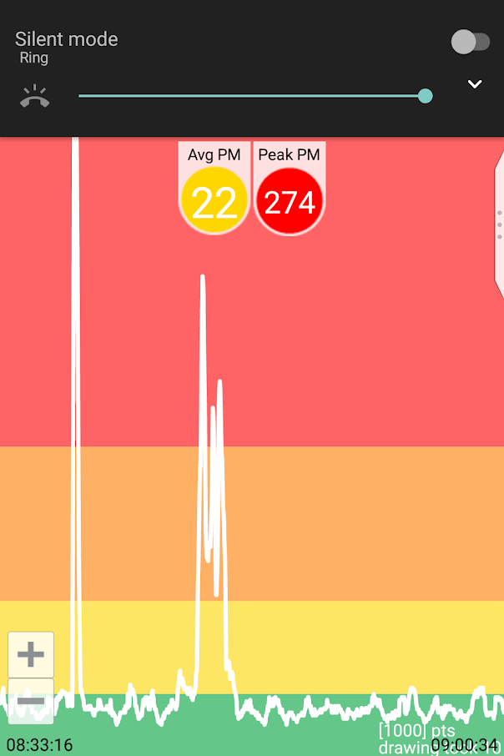

Particulate 10 on 3rd May 2019, 8.33am – 9.00 am

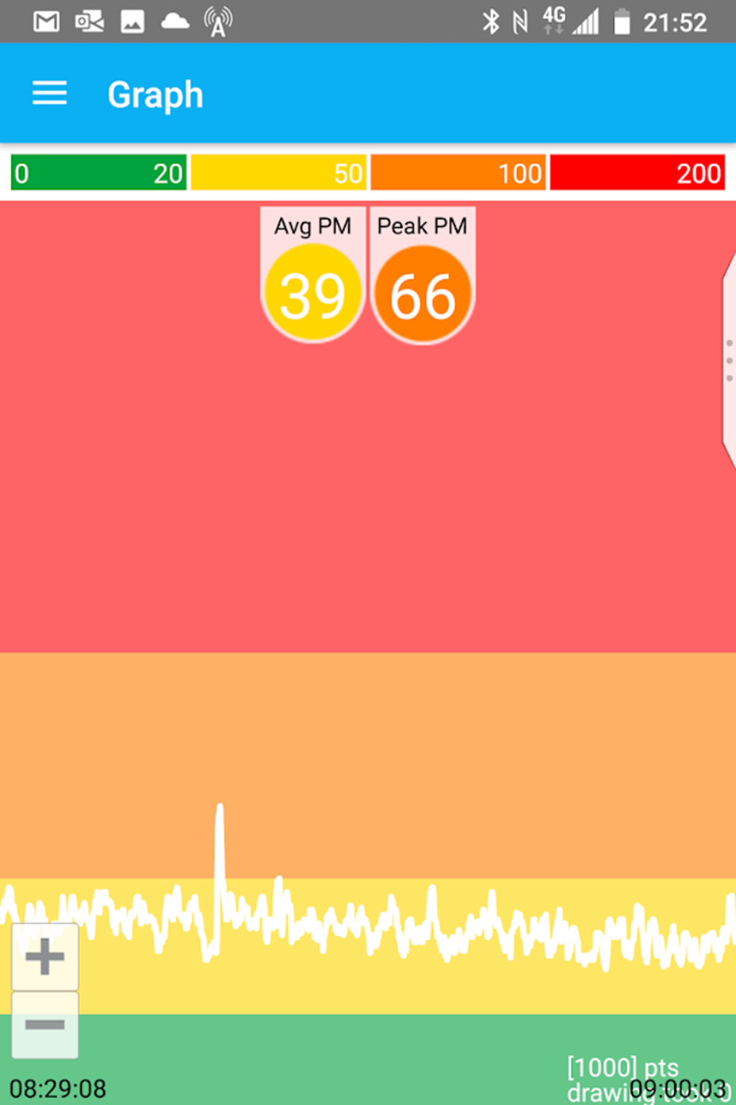

Particulate 10 on 20th May 2019, 8.29am – 9.00 am

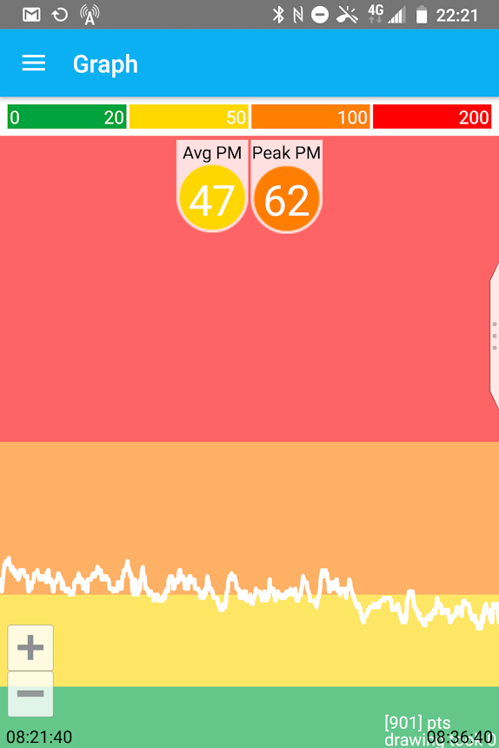

Particulate 10 on 24th June 2019, 8.21am – 8.36 am