Appendix 19

22 October 2019

Children exposed to five times more air pollution on school run

A new King's report has found that London children travelling to primary schools across the capital are five times more exposed to air pollution than at any other time of the day.

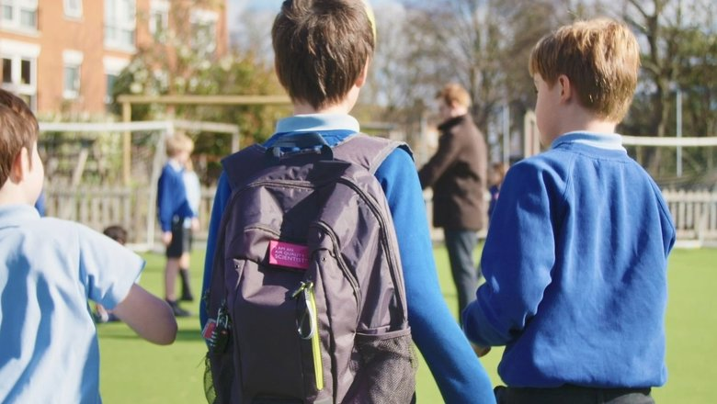Air monitoring backpacks

Some 250 pupils took part in the [study](https://www.kcl.ac.uk/news/worlds-largest-study-to-monitor-air-quality-exposure-of-250-children), funded by the Mayor of London, by carrying special backpacks with state-of-the-art Dyson air quality sensors on their journey to and from school.

The pupils were from primary schools in Richmond, Greenwich, Haringey, Hammersmith and Fulham, and Kensington & Chelsea. They each carried the specialist backpacks, which measured fine particulate matter (PM2.5) and nitrogen dioxide (NO2) levels, for a week.

Data revealed that:

* Pupils were exposed to on average five-times-higher concentrations of harmful NO2 pollution on the school run than when they were at school
* PM2.5­ concentrations were also higher during the journey to school, though the difference was less pronounced
* For both NO2 and PM2.5 children who walked to school by backstreets were exposed to the lowest levels of pollution
* The highest concentrations were recorded by children walking along main roads
* Pollution levels were higher in cars and buses than on back streets
* Parents who drive to school can contribute to high levels of air pollution on back streets as they tend to use these roads for school runs while leaving their car engines idling