15a Fitzroy Square, Lower Ground Floor Flat W1T 6EF

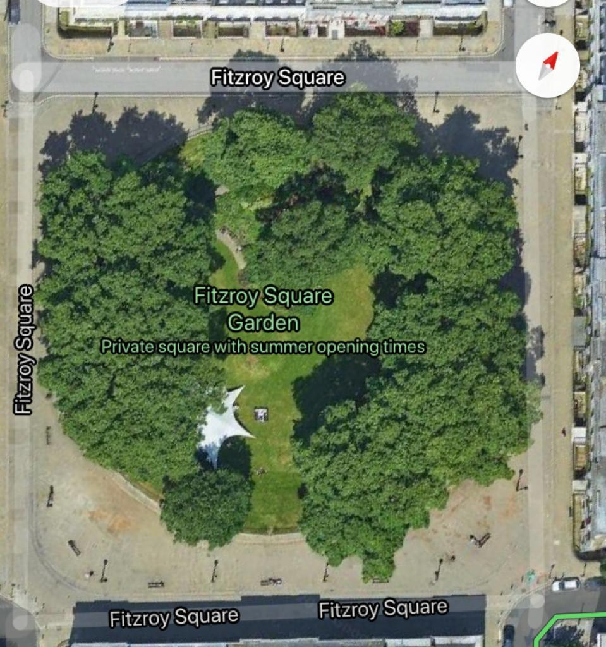

T1-9: Plane: Crown lift to 6m on the outside only (not garden side) and remove major dead wood and hanging branches to avoid branches being snapped by high-sided vehicles