**SUN HOUSE**

[Be the first to contribute](https://historicengland.org.uk/listing/the-list/list-entry/1322140#contributions-banner)

**Overview**

Heritage Category:

Listed Building

Grade:

II*

List Entry Number:

1322140

Date first listed:

14-May-1974

Statutory Address:

SUN HOUSE, 9, FROGNAL WAY

**Map**

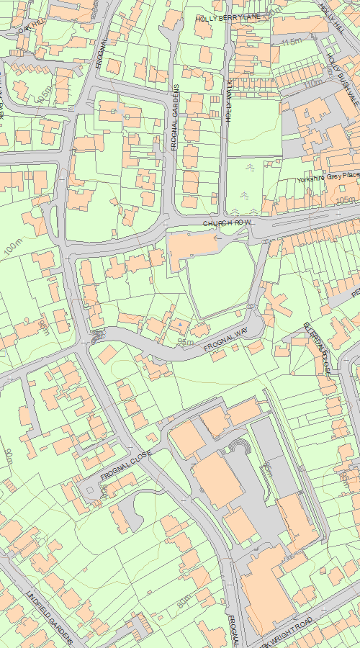

© Crown Copyright and database right 2020. All rights reserved. Ordnance Survey Licence number 100024900.  
© British Crown and SeaZone Solutions Limited 2020. All rights reserved. Licence number 102006.006.  
Use of this data is subject to [Terms and Conditions](https://historicengland.org.uk/terms/website-terms-conditions/).

The above map is for quick reference purposes only and may not be to scale. For a copy of the full scale map, please see the attached PDF - [1322140.pdf (opens in a new window)](http://mapservices.HistoricEngland.org.uk/printwebservicehle/StatutoryPrint.svc/292188/HLE_A4L_Grade|HLE_A3L_Grade.pdf)

The PDF will be generated from our live systems and may take a few minutes to download depending on how busy our servers are. We apologise for this delay.

This copy shows the entry on 17-Jun-2020 at 11:14:12.

**Location**

Statutory Address:

SUN HOUSE, 9, FROGNAL WAY

The building or site itself may lie within the boundary of more than one authority.

County:

Greater London Authority

District:

Camden (London Borough)

National Grid Reference:

TQ 26181 85542

**Details**

CAMDEN  
  
TQ2685NW FROGNAL WAY 798-1/26/542 (North side) 14/05/74 No.9 Sun House   
  
GV II*  
  
Detached house. 1935-6. By Maxwell Fry. Reinforced concrete walls using wallboard shuttering. Flat roof. 3 storeys and roof terrace. Continuous strip windows; glazing altered. On a steeply sloping south-facing site the ground floor right-hand bay being the projecting entrance and garage; to left, the rear retaining wall and thin steel pilotis support the 1st floor continuous balcony with tubular steel railings. 1st floor windows plate glass sliding French windows; right hand end of balcony, with projecting canopy, breaks forward over garage and entrance; left hand end with panel of small glazed lights in end wall and thin steel piloti supporting a loggia at 2nd floor level, now panelled in. 2nd floor windows originally sliding, now metal framed casements. Parapet with tubular rail balustrade to roof terrace with projecting canopy. INTERIOR: not inspected. HISTORICAL NOTE: Fry was a founder member of the MARS Group which did much to forward the cause of the new architecture. It is a pioneer work of the Modern Movement in the UK.   
  
  
  
  
  
Listing NGR: TQ2617985543

**Legacy**

The contents of this record have been generated from a legacy data system.

Legacy System number:

477450

Legacy System:

LBS

**Legal**

This building is listed under the Planning (Listed Buildings and Conservation Areas) Act 1990 as amended for its special architectural or historic interest.

End of official listing