**SHEPHERDS WELL**

[Be the first to contribute](https://historicengland.org.uk/listing/the-list/list-entry/1322138#contributions-banner)

**Overview**

Heritage Category:

Listed Building

Grade:

II

List Entry Number:

1322138

Date first listed:

11-Jan-1999

Statutory Address:

SHEPHERDS WELL, 5, FROGNAL WAY

**Map**

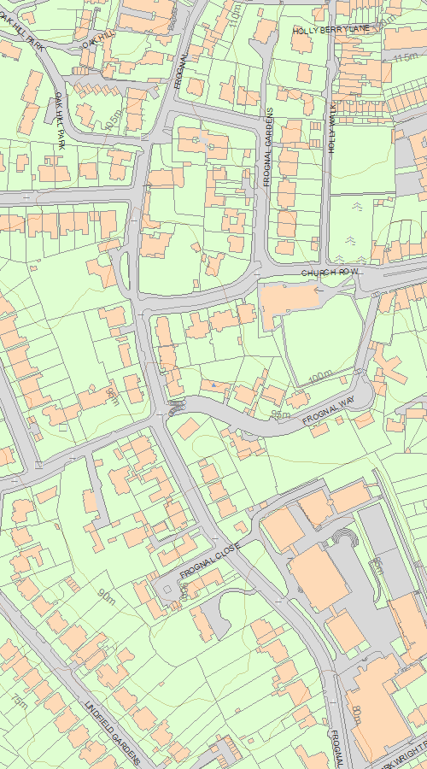

© Crown Copyright and database right 2020. All rights reserved. Ordnance Survey Licence number 100024900.  
© British Crown and SeaZone Solutions Limited 2020. All rights reserved. Licence number 102006.006.  
Use of this data is subject to [Terms and Conditions](https://historicengland.org.uk/terms/website-terms-conditions/).

The above map is for quick reference purposes only and may not be to scale. For a copy of the full scale map, please see the attached PDF - [1322138.pdf (opens in a new window)](http://mapservices.HistoricEngland.org.uk/printwebservicehle/StatutoryPrint.svc/292186/HLE_A4L_Grade|HLE_A3L_Grade.pdf)

The PDF will be generated from our live systems and may take a few minutes to download depending on how busy our servers are. We apologise for this delay.

This copy shows the entry on 17-Jun-2020 at 11:23:10.

**Location**

Statutory Address:

SHEPHERDS WELL, 5, FROGNAL WAY

The building or site itself may lie within the boundary of more than one authority.

County:

Greater London Authority

District:

Camden (London Borough)

National Grid Reference:

TQ 26134 85548

**Details**

CAMDEN  
  
TQ2685NW FROGNAL WAY 798-1/26/1771 (North side) No.5 Shepherds' Well   
  
GV II  
  
Detached house. 1929-30. By Adrian Gilbert-Scott for himself. Grey-brown handmade bricks, red pantiled roof, white-painted wooden sash windows. Neo-Georgian style, showing influence of Lutyens. Symmetrical, with low hipped roof, low chimneys at ends and eaves cornice. 2 full storeys, with matching dormers in roof added later. Front symmetrical, of 7 windows' width; motor house projecting to right. Large sash windows with close panes to ground storey, smaller ones above. Central front door with porch on Ionic columns added later in matching style. Rear elevation with slight central projection. INTERIOR not inspected.   
  
  
  
  
  
Listing NGR: TQ2613785548

**Legacy**

The contents of this record have been generated from a legacy data system.

Legacy System number:

477448

Legacy System:

LBS

**Legal**

This building is listed under the Planning (Listed Buildings and Conservation Areas) Act 1990 as amended for its special architectural or historic interest.

End of official listing