**66, FROGNAL**

[2 contributions](https://historicengland.org.uk/listing/the-list/list-entry/1113062#contributions-banner)

**Overview**

Heritage Category:

Listed Building

Grade:

II*

List Entry Number:

1113062

Date first listed:

01-Aug-1973

Statutory Address:

66, FROGNAL

**Map**

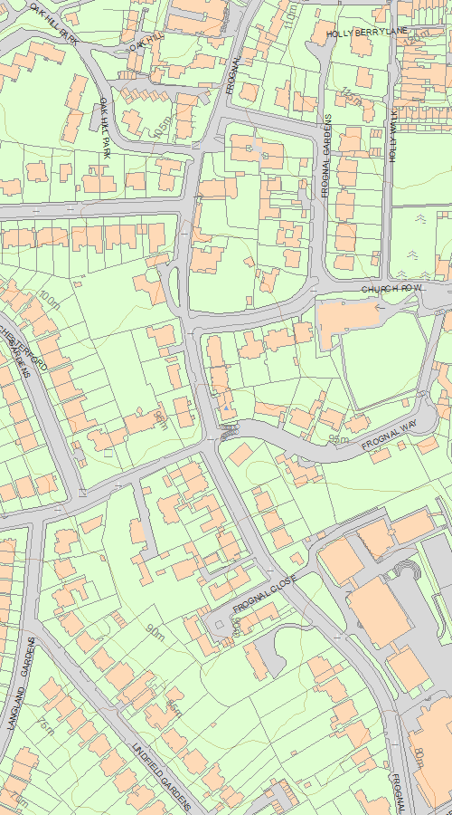

© Crown Copyright and database right 2020. All rights reserved. Ordnance Survey Licence number 100024900.  
© British Crown and SeaZone Solutions Limited 2020. All rights reserved. Licence number 102006.006.  
Use of this data is subject to [Terms and Conditions](https://historicengland.org.uk/terms/website-terms-conditions/).

The above map is for quick reference purposes only and may not be to scale. For a copy of the full scale map, please see the attached PDF - [1113062.pdf (opens in a new window)](http://mapservices.HistoricEngland.org.uk/printwebservicehle/StatutoryPrint.svc/375233/HLE_A4L_Grade|HLE_A3L_Grade.pdf)

The PDF will be generated from our live systems and may take a few minutes to download depending on how busy our servers are. We apologise for this delay.

This copy shows the entry on 17-Jun-2020 at 11:16:46.

**Location**

Statutory Address:

66, FROGNAL

The building or site itself may lie within the boundary of more than one authority.

County:

Greater London Authority

District:

Camden (London Borough)

National Grid Reference:

TQ 26103 85548

**Details**

CAMDEN  
  
TQ2685NW FROGNAL 798-1/26/523 (East side) 01/08/73 No.66   
  
GV II*  
  
Detached house on corner site. 1937-8. By Colin Lucas with Amyas Connell and Basil Ward. Roughcast on reinforced concrete monolithic structure with floors supported on freestanding reinforced concrete pilotis. Flat roof over hanging 2nd floor; post-war alterations filling in sundeck on top floor by Trevor Dannatt. EXTERIOR: 3 storeys, 13 window continuous strip. Main facade with projecting central rectangular staircase, to full height, with glazed rectangular panels to each return. Ground floor left forms an open carport with garage; staircase to extreme left leads to 1st floor entrance with plain canopy. Ground floor right, glazed. Upper floors have continuous strips of large pane sliding windows, those at 1st floor with round tie-plates above and 2nd floor slightly recessed. Right hand return has glazed, recessed ground floor, the upper floors supported on pilotis and having a continuous raked flower trough; a small rectangular window to each floor. Rear elevation with stair to right hand 1st floor terrace with tubular railings; central plate-glass bay with strip window bay to left. 2nd floor with continuous balcony having tubular railings; 2 left hand bays with plate-glass French windows overhung by flat roof. INTERIOR: not inspected. HISTORICAL NOTE: a pioneer work of the Modern Movement in the UK. Connell and Ward were early admirers of Le Corbusier; Lucas, similarly influenced and frustrated by conventional builders, had set up his own company to develop ideas for reinforced concrete. The three worked as a team from 1933, for six years producing a series of houses that no contemporary firm could match.   
  
  
  
  
  
Listing NGR: TQ2610385548

**Legacy**

The contents of this record have been generated from a legacy data system.

Legacy System number:

477412

Legacy System:

LBS

**Legal**

This building is listed under the Planning (Listed Buildings and Conservation Areas) Act 1990 as amended for its special architectural or historic interest.

End of official listing