Construction Management
Plan
pro forma

Contents

Revisions 3

Introduction 4
Timeframe 6

Contact 7

Site 9

Community liaison 12

Transport 14

Environment 26

Agreement 31

Revisions & additional material

Please list all iterations here:
Date | Version | Produced by
9th January 2020 | 1 | Sir Robert McAlpine Ltd
7th February 2020 | 2 | Sir Robert McAlpine Ltd
12th May 2020 | 3 | Sir Robert McAlpine Ltd
5th June 2020 | 4 | Sir Robert McAlpine Ltd
21st July 2020 | 5 | Sir Robert McAlpine Ltd

Additional sheets
Please note – the review process will be quicker if these are submitted as Word documents or searchable PDFs.
Date | Version | Produced by

Introduction

The purpose of the Construction Management Plan (CMP) is to help developers to minimise construction impacts and relates to all construction activity both on and off site that impacts on the wider environment.
It is intended to be a live document whereby different stages will be completed and submitted for application as the development progresses.
The completed and signed CMP must address the way in which any impacts associated with the proposed works, and any cumulative impacts of other nearby construction sites, will be mitigated and managed. The level of detail required in a CMP will depend on the scale and nature of development. Further policy guidance is set out in Camden Planning Guidance (CPG) 6: Amenity and (CPG) 8: Planning Obligations.
This CMP follows the best practice guidelines as described in the Construction Logistics and Community Safety (CLOCS) Standard and the Guide for Contractors Working in Camden.
Camden charges a fee for the review and ongoing monitoring of CMPs. This is calculated on an individual basis according to the predicted officer time required to manage this process for a given site.

The approved contents of this CMP must be complied with unless otherwise agreed with the Council in writing. The project manager shall work with the Council to review this CMP if problems arise during construction. Any future revised plan must also be approved by the Council and complied with thereafter.
It should be noted that any agreed CMP does not prejudice or override the need to obtain any separate consents or approvals such as road closures or hoarding licences.
If your scheme involves any demolition, you need to make an application to the Council’s Building Control Service. Please complete the “Demolition Notice.”
Please complete the questions below with additional sheets, drawings and plans as required. The boxes will expand to accommodate the information provided, so please provide as much information as is necessary. It is preferable if this document, and all additional documents, are completed electronically and submitted as Word files to allow comments to be easily documented. These should be clearly referenced/linked to from the CMP. Please only provide the information requested that is relevant to a section.
(Note the term 'vehicles' used in this document refers to all vehicles associated with the implementation of the development, e.g. demolition, site clearance, delivery of plant & materials, construction etc.)
Revisions to this document may take place periodically.
Timeframe
DEVELOPER ACTIONS

COUNCIL ACTIONS

Planning Permission granted

0ommunity liaison

Appoint principal contractor

Begin community liaison

Work can commence if CMP is approved

Council response to second draft

Submit draft CMP

Work can commence if draft CMP is approved

Resubmission of CMP if first draft required further development

2ommunity liaison

3ommunity liaison

1ommunity liaison

INDICATIVE TIMEFRAME (MONTHS)
4ommunity liaison

Council response to draft

Contact
1. Please provide the full postal address of the site and the planning reference relating to the construction works.

Address: The Shaftesbury Theatre
210 Shaftesbury Avenue, London WC2H8DP
Planning reference number to which the CMP applies:
The planning references is:
2018/0575/P
List Building Consent reference is:
2017/7073/L

2. Please provide contact details for the person responsible for submitting the CMP.

Name: Mr D Swain – Sir Robert McAlpine Ltd
Address: 63 St. Mary Axe, London, EC3A 8AA
Email: denny.swain@srm.com
Phone: 07989 390809

3. Please provide full contact details of the site project manager responsible for day-to-day management of the works and dealing with any complaints from local residents and businesses.

Name: Mr. J Whiteaker – Sir Robert McAlpine Ltd
Address: c/o The Shaftesbury Theatre, 210 Shaftesbury Avenue, London WC2H8DP
Email: j.whiteaker@srm.com
Phone: 07970205652

4. Please provide full contact details of the person responsible for community liaison and dealing with any complaints from local residents and businesses if different from question 3. In the case of Community Investment Programme (CIP), please provide contact details of the Camden officer responsible.

Name: Mr J Williams
Address: The Shaftesbury theatre
210 Shaftesbury Avenue, London WC2H 8DP
Email: jwilliams@shaftesburytheatre.com
Phone: 020 73793345

5. Please provide full contact details including the address where the main contractor accepts receipt of legal documents for the person responsible for the implementation of the CMP.

Name: Mr D Swain – Sir Robert McAlpine Ltd
Address: 63 St. Mary Axe, London, EC3A 8AA
Email: denny.swain@srm.com
Phone: 07989 390809

Site
6. Please provide a site location plan and a brief description of the site, surrounding area and development proposals for which the CMP applies.

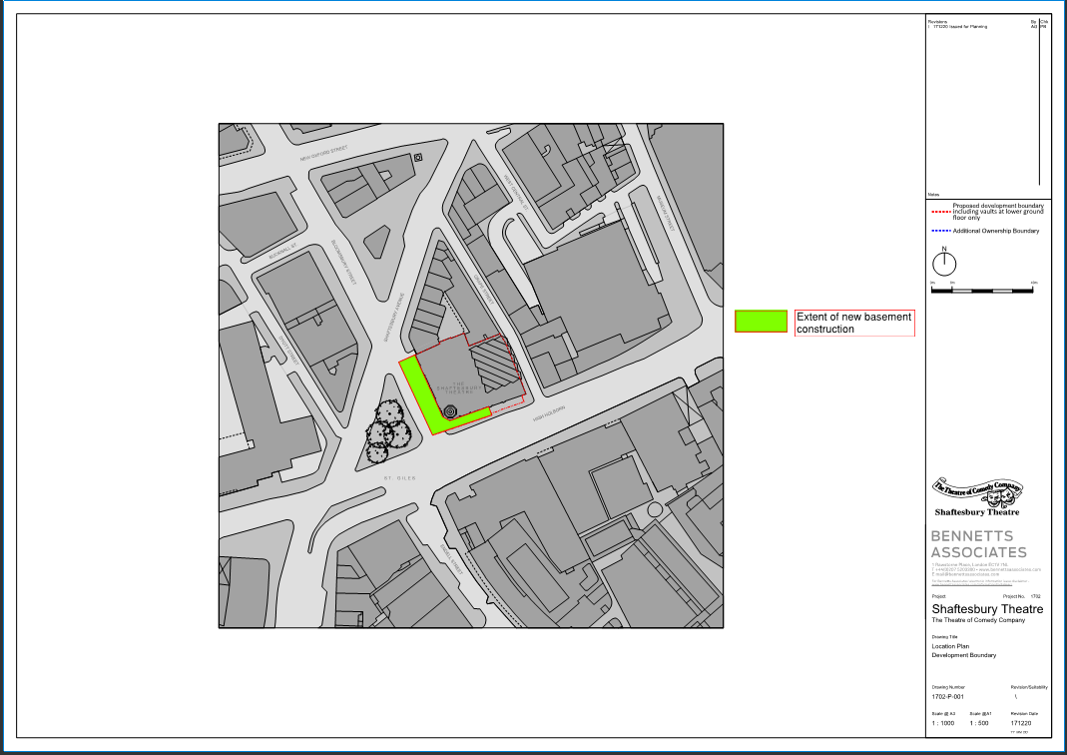
The development proposals are for a new basement to the existing Shaftesbury Theatre. The above location plan shows the proposed development boundary and the extent of the new basement construction. The basement is single storey extending under the pavement of High Holborn and beneath the carriageway of Bloomsbury St. This road in turn becomes pedestrianised as part of the West End Project works. Within the theatre alterations to the existing basement slab will be carried out to form a uniform level from existing to new. The space will then be fitted out to form a new bar and associated facilities.

7. Please provide a very brief description of the construction works including the size and nature of the development and details of the main issues and challenges (e.g. narrow streets, close proximity to residential dwellings etc).

The basement will be formed using sheet piles. When excavated to formation a reinforced concrete raft will be cast, followed by RC walls, columns and ground floor slab. The basement extends approx. 6.9m from the face of the building into Bloomsbury St and 3.2m into High Holborn and has a total area of approx. 280m². The site is in the heart of the West End. The nearest residential buildings are King Edwards Mansions to the rear of the block as shown on the plan included for question 10. Access to the site is good via the A400 from the north and the A40 from the West, once the traffic flow has been reversed. Currently access on the A40 would be from the East.

8. Please provide the proposed start and end dates for each phase of construction as well as an overall programme timescale. (A Gantt chart with key tasks, durations and milestones would be ideal).
To be updated in due course
Key dates:
Commence site establishment / Erect hoardings – August 2020
Commence works – August 2020
Handover Bloomsbury St to Camden West End Project – July 2021
Handover High Holborn to Camden West End Project – Aug 2021
Practical Completion of the works – Sept 2021
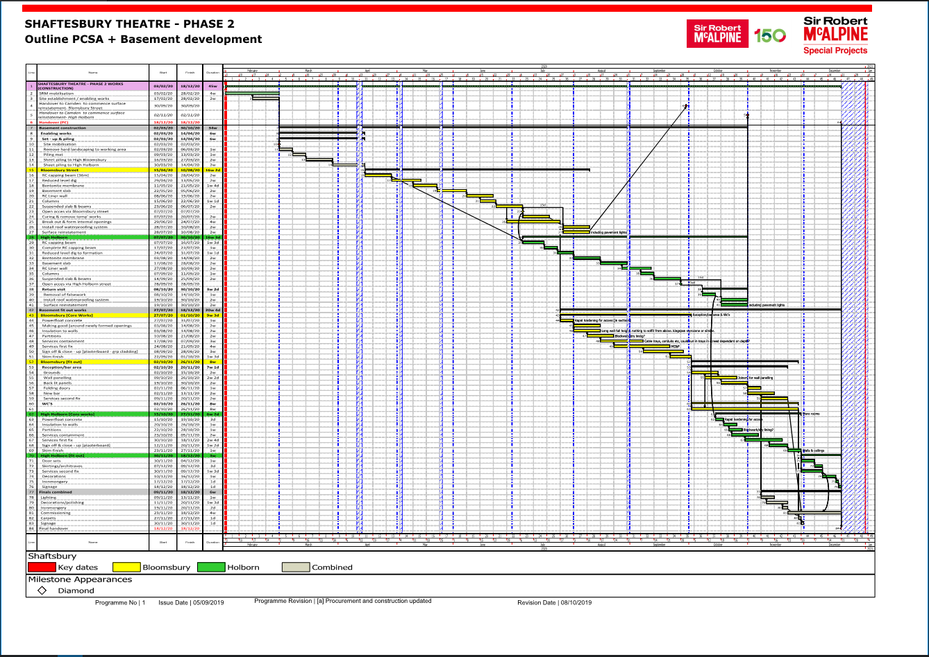
9. Please confirm the standard working hours for the site, noting that the standard working hours for construction sites in Camden are as follows:

- 8.00am to 6pm on Monday to Friday
- 8.00am to 1.00pm on Saturdays
- No working on Sundays or Public Holidays

The site working hours will not exceed Camden standard working hours for construction sites

Community Liaison
A neighbourhood consultation process must have been undertaken prior to submission of the CMP first draft.
This consultation must relate to construction impacts, and should take place following the granting of planning permission in the lead up to the submission of the CMP. A consultation process specifically relating to construction impacts must take place regardless of any prior consultations relating to planning matters. This consultation must include all of those individuals that stand to be affected by the proposed construction works. These individuals should be provided with a copy of the draft CMP, or a link to an online document. They should be given adequate time with which to respond to the draft CMP, and any subsequent amended drafts. Contact details which include a phone number and email address of the site manager should also be provided.
Significant time savings can be made by running an effective neighbourhood consultation process. This must be undertaken in the spirit of cooperation rather than one that is dictatorial and unsympathetic to the wellbeing of local residents and businesses.
These are most effective when initiated as early as possible and conducted in a manner that involves the local community. Involving locals in the discussion and decision making process helps with their understanding of what is being proposed in terms of the development process. The consultation and discussion process should have already started, with the results incorporated into the CMP first draft submitted to the Council for discussion and sign off. This communication should then be ongoing during the works, with neighbours and any community liaison groups being regularly updated with programmed works and any changes that may occur due to unforeseen circumstances through newsletters, emails and meetings.
Please note that for larger sites, details of a construction working group may be required as a separate S106 obligation. If this is necessary, it will be set out in the S106 Agreement as a separate requirement on the developer.

Cumulative impact
Sites located within high concentrations of construction activity that will attract large numbers of vehicle movements and/or generate significant sustained noise levels should consider establishing contact with other sites in the vicinity in order to manage these impacts.
The Council can advise on this if necessary.
10. Sensitive/affected receptors
Please identify the nearest potential receptors (dwellings, business, etc.) likely to be affected by the activities on site (i.e. noise, vibration, dust, fumes, lighting etc.).
The marked up drawing below shows the nearest potential receptors to be affected by the works. 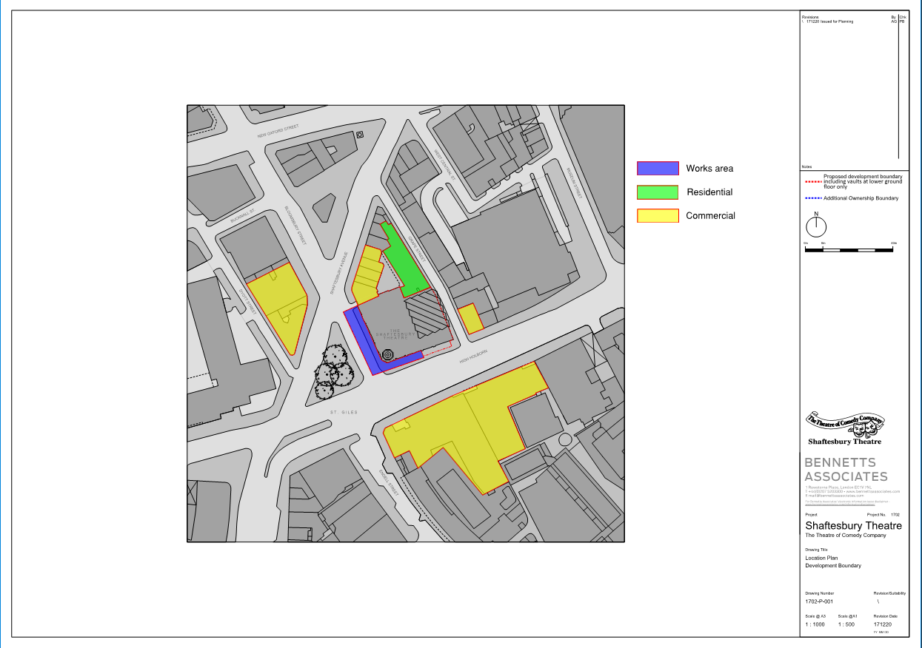
11. Consultation
The Council expects meaningful consultation. For large sites, this may mean two or more meetings with local residents prior to submission of the first draft CMP.
Evidence of who was consulted, how the consultation was conducted and a summary of the comments received in response to the consultation should be included. Details of meetings including minutes, lists of attendees etc. should be appended.
In response to the comments received, the CMP should then be amended where appropriate and, where not appropriate, a reason given. The revised CMP should also include a list of all the comments received. Developers are advised to check proposed approaches to consultation with the Council before carrying them out. If your site is on the boundary between boroughs then we would recommend contacting the relevant neighbouring planning authority.
Please provide details of consultation of draft CMP with local residents, businesses, local groups (e.g. residents/tenants and business associations) and Ward Councillors.
There was a residents/neighbours meeting held on 31 October 2018 prior to the commencement of Phase 1, local residents and businesses attended. All residents were given details of the Theatre’s website where there was a constant update of activity especially when likely to cause disturbance. Additionally, residents were advised of any exceptional Sunday/overnight working in advance by email.
SRM, the client and architect attended a meeting with residents on 15th January 2020. The Phase 2 project was explained to all attendees with any questions raised, responded in the meeting. Key activities and any disruptive activity advised in advance. These will be displayed on the Theatre’s website/ emailed out to the theatres local resident database.

12. Construction Working Group
For particularly sensitive/contentious sites, or sites located in areas where there are high levels of construction activity, it may be necessary to set up a construction working group.
If so, please provide details of the group that will be set up, the contact details of the person responsible for community liaison and how this will be advertised to the local community, and how the community will be updated on the upcoming works i.e. in the form of a newsletter/letter drop, or weekly drop in sessions for residents.
We do not believe the site to be particularly sensitive or contentious. If a construction working group is required then this will be led by Mr. James Williams and Mr. Denny Swain, see sections 4 and 5 for details.
13. Schemes
Please provide details of your Considerate Constructors Scheme (CCS) registration. Please note that Camden requires enhanced CCS registration that includes CLOCS monitoring. Please provide a CCS registration number that is specific to the above site.
Contractors will also be required to follow the Guide for Contractors Working in Camden. Please confirm that you have read and understood this, and that you agree to abide by it.
SRM shall apply for CCS registration upon award of the contract.
14. Neighbouring sites

Please provide a plan of existing or anticipated construction sites in the local area and please state how your CMP takes into consideration and mitigates the cumulative impacts of construction in the vicinity of the site. The council can advise on this if necessary.

The site is shown in red outline on the drawing below. We checked all the streets shown on the plan and there are no construction sites.
Other nearby sites: Soho place, Consolidated Land Development, and Castlewood House / Medius House.
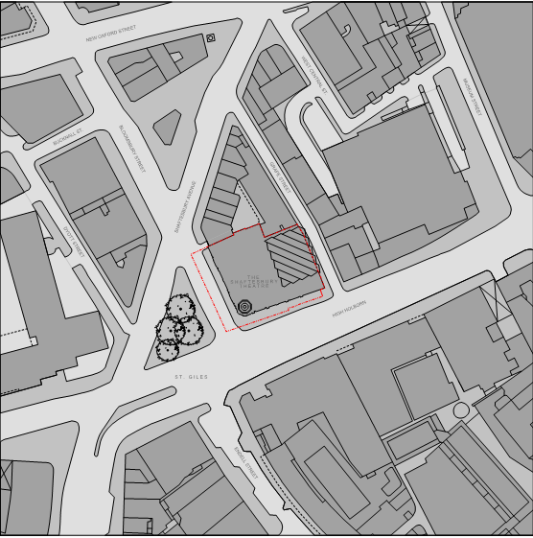

Transport
This section must be completed in conjunction with your principal contractor. If one is not yet assigned, please leave the relevant sections blank until such time when one has been appointed.
Camden is a CLOCS Champion, and is committed to maximising road safety for Vulnerable Road Users (VRUs) as well as minimising negative environmental impacts created by motorised road traffic. As such, all vehicles and their drivers servicing construction sites within the borough are bound by the conditions laid out in the CLOCS Standard.
This section requires details of the way in which you intend to manage traffic servicing your site, including your road safety obligations with regard to VRU safety. It is your responsibility to ensure that your principal contractor is fully compliant with the terms laid out in the CLOCS Standard. It is your principal contractor’s responsibility to ensure that all contractors and sub-contractors attending site are compliant with the terms laid out in the CLOCS Standard.
Checks of the proposed measures will be carried out by CCS monitors as part of your enhanced CCS site registration, and possibly council officers, to ensure compliance. Please refer to the CLOCS Standard when completing this section.
Please contact CLOCS@camden.gov.uk for further advice or guidance on any aspect of this section.
CLOCS Contractual Considerations

15. Name of Principal contractor:
Sir Robert McAlpine Ltd
16. Please submit the proposed method for checking operational, vehicle and driver compliance with the CLOCS Standard throughout the duration of the contract (please refer to our CLOCS Overview document and Q18 example response).
Information will be included in the site induction on this for those that are working on the site. This will also be included in the subcontract that is sent out ensuring that all that are involved with the project understand the added level of care that is needed and also the requirements of staff and equipment.
All drivers of vehicles of over 3.5t will have undertaken Safe Urban Driver training, and all vehicles over 3.5t will be fitted with blind spot minimalisation equipment (Fresnel lens / CCTV) and audible left turn alerts. Operators must be FORS accredited. FORS Silver operators should already be complaint with CLOCS. Where accredited to FORS Bronze level, written confirmation will be provided to ensure the above requirements are met.
The traffic management plan for the project will also be constantly reviewed to ensure constant safe movement of vehicles to and from the site.

17. Please confirm that you as the client/developer and your principal contractor have read and understood the CLOCS Standard and included it in your contracts.

I confirm that I have included the requirement to abide by the CLOCS Standard in my contracts to my contractors and suppliers:

The CLOCS Standard requirements have been included within the SRM standard sub-contract conditions.
Please contact CLOCS@camden.gov.uk for further advice or guidance on any aspect of this section.
Site Traffic

Sections below shown in blue directly reference the CLOCS Standard requirements. The CLOCS Standard should be read in conjunction with this section.

18. Traffic routing: “Clients shall ensure that a suitable, risk assessed vehicle route to the site is specified and that the route is communicated to all contractors and drivers. Clients shall make contractors and any other service suppliers aware that they are to use these routes at all times unless unavoidable diversions occur.” (P19, 3.4.5)

Routes should be carefully considered and risk assessed, taking into account the need to avoid where possible any major cycle routes and trip generators such as schools, offices, stations, public buildings, museums etc.

Consideration should also be given to weight restrictions, low bridges and cumulative impacts of construction (including neighbouring construction sites) on the public highway network. The route(s) to and from the site should be suitable for the size of vehicles that are to be used.

Please show vehicle approach and departure routes between the site and the Transport for London Road Network (TLRN). Please note that routes may differ for articulated and rigid HGVs.
Routes should be shown clearly on a map, with approach and departure routes clearly marked. If this is attached, use the following space to reference its location in the appendices.
Delivery Route – Before Eastbound High Holborn is open
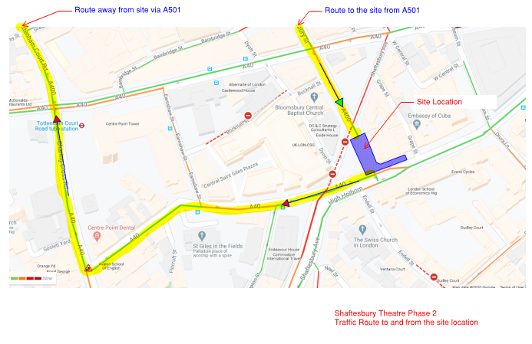
Delivery Route – After Eastbound High Holborn is open
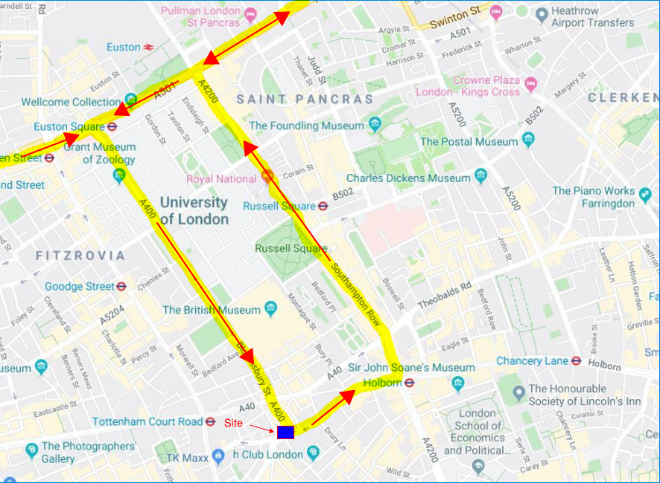
b. Please confirm how contractors and delivery companies will be made aware of the route (to and from the site) and of any on-site restrictions, prior to undertaking journeys.
The route to and from site and site restrictions will be included within the SRM standard sub-contract conditions.
19. Control of site traffic, particularly at peak hours: “Clients shall consider other options to plan and control vehicles and reduce peak hour deliveries” (P20, 3.4.6)

Construction vehicle movements should be restricted to the hours of 9.30am to 4.30pm on weekdays and between 8.00am and 1.00pm on Saturdays. If there is a school in the vicinity of the site or on the proposed access and/or egress routes, then deliveries must be restricted to the hours of 9.30am and 3pm on weekdays during term time.

Vehicles may be permitted to arrive at site at 8.00am if they can be accommodated on site. Where this is the case they must then wait with their engines switched off.

A delivery plan should ensure that deliveries arrive at the correct part of site at the correct time. Instructions explaining such a plan should be sent to all suppliers and contractors.

Please provide details of the types of vehicles required to service the site and the approximate number of deliveries per day for each vehicle type during the various phases of the project.

For Example:
32t Tipper: 10 deliveries/day during first 4 weeks
Skip loader: 2 deliveries/week during first 10 weeks
Artic: plant and tower crane delivery at start of project, 1 delivery/day during main construction phase project
18t flatbed: 2 deliveries/week for duration of project
3.5t van: 2 deliveries/day for duration of project

Weeks 1-4: 18t flatbed 4 deliveries / day
Transit van 2 deliveries / day
Weeks 5-10: Steel bodied tipper 4 / day
18t flatbed 4 deliveries / day
Articulated lorry 2 deliveries / day
Transit van 2 deliveries / day
Weeks 11-16: steel bodied tipper 10 / day
18t flatbed 4 deliveries / day
Concrete mixer lorries 4 deliveries / day
Transit van 2 deliveries / day
Weeks 17-21: 18t flatbed 4 deliveries / day
Concrete mixer lorries 8 deliveries / day
Transit van 2 deliveries / day
Weeks 22-25: steel bodied tipper 6 / day
18t flatbed 6 deliveries / day
Concrete mixer lorries 6 deliveries / day
Transit van 2 deliveries / day
Weeks 26-30: 18t flatbed 4 deliveries / day
Concrete mixer lorries 6 deliveries / day
Transit van 4 deliveries / day
Weeks 31-35: 18t flatbed 4 deliveries / day
Transit van 4 deliveries / day
Weeks 36-39: 18t flatbed 4 deliveries / day
Transit van 4 deliveries / day
Weeks 40-46: Transit van 8 deliveries / day

b. Cumulative effects of construction traffic servicing multiple sites should be minimised where possible. Please provide details of other developments in the local area or on the route that might require deliveries coordination between two or more sites. This is particularly relevant for sites in very constrained locations.
Not applicable
c. Please provide swept path analyses for constrained manoeuvres along the proposed route.
Not applicable

d. Consideration should be given to the location of any necessary holding areas/waiting points for sites that can only accommodate one vehicle at a time/sites that are expected to receive large numbers of deliveries. Vehicles must not queue or circulate on the public highway. Whilst deliveries should be given set times to arrive, dwell and depart, no undue time pressures should be placed upon the driver at any time.

Please identify the locations of any off-site holding areas or waiting points. This can be a section of single yellow line that will allow the vehicle to wait to phone the site to check that the delivery can be accommodated.

Please refer to question 24 if any parking bay suspensions will be required to provide a holding area.

There should be no requirement for offsite holding areas as we shall manage deliveries, also there is enough space on site should two deliveries turn up at the same time.

e. Delivery numbers should be minimised where possible. Please investigate the use of construction material consolidation centres, and/or delivery by water/rail if appropriate.

Not applicable

f. Emissions from engine idling should be minimised where possible. Please provide details of measures that will be taken to reduce delivery vehicle engine idling, both on and off site (this does not apply to concrete mixers).

The site rules will state that vehicles must turn off their engines when they arrive on site.
20. Site access and egress: “Clients shall ensure that access to and egress from the site is appropriately managed, clearly marked, understood and clear of obstacles.” (P18, 3.4.3)
This section is only relevant where vehicles will be entering the site. Where vehicles are to load from the highway, please skip this section and refer to Q23.
Vehicles entering and leaving the site should be carefully managed, using gates that are clearly marked and free from obstacles. Traffic marshals must ensure the safe passage of all traffic on the public highway, in particular pedestrians and cyclists, when vehicles are entering and leaving site, particularly if reversing.
Traffic marshals, or site staff acting as traffic marshals, should hold the relevant qualifications required for directing large vehicles when reversing. Marshals should be equipped with ‘STOP – WORKS’ signs (not STOP/GO signs) if control of traffic on the public highway is required. Marshals should have radio contact with one another where necessary.

a. Please detail the proposed site access and egress points on a map or diagram. If this is attached, use the following space to reference its location in the appendices.
(A40)
(A400)
The drawing below shows vehicular and pedestrian access and egress.
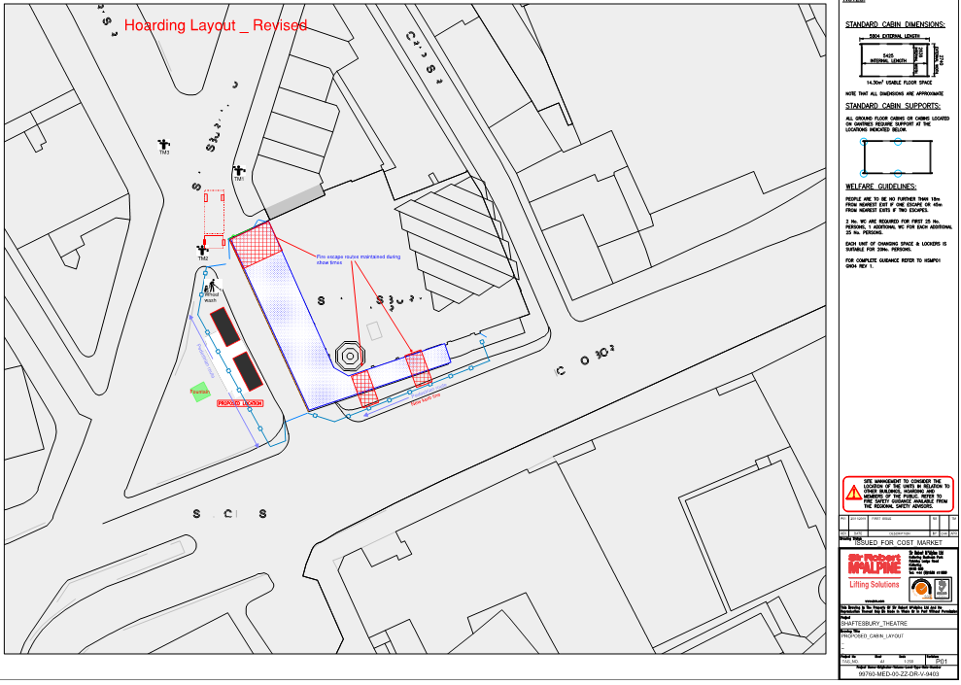
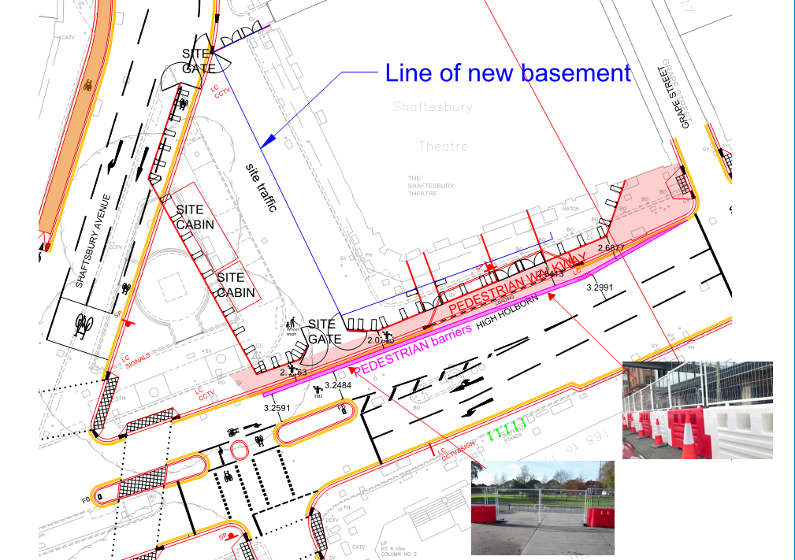

b. Please describe how the access and egress arrangements for construction vehicles in and out of the site will be managed, including the number and location of traffic marshals where applicable. If this is shown in an attached drawing, use the following space to reference its location in the appendices.

The CTMP will remain a ‘live’ document and will be updated by Sir Robert McAlpine as and when required and following consultation with Camden.
Sir Robert McAlpine (SRM) will manage traffic movements in and around the Shaftesbury Theatre including construction traffic and plant movements, segregating the general public from site construction and delivery traffic and as far as is reasonably practicable ensuring site personnel are also segregated / protected from these traffic movements.
Traffic Marshalls
All vehicle movements will be supervised by competent and certified Traffic marshals/ banksman ensuring traffic flow and pedestrian safety is maintained on High Holborn, Bloomsbury Street & Shaftesbury Avenue.
Pedestrian Safety
Site hoardings with appropriate lighting will be erected along the site frontages. The perimeter hoarding along Shaftesbury Avenue will go into the cycle lane on the carriageway but remain 450mm away from the traffic lane. Pedestrians will need to cross to the opposite side of the road via the pedestrian lights.
Turning Vehicles
SRM preferred option is to employ a one-way system through the site with vehicles entering from Bloomsbury Street (North Gate) and then exiting on to High Holborn and turning left towards the A4200.
Location of loading and unloading
All loading and unloading will take place within the site compound which is bounded by fixed hoardings. Traffic Marshalls (TM) will ensure safety to public when vehicles enter and leave the site.

c. Please provide swept path drawings for vehicles accessing/egressing the site if necessary. If these are attached, use the following space to reference their location in the appendices.

Swept paths are show below of articulated and rigid vehicles.
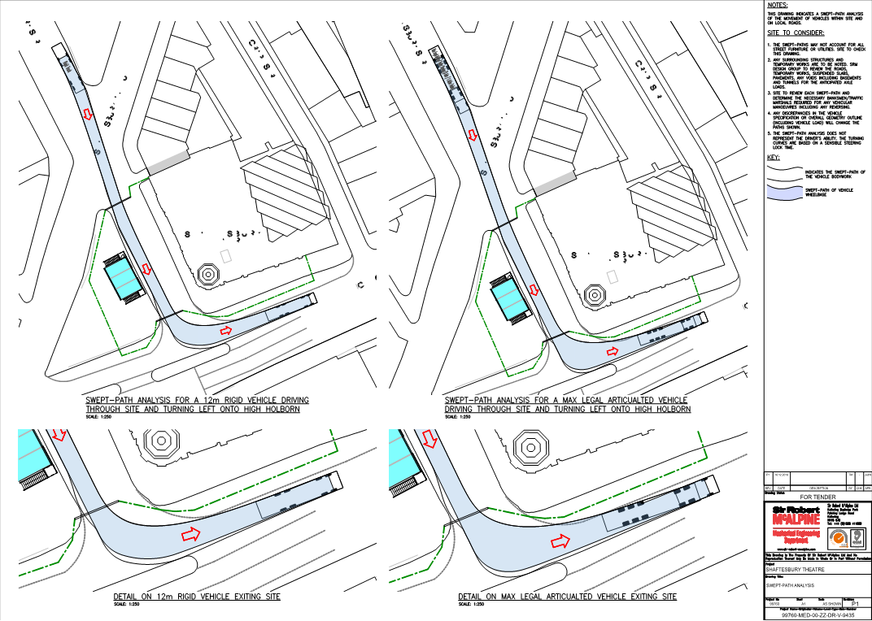

d. Provision of wheel washing facilities should be considered if necessary. If so, please provide details of how this will be managed and any run-off controlled. Please note that wheel washing should only be used where strictly necessary, and that a clean, stable surface for loading should be used where possible.
The drawing included for Q.20a shows the location of jet washer to be used to clean the wheels of vehicles leaving the site. We believe the requirement to do so will be minimal as the lorry will remain on the road surface and will not enter the excavation. Run off from the jet washer will be caught in a nearby gully fitted with a drain guard to catch the sediment.

21. Vehicle loading and unloading: “Clients shall ensure that vehicles are loaded and unloaded on-site as far as is practicable.” (P19, 3.4.4)

This section is only relevant if loading/unloading is due to take place off-site on the public highway. If loading is taking place on site, please skip this section.

a. please provide details of the parking and loading arrangements for construction vehicles with regard to servicing and deliveries associated with the site (e.g. delivery of materials and plant, removal of excavated material). This is required as a scaled site plan, showing all points of access and where materials, skips and plant will be stored, and how vehicles will access and egress the site. If this is attached, use the following space to reference its location in the appendices. Please outline in question 24 if any parking bay suspensions will be required.
N/A
b. Where necessary, Traffic Marshalls must ensure the safe passage of pedestrians, cyclists and motor traffic in the street when vehicles are being loaded or unloaded. Please provide detail of the way in which marshals will assist with this process, if this differs from detail provided in Q20 b.
As the Eastbound High Holborn carriageway is not due to be open until Jan 2021, due to works being carried out by Camden’s contractor.
SRM will use two routes into the site (until the Eastbound route is open). Deliveries will either arrive via High Holborn or Bloomsbury Street both routes will unfortunately require vehicles to reverse back onto the carriageway they have entered, as the site is too small to accommodate a turning circle.
As pedestrians cannot be excluded, the appointed traffic marshal(s) will control the manoeuvres. Members of the public will be segregated at the crossover points via crowd barriers or similar. While vehicle movements will be stopped until all pedestrians are in a safe position. In the event pedestrians refuse to remain in a safe position, then all operations will cease, until it was safe to resume.
Reversing on to Bloomsbury Street - traffic marshal No.1 will direct members of the public on to the pedestrian crossing on Shaftesbury Avenue to prevent them walking across the vehicle gates. The vehicle will remain on site with the North Gate opened until the lights on Bloomsbury Street have changed. Traffic marshal No. 3 will then direct the vehicle straight back into the hatched area on the junction of Bloomsbury Street & Shaftesbury Avenue, ensuring the pedestrian crossing on Shaftesbury Avenue is not impeded. The vehicle will then head along Shaftesbury Avenue and join the general flow of traffic. SRM don’t believe there is any requirement for the timing of the signals to be adjusted as the manoeuvre should be completed prior the traffic lights changing.
Reversing on to High Holborn – Traffic Marshal 1 & 2 will open the Heras Gate Panels on the pedestrian barrier system to close off the pedestrian walkway with members of the public held either side of the crossover. Traffic Marshall No. 3 will then open the site gates and reverse the vehicle into the closed off Eastbound carriageway. The pedestrian walkway would then be reopened, and the marshal(s) would then assist the vehicle to filter onto the West Bound carriageway on High Holborn helped by the changing signals.

Street Works

Full justification must be provided for proposed use of the public highway to facilitate works. Camden expects all options to minimise the impact on the public highway to have been fully considered prior to the submission of any proposal to occupy the highway for vehicle pit lanes, materials unloading/crane pick points, site welfare etc.
Please note that Temporary Traffic Orders (TTOs) and hoarding/scaffolding licenses may be applied for prior to CMP submission but won’t be granted until the CMP is signed-off.

Please note that there is a two week period required for the statutory consultation process to take place as part of a TTO.

If the site is on or adjacent to the TLRN, please provide details of preliminary discussions with Transport for London in the relevant sections below.

If the site conflicts with a bus lane or bus stop, please provide details of preliminary discussions with Transport for London in the relevant sections below.

22. Site set-up
Please provide a scaled plan detailing the local highway network layout in the vicinity of the site. This should include details of on-street parking bay locations, cycle lanes, footway extents, relevant street furniture, and proposed site access locations. If these are attached, use the following space to reference their location in the appendices.
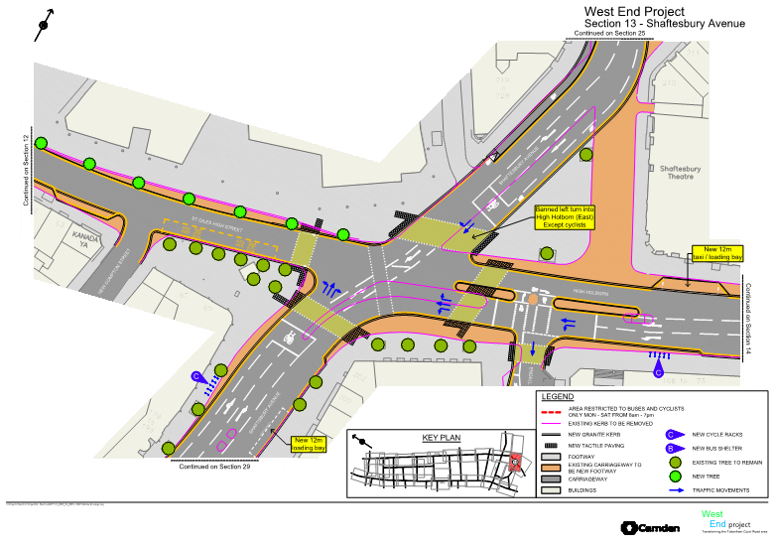
23. Parking bay suspensions and temporary traffic orders
Parking bay suspensions should only be requested where absolutely necessary and these are permitted for a maximum of 6 months only. For exclusive access longer than 6 months, you will be required to obtain a Temporary Traffic Order (TTO) for which there is a separate cost.
Please provide details of any proposed parking bay suspensions and/or TTO’s which would be required to facilitate the construction - include details of the expected duration in months/weeks. Building materials and equipment must not cause obstructions on the highway as per your CCS obligations unless the requisite permissions are secured.
Information regarding parking suspensions can be found here.
N/A
24. Occupation of the public highway
Please note that use of the public highway for storage, site accommodation or welfare facilities is at the discretion of the Council and is generally not permitted. If you propose such use you must supply full justification, setting out why it is impossible to allocate space on-site. We prefer not to close footways but if this is unavoidable, you should submit a scaled plan of the proposed diversion route showing key dimensions.
a. Please provide justification of proposed occupation of the public highway.
As demonstrated the maximum width of footpath that can be maintained without entering the carriageway is 1.6m. In line with correspondence and request from Camden to use the current redundant Eastbound lane on High Holborn so that a 2, footpath for social distancing can be maintained.
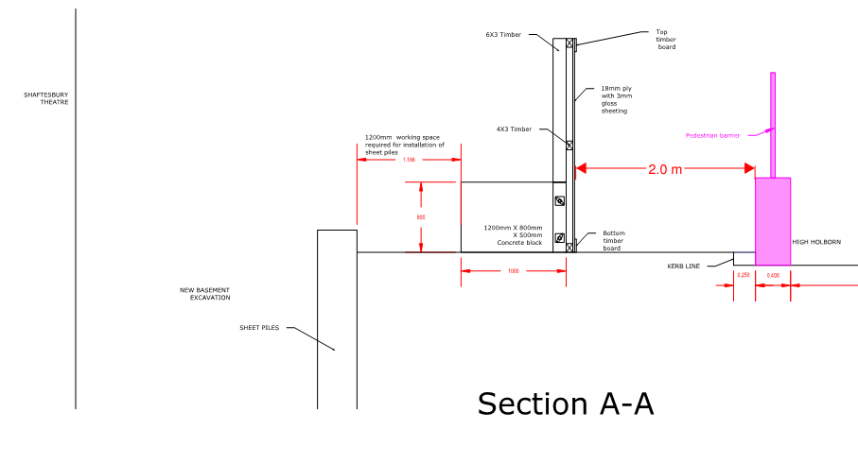
b. Please provide accurate scaled drawings of any highway works necessary to enable construction to take place (e.g. construction of temporary vehicular accesses, removal of street furniture etc). If these are attached, use the following space to reference their location in the appendices.
Lamp post to be removed
The drawing below shows the location of bollards and a lamp post on High Holborn to be removed.
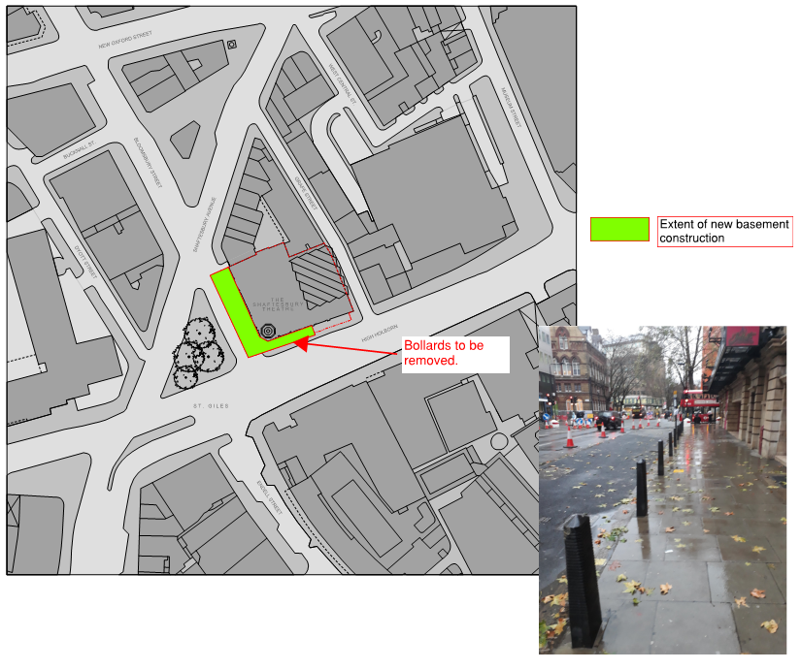
25. Motor vehicle and/or cyclist diversions
Where applicable, please supply details of any diversion, disruption or other anticipated use of the public highway during the construction period. Please show locations of diversion signs on drawings or diagrams. If these are attached, use the following space to reference their location in the appendices.
None
26. Scaffolding, hoarding, and associated pedestrian diversions
Pedestrians safety must be maintained if diversions are put in place. Vulnerable footway users should also be considered. These include wheelchair users, the elderly, those with walking difficulties, young children, those with prams, the blind and partially sighted. Appropriate ramps must be used if cables, hoses, etc. are run across the footway.
Any work above ground floor level may require a covered walkway adjacent to the site. A licence must be obtained for scaffolding and gantries. The adjoining public highway must be kept clean and free from obstructions, and hoarding should not restrict access to adjoining properties, including fire escape routes. Lighting and signage should be used on temporary structures/skips/hoardings etc.
A secure hoarding will generally be required at the site boundary with a lockable access.
a. Where applicable, please provide details of any hoarding and/or scaffolding that intrudes onto the public highway, describing how pedestrian safety will be maintained through the diversion, including any proposed alternative routes. Please provide detailed, scale drawings that show hoarding lines, gantries, crane locations, scaffolding, pedestrian routes, parking bay suspensions, remaining road width for vehicle movements, temporary vehicular accesses, ramps, barriers, signage, lighting etc. If these are attached, use the following space to reference their location in the appendices.
The drawing included in Q.20a shows the extent of the hoarding.
We shall ensure hoardings are placed such that suitable footpaths widths are maintained and at the location of Shaftesbury Avenue and where the footpath can’t remain open, refer to response to Q.20b
b. Please provide details of any other temporary structures which would overhang/oversail the public highway (e.g. scaffolding, gantries, cranes etc.) If these are attached, use the following space to reference their location in the appendices.
None
27. Services
Please indicate if any changes to services are proposed to be carried out that would be linked to the site during the works (i.e. connections to public utilities and/or statutory undertakers’ plant). Larger developments may require new utility services. If so, a strategy and programme for coordinating the connection of services will be required. If new utility services are required, please confirm which utility companies have been contacted (e.g. Thames Water, National Grid, EDF Energy, BT etc.) You must explore options for the utility companies to share the same excavations and traffic management proposals. Please supply details of your discussions.
Services diversions will be carried out by others prior to the works taking place and are currently on going.
The drawing below shows the extent of the services diversions.
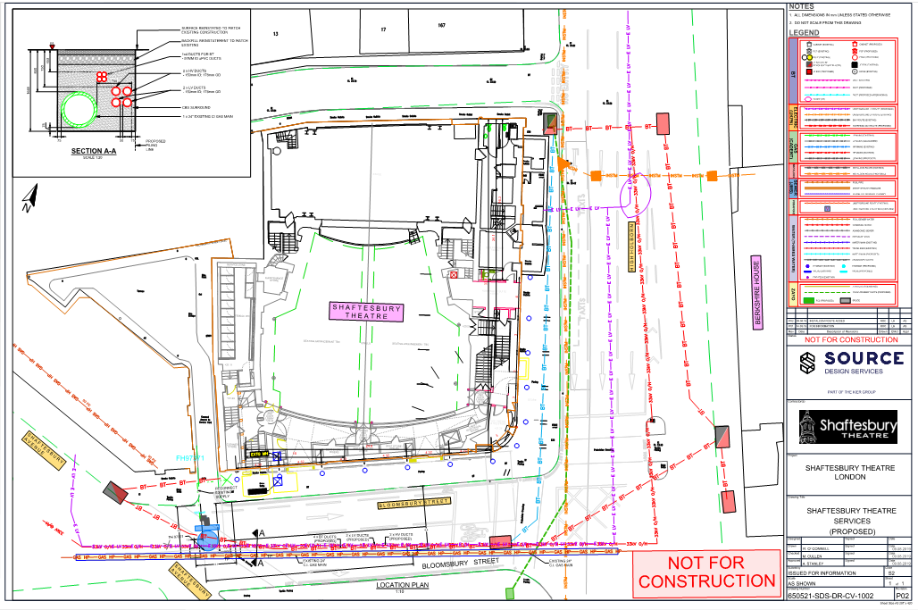
The following drawings shows two proposed sewer connections.
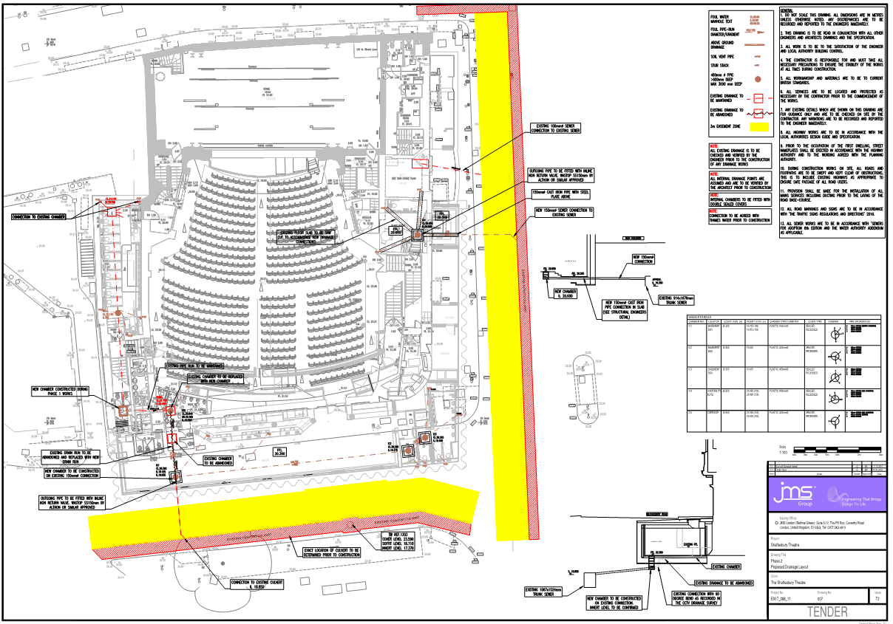
Environment
To answer these sections please refer to the relevant sections of Camden’s Minimum Requirements for Building Construction (CMRBC).
28. Please list all noisy operations and the construction method used, and provide details of the times that each of these are due to be carried out.
All noisy operations will be carried out during normal working hours, Monday – Friday 8.00am – 6.00pm, and Saturday 8.00am – 1.00pm.
Noisy operations will include:
- Stripping existing surfaces
The existing surface will be broken by a 13t excavator and loaded away by lorries.
- Pile probing and installation of sheet piles
Pile probing will be carried out by drilling a flight auger into the soil. Noise from this operation is not great and is generated only by the engine of the auguring rig.
The installation of the sheet piles will be carried out by TOSA silent piling rig to minimise noise.
- Removal of existing vaults
Some breaking may be required, although as the vaults are of brick construction their removal by a 13t excavator should be relatively quick and straightforward.
- Concrete works
Generally, the noisiest operation for concrete works is the use of the vibrating poker to consolidate the concrete. The poker is used for short periods and only on days when concrete is placed.
29. Please confirm when the most recent noise survey was carried out (before any works were carried out) and provide a copy. If a noise survey has not taken place please indicate the date (before any works are being carried out) that the noise survey will be taking place, and agree to provide a copy.
A background noise survey was carried out in January 2020 before any of the works have taken place. The results of this survey are available upon request.
30. Please provide predictions for noise and vibration levels throughout the proposed works.
Noise and vibration levels will be kept as low as possible to get work for the project done. This will be by using best practical means such as acoustic hoarding and silent piling.
The vibration trigger level will be set at 10mm/s.
31. Please provide details describing mitigation measures to be incorporated during the construction/demolition works to prevent noise and vibration disturbances from the activities on the site, including the actions to be taken in cases where these exceed the predicted levels.
Best practical means will be used in all activities on site; however, the following are some
mitigating measures that will be used:
- Regular communication with the local receptors to the site will be had if there are going to be any activities that may be high in noise/vibrations. Site team contact information will be on the hoarding of the project to ensure that any complaints can be received and dealt with quickly to prevent long disruptions to those near the site.
- When not being used, all machinery will be switched off to prevent unneeded noise or vibrations.
- As agreed with the Camden Environmental Health Officer, a vibration monitor will be set up for the duration of the project to ensure that accurate readings can be taken and monitored. If exceedances were to occur, the method of work taking place would be reviewed and changed where necessary.
- Ad-hoc noise monitoring will be done to ensure that noise is kept to a reasonable level.
- Hydraulic breaking methods will be preferred over traditional impact methods.
- A silent piling rig will be used to minimise noise levels.
- Areas where noise is expected will have acoustic hoarding set up as an effort to lower the level of noise heard outside of the site.
- No audio equipment will be allowed on site e.g. radios.
- All operatives are briefed during induction, TBTs and method statements on the importance of reducing noise and vibrations.
- The right equipment will be selected for the works. We will ensure machinery is running on optimum level and are well maintained.

32. Please provide evidence that staff have been trained on BS 5228:2009
Staff on site will be trained on BS 5228:2009 for noise and vibrations best practice with training logs retained for record.
33. Please provide details on how dust nuisance arising from dusty activities, on site, will be prevented.
Best practical means will be used throughout the project to ensure that dust does not
become a nuisance to those that are around the site.
- Dust suppression via the use of water dampening and extracts on tools will be used on activities where possible – this greatly reduces the dust kicked up into the air.
- Where cutting of materials is unavoidable on site, only equipment fitted with appropriate dust suppression tools will be used, such as water sprays or local extraction.
- Any vehicle transporting lose or dusty materials will always have sheets covering them when moving.
- Access and egress points shall be maintained to ensure dust and mud mobilisation is minimised with regular site surveillances carried out to ensure compliance.
- Use of design/prefabrication to reduce the need for grinding, sawing and cutting on site wherever reasonably practicable.

34. Please provide details describing how any significant amounts of dirt or dust that may be spread onto the public highway will be prevented and/or cleaned.

Wheel wash station is set up at the entrance to the site, this will only be used if there are significant amounts of mud or dirt on equipment leaving the site. This is to stop mud and muck from the site entering the main roads surrounding the site.
At the end of each day there will be a sweep at the entrance and outside of the project to ensure that the surrounding area is kept clear from site mess – this will be recorded each day with an operative’s signature confirming that it has been done.
There will be regular recorded surveillances completed to ensure that the site remains clean and doesn’t see mess leave the site boundaries.

35. Please provide details describing arrangements for monitoring of noise, vibration and dust levels.

A vibration monitor will be installed to monitor effect of the site works on adjacent properties; trigger levels as explained in points above will be adhered to.
There are no out of hours work scheduled – it has been agreed with the Environmental Health Officer that ad-hoc noise monitoring will be done to ensure that noise is kept to a reasonable level. In case of noise-related complaints the method of work should be reviewed to see if there is a quieter solution.
Following the risk assessment procedure in the guidance provided by the EHO and the AQ Officer, it was determined and agreed that the magnitude of dust, and therefore impact, from activities would be low. As such no permanent dust monitoring is required.

36. Please confirm that a Risk Assessment has been undertaken at planning application stage in line with the GLA policy. The Control of Dust and Emissions During Demolition and Construction 2104 (SPG), that the risk level that has been identified, and that the appropriate measures within the GLA mitigation measures checklist have been applied. Please attach the risk assessment and mitigation checklist as an appendix.

Looking at the proximity of the local receptors around the project, the impact on ecology and the impact on human health, and in accordance with The Control of Dust and Emissions During Demolition and Construction 2014, the site is classed as of SMALL dust potential magnitude due to the type of works being carried out.
With the risk assessment undertaken and with the use of mitigation’s measures listed within question 33 the impact of dust from the site is identified as low.

37. Please confirm that all of the GLA’s ‘highly recommended’ measures from the SPG document relative to the level of risk identified in question 36 have been addressed by completing the GLA mitigation measures checklist.

Measures from the SPG document have been looked at and considered for this project. As stated in previous questions areas such as stakeholder engagement, plant on site, off site cutting, site lay out and more have all been considered and ways to minimise dust will be used where possible.

38. If the site is a ‘High Risk Site’, 4 real time dust monitors will be required. If the site is a ‘Medium Risk Site’, 2 real time dust monitors will be required. The risk assessment must take account of proximity to sensitive receptors (e.g. schools, care homes etc), as detailed in the SPG. Please confirm the location, number and specification of the monitors in line with the SPG and confirm that these will be installed 3 months prior to the commencement of works, and that real time data and quarterly reports will be provided to the Council detailing any exceedances of the threshold and measures that were implemented to address these.
As the site is thought to be low risk, it has been agreed with the Environmental Health Officer and the Air Quality officer that there is not a need for a permanent dust monitor. Works taking place will have constant supervision to ensure that best practical means are being used to ensure that dust is being kept at a minimum. Regular visual inspections will be carried out to ensure compliance.
39. Please provide details about how rodents, including rats, will be prevented from spreading out from the site. You are required to provide information about site inspections carried out and present copies of receipts (if work undertaken).

Good housekeeping will ensure that rodents are not in the site and spreading out. This will include keeping bins and waste areas neat and tidy. Canteen waste and other general office waste will need to be removed at the end of each day before the site is shut down. The project is mainly going to have works taking place outside, good housekeeping regime and regular visual inspections will be introduced to prevent rodent infestation. If rodents are found on site, the Camden Pest Control will be contacted on how to best deal with the situation.

40. Please confirm when an asbestos survey was carried out at the site and include the key findings.
An asbestos survey was carried out in 2019, all known asbestos was removed from the building.

41. Complaints often arise from the conduct of builders in an area. Please confirm steps being taken to minimise this e.g. provision of a suitable smoking area, tackling bad language and unnecessary shouting.

Conduct and consideration to the public is covered in our site inductions and unacceptable behaviour is not tolerated by Sir Robert McAlpine. We shall provide a smoking area within the site demise.

42. If you will be using non-road mobile machinery (NRMM) on site with net power between 37kW and 560kW it will be required to meet the standards set out below. The standards are applicable to both variable and constant speed engines and apply for both PM and NOx emissions.
From 1st September 2015

(i) Major Development Sites – NRMM used on the site of any major development will be required to meet Stage IIIA of EU Directive 97/68/EC

(ii) Any development site within the Central Activity Zone - NRMM used on any site within the Central Activity Zone will be required to meet Stage IIIB of EU Directive 97/68/EC

From 1st September 2020

(iii) Any development site - NRMM used on any site within Greater London will be required to meet Stage IIIB of EU Directive 97/68/EC

(iv) Any development site within the Central Activity Zone - NRMM used on any site within the Central Activity Zone will be required to meet Stage IV of EU Directive 97/68/EC

Please provide evidence demonstrating the above requirements will be met by answering the following questions:
- Construction time period: (08/20 - 09/21)

- Is the development within the CAZ? (Y/N): Y

- Will the NRMM with net power between 37kW and 560kW meet the standards outlined above? (Y/N): Y

- Please provide evidence to demonstrate that all relevant machinery will be registered on the NRMM Register, including the site name under which it has been registered:
The site will be registered on the NRMM London Website under the name Shaftesbury Theatre Phase 2 – This will be set up before any machinery comes to the site.

- Please confirm that an inventory of all NRMM will be kept on site and that all machinery will be regularly serviced and service logs kept on site for inspection:
A document will be used to store this information, and this will be kept in the project folder on site and on the project drive.

- Please confirm that records will be kept on site which details proof of emission limits, including legible photographs of individual engine plates for all equipment, and that this documentation will be made available to local authority officers as required:
All required photos of proof such as engine plates, plant ID numbers etc will be kept in an individual folder on site and will also be on the project drive.

SYMBOL IS FOR INTERNAL USE

Agreement
The agreed contents of this Construction Management Plan must be complied with unless otherwise agreed in writing by the Council. This may require the CMP to be revised by the Developer and reapproved by the Council. The project manager shall work with the Council to review this Construction Management Plan if problems arise in relation to the construction of the development. Any future revised plan must be approved by the Council in writing and complied with thereafter.
It should be noted that any agreed Construction Management Plan does not prejudice further agreements that may be required such as road closures or hoarding licences.

Signed: …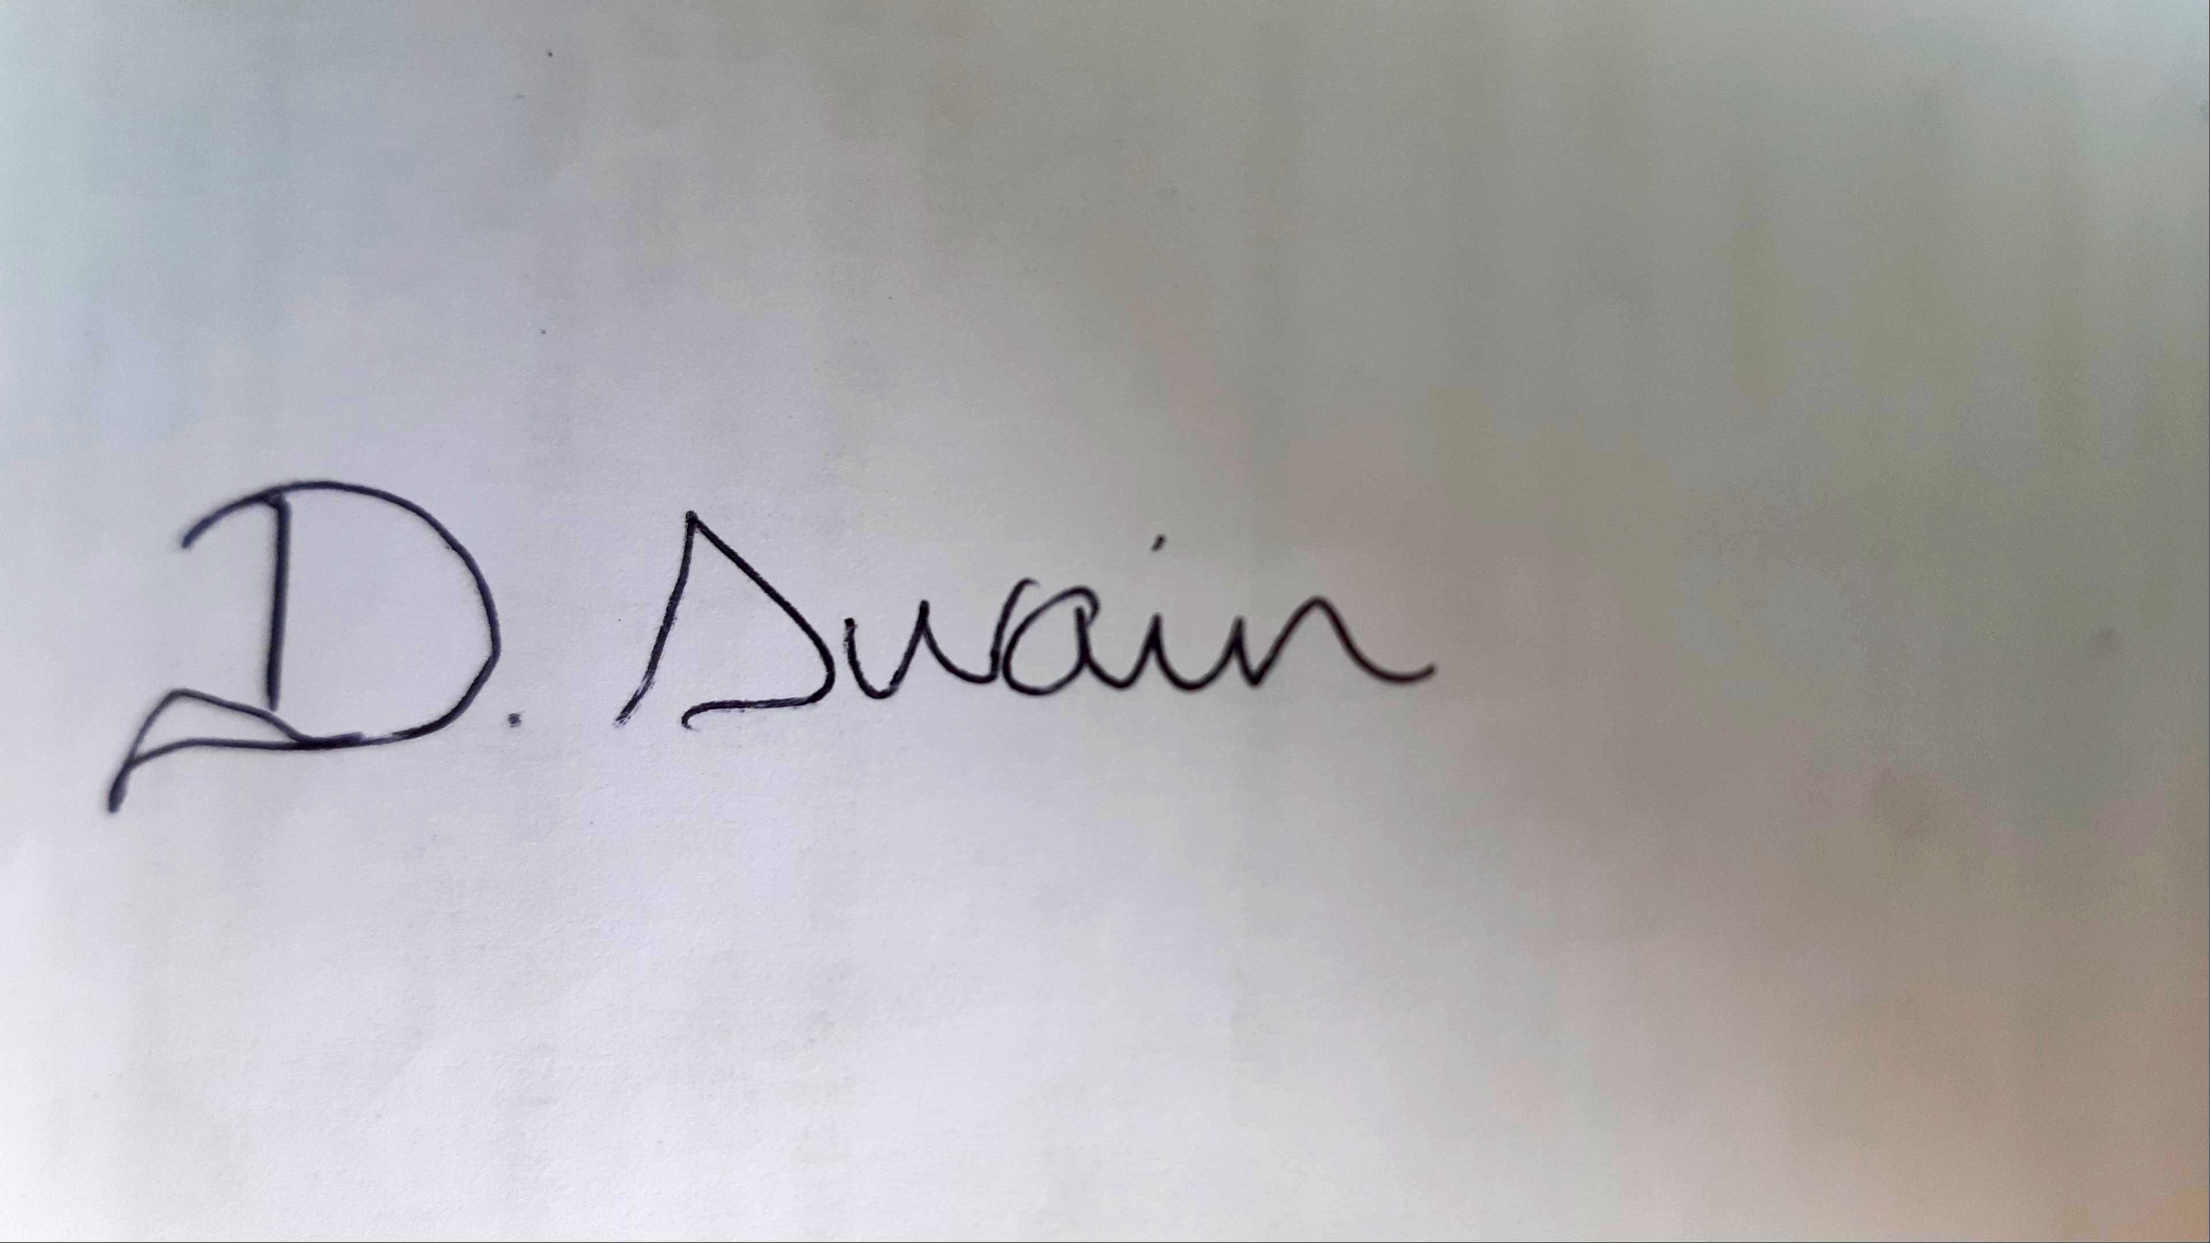………

Date: …………21st July 2020…………

Print Name: ………Denny Swain………………….….

Position: ……Project Manager Sir Robert McAlpine Ltd……

Please submit to: planningobligations@camden.gov.uk

End of form.

