**51 Lancaster Grove, London NW3 4HB**

**Planning Permission to Fell Common Lime Tree**

We have one common lime tree in our front drive which is situated against our front boundary wall. The tree has outgrown the limited space it has between our bounday wall, bike shed and water feature. See photos 1 and 2.

The growth of the tree has caused our boundary wall to crack right through the wall and along the whole height of the wall in two places – see photos 3, 4, 5 and 6.

There is a risk that the boundary wall may collapse onto the pavement due to the continued growth of the tree as the only way the tree can continue to grow will cause it to push further against the wall. The wall has already had to be built around the tree (see photos 7 and 8). The pavement is in frequent use, especially during term time with young children walking to school.

There is not sufficient space for such a large tree in the small bed between our stone water feature and boundary wall.

We have been advised by our tree surgeon that the tree ought to be felled to the ground to avoid further damage to the wall and risk of the wall falling on to passers-by. It is also undermining our bike shed and water feature. The flower bed was not designed to accommodate a tree as large as it has become.

We therefore request permission to fell the tree.

Below is a drawing showing the position of the tree in our front drive.



**PHOTOS**

Photos 1 and 2 show the tree in the front bed between the boundary wall, bike shed (behind the ivy) and stone water feature. There is very limited space for the tree to grow because the trunk is already pushing against the front wall and is very close to the stone water feature.

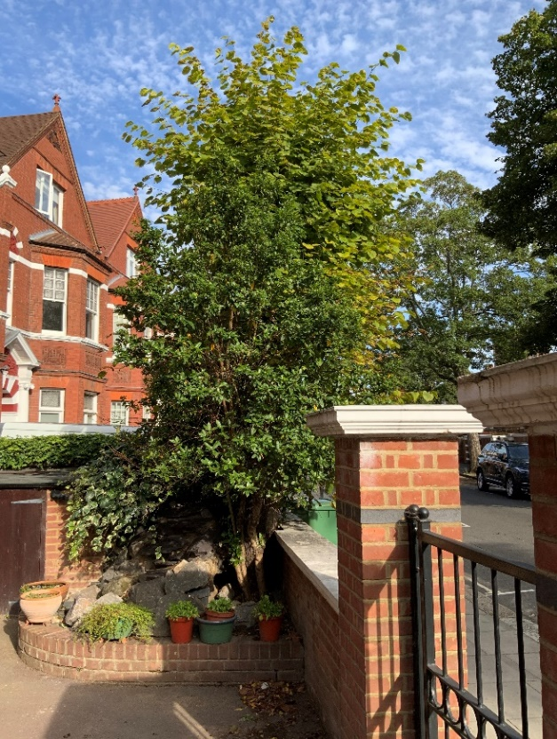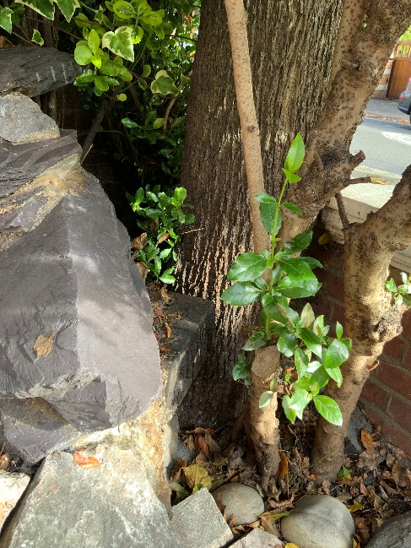

Photos 3, 4, 5 and 6 show the cracks in boundary wall which now go all the way through the wall from front to back and from top to bottom.

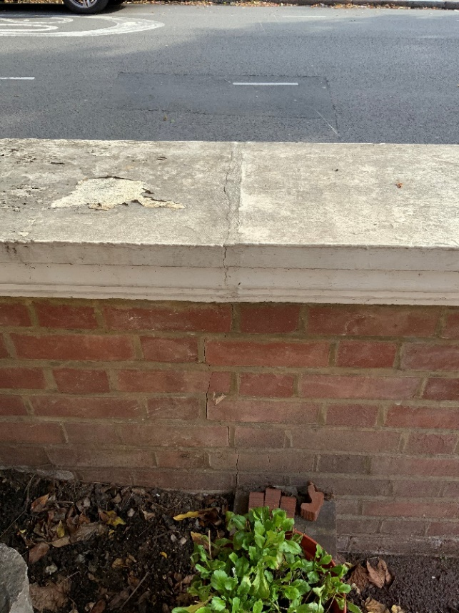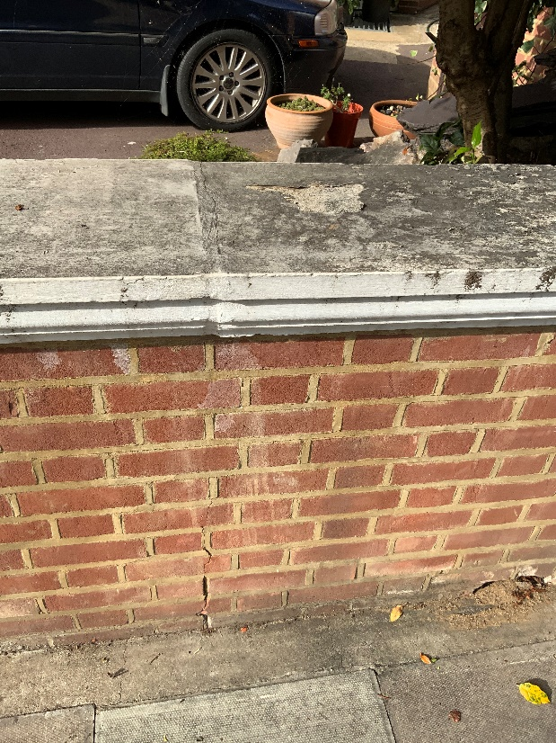

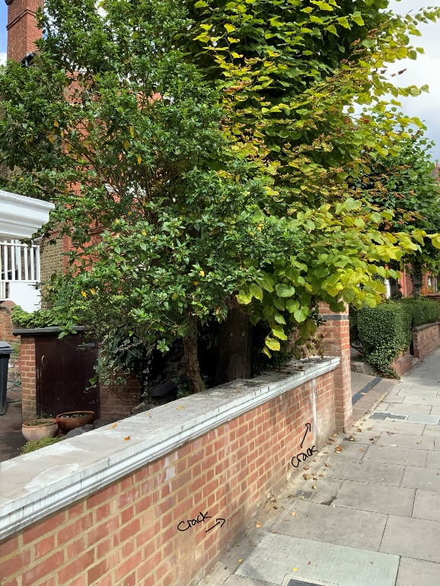

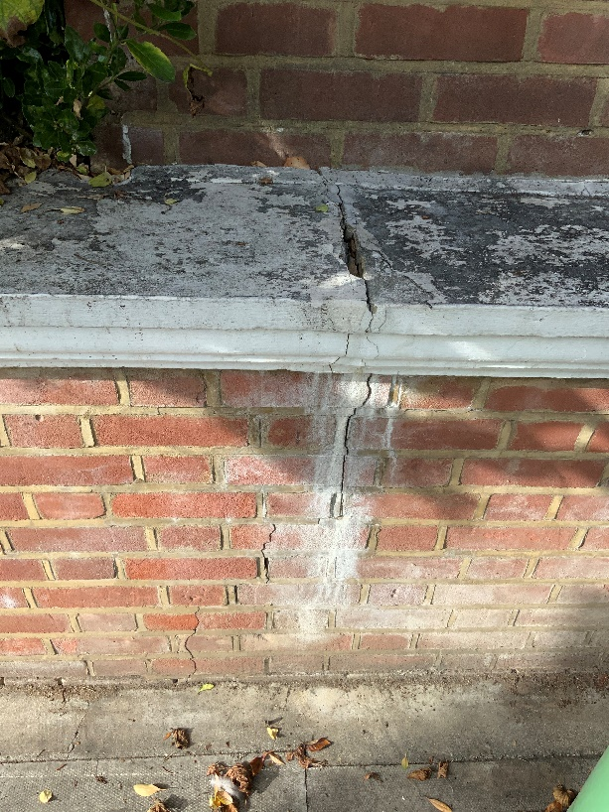

Photos 7 and 8 show the wall built around the tree. There is no further room for the tree to grow because the tree trunk is already pushing against the wall on the left hand side.

