**Lead Local Flood Authority comments**

|  |  |
| --- | --- |
| Scheme Address | 69 Avenue Road |
| Planning Reference | 2020/2330/P |
| Date | 12/8/20 |



The site is on a previously flooded street (2002 major flood incident) and therefore is designated locally as an area of higher flood risk under the Local Plan (policy CC3). See extract below from Camden’s Strategic Flood Risk Assessment.

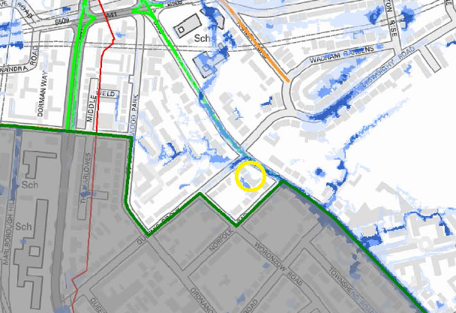 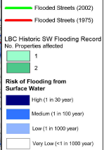

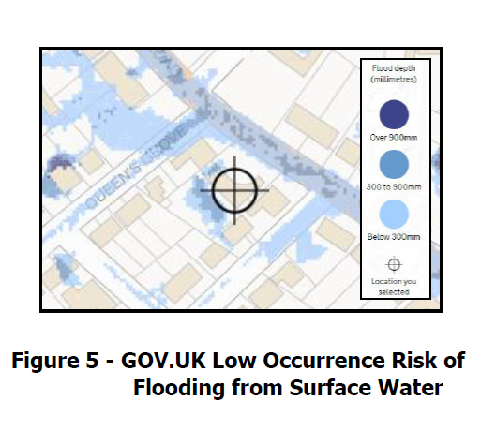

Figure 5 from the report gives an approximate indication of the modelled extents and locations of surface water flooding at or around the site.

In addition section 5.22 of the Surface Water Flow and Flood Risk Assessment identifies that the site as being located within close proximity to the original route of a tributary of the River Tyburn and that overland flow may still be following the original course. Overland flow is shown to drain along Avenue Road.

Local Plan policy CC3 requires developments to reduce their water consumption, reduce pressure on the combined sewer network and mitigate the risk of flooding as per following extracts for areas of elevated flood risk:

* + Developments must be designed to be water efficient. This can be achieved through the installation of water efficient fittings and appliances (which can help reduce energy consumption as well as water consumption) and by capturing and re-using rain water and grey water on-site. Residential developments will be expected to meet the requirement of 110 litres per person per day (including 5 litres for external water use)
  + A Flood Risk Assessment should identify how a development will be designed to cope with flooding and how the risk will be mitigated without increasing the risk elsewhere. Recommendations in the FRA will be secured by planning condition.
  + Development located within areas at risk of flooding should not place additional pressure on the existing drainage infrastructure.
  + The Council will require developments to utilise Sustainable Drainage Systems (SuDS), to achieve greenfield run-off rates, unless demonstrated that this is not Feasible. Surface water should be managed as close to its source as possible, in line with the drainage hierarchy in the London Plan.
  + Development should also demonstrate how it will mitigate the potential flooding of other properties. When determining the suitability of SuDS, vulnerability and the importance of local ecological resources, such as water quality and biodiversity should be considered
  + A drainage report should be submitted with all major applications, basement developments and other vulnerable development in areas identified at risk of flooding. This should include:
    - identification of flood risk;
    - assessment of existing run-off rates;
    - calculation of greenfield run-off rates;
    - identification of measures, in line with the drainage hierarchy, to reduce runoff
    - rates; and
    - calculation of proposed run-off rates.
  + The Council will not permit basement schemes which include habitable rooms and other sensitive uses for self-contained basement flats and other underground structures in areas prone to flooding (“Policy A5 Basements”).

The following comments and required actions are noted:

|  |  |  |
| --- | --- | --- |
| ***Policy requirement*** | ***Comments*** | ***Actions required*** |
| Water efficiency | Energy and Sustainability Statement Page 19 states the development aim to reduce water consumption to below 105 litres per person per day. | To be secured through s106 |
| FRA | A FRA is submitted.  The FRA section 5.3 notes that “Avenue Road is recorded of being flooded in the 2002 event. There is no record of the site being affected by this flooding event.”  Proposed mitigation includes the following:   * the basement extension includes an appropriate tanked system or equivalent to prevent groundwater ingress into the basement. * Finished Floor Levels being set above the design flood water level. (150mm above the surrounding ground levels – 5.32). With the mitigation measure of retaining walls for the proposed lightwell in place. * It is recommended that non-return   valves or a positive pumped system are implemented within the proposed basement to reduce the risk of sewers surcharging into the property. (5.31)   * Levels on the site are higher than Avenue Road carriageway (5.31) * Proposed to implement a green roof with 10-15cm subbase which is underlain with a blue roof. | The road was previously flooded (2002) and therefore is considered locally designated as an area of higher flood risk.  In addition the site is in close proximity to the original route of a tributary of the River Tyburn and overland flow may still be following the original course.  See “No habitable basements” below |
| No extra pressure on sewers | 5.30 Flows off the site without any mitigation will increase post development (ignoring climate change), as there is an increase in hard standing on the site. The site will be implementing mitigation measures to reduce surface water flows off the site post development. These mitigation measures should not change the risk of flooding from sewers. | Further details required. |
| SuDS and drainage hierarchy | Green –blue roof proposed roof to ensure a 50% decrease in surface water runoff rates. | Blue-green combination roof is encouraged. Details required. |
| Drainage report | 5.65 The detailed surface water system should be designed in accordance with local planning policy and will be designed such that runoff from the 1% AEP rainfall event plus climate change allowance is fully retained on the site and discharged at the controlled rate. Full drainage design will be undertaken at the detailed design stage | Drainage should include climate change +40% and include a maintenance plan. |
| No habitable basements | Basement includes habitable rooms and sensitive uses such as plant rooms. | The Local Plan is clear in policy A5 that the Council will not permit basement schemes which include habitable room and other sensitive uses in areas prone to flooding.  The plans propose a number of habitable rooms and also plant rooms which could create risks to health and safety if flooded.  Proposed use of the basement should not include habitable rooms or sensitive uses. If the proposals are not amended then refusal is recommended. |

***Further action for applicant:*** Please see list above.

The proposal is in an area considered locally designated as an area of higher flood risk and therefore the basement should not include habitable rooms or other sensitive uses (such as plant rooms) and refusal is recommended if this is not amended. In addition the drainage plan does not account for climate change and does not set out the required storage volumes.

**Recommendation:** **Further information required. Refusal recommended** if the basement includes habitable rooms and sensitive uses.