Hi all,

As discussed on the call today, I will proceed with giving Next and ISD the go ahead to install the external cameras on Elephant house.

As per the below snipping.

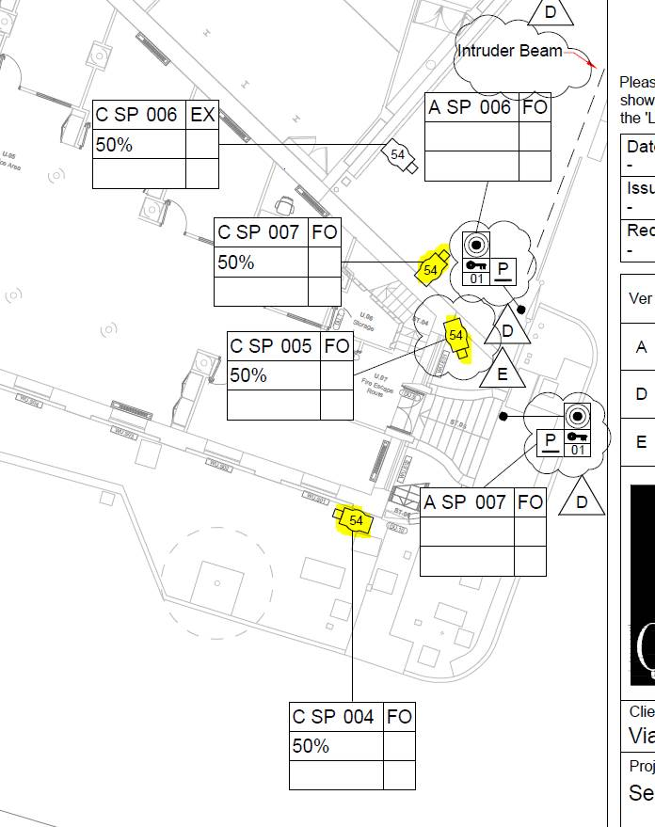

Kind regards,