
Deliveroo Editions Swiss Cottage – Site Monitoring Proforma
Form 1: Monitoring the implementation of the Operational Management Plan (OMP) on-site
Date: 19th June 2020
Time: 7.00 – 9.00pm
Names: Rebecca Stevenson

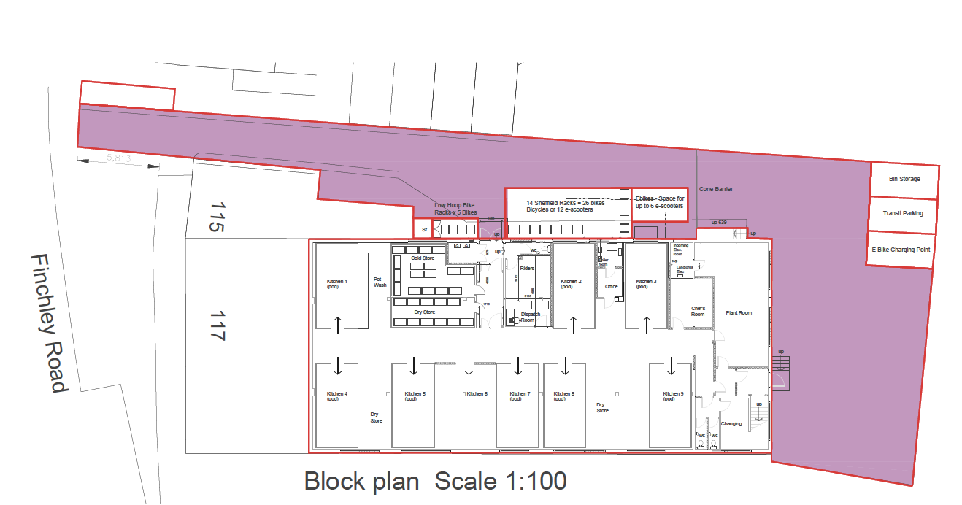Location Plan
Supplier Delivery Parking
Refuse Storage
Traffic Cones
Survey location

 | DELIVEROO RIDER DELIVERIES
1. | Number of riders entering the site (tally) | Total:
2. | Were all riders on e-scooters/bikes or bicycles? | Yes ☒ No ☐
 | If no, please state:
 | How many were not on an e-scooter/bike or bicycle: | 80/20 in favour of cycles
 | What vehicle they were on: | Predominantly bicycles
3. | Were there any incidents of conflicts, such as near collisions, with pedestrians when riders entered/exited the site? | Yes ☐ No ☒
 | Please provide full details if so:
 | a)
 | Time of the incident:
 | Location of the incident:
 | Details of what happened:
 | Details of any action taken on site:
 | Any other comments:
 | b)
 | Time of the incident:
 | Location of the incident:
 | Details of what happened:
 | Details of any action taken on site:
 | Any other comments:
 | c)
 | Time of the incident:
 | Location of the incident:
 | Details of what happened:
 | Details of any action taken on site:
 | Any other comments:
 | d)
 | Time of the incident:
 | Location of the incident:
 | Details of what happened:
 | Details of any action taken on site:
 | Any other comments:
 | e)
 | Time of the incident:
 | Location of the incident:
 | Details of what happened:
 | Details of any action taken on site:
 | Any other comments:
4. | Was sufficient parking available for all riders entering the site at all times? | Yes ☒ No ☐
 | If no, please provide details:
 | Time and duration that parking was not available:
 | The number of spaces short:
 | Whether any riders were prevented from entering the site by a Marshal when parking was at full capacity
 | Any other comments?
5. | Were riders waiting inside the building to collect their order at all times? | Yes ☐ No ☒
 | If no, please provide details Due to covid ridders are waiting quietly on foot on the slip road
 | Time and duration of incident:
 | Number of riders waiting outside:
 | Location of riders:
 | Any other comments:
6. | Were traffic cones in place to ensure riders do not pass the line indicated on the above plan? | Yes ☒ No ☐
7. | Did any riders park beyond the traffic cones when collecting an order? | Yes ☐ No ☒
 | If yes, please provide details:
 | Time of the incident:
 | How many riders:
 | Location where riders parked:
 | Any action taken by a Marshal:
 | Any other comments:
8. | Did all riders turn left onto Finchley Road when exiting the site? | Yes ☒ No ☐
 | If no, please provide details:
 | Time of the incident:
 | How many riders:
 | Any action taken by a Marshal:
 | Any other comments:
 | SUPPLIER DELIVERIES
1. | Number of supplier vehicles entering the site (tally) | Total:
2. | Were any supplier deliveries made outside of the hours of 8:00am to 4:00pm? | Yes ☐ No ☒ N/A ☐
 | If yes, please provide details:
 | Time of incident:
 | Any action taken by a Marshal:
 | Any other comments:
3. | Did all supplier vehicles access the site in forward gear? | Yes ☐ No ☐ N/A ☒
 | If no, please provide details:
 | Time of incident:
 | Any action taken by a Marshal:
 | Any other comments:
4. | Did all supplier vehicles park in the dedicated car parking space shown on the above plan? | Yes ☐ No ☐ N/A ☒
 | If no, please provide details:
 | Time of incident:
 | Location where vehicle parked:
 | Any action taken by a Marshal:
 | Any other comments:
5. | If there were more than two suppliers on site at one time, was the second instructed to wait at the rear of the building or in the dedicated  loading area on the Finchley Road? | Yes ☐ No ☐ N/A ☒
 | If no, please provide details:
 | Time of incident:
 | Any action taken by a Marshal:
 | Any other comments:
6. | Did all supplier vehicles leave the site in forward gear? | Yes ☐ No ☐ N/A ☒
 | If no, please provide details:
 | Time of incident:
 | Any action taken by a Marshal:
 | Any other comments:
 | MARSHALS
1. | Were two marshals in place at all times? | Yes ☒ No ☐
 | If no, please provide details
 | Time and duration of incident:
 | Any other comments:
2. | Did the Marshalls have clipboards at all times? | Yes ☒ No ☒
 | If no, please provide details: they are now using radios to report incidents to the manager
 | Time and duration of the incident:
 | Any other comments:
3. | Is the Marshal positioned at the entrance to the site carrying out the following at all times:-
(a) | Refusing access to riders accessing the Site from the stairs to the right of the access slope on Dobson Close and ensuring their order is re-assigned | yes
 | If no, please provide details:
 | Time of incident:
 | Any other comments:
(b) | Refusing access to riders who approach the Site in breach of the highway code and ensuring their order is re-assigned | N/A
 | If no, please provide details:
 | Time of incident:
 | Any other comments:
(c) | Ensuring that riders are directed to the parking area and not obstructing the pavement | Yes ☒ No ☐
 | If no, please provide details:
 | Time of incident:
 | Any other comments:
(d) | If applicable, ensuring that only those supplier vehicles that are no larger than 7.5t and 7.2m in length were permitted access to the site | Yes ☒ No ☐ N/A ☐
 | If no, please provide details:
 | Time of incident:
 | Any other comments:
4. | Is the marshal positioned at the parking area carrying out the following at all times:-
(a) | Assisting with rider parking | Yes ☒ No ☐
 | If no, please provide details:
 | Time of incident:
 | Any other comments:
(b) | Directing riders inside the building to wait to collect their order | Yes ☒ No ☐
 | If no, please provide details:
 | Time of incident:
 | Any other comments:
(c) | If applicable, assisting supplier deliveries to manoeuvre their vehicles | Yes ☒ No ☐ N/A ☐
 | If no, please provide details:
 | Time of incident:
 | Any other comments:
(d) | If applicable, asking delivery drivers to turn off their audible reversing alarm | Yes ☐ No ☐ N/A ☒
 | If no, please provide details:
 | Time of incident:
 | Any other comments:
 | REFUSE STORAGE
1. | Are the refuse bins stored in the car park space shown on the above plan? | Yes ☒ No ☐
 | NOISE MITIGATION
1. | Are the signs in place at the entrance to the site reminding patrons to keep noise to a minimum? | Yes ☒ No ☐
2. | Were there any incidents of raised voices from riders / kitchen staff? | Yes ☐ No ☒
 | If yes, please provide details
 | Time and duration of the incident:
 | Description of the incident:
 | Any action taken:
 | Any other comments:

Additional pages
3.
Time of the incident:
Location of the incident:

Details of what happened:

Details of any action taken on site:

Any other comments:

Time of the incident:

Location of the incident:

Details of what happened:

Details of any action taken on site:

Any other comments:

Time of the incident:

Location of the incident:

Details of what happened:

Details of any action taken on site:

Any other comments:

Time of the incident:

Location of the incident:

Details of what happened:

Details of any action taken on site:

Any other comments:

Time of the incident:

Location of the incident:

Details of what happened:

Details of any action taken on site:

Any other comments:

