

The Society examines all Planning Applications relating to Hampstead and Hampstead Heath Fringes, and assesses them for their impact on conservation and on the local environment.

# To London Borough of Camden, Development Control Team

**Planning Ref:** 2019/5835/P

**Address:** 4B Hampstead Hill Gardens London NW3 2PL

**Case Officer:** Rachel English **Date**: 4.8.2020.

We have previously sent an objection to the above proposed new house.

The following contains additional objections based on the subsequent amendments and assessments made by the applicant and the objectors.

We have major concerns about this planning application and its impact on neighbouring properties.

Calculating the slope angle from contour lines on the 1:5000 OS map the planned basement is proposed to be dug on a hill side with a general slope of 7° rising to a short steeper slope of more than 8° east-west to its immediate north. While the ground surface flattens out a little across the site, insufficient boreholes have been undertaken to triangulate the slope angle of the underlying clay, which is the relevant slope here and possibly steeper. The superficial layer named 'Made Ground' is actually the solifluction Head laid down at the end of the last Ice Age and now with some brick fragments within it. It has an even higher tendency to landslide as well as raised permeability to groundwater. **( Ellison, 2004 -** **see below).**

Consequently this address appears on the crimson line denoting high and very high potential landslide activity on the BGS map Areas of Slope Instability (see below). Yet the Campbell Reith BIA Audit states: "It is accepted that there are no slope stability concerns regarding the proposed development."

This is a basic factor that should have been taken very seriously in the BIA and the BIA Audit, especially in view of the potential for aggravating differential subsidence with the attached neighbour 4A. The proposed work would add to landslip risk, and by blocking and constraining the groundwater flowing eastwards from the spring line along this transition zone between the Claygate Beds and unit D of the London Clay Formation, much of it within the superficial Head, this adds increased pore water pressure and silt erosion to the risk of landslide. **See RA Ellison (2004) ‘Geology of London' (below).**

We suspect these potential changes in ground stability renders the tests used to calculate potential vertical movement and horizontal strain invalid as their calculations require stable ground conditions. The boreholes themselves were undertaken on behalf of the Loss Adjustor Claim firm Crawfords on a dry day. They appear to consider the whole of London to be on London Clay and in our experience accept inappropriate sampling methods and ignore or are unable to understand the relevance of what is found.

Considering the large number of cases of subsidence and landslide in the immediate area of Hampstead Hill Gardens and Pond Street, not to mention Downshire Hill, Keats Grove and Heath Hurst Road, we believe that undertaking this basement dig without adequate analysis and with this particular design for a semi-detached property is folly.

**Please refuse on the basis of inadequacies of the BIA and the BIA audit and risk to surrounding buildings**

Further maps & information on next page**.**

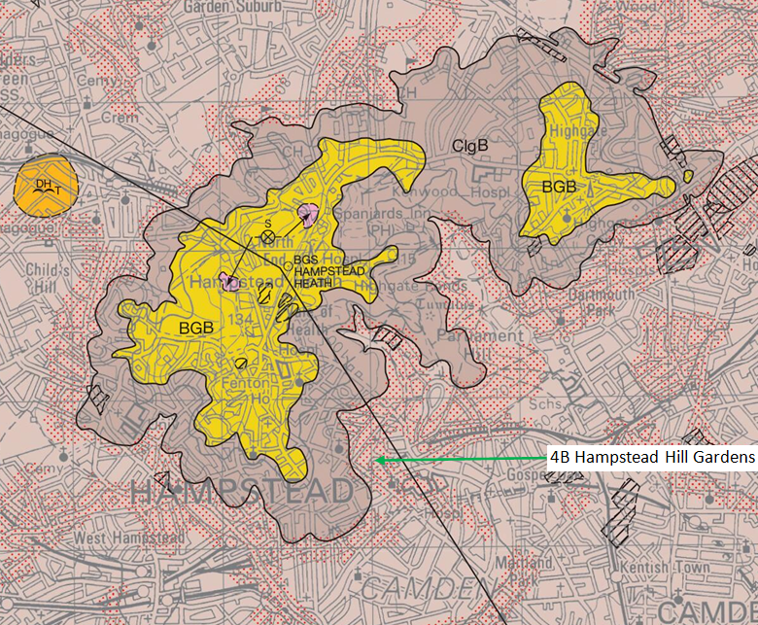

**British Geological Survey 1 : 50 000 series North London Sheet 256 Bedrock and Superficial Deposits**

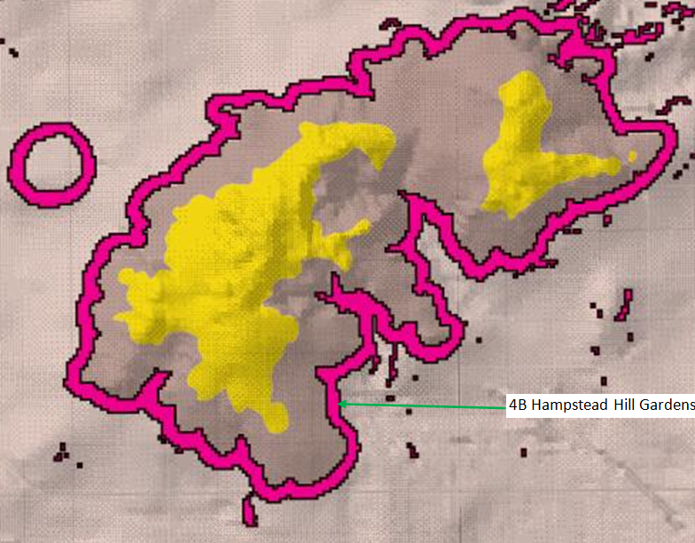

**British Geological Survey Areas for Greatest Potential for Slope Instability**

http://www.largeimages.bgs.ac.uk/iip/mapsportal.html?id=1001750

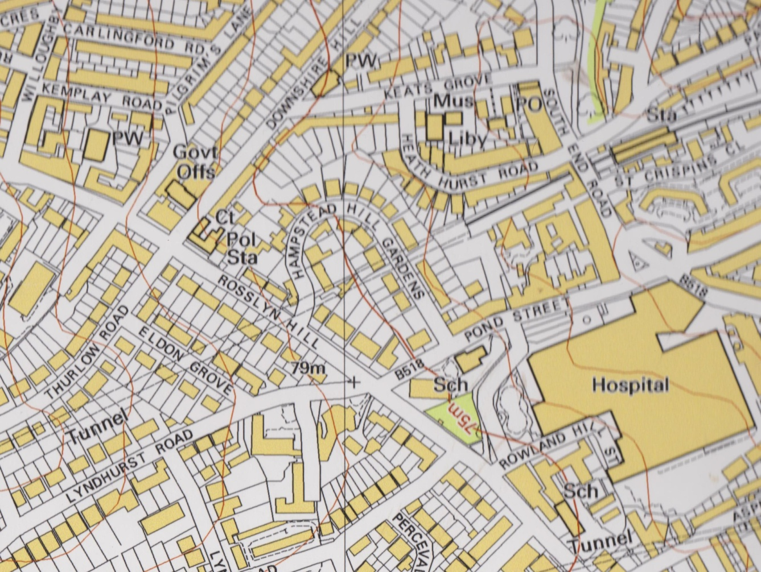

**from 1:5000 OS map**

**Extracts From: RA Ellison (2004) ‘Geology of London: Special Memoir for 1:50 000 Geological sheets 256 (North London)’ British Geological Survey, Keyworth, Nottingham:**

**Page 98:** ... Landslides on London Clay slopes are well known, and have been the subject of much research.... Hutchinson (1967) concluded that an angle of 8° was the ultimate angle of stability. The Claygate Member... is more susceptible to slope instability than the bulk of the London Clay. It has high plasticity and high moisture content on account of water-bearing sand layers. ...

Many London Clay slopes greater than 3° are covered with a veneer of Head, which may not be shown on geological maps. Culshaw and Crummy (1991) suggested that these too should be considered as potentially unstable. The head is composed of redeposited London Clay, including the Claygate Member; it is derived by downslope solifluction and soil creep and may contain relict shear surfaces. The shear strength is likely to be at, or close to, its residual value. Reactivation of the shear surfaces may occur if the slopes are undercut, loaded, saturated or the water table rises.