Objection to Deliveroo’s application

**Appendix A**

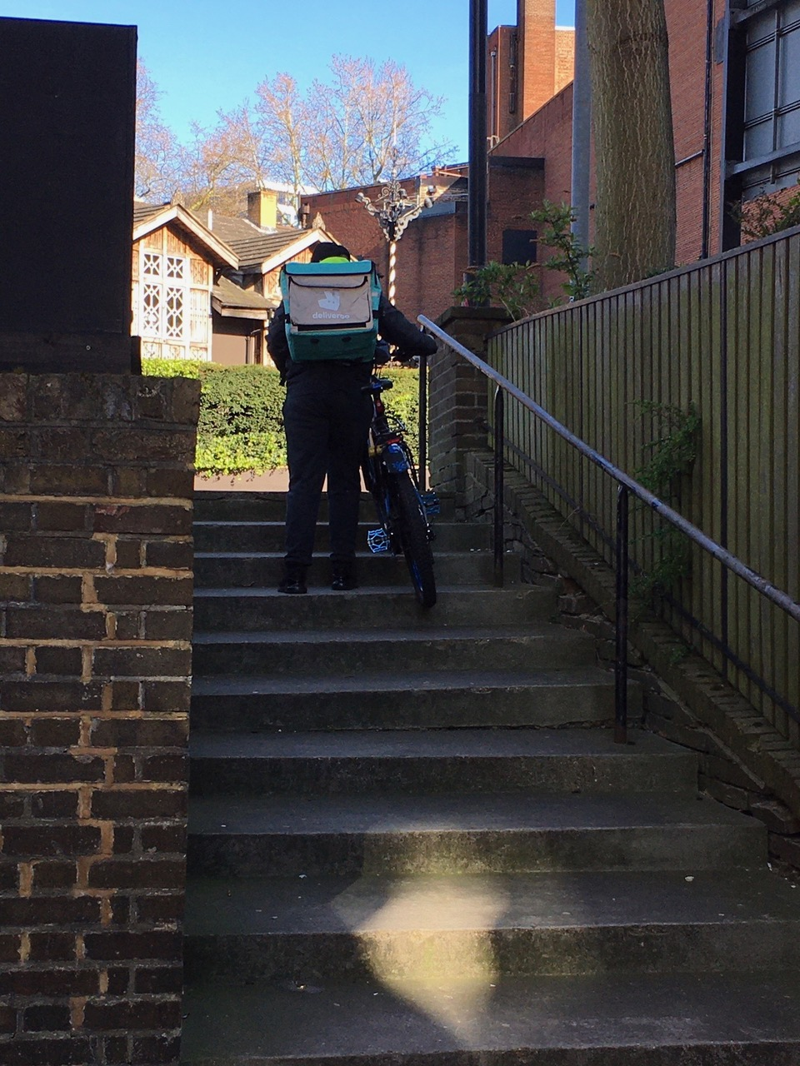

Saturday 4 April 2020 at 4:33pm

**Appendix B**

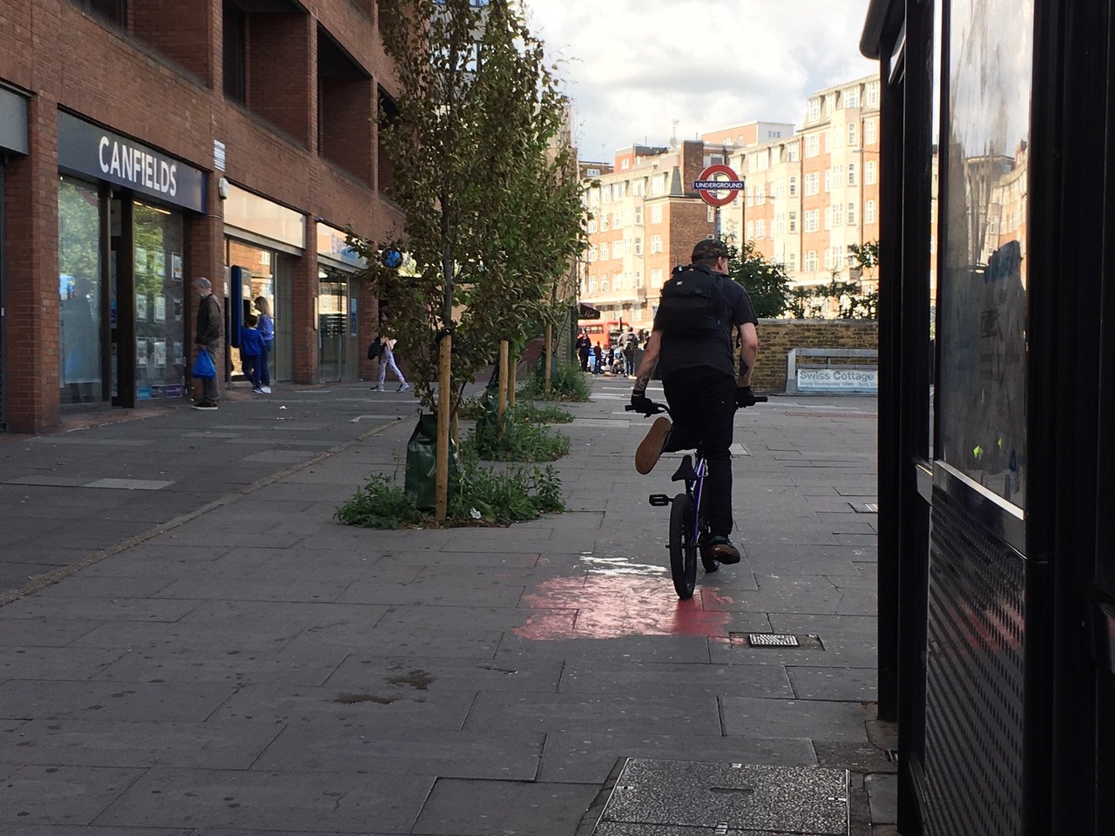

Thursday 2 July 2020 at 4:17pm

**Appendix C**



Deliveroo rider cutting across the A41 - Thursday 25 June 2020 at 4:30pm

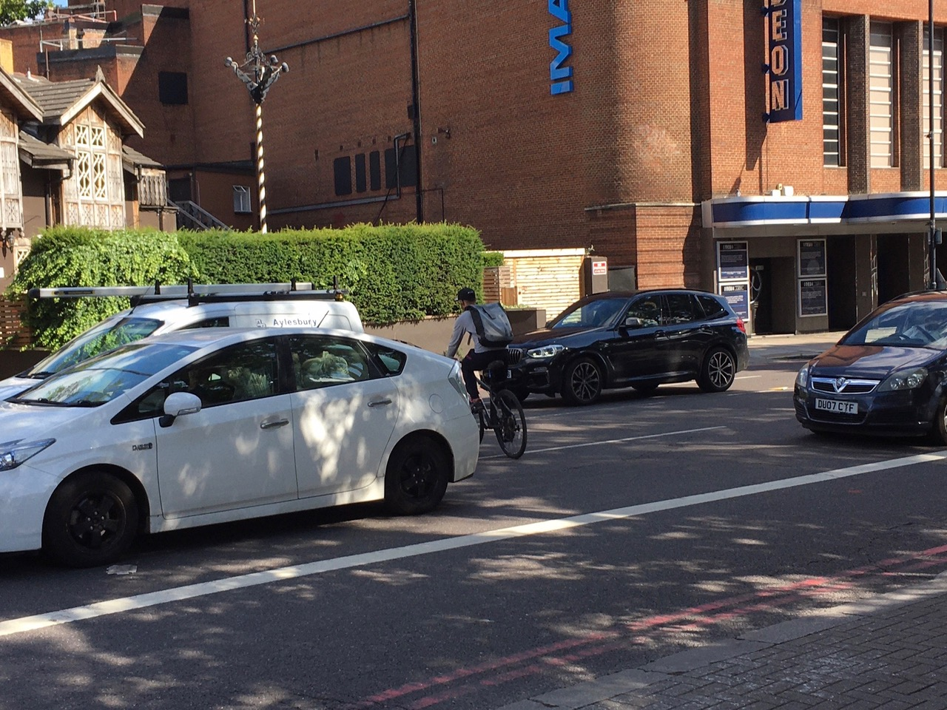

Deliveroo rider cutting across the A41 after leaving the slip road, causing one of the drivers to honk the horn - Tuesday 21 July 2020 at 4:11pm

**Appendix D**

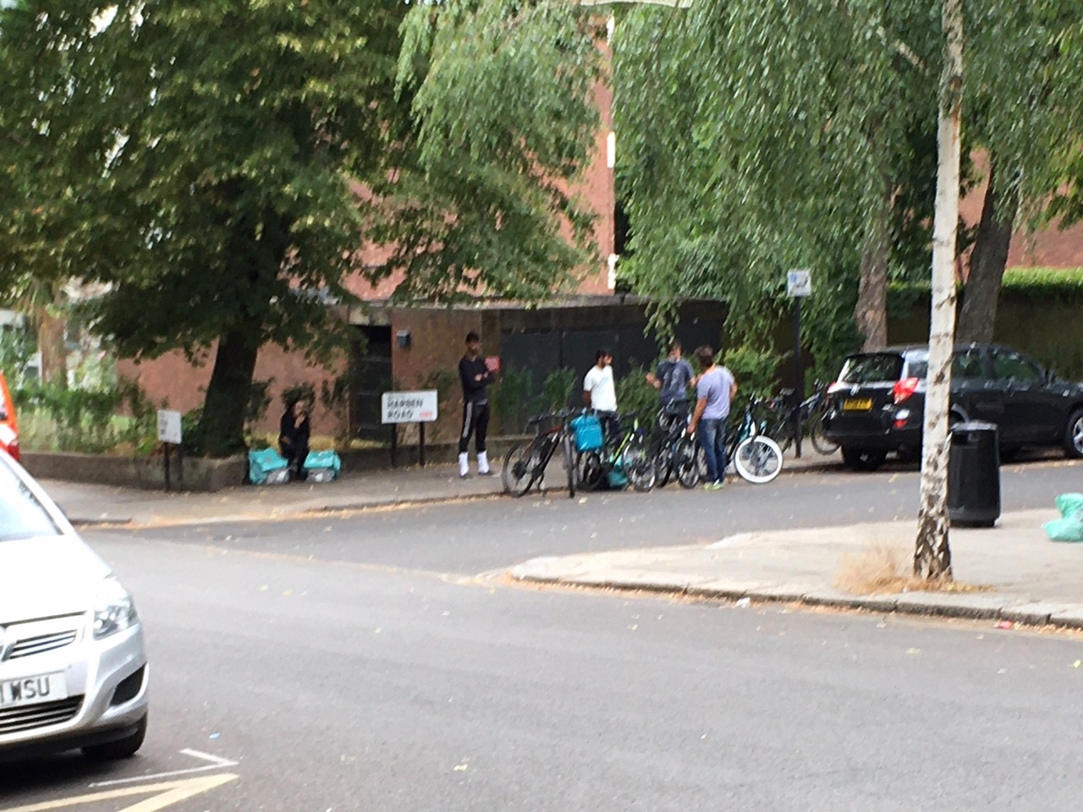

Deliveroo riders congregating on Harben Road, some not observing the social distancing rules - Friday 24 July 2020 at 2:42pm

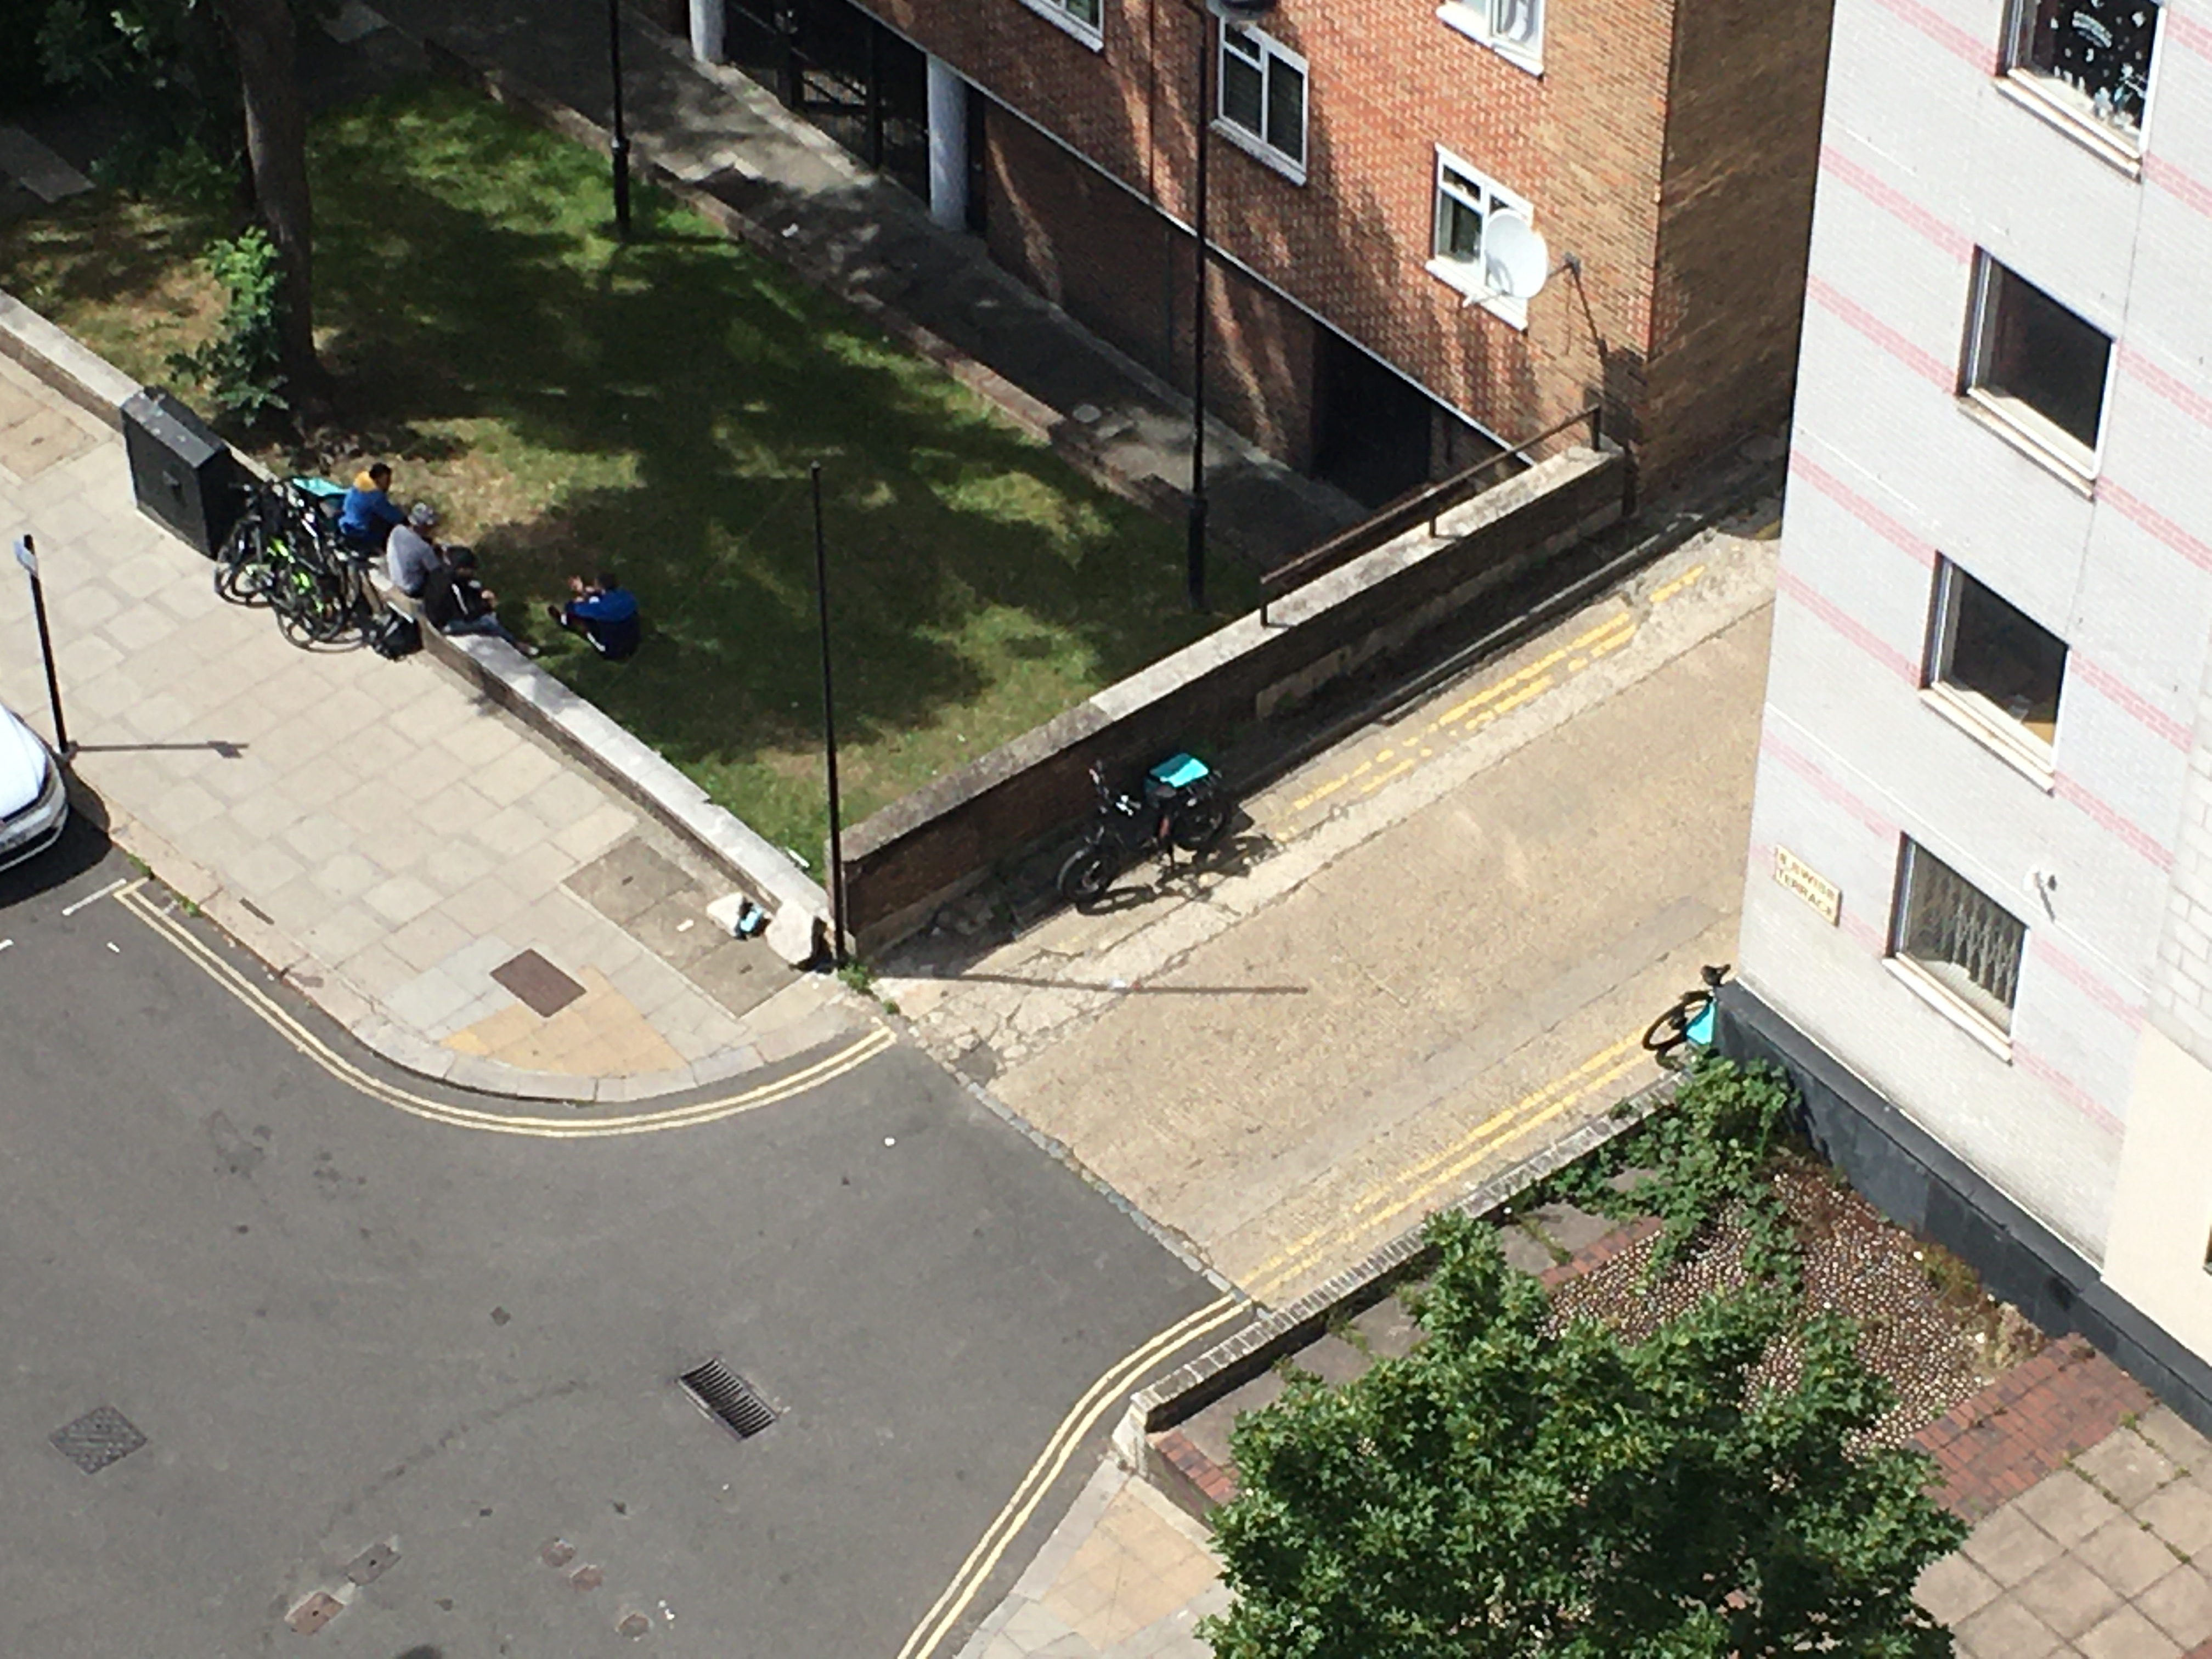

Deliveroo riders on Belsize Road, outside exit 5 of Swiss Cottage station – Wednesday 29 July 2020 at 2:22pm (taken by Edie Raff)

**Appendix E**

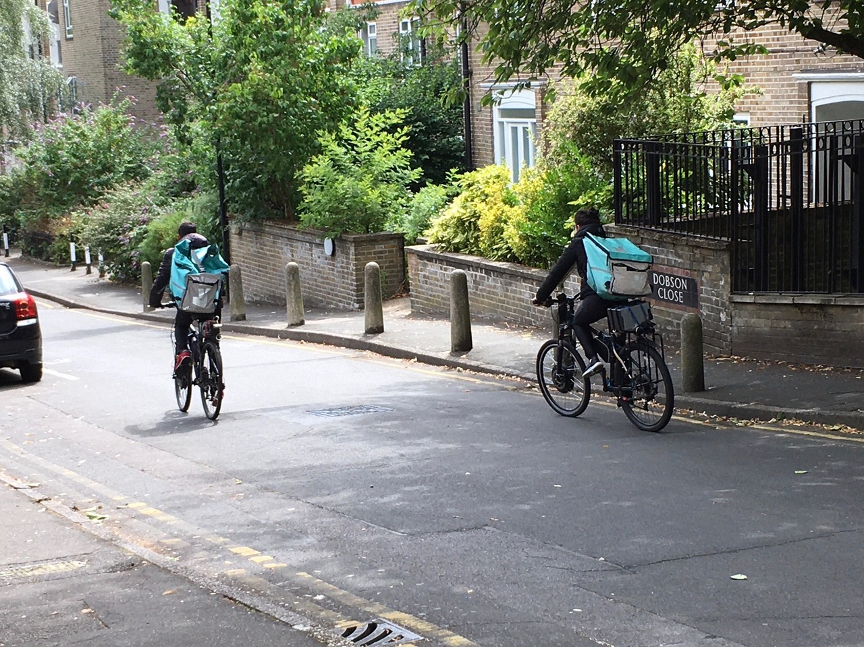

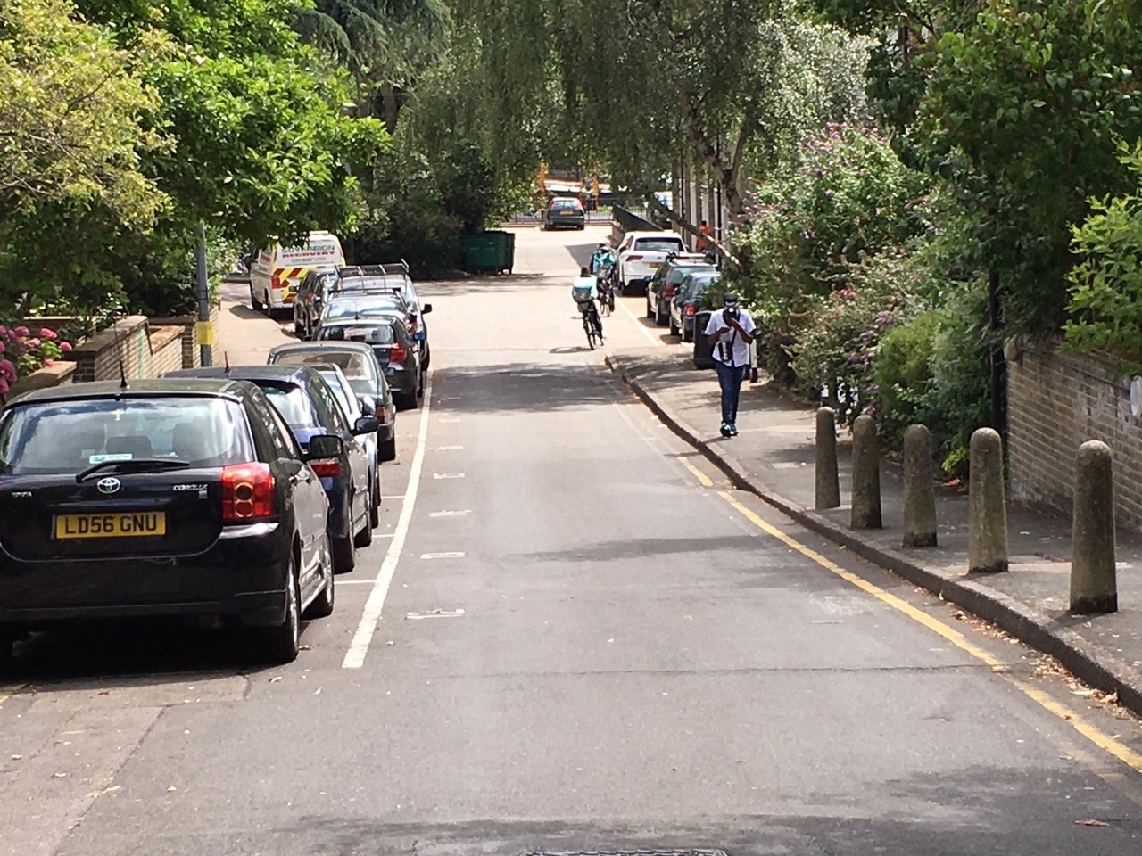

Two Deliveroo riders using Dobson Close as a shortcut to cycle towards the playground, which leads to Hilgrove Road and Finchley Road - Thursday 16 July 2020 at 2:45pm

**Appendix F**

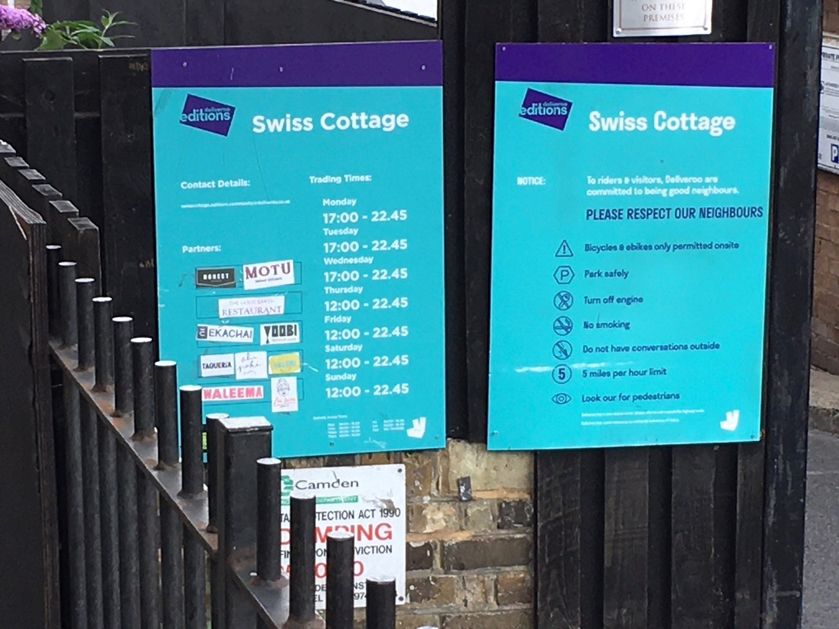

Deliveroo Editions Swiss Cottage notice showing inaccurate trading hours - Saturday 25 July 2020 at 11:35am