LDC Report | 28/08/2020
Officer |  | Application Number
Raymond Yeung |  | 2020/2970/P
Application Address |  | Recommendation
Flat A  78 Belsize Park Gardens  London  NW3 4NG |  | Grant Certificate
1st Signature |  | 2nd Signature (if refusal)

Proposal
Continued use of the property as a single residential unit following the amalgamation of 3 flats (Use Class C3).

Assessment
The host property is a 4 storey residential property with additional roof level, comprising 7 flats.

The application site Flat A relates to a maisonette spanning across the rear of the lower ground garden level and the entire raised ground floor level.

The original layout (pre 1997) consists of Flats A, C and D, Flat A being to the rear of the raised ground level, Flat C on the rear of the lower garden level and Flat D to the front of the raised ground level. It is claimed that Flat C and D has been altered in 1997 to become amalgamated to be part of Flat A.

The building is not listed and is located in the Belsize Park Conservation Area.

The application seeks to demonstrate that use of Flat A as single residential unit has occurred for a period of 4 years or more such that the continued use would not require planning permission.

The applicant is required to demonstrate, on the balance of probability, that the existing residential unit has existed for a period of 4 or more years.

Applicant’s Evidence

The applicant has submitted the following information in support of the application:

- A supporting statement with appendices to show a lease agreed in 2006 which confirms that Flat A was created on 1st December 1997. The statement also include supporting drawings, floor layouts, planning references and building control correspondence to state the alterations dated back to 1997.

The applicant has also submitted the following plans:

- A site location plan outlining the application site
- Current floor plans

Council’s Evidence

There is no relevant planning history or enforcement action on the subject site.

The Council tax website VOA.gov.uk demonstrates that Flats C and D do not exist which is consistent with the applicants assertions that they have been amalgamated to form Flat A.

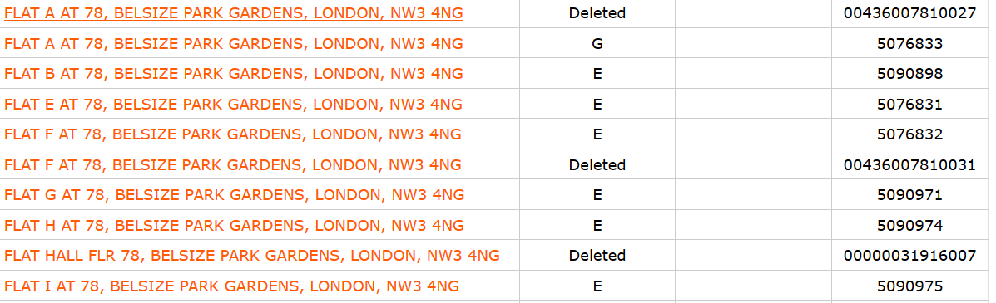

A further look on the Council’s GIS software is also consistent with the above as it shows all flats A-I apart from Flats C and D.

Assessment

The Secretary of State has advised local planning authorities that the burden of proof in applications for a Certificate of Lawfulness is firmly with the applicant (DOE Circular 10/97, Enforcing Planning Control: Legislative Provisions and Procedural Requirements, Annex 8, para 8.12). The relevant test is the “balance of probability”, and authorities are advised that if they have no evidence of their own to contradict or undermine the applicant’s version of events, there is no good reason to refuse the application provided the applicant’s evidence is sufficiently precise and unambiguous to justify the grant of a certificate. The planning merits of the use are not relevant to the consideration of an application for a certificate of lawfulness; purely legal issues are involved in determining an application.

The Council does not have any evidence to contradict or undermine the applicant’s version of events.

The information provided by the applicant is deemed to be sufficiently precise and unambiguous to demonstrate that ‘on the balance of probability’ the single residential unit for a period of more than 4 years as required under the Act. Furthermore, the Council’s evidence does not contradict or undermine the applicant’s version of events.

Recommendation: Grant Certificate of Lawfulness

