MM MELNYK
FLAT 3, 4 HAMPSTEAD HILL GARDENS, LONDON NW3 2PL

FAO: Ms Rachel English, Senior Planning Officer, Camden Council

Re: Planning application 2019/5835/P - 4b Hampstead Hill Gardens

I write to place on record my objection to the above planning application.

This is the third attempt by the applicant to put forward proposals that satisfy the relevant planning policies. Ditto, this is my third letter of objection. Notwithstanding the amendments outlined in this latest revision, the proposal fails to satisfy numerous aspects of the London Plan, the Camden Local Plan, the Hampstead Neighbourhood Plan and the Conservation Area Statement.

I note the headline proposal refers to “construction of a new 2 storey residential dwelling with rooms in the roof and basement.” The application detail suggests a more accurate description would be ‘construction of a new residential dwelling on 4 levels following demolition of the existing 2 storey dwelling’.

The application remains fundamentally flawed and should be rejected outright.

Specifically, this third revision:
- Fails on design, height and massing. Such a development would compete with nearby historic architecture rather than resonating with the same.

Policy D2, para 7.6 Camden Local Plan (2017) notes “The setting of a listed building is of great importance and should not be harmed by unsympathetic neighbouring properties”. This statement is similarly confirmed in the London Plan; Policy 7.8.

This application is demonstrably unsympathetic to the setting of neighbouring listed buildings.

- It continues to represent overdevelopment relative to the surrounding area and of the existing site which the applicant’s own Heritage Statement confirmed to be “on a narrow plot”.

- It clearly represents the type of creeping development which the Council is obligated to rebuff. Site history shows the original land to have been open, then a tennis court (part of 4 Hampstead Hill Gardens); a garage in the 1950s followed by a two-storey house in the 1960s. The latter “built as a connected residential development to 4a”. Notably, this was built as a house subordinate to 4a.

The Council should not permit the building of a house on 4 levels on this small plot of land which, uniquely, has had over 70 years of being reinvented and growing ever larger. It is time to say, ‘enough is enough’.

- It would cause harm to roof, sky and streetscapes. A house of this height and mass, in this most sensitive location, would be disruptive from numerous viewpoints both public and private.

From a street perspective, views of Grade 2 listed St Stephen’s church (Rosslyn Hill), the flank elevation of No 6 and the rear roofscape of No4 would be materially impacted.

The enclosed photographs show the perspective from first floor level of 4 Hampstead Hill Gardens.

- The negative impact to sunlight, daylight and the impact of overshadowing. The views (roof and sky) and the light into the living area of my first-floor apartment would be adversely impacted. Having owned this for over 20 years, it would be a material blow to the peaceful enjoyment of my home.

This development, if permitted, would adversely affect the enjoyment of the rear garden of 4 Hampstead Hill Gardens; a residential amenity for four family units, including young children, who reside at this address. Over many years we have put time, care and much expense into creating a garden that is diverse, now maturing and friendly to wildlife. The garden would be greatly overshadowed by such a development and a material loss of sunlight would be inevitable.

The covering letter from DP9 dated 28th May 2020 states “a revised Daylight, Sunlight and Overshadowing Assessment has not been resubmitted” suggesting that, due to the revisions, “it will perform better from a DSO than the previous proposals.”

Prior concerns raised by me, by Flat 2, 4 Hampstead Hill Gardens and by 4a Hampstead Hill Gardens, amongst others, have been ignored. This statement is testament to the applicant knowing a further DSO Assessment will deliver the same unsatisfactory conclusion. In view of such disregard, the objections made by residents re DSO issues should be accepted by the Planning Office as entirely valid and should be upheld.

The enclosed photographs serve to illustrate the point. I also, and respectfully, ask that the revised neighbour’s Heritage Report submitted by Alex Shinder is accepted as part of our objection to this application. It is expert and serves to best articulate our concerns in relation to heritage and conservation area issues.

- The BIA is inadequate; the desktop audit fails to satisfy concerns. Amongst numerous points, the site history includes two prior subsidence claims; soil testing and borehole sinking dating back to February 2015 to support a subsidence related insurance claim and which are not specific for the purpose of a basement development as per this development. Prevention of damage to neighbouring properties is reliant on “perfect workmanship”.

There are many aspects of the BIA and the subsequent audit which rightly concern neighbours. It is incumbent for the applicant to have satisfied every single point. He has failed to do so. On this basis, the application should be rejected

- It adds nothing to the housing stock in Camden. The house, in its existing form, meets housing standards space requirements for family occupation. The notion that such a significant development enables the applicant to continue to occupy the site owned by the family for some 70 years is quaint but is greatly outweighed by the damage the development would do to the surrounding area.

Many of the large houses in Hampstead Hill Gardens are conversions which accommodate multiple family units. The privilege of living in such a graceful setting is tempered by space constraints and ‘communal’ living for many of the street’s residents. The location, the unique and pleasing nature of the road with easy access to excellent local amenities makes such compromise fair and reasonable.

The applicant’s desire for such a substantial increase in domestic space is incompatible with the size of the site, its sensitive location and the damage it would cause to the local area.

My/our objections do not seek to block redevelopment per se but specifically this proposal which is too aggressive by far. As per the applicant’s own Heritage Statement, redevelopment of this site should amount to “fitting a new house into a vacant place without causing anyone to feel outrage”.

Yours Sincerely,
Marie Melnyk

6th July 2020

Enc.: Photographs
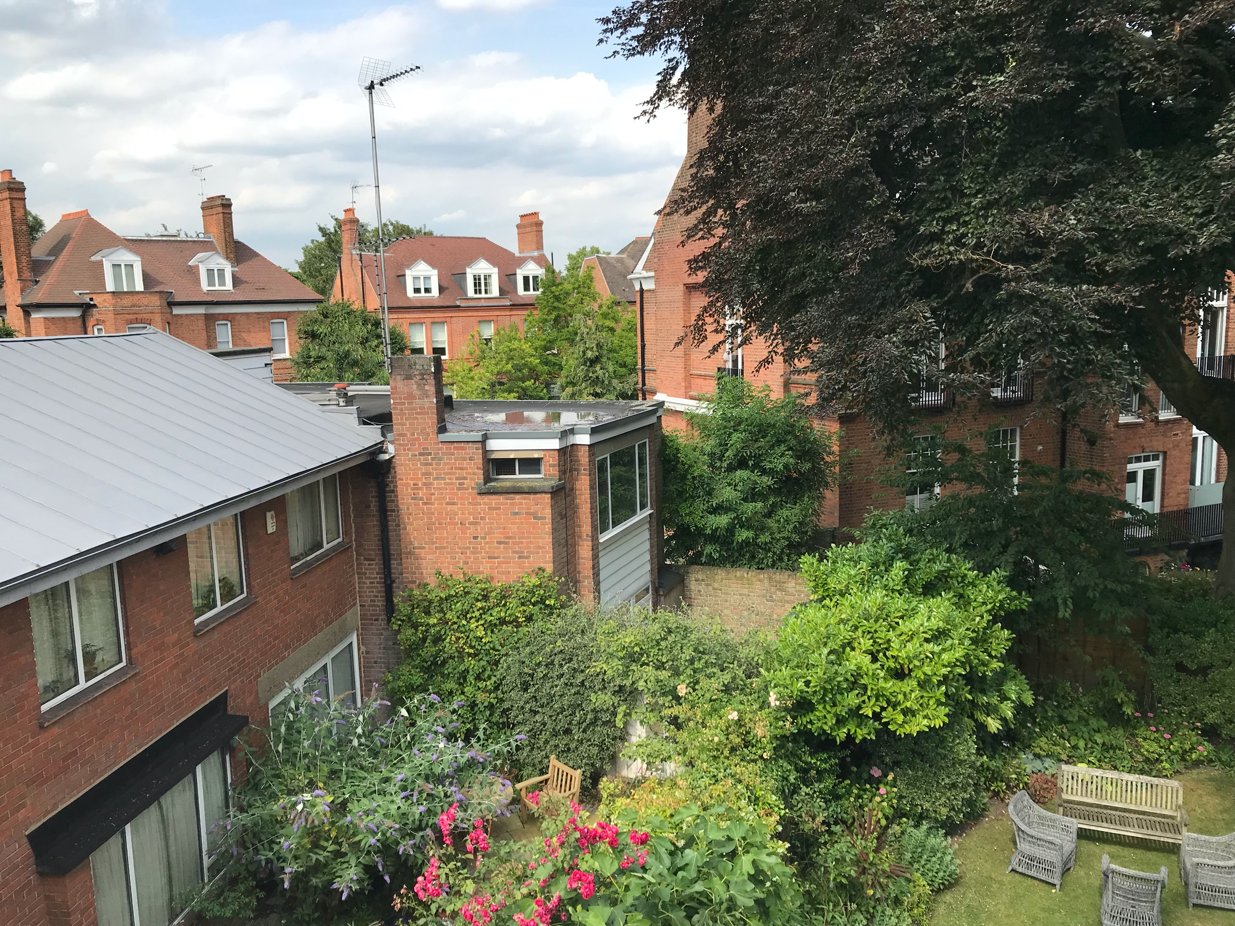

Photograph from first floor apartment of 4 Hampstead Hill Gardens.
It illustrates:
4a and 4b Hampstead Hill Gardens along with the flank wall of No 6;
The roof and skyscape from this first-floor perspective;
To the right, part of the significant copper beech tree

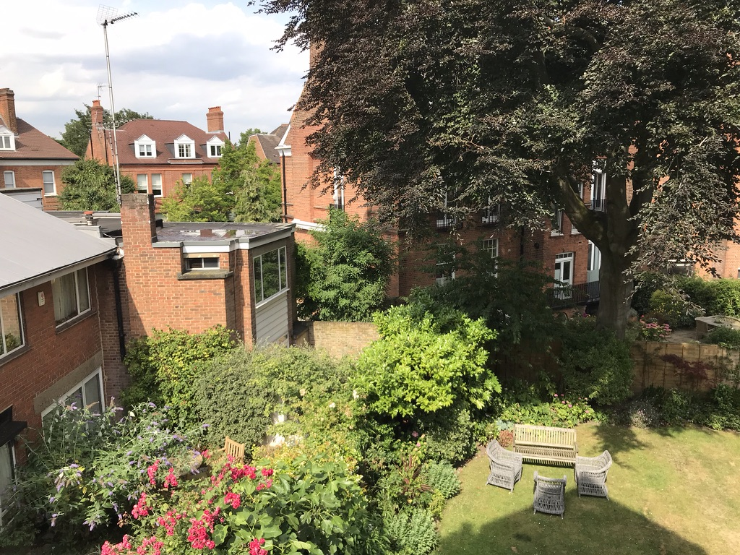

The photographs also demonstrate part of the maturing garden at 4 Hampstead Hill Gardens;

A three-storey house will adversely impact on sunlight and enjoyment of the rear garden for residents of 4 Hampstead Hill Gardens …
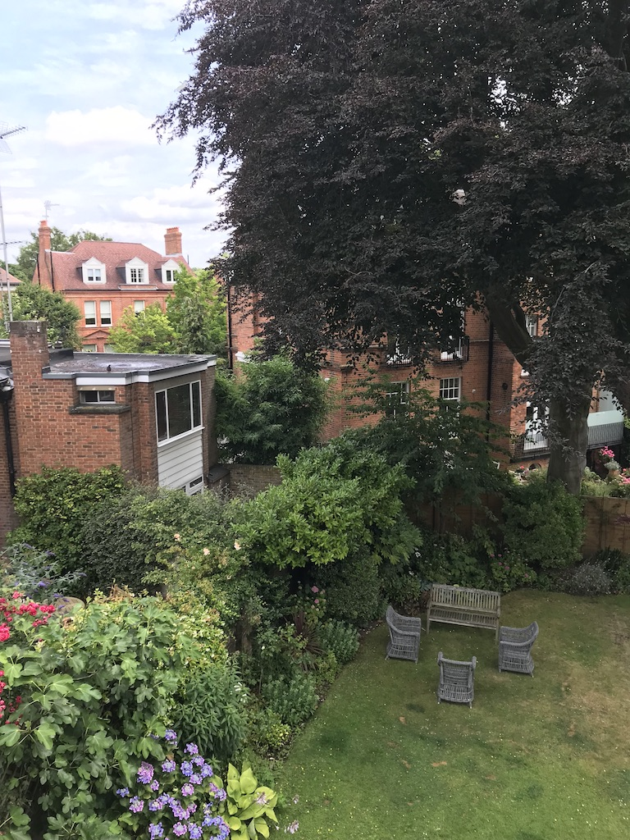

It will also impact on the daylight into and the sky and roof views from my first-floor apartment.

