**5 and 5A, Greville Place**

[Be the first to contribute](https://historicengland.org.uk/listing/the-list/list-entry/1271399#contributions-banner)

**Overview**

Heritage Category:

Listed Building

Grade:

II

List Entry Number:

1271399

Date first listed:

14-May-1974

Statutory Address:

5 and 5A, Greville Place, London, NW6 5JP

**Map**

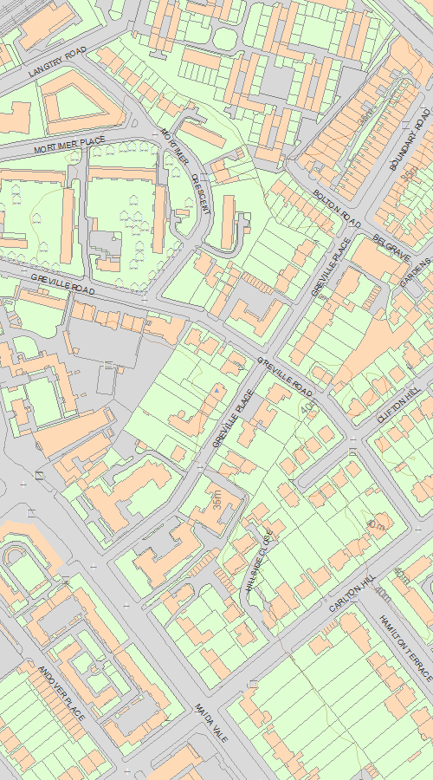

© Crown Copyright and database right 2020. All rights reserved. Ordnance Survey Licence number 100024900.  
© British Crown and SeaZone Solutions Limited 2020. All rights reserved. Licence number 102006.006.  
Use of this data is subject to [Terms and Conditions](https://historicengland.org.uk/terms/website-terms-conditions/).

The above map is for quick reference purposes only and may not be to scale. For a copy of the full scale map, please see the attached PDF - [1271399.pdf (opens in a new window)](http://mapservices.HistoricEngland.org.uk/printwebservicehle/StatutoryPrint.svc/247821/HLE_A4L_Grade|HLE_A3L_Grade.pdf)

The PDF will be generated from our live systems and may take a few minutes to download depending on how busy our servers are. We apologise for this delay.

This copy shows the entry on 15-Apr-2020 at 15:01:53.

**Location**

Statutory Address:

5 and 5A, Greville Place, London, NW6 5JP

The building or site itself may lie within the boundary of more than one authority.

County:

Greater London Authority

District:

Camden (London Borough)

National Grid Reference:

TQ 25817 83424

**Details**

TQ2583SE 798-1/80/708  
  
CAMDEN GREVILLE PLACE (North West side) Nos. 5 AND 5A   
  
(Formerly Listed as: GREVILLE PLACE Nos.1-5 (Odd))  
  
14/05/74   
  
GV II  
  
Detached house. Early C19, altered, with later extension. Stucco with plain first floor band. Slated hipped roof with slab chimney-stack and projecting eaves. Two storeys and basement. Three windows. Doorway in recessed entrance extension with C20 hood. Ground floor, architraved sashes; first floor, architraves to segmental-arched shallow recesses having square-headed sashes.  
  
INTERIOR: not inspected.  
  
Listing NGR: TQ2581783424

**Legacy**

The contents of this record have been generated from a legacy data system.

Legacy System number:

477903

Legacy System:

LBS

**Legal**

This building is listed under the Planning (Listed Buildings and Conservation Areas) Act 1990 as amended for its special architectural or historic interest.

End of official listing