**REDINGTON FROGNAL**

NEIGHBOURHOOD FORUM

9 July 2020

Dear Mr. Hope,

**24 Ferncroft Avenue: 2020/2471/P– objection**

Metal gates are not a traditional feature of the Redington Frognal Conservation Area. Together with the replacement of front gardens by car parks, they are causing very serious cumulative harm to the Conservation Area, as has been noted in both the 2003 and 2020 Conservation Area appraisals.

The Conservation Area character is based on garden suburbs, so that landscape infrastructure is of fundamental importance to the special architectural or historic interest and character and appearance of the area: in particular mature trees and hedges.

In the application of Section 72 of the Planning (Listed Buildings and Conservation Areas) Act 1990, as Amended, it is important to understand the central contribution of the amalgam of front gardens.

A number of adjacent front boundary treatments forming a positive contribution to Ferncroft Avenue are shown below, while the black and white photos which follow are of metal railing-free original front boundary treatments.

We disagree with the conclusion of the Design and Access Statement that high brick walls and metal gates and railings will enhance the Conservation Area. Indeed, it will harm not only the Conservation Area but also the setting of this non-designated heritage asset by CHB Quennell for which the Neighbourhood Forum seeks Local Listing.

**Existing “positive” front boundary treatment at 24 Ferncroft Avenue**

**Low retaining front boundary walls and hedges, immediately south of and opposite 24 Ferncroft Avenue**

**Original Front Boundary Treatments for CHB Quennell Houses (Source: *Modern Suburban Houses* by CHB Quennell)**

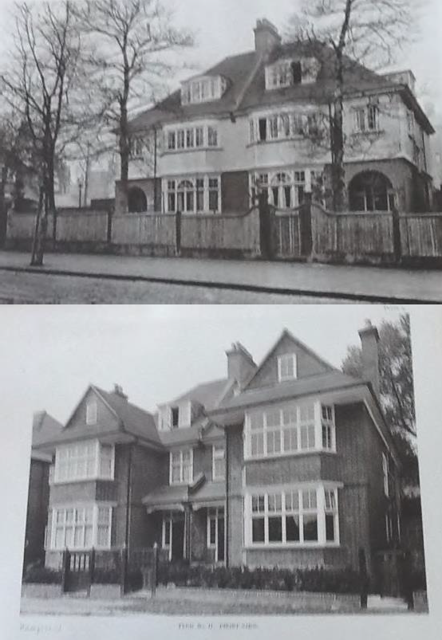

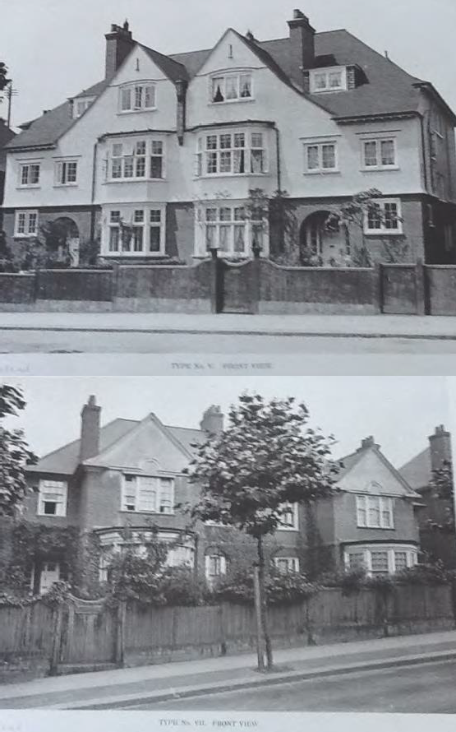

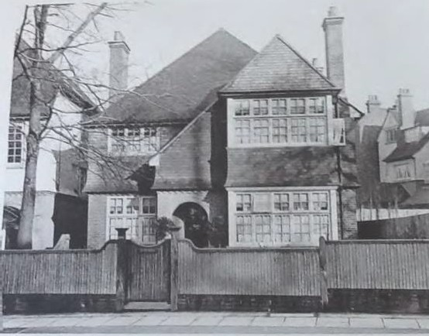

f\l'I \ xt \T II\\

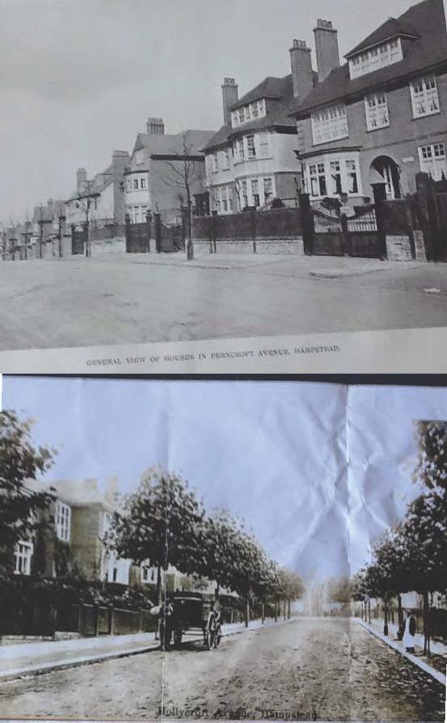

Yours sincerely,

Nancy Mayo

Secretary

Redington Frognal Neighbourhood Forum

<http://www.redfrogforum.org/>