|  |
| --- |
| **METHOD STATEMENT** |
| Bedford Passage – CFA piling |

|  |  |  |  |
| --- | --- | --- | --- |
| **Method statement No.** | **KB_P321_MS_01** | **Revision No.** | 00 |
| **Title** | **CFA Piling** | | |
| **Start Date of Works** | **TBC** | **Duration** | 4 weeks |

|  |  |  |  |  |
| --- | --- | --- | --- | --- |
| **Revision History** | | | | |
| Document No. | Revision No. | Issue Date | Author | Description of Modifications |
| **KB_P321_MS_01** | 00 | 13/05/20 | A Panchal | First issue |
|  |  |  |  |  |
|  |  |  |  |  |

|  |  |  |  |  |
| --- | --- | --- | --- | --- |
| **This Revision** | | | | |
|  | Print Name | Signature | Position | Issued to: |
| Author | Asha Panchal |  | Engineer |  |
| Checked by | Michael Cook |  | Project Manager |  |

|  |  |  |  |  |  |  |
| --- | --- | --- | --- | --- | --- | --- |
| **Status of This Revision** | | | | | | |
| **Overall Approval Status** | | | | **Yes** | **No** | **Date** |
| Cat A | Accepted for implementation. Work may proceed as planned. | | |  |  |  |
| Cat B | Not accepted for implementation. Resubmission required. | | |  |  |  |
| Date Returned to Contractor | | | | | |  |
|  | | | | | | |
| **Sign off by Project Manager** | | **Print Name** | **Signature** | | | **Date** |
|  |  | | |  |

|  |
| --- |
| **Table of Contents** |
| 1. Introduction  2. Scope of Works  3. Enabling Works  4. Method of Works  5. Logistics  6. Hazards / Risks –Refer to risk assessments for further details  1. Control Measures (Permits, Exclusion Zones, PPE etc)  2. Resources  3. Training & Supervision  4. Emergency Arrangements  5. Contractor Monitoring & Compliance  6. Appendix A – Risk Assessments  7. Appendix B – COSHH Assessments  8. Appendix C – Site location plan  9. Appendix D – Proximity of secant wall to existing boundary wall founded on underpins  10. Appendix E – Risk assessment and Method Statement Briefing Sheet |

|  |  |  |
| --- | --- | --- |
| **Risk Assessment Index** | | **New for this Task Specific MS** |
| **Number** | **Title** |  |
|  | **Piling site specific risk assessment** | Y |
|  | **Site logistics** | N |
|  | **Lifting operations** | N |
|  | **Plant maintenance** | N |
|  | **CFA piling** | N |
|  | **General piling attendance** | N |

|  |  |  |
| --- | --- | --- |
| **COSHH Assessment Index** | | **New for this Task Specific MS** |
| **Number** | **Operation / Process / Substance** |  |
|  | **Diesel** | Y |
|  | **Engine oil** | Y |
|  | **Hydraulic oil** | Y |
|  | **Ad blue** | Y |
|  | **Morris grease** | Y |
|  | **Mould oil** | Y |
|  | **Ready mix concrete** | Y |
|  | **Prime-a-pump** | Y |
|  | **Survey spray marker** | Y |
|  | **Petrol** | Y |
|  | **Two stroke oil** | Y |

|  |  |
| --- | --- |
| **Health and Safety Factors** | |
| **Phase** | **Key Factors** |
| **Design** | * Structural knowledge of the structure and site surveys or assessments * Structural knowledge of any adjacent structure * Equipment and methods selected for Work |
| **Planning** | * Site knowledge * Health and Safety risk assessment * Development of safe sequences of work activities |
| **Execution** | * Workforce Supervision * Control of method statements implementation * Communication of unplanned discoveries * Safety information and training selection |

|  |
| --- |
| Introduction |
| A number of Ø600mm CFA piles will be constructed along the southern and south-eastern elevation as part of Bedford Passage development. The secant wall elevation adjacent Middlesex House has, in the past, been underpinned.  The site address is Middlesex Hospital Annexe, 44 Cleveland Street, Fitzrovia, London, W1.  Before any works progress on site, all operatives must be briefed and signed up to the current approved copy of this method statement and the associated risk assessments. Please refer to **Appendix E – Risk Assessment and Method Statement Briefing Sheet** will be briefed by the Project Manager for a copy of the relevant briefing sheet which will be used to capture the briefing records.  This Method Statement will be reviewed periodically with a maximum of six weeks between review dates by the Project Manager. If there are any changes to the works or proposed methodology the method statement will be updated, brief to operatives and re-issued to all relevant persons.  All operatives will be required to attend a site induction facilitated by the Main Contractor upon arrival to site. |
| Scope of Works |
| This method statement covers the installation of Ø600mm diameter secant wall piles (49.5 linear metres) at approximately 900mm centres around south-eastern and southern perimeter of the Bedford Passage University College London Hospital (UCLH) development.  The main site borders Middlesex House to the south, Astor College gymnasium to the east, the Wellcome Building to the north and the North House, Workhouse and South House to the west as shown in Appendix C.  The piling area is limited to the southern and eastern ends of the site and borders onto Middlesex House, 13 Tottenham Mews, Astor College and South House, as shown in Figure 1 in Appendix C.  **The works which Keltbray Piling are undertaking are for the installation of approximately:**  male secant wall piles 600mm diameter (average pile length of 9.5m – 12.5m) formed of minimum C30/37 grade concrete or higher – see pile design schedule for details  female secant wall piles 600mm diameter (average pile length of 7m) typically formed of C8/10 grade concrete or similar – see pile design schedule for details  The piling works will be carried out using the Soilmec SR30 in CFA configuration.  The piling area borders onto an existing Victorian boundary wall founded on underpins. Monitoring of the boundary wall and other structures will be carried out by others during the works. Trigger levels set for the adjacent structures are:  Green: <11mm  Amber: 11mm  Red: >15mm  MOLA are present on site and overseeing works undertaken by enabling works. A watching brief may also be in force during the piling works.  Vehicular access and egress will be obtained from Cleveland Street, with an access point into site opposite Foley Street. Access is restricted owing to a scaffold by the entrance; a small concrete wagon may be required to facilitate the works. Banksmen and traffic marshals will be required to control vehicle movements into and out of site.  Pedestrian access can be obtained from Goodge Street underground station on the Northern Line. General access, traffic marshalling and site security will be provided and maintained by others. |

|  |
| --- |
| Enabling Works |
| * Site establishment (hoarding, welfare, site office, potable water, power) – by others * Slab breakout (if required) – by others * Probing, underpin survey, UXO survey – by others * Protection, diversion, isolation of live services within the piling site – by others * Piling mat installation – by others * Piling platform plate bearing tests – by others * Guidewall construction – by others * Guidewall removal – by others * Control point station establishment – by others * Permits – by client * Lift plan, RAMS, ITP – KB * Rigging up – KB |

|  |
| --- |
| Method of Works |
| **The procedure for installing the Continuous Flight Auger bored piles is detailed below:**  **Works will be constructed in accordance with the following Keltbray Piling procedures;**   * ***KP-COMP-PRO-035 Establishing Control Points*** * ***KP-COMP-PRO-020 Permit to Pile Procedure*** * ***KP-COMP-PRO-014 CFA Auger Assembly Procedure*** * ***KP-COMP-PRO-031 CFA Procedure*** * ***KP-COMP-PRO-033 CFA Calibration Procedure*** * ***KP-COMP-PRO-038 Adding Water Procedure*** * ***KP-COMP-PRO-037 Concrete Blow Out Procedure*** * ***KP-COMP-PRO-039 Non Conformity and Corrective Action*** * ***KP-COMP-PRO-007 Concrete Pumping Procedure*** * ***KP-COMP-PRO-025 CFA and LDP Rigging Up Procedure SR30***   *Any deviations from the approved working procedures listed above which are expected to occur during the under taking of this project will be detailed in the below sequence of works:  Before any works take place the Piling Platform Certificate is required to be signed and issued to the Keltbray Piling site management team, prior to either the crane or piling rig being erected or working. (The platform installation is designed and installed by others).   * ***KP-COMP-PRO-020 Permit to Pile Procedure***   Once the Piling Platform certificate has been received, work will be undertaken for the rigging up process of the Piling rig. This will be done in accordance with:   * ***KP-COMP-PRO-025 CFA and LDP Rigging Up Procedure SR30***   **Access and logistics**  The base units for the rigs and cranes will be delivered by low loaders. These deliveries are all classed as abnormal loads and are only permitted to travel inside London between the hours of 19:00 and 07:00. Therefore all rig and crane deliveries will be either before 07:00hrs or after 19:00hrs (outside normal working hours).  Notification to be given 48 hours in advance of deliveries entering site and movement order to be issued to client.  Other vehicles to be used for ancillary and piling equipment will include 40’ wagons, semi low loaders and rigid wagons (including HIAB’s). All deliveries will be between the hours of 08:00 and 18:00 unless prior approval is gained.  At all times (once rigged up) piling rig and attending crane once rigged up must stay within the confines of the designated and certified piling platform for all operations from mobilisation through to de-mobilisation  Upon arrival to site all low-loaders will enter site via Foley Road to gain direct access to site. The low loaded shall pick up the trailer and depart from site. For de-mobilisation these activities will be undertaken in reverse.  Access to site is restricted by scaffolding and the turning circle is tight; the plant manager be brief the drivers on the planned access routes. Traffic marshals will use stop/go boards to control traffic and barriers to manage pedestrians during vehicle movements.  During the works a **small concrete wagon may be required** to ensure safe access to site; to be decided by KBP Project Manager / KBP supervisor.  During these works the piling area will be segregated with physical barriers.  **Site set up and briefings**  Secant wall will follow the same procedure for CFA piling. This will be done in accordance with;   * ***KB-COMP-PRO-031 CFA Procedure*** * All operatives will attend a site induction and a specific Keltbray Piling site induction and provide proof of competency * All operatives will attend a ‘Daily Activity Briefing’ prior to the commencement of every shift, briefing will include but not limited to; planned activities for the shift, deliveries/collections, site logistics * Site working hours are from 0800hrs until 1800hrs (Monday to Friday) * Service drawings to be provided to KBP by Principal Contractor * MOLA will be on site overseeing the enabling works – a watching brief may also be imposed on the piling works. * The piling platform will be limited to the works area only and is anticipated to be approximately 15m wide, this will installed and tested by others. The piling platform level has been given as 26.75mAD. * The guide wall will be installed by others in advance of the piling works and will consist of a minimum and maximum diameter perforation as agreed with the Project Manager from Keltbray Piling. The guide wall will be constructed close to the existing boundary wall and should be designed and installed to withstand rig track pressure. Removal of the guide wall shall also be carried out by others. * The KBP setting out engineer will check the positioning of the guidewall with the current piling schedule to confirm the pile positions are correct, during mobilisation but **before** any piling works commence. * The secant wall will be constructed adjacent an existing underpinned wall. Appendix D shows that the piled wall will be offset 100mm back from the extent of the underpin. An exclusion zone line will be marked out on site with physical barriers or red/white sleepers and operatives will be briefed to ensure they are aware of the extent to which they can work. * An adequate number of pile positions will be established by the setting out engineer and agreed with the KBP Project Manager. The pile schedule will be provided by the KBP Contracts Engineer * Boring at each pile location will only start when the correct reinforcement cage has arrived on site and has been checked against the reinforcement drawings for that pile * The works area will be segregated with physical barriers with signage * If at any point the rig encounters an **obstruction or suspected obstruction,** **all works must cease immediately** and be reported to the KBP project manager. At no point can additional shock/surcharge loads be imposed directly in front of the existing wall.      * The star wheel cleaner will be maintained and functional during piling to prevent clay arisings from flighting up the auger stem. An excavator will be in attendance to ensure that any clay not removed by the star wheel cleaner is dealt with approximately 0.5m before the exceeding the height of the existing wall. * If an excess of clay flights up the auger stem, the bankman will instruct the rig operator to stop until the clay has been removed by the attendant excavator. * Construction will continue as per the standard piling procedures   **CFA construction**  Secant wall piling – No guide wall installation will be required, secant wall will follow the same procedure for CFA piling. This will be done in accordance with;   * ***KB-COMP-PRO-031 CFA Procedure***   Before works start on site the wall thickness of the steel concrete pipes on the rig will be measured and recorded, flexible concrete hoses will be new and will be pressure tested as required during the works.  Concrete hoses full of concrete will be moved by the 360 excavator attending the piling rig.  Setting out and as-built information will be carried out by a dedicated full time setting out engineer provided by others  If during piling works concrete has been tested and is out of specification, then the procedure for adding water must be adhered to. This will be done in accordance with:   * ***KP-COMP-PRO-038- Adding Water Procedure*** * Water must never be added without first speaking to the batching plant and obtaining approval from KP Project Manager   Following completion of the shifts piling works the following procedure will be adhered to as regards the blowing out of concrete lines: This will be done in accordance with:   * ***KP-COMP-PRO-037-Concrete Blow Out Procedure*** * If during normal operation the concrete lines becomes blocked then before attempts are made to clear the blockage a senior member (PM or supervisor) of the piling team will be contracted to oversee the process.   **NCRs**  Should any non-conformities arise which deviate from the specification and the Keltbray ITP, then an NCR will be raised for this pile and communicated with the principal contractor and the design team. This will be done in accordance with:   * ***KP-COMP-PRO-039-Non Conformity and Corrective Action.***   The project piling specification details a non-standard deviation from the general piling specification noted in ICE SPERW and Keltbray piling procedures in the following instance:  Secant piles:   * Plan position tolerance required: +/- 25mm within guidewall * Verticality tolerance required: 1:75   Arrangements for controlling waste on site are;   * Minimising the volume of waste created by your work activities * Segregating ‘hazardous waste’ from ‘non-hazardous wastes’ for final disposal from site   Shown below is the indicative installation sequence for the secant piled wall.     * Day 1 – Female piles 1, 5, 9, 13 etc. * Day 2 – Female piles 3, 7, 11, 15 etc. * Day 3 – Male Piles 2, 6, 10, 14 etc. * Day 4 – Male Piles 4, 8, 12, 16 etc.   It may be the case that the full sequence of male piles cannot be installed in days 3 & 4. The rigs will continue to install the male piles until all the piles in the run are installed.  Male piles are to be installed no later than 7-10 days of the female piles being installed on site where possible.  Concrete cubes are to be taken from the female concrete mix and tested at 3, 5, 7 and 56 days, these will be taken off site for storage. A cube register will be periodically updates demonstrating strength gained against time.  Male pile cubes to be tested on the following days 7, 28, 28 and spare (56 days if needed)  Pile installation sequence consists of pre-bore to concreting within a single shift with pile bores located within 4*D* (pile diameter centre to centre) not completed within a 24hr period. |

|  |
| --- |
| Logistics |
| * All vehicle movements entering and leaving site will be managed by other traffic marshals on and off Cleveland Street. A banksman will control vehicle movements within the piling site * Small concrete wagon may be required to bring concrete to site * Tight turning circle into site and scaffold present at site entrance. Drivers to be briefed on suitable route to site * Vehicles entering site will either turn off Cleveland Street or enter directly from Fowley Street before passing through the site hoarding. The deliveries will be marshalled within the site and offloaded in the appropriate area * No deliveries occur before 0800hrs or after 1800hrs unless they are abnormal loads in which case the Principal Contractor will be advised well in advance * All site and piling works will be between the hours of 0800hrs and 1800hrs. Where works overrun due to unforeseen circumstances, those affected will be informed with as much notice as possible. * No work is permitted on Sunday and bank holidays * The Piling rig and crawler crane will be unloaded within the site boundary (access permitting). * All waste materials, namely pile arisings will be transferred using licensed hauliers to a licensed facility; these works will be carried out by others * Exclusion zones will be formed around piling areas by use of crowd control barriers/cones and red and white poles, which will be established once the piling rig is in position and ready to commence drilling * All 360 excavators are fitted with cameras and personnel working within the piling site adhere to the KB thumbs up policy before moving around plant |

|  |  |  |  |
| --- | --- | --- | --- |
| Hazards / Risks –Refer to risk assessments for further details | | | |
| Keltbray Management having carried out a risk assessment and have identified the following   * Piling Rig Operations * Concreting * Deliveries/Unloading * Use of plant * Plant and vehicle movements * Refuelling plant and machinery * Manual handling * Lifting Operations * Fire prevention * Use of MEWP (working at height) * Existing boundary wall * Neighbouring roof structure at Middlesex House   COSHH – as identified in the COSHH assessment index  Temporary task lighting and power   * All task specific lighting required will be provided by Keltbray   Housekeeping   * Keltbray Piling operatives have a duty to maintain a tidy and safe working area. This will apply in both the construction site and the welfare area. * Operatives will ensure that they assist in the tidiness of the site by ensuring work area is clear and any rubbish is placed in the designated skips. | | | |
| **Significant Hazards** | **Risks** | **Controls** | |
| **Working at height** | Falls from height  Materials falling from height | Personnel to use only designated and approved access to height, e.g. MEWP and other approved access.  Any persons required to work at or near an open leading edge will wear a full body harness, fall restraint will be used rather than fall arrest by means of using a rope lanyard attached to a suitable anchor that will prevent a fall rather than arrest a fall. | |
| Materials dropping from height onto site personnel causing serious injury / fatality | Ensure debris is cleared off CFA auger string – ensure star wheel is functional and maintained regularly.  Use tool tethering when working at height.  Exclusions zones will be set up as required. | |
| **Plant / vehicle movements** | Striking of persons / plant / materials / structure | Plant to work within exclusion zones  Unauthorised / accidental access to be controlled by forming and maintaining exclusion zones. | |
|  | Traffic routes to be agreed and controlled by traffic marshals | |
|  | Vehicles accessing site will be briefed beforehand on suitable route to minimise risks and disruption when turning into site.  Banksman needed to safely marshal vehicles in/out of site.  Use of stop/go boards to control vehicle movements in/out of site. | |
|  | Vehicles to be escorted through site by Keltbray traffic marshal. Loading area under control of Keltbray traffic marshal. | |
| **Hot Works** | Fire | Hot work permits, firewatchers, extinguisher and / or water hose. Fire retardant polystyrene protection in use. | |
| **Noise & Dust** | Damage to hearing / respiratory system. Environmental pollution. | Dust suppression. Ear & respiratory protection, exclusion zones. | |
| **Existing boundary wall** | Collapse of existing boundary wall during piling works or guidewall installation | Position of piled wall to be agreed in advance of works. Guidewall, installed by others, will be adequately constructed and set out with high precision.  At start of project during mobilisation, KBP engineer will double check that guidewall pile positions match pile design schedule. Any discrepancy to be reported to project manager immediately. | |
| Undermining of existing boundary wall if piling rig augers through underpin | Probing for obstructions will be carried out by others in advance of works to identify depth and extent of underpin prior to any piling works.  Edge of piled wall will be maintained a minimum of 100mm from face of underpin | |
| **Adjacent structures** | Obstructions | If **any obstructions** are encountered all piling works must **cease immediately** and KBP project manager to be informed to agree on next course of action | |
| **Piling activities** | Archaeological discovery | MOLA on site; watching brief may be in place for duration of works | |

|  |  |  |  |  |  |  |  |  |
| --- | --- | --- | --- | --- | --- | --- | --- | --- |
| Control Measures (Permits, Exclusion Zones, PPE etc) | | | | | | | | |
| Permits Required | Yes | | No | Assessments (Attach If Yes) | | Yes | | No |
| **Hot Works** | X | |  | **COSHH** | | X | |  |
| Crane check list | X | |  | Noise | | X | |  |
| Excavation | X | |  | Manual handling | | X | |  |
| Confined space entry |  | | X | Electrical Isolation | |  | | X |
| Riser shafts |  | | X |  | |  | |  |
| **Further Control Measures / Security Requirements.** | | | | | | | | |
| As stated above, due to the nature of the works being carried out on the site, no personnel are to enter the building / working areas without express permission for the site manager or the supervisor in charge of that area of works. | | | | | | | | |
| Prior to works commencing all relevant precautions must be in place e.g. safe access, electrical disconnections, removal of hazardous materials, surveys etc. (this list is not exhaustive and items are dependent on the specific scope of works covered by this MS – include specific items in section 3 above | | | | | | | | |
| **Personal Protective Equipment** | Yes | No | |  | Yes | | No | |
| Safety Helmet – BS EN 397 | X |  | | Gloves BS EN 388 | X | |  | |
| Protective Footwear - BS EN 345 | X |  | | Hearing Protection BS EN 352 | X | |  | |
| High Visibility Clothing - BS EN 471 | X |  | | Fire Proof Overalls - BS EN 531 |  | | X | |
| Eye protection BS EN166 | X |  | | Body Harness BS EN361 | X | |  | |
| Face Respirator BS EN 140 |  | X | | Other? (state) |  | |  | |
|  | | | | | | | | |
| **Equipment To Be Used** | Yes | | No | **Equipment To Be Used** | Yes | | No | |
| Lifting | X | |  | Cradle |  | | X | |
| Materials hoist |  | | X | Excavation shoring | X | |  | |
| MEWP | X | |  | Ventilation Equipment |  | | X | |
| Ladder |  | | X | Cable avoidance tool - CAT | X | |  | |
| Passenger Hoist |  | | X | Mechanical tools | X | |  | |
| Test Equipment - state |  | | X | Lifting slings/chains | X | |  | |
| Task Lighting | X | |  | Mechanical plant (excavator) | X | |  | |
| Scaffolding |  | | X |  |  | |  | |
| Mobile scaffolds |  | | X |  |  | |  | |

|  |  |  |  |  |  |  |  |  |  |
| --- | --- | --- | --- | --- | --- | --- | --- | --- | --- |
| Resources | | | | | | | | | |
| Management / Supervision | | | | | | | | | |
| **Management / Supervision**  1no Operations Director (visiting) – Lee Cain 07826 945535  1no Managing Director (visiting) – Stuart Norman 07793 650514  1no Project Manager – TBC  1no Contracts Engineer – TBC  1no Site Supervisor / First Aider / Fire marshal – TBC | | | | | | | | | |
| Labour | | | | | Plant & Equipment | | | | |
| 1no rig driver  1no rig attendant  1no crane driver  1no banksman  1no slinger/signaller  1no operative  1no 360 excavator operator  1no traffic marshal  1no setting out engineer  1no dumper driver | | | | | 1no SR30 piling rig  1no telescopic crawler crane  1no MEWP  1no 13t excavator  600mm diameter auger string  Concrete hoses  1no concrete pump  1no compressor  1no jet wash bowser  1no storage container  1no COSHH store  1no diesel bowser  1no concrete washout skip  1no blowout chamber  Crowd control barriers / cones and red-white poles | | | | |
| Materials | | | | | | | | | |
| Ready mix C32/40 & P100 concrete – from an QSRMC registered supplier  Reinforcement cages (prefabricated) – from a CARES approved supplier  Diesel – to be stored in 110% bunded bowser | | | | | | | | | |
|  | | | | | | | | | |
| Training & Supervision | | | | | | | | | |
| Training Certificates Required | | | | | | | | | |
|  | Yes | | No |  | | | | Yes | No |
| Scaffold |  | | X | Mobile Elevating Platform | | | | X |  |
| Forklift |  | | X | Mobile Access Towers / steps | | | |  | X |
| Dumper | X | |  | Banksman | | | | X |  |
| Excavator | X | |  | Abrasive Wheels | | | | X |  |
| Mobile Crane | X | |  | Tower crane | | | |  | X |
| Skid steer |  | | X |  | | | |  |  |
| Others (Please state): |  | | | | | | | | |
| Overall Assessment of Risk after the Implementation of Control Measures (tick one) | | | | | | | | | |
| Low | | Moderate | | | | Substantial | High | | |
|  | | X | | | |  |  | | |

|  |  |  |  |  |
| --- | --- | --- | --- | --- |
| Emergency Arrangements | | | | |
| First Aid Measures required | Security Measures required | | | |
| Fire aid kit available on site and in site office | Training first aider on site | | | |
| **Nearest A&E hospital**  **(020 3447 0083)** | **University College Hospital A&E**  **235 Euston Rd, Fitzrovia, London NW1 2BU** | | | |
|  | | | | |
|  | | | | |
| Contractor Monitoring & Compliance | | | | |
| Who is accountable for monitoring compliance with the method statement? | Project Manager | | | |
| Will any test / sampling requirements impose compliance standards? | **Yes** |  | **No** |  |
| If yes, who will carry them out and with what equipment? |  | | | |

|  |
| --- |
| Appendix A – Risk Assessments |
|  |

|  |
| --- |
| Appendix B – COSHH Assessments |
|  |

|  |
| --- |
| Appendix C – Site location plan |

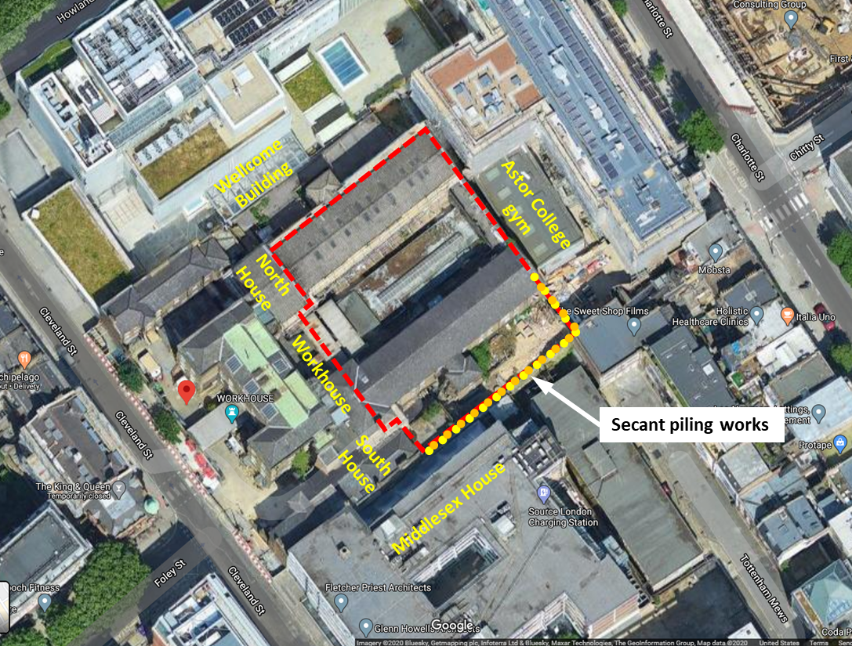

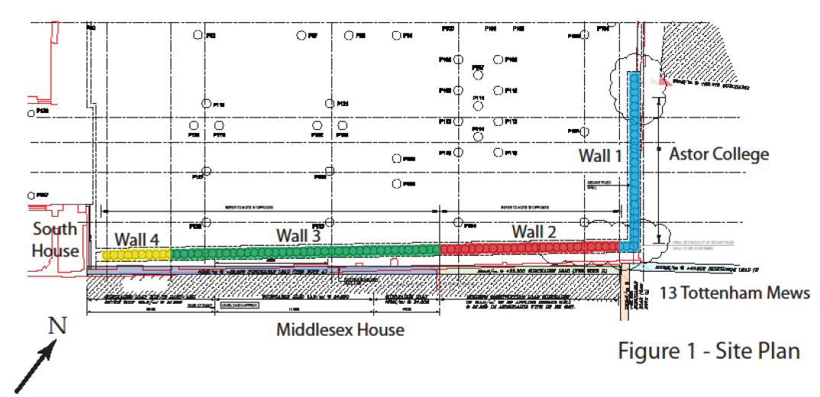

|  |
| --- |
| Appendix D – Proximity of secant wall to existing boundary wall founded on underpins |
|  |

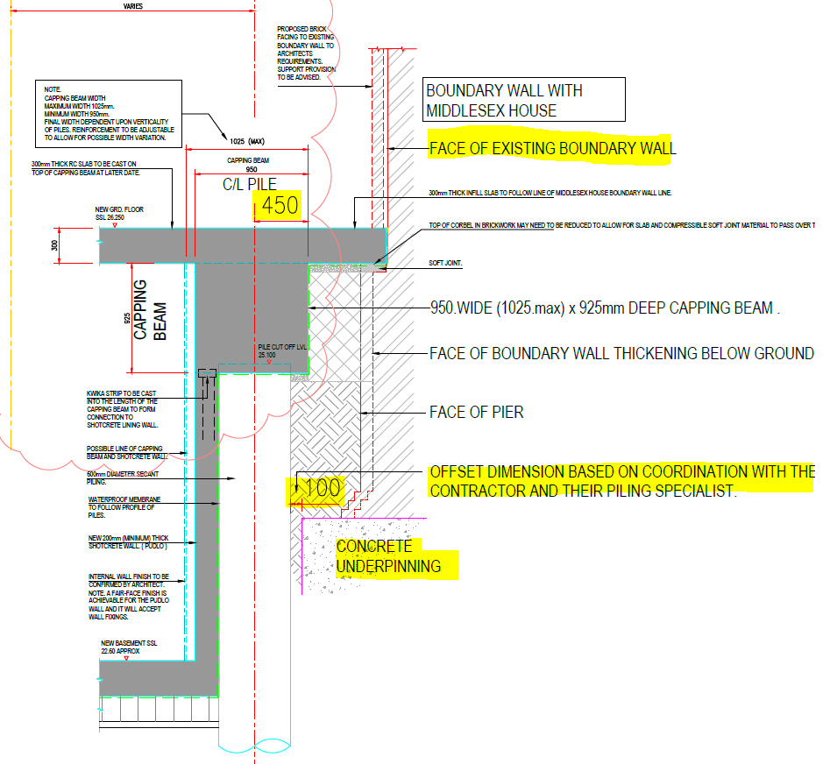

Extract from drawing:

***MHA-ACM-BW.2-XX-DE-S-1002_SOUTH BOUNDARY WALL WITH MIDDLESEX HOUSE. SECTION 2 - 2***

|  |  |  |  |  |  |  |  |  |
| --- | --- | --- | --- | --- | --- | --- | --- | --- |
| Appendix E – Risk assessment and Method Statement Briefing Sheet | | | | | | | | |
|  | | | | | | | | |
| **Method Statement, Risk & COSHH Assessment Talk Attendance Register** | | | | | | | | |
| **Project Name** | | Bedford Passage | | **MS/RA No** | | KB_P30X_MS_01 | | |
| **Title** | | CFA secant wall piling | | | | | | |
| **I hereby acknowledge that I have attended, received and understood the above mentioned Method Statement and Risk Assessment talk.** | | | | | | | | |
| No | Print Name | | Signature | | Date | | Briefed by | |
| 1 |  | |  | |  | |  | |
| 2 |  | |  | |  | |  | |
| 3 |  | |  | |  | |  | |
| 4 |  | |  | |  | |  | |
| 5 |  | |  | |  | |  | |
| 6 |  | |  | |  | |  | |
| 7 |  | |  | |  | |  | |
| 8 |  | |  | |  | |  | |
| 9 |  | |  | |  | |  | |
| 10 |  | |  | |  | |  | |
| 11 |  | |  | |  | |  | |
| 12 |  | |  | |  | |  | |
| 13 |  | |  | |  | |  | |
| 14 |  | |  | |  | |  | |
| 15 |  | |  | |  | |  | |
| 16 |  | |  | |  | |  | |
| 17 |  | |  | |  | |  | |
| 18 |  | |  | |  | |  | |
| 19 |  | |  | |  | |  | |