Consent of individual to being specified as premises supervisor

RISHU PAL WALIA

I
[full name of prospective premises supervisor]

Of
Nicholls Court.
2C Nicholls Avenue
Uxbridge – UB8 3JL
[home address of prospective premises supervisor]

hereby confirm that I give my consent to be specified as the designated premises supervisor in relation to the application for
Vary the designated premises supervisor
[type of application]

by
SAMI KARIM & SONS LIMITED
[name of applicant]

2230
relating to a premises licence
[number of existing licence, if any]

for
5 Coptic Street, London, WC1A 1NH

[name and address of premises to which the application relates]

and any premises licence to be granted or varied in respect of this application made by
SAMI KARIM & SONS LIMITED
[name of applicant]

concerning the supply of alcohol at
5 Coptic Street, London, WC1A 1NH
[name and address of premises to which application relates]

I also confirm that I am entitled to work in the United Kingdom and am applying for, intend to apply for or currently hold a personal licence, details of which I set out below.

Personal licence number
9990913/1
[insert personal licence number, if any]

Personal licence issuing authority
Chartered Institute of Environmental Health
[insert name and address and telephone number of personal licence issuing authority, if any]

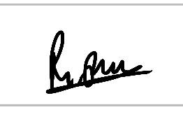
Signed

Name (please print)
RISHU PAL WALIA

10 May 2020
Date

