Site Name: | Theatre Ticket Shop |  |  | ATM Location  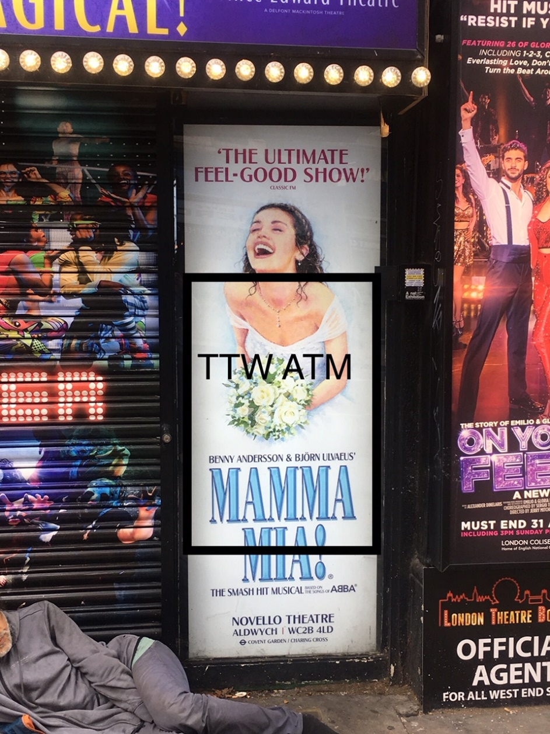  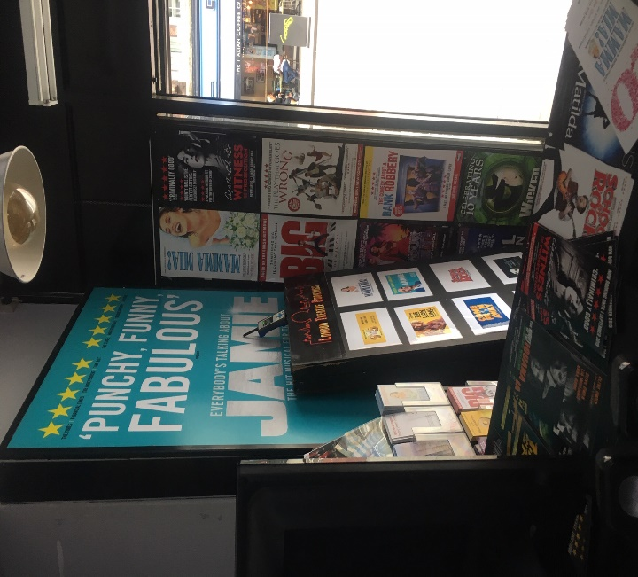  Front of Shop
Address: | 88 Charing Cross Road, The Circus, London, WC2H 2JA
Site Contact: | Baz Mohammed Mangal
Phone: | T: TBA M: 07799 674070
Email: | b-mangal@hotmail.co.uk
ATM Type: | NCR SS26 (TTW)
Opening Hours: | Mon – Sun 09.00 – 23.00hrs
Signage: | ATM Euronet Standard, Plus Light Box
Notes: This venue was a theatre ticket box office, merchant will be taking over the shop and still having a theatre ticket box desk within the shop and all signage for the theatre shows will remain to bring in customers. The merchant will also have a souvenir shop and sweets and drinks etc. The site is located next door to Mc Donald’s and across the road from the Harry Potter theatre show, in the middle of theatre land. Massive footfall of tourists within the area. This venue is located within a the heart of London, with access to Leicester Square, China Town, Soho, Tottenham Court Road, Covent Gardens. This location is the perfect location for any TTW ATM.
ATM Location:
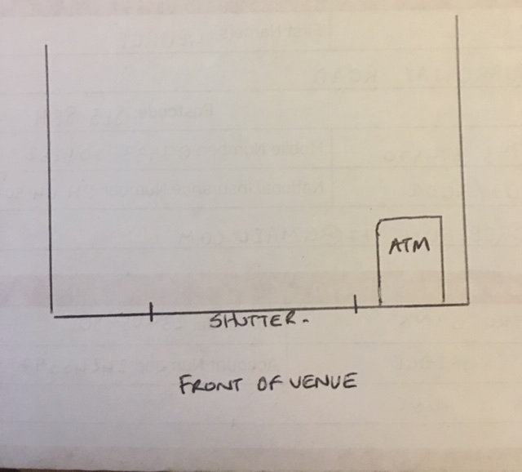
Wall Sign New Lightbox location if allowed, possible three locations merchant to clarify once spoken to the landlord. Locations shown below. Location one above the current wall sign, location two & three on between gap of current sign on wall.
The merchant has requested that we put a strong glass or metal plate or something around the glass area of where the ATM will be installed for security reasons.
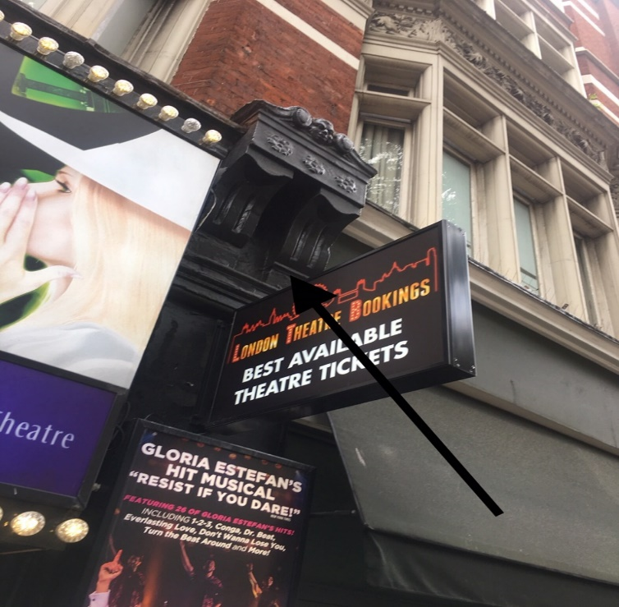

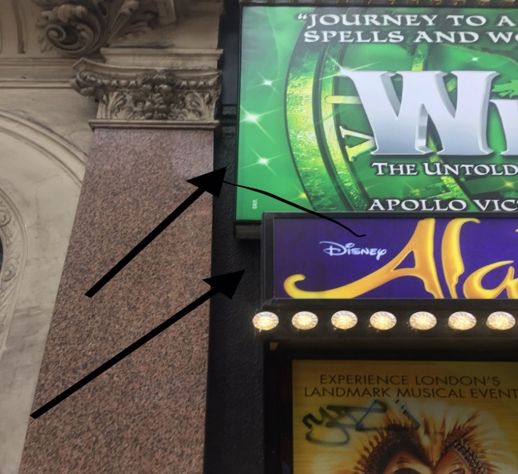
Site Approved by: |  | Jorge Pessoa | Date: |  | 06/08/2019

