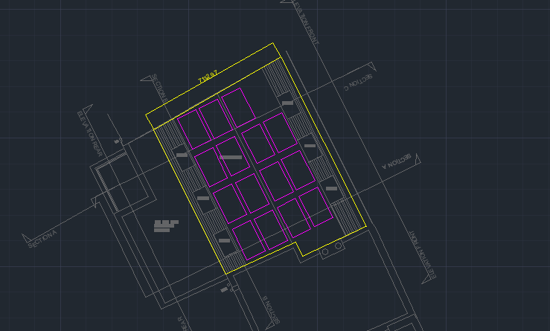

400W LG Solar Mono Neon2 BiFacial solar panel

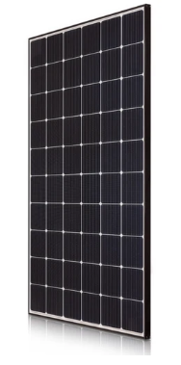 Part No: LG400N2T-A5 Panels - Monocrystalline BiFacial solar panel

Rating: 400W

Efficiency: 18.9%

Width: 1,024mm

Height: 2,064mm

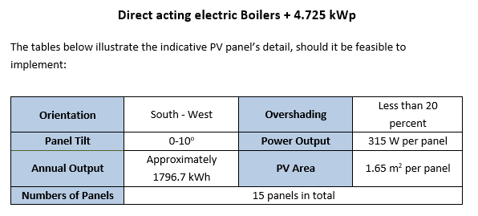

* The proposed building needs to achieve 4.725 kWp
* With the above panel, it can achieve 4.8 kWp with 15 panels as drawn above