**Construction Management**

**Plan**

**pro forma** v2.2

**Arthur Stanley House**

**40-50 Tottenham Street London**

**W1T 4RN**

**Ver 2.**

**Contents**

**Revisions 3**

**Introduction 4**

**Timeframe 6**

**Contact** **7**

**Site** **9**

**Community liaison** **16**

**Transport** **21**

**Environment** **42**

**Agreement**  **49**

# Revisions & additional material

Please list all iterations here:

|  |  |  |  |
| --- | --- | --- | --- |
| **Date** | **Version** | **Produced by** | **Amendments** |
| 03.04.2020 | 1 | 21 Construction |  |
| 27.04.2020 | 2 | 21 Construction | Q14, Q18, Q20, Q22.c, Q22.d, Q27.1 |
|  |  |  |  |

**Additional sheets**

Please note – the review process will be quicker if these are submitted as Word documents or searchable PDFs.

|  |  |  |  |
| --- | --- | --- | --- |
| **Date** | **Document Name** | **Version** | **Comments** |
| 03.04.2020 | Appendix A – Draft Contract Summary | R0.1 |  |
| ~~03.04.2020~~ | ~~Appendix B – Traffic Management Plan~~ | ~~Rev A~~ | Removed from Vers 2 |
| 03.04.2020 | Appendix C – Asbestos Survey | Ver 1 |  |
| 03.04.2020 | Appendix D – Prime Pest Control Report | Ver - |  |
| 03.04.2020 | Appendix E – Baseline NVD Monitoring Results | Ver - |  |
| 28.04.2020 | Addendum to CMR – CMP Working Framework Pollution Team Ref: 2017/4306/P | Rev 1 | Supplied by Camden |

# Introduction

The purpose of the **Construction Management Plan (CMP)** is to help developers to minimise construction impacts, and relates to both on site activity and the transport arrangements for vehicles servicing the site.

It is intended to be a live document whereby different stages will be completed and submitted for application as the development progresses.

The completed and signed CMP must address the way in which any impacts associated with the proposed works, and any **cumulative impacts of other nearby construction sites**, will be mitigated and managed. The level of detail required in a CMP will depend on the scale and kind of development. Further policy guidance is set out in Camden Planning Guidance [**(CPG)** 6: Amenity](http://www.camden.gov.uk/ccm/content/environment/planning-and-built-environment/two/planning-policy/supplementary-planning-documents/camden-planning-guidance.en) and [**(CPG)** 8: Planning Obligations](http://www.camden.gov.uk/ccm/content/environment/planning-and-built-environment/two/planning-policy/supplementary-planning-documents/camden-planning-guidance.en).

This CMP follows the best practice guidelines as described in [Transport for London’s](https://www.tfl.gov.uk/info-for/freight/safety-and-the-environment/improving-construction-safety) (TfL’s Standard for [Construction Logistics and Community Safety](http://www.clocs.org.uk/standard-for-clocs/) (**CLOCS**) scheme) and [Camden’s Minimum Requirements for Building Construction](http://www.camden.gov.uk/ccm/cms-service/download/asset?asset_id=3257318) **(CMRBC)**.

The approved contents of this CMP must be complied with unless otherwise agreed with the Council in writing. The project manager shall work with the Council to review this CMP if problems arise in relation to the construction of the development. Any future revised plan must also be approved by the Council and complied with thereafter.

It should be noted that any agreed CMPdoes not prejudice or override the need to obtain any separate consents or approvals such as for road closures or hoarding licences.

If your scheme involves any demolition, you need to make an application to the Council’s Building Control Service. Please complete the “[**Demolition Notice**](http://www.camden.gov.uk/ccm/content/environment/building-control/file-storage-items/demolition-notice---the-building-act-1984-section-80-notice-bc104-.en)**.**”

Please complete the questions below with additional sheets, drawings and plans as required. The boxes will expand to accommodate the information provided, so please provide as much information as is necessary. **It is preferable if this document, and all additional documents, are completed electronically and submitted as Word files to allow comments to be easily documented. These should be clearly referenced/linked to from the CMP.**

Please notify that council when you intend to start work on site. Please also notify the council when works are approximately **3 months from completion.**

(Note the term 'vehicles' used in this document refers to all vehicles associated with the implementation of the development, e.g. demolition, site clearance, delivery of plant & materials, construction, etc.)

Revisions to this document may take place periodically.Timeframe

**DEVELOPER ACTIONS**

**COUNCIL ACTIONS**

**Post app submission**

**0ommunity liaison**

**Appoint principal contractor**

**Requirement to submit CMP**

**Begin community liaison**

**Council response to second draft**

**Work can commence if draft CMP is approved**

**Resubmission of CMP if first draft refused**

**2ommunity liaison**

**3ommunity liaison**

**1ommunity liaison**

INDICATIVE TIMEFRAME (MONTHS)

**4ommunity liaison**

**Council response to draft**

**Submit draft CMP**

# Contact

1. Please provide the full postal address of the site and the planning reference relating to the construction works.

**Address:** Arthur Stanley House, 40-50 Tottenham Street, London, W1T 4RN

**Planning reference number to which the CMP applies:** 2017/4306/P

2. Please provide contact details for the person responsible for submitting the CMP.

**Name:** Chris Lewis

**Address**: 4th Floor, Boundary House, 91-93 Charterhouse Street, London, EC1M 6HR

**Email:** Chris.Lewis@21.Construction

**Phone**: 07725 478 847

3. Please provide full contact details of the site project manager responsible for day-to-day management of the works and dealing with any complaints from local residents and businesses.

**Name:** Chris Lewis

**Address:** 4th Floor, Boundary House, 91-93 Charterhouse Street, London, EC1M 6HR

**Email:** Chris.Lewis@21.Construction

**Phone:** 07725 478 847

4. Please provide full contact details of the person responsible for community liaison and dealing with any complaints from local residents and businesses if different from question 3. In the case of [**Community Investment Programme (CIP)**](http://www.camden.gov.uk/ccm/content/environment/planning-and-built-environment/two/placeshaping/twocolumn/the-community-investment-programme.en), please provide contact details of the Camden officer responsible.

**Name:** Chris Lewis

**Address:** 4th Floor, Boundary House, 91-93 Charterhouse Street, London, EC1M 6HR

**Email:** Chris.Lewis@21.Construction

**Phone:** 07725 478 847

5. Please provide full contact details including the address where the main contractor accepts receipt of legal documents for the person responsible for the implementation of the CMP.

**Name:**  Chris Lewis

**Address:**  4th Floor, Boundary House, 91-93 Charterhouse Street, London, EC1M 6HR

**Email:** Chris.Lewis@21.Construction

**Phone:** 07725 478 847

# Site

6. Please provide a site location plan and a brief description of the site, surrounding area and development proposals for which the CMP applies.

**The site is situated at the junction of Tottenham Mews and Tottenham Street, as shown in figures 6.1**

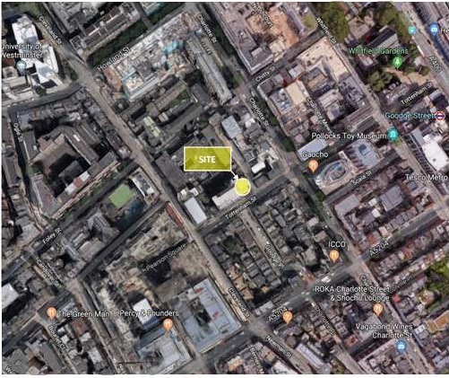

**6.1 Site Location Description:**

Tottenham Street is a 6.0 metre wide road that connects Tottenham court Road in the northeast to Cleaveland Street, Tottenham Street is one-way westbound only and is located within LB Camdens Controlled Parking Zone CA-E. The street is lit, with standard width footways provided along both sides of the carriageway.

Tottenham Mews is an access-only street providing general and servicing access to the existing land uses on Tottenham Mews. The exit from Tottenham Mews is restricted to right-turn only by Virtue of the one-way operation along Tottenham Street.

Single yellow line parking restrictions are in place, between the hours of 08.30 to 18.30 Monday to Saturday.

Directly in front of Arthur Stanley House are three on-street disabled parking bays located on Tottenham Street. 21C will apply for these to be suspended once McGee have completed their works. Along the southern side of Tottenham Street between Charlotte Street and Cleveland Street are three on-street ‘pay and display’ parking bays with a maximum duration stay of two hours, and four ‘resident permit holders only’ parking bays which apply Monday to Saturday 08.30 to 18.30. Where parking bays are not located, there are single or double yellow line parking restrictions in force.

Tottenham street forms a junction with A400 Tottenham Court Road some 110 metres to the east of the site. The A400 Tottenham Court Road forms part of the Strategic Road Network (SRN), for with LB Camden are the highway authority. Some 320 metres to the north, the A400 Tottenham Court Road forms a junction with the A501 Euston Road which is classified as a red route forming part of the TLRN. The location of the site in the context of the wider highway network is shown in Figure 2.

**Figure 6.2: Local Road Hierarchy (extract from the Camden development policies 2010-2025**

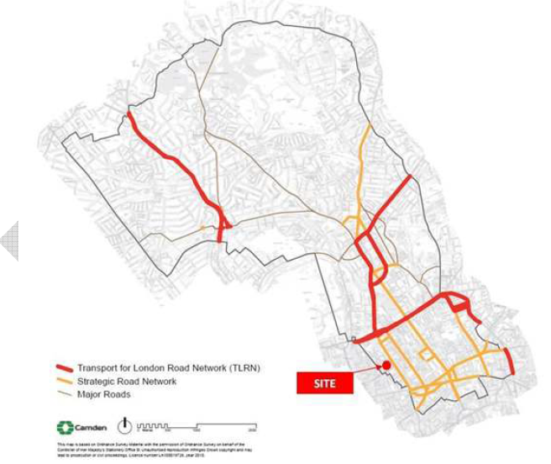

**6.2 Cycle Hire Stations:**

The following cycle hire stations are located in the vicinity of the site:

1. Howland Street, Fitzrovia
2. Scala Street, Fitzrovia
3. Charlotte Street, Fitzrovia
4. Foley Street, Fitzrovia

**Figures 6.3: Cycle Hire Locations**

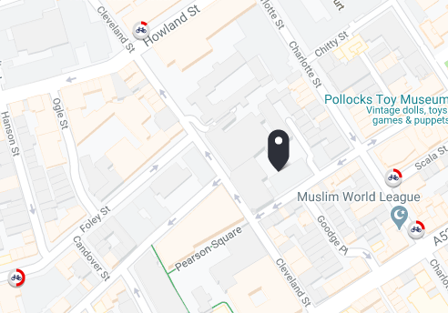

**6.3 Development Proposal:**

Refurbishment of the existing eight storey Arthur Stanley House (Ground plus seven storeys, with two lower ground floor levels), reconfiguration of the seventh floor and extension at the rear of the building and construction of a new build element to the rear facing Tottenham Mews to enable a change of use from health care (Class D1) to a mixed use development comprising office floor space (Class B1), flexible office (Class B1) healthcare (Class D1) floor space at ground and first floor levels and residential units (Class C3) (2 x studio 2 x 1 bed; 4 x 2 bed; 1 x 3 bed) and associated landscaping fronting Tottenham mews including all necessary enabling works.

**1**

**Arthur Stanley House**

**2**.

**3**

**4**

7. Please provide a very brief description of the construction works including the size and nature of the development and details of the main issues and challenges (e.g. narrow streets, close proximity to residential dwellings etc).

The project comprises of the refurbishment of the existing eight storey Arthur Stanley House includes:

* Brick cladding to the new elevations and cleaning of the existing brick façade to Tottenham Street.
* New windows and roof coverings plus new windows to all elevations.

The scheme will include the fit out of 10 residential units/flats on Tottenham Mews and the CAT A fit out to the 7 storey office space

8. Please identify the nearest potential receptors (dwellings, business, etc.) likely to be affected by the activities on site (i.e. noise, vibration, dust, fumes, lighting etc.).

52 Tottenham Street

43 Tottenham Street Camellia Nikolova

37 Tottenham Street Lovefone

13 Tottenham Mew Office Building

38 Tottenham Street

7 Tottenham Mews West End Residences

6 Tottenham Mews Protape data stores

15 Goodge Place Fitzrovia Neighbourhood Centre

4-7 Tottenham Mews

10-19 Tottenham Mews

Middlesex House 34-42 Cleveland Street

24-32 Cleveland Street

9. Please provide a scaled plan detailing the local highway network layout in the vicinity of the site. This should include details of on-street parking bay locations, cycle lanes, footway extents and proposed site access locations.

Please refer to section 6.

10. Please provide the proposed start and end dates for each phase of construction as well as an overall programme timescale. (A Gantt chart with key tasks, durations and milestones would be ideal).

Start on site 18th May 2020

Completion 14th May 2021

Please see 21C Draft Contract Programme attached in Appendix A

11. Please confirm the standard working hours for the site, noting that the standard working hours for construction sites in Camden are as follows:

**8.00am to 6.00pm on Monday to Friday**

**8.00am to 1.00pm on Saturdays**

**No working on Sundays or Public Holidays**

We confirm that the standard working hours for construction sites in Camden, as stated below will be adhered to. Noisy works will be in 2 hour on 2 hours off periods starting at 08.00am – 10.00am on.

Standard deliveries will be kept within the timeframes in table 11.2 below

|  |  |
| --- | --- |
| **Table 11.1** |  |
| **General Construction Works:** | |
| Monday – Friday | 08:00 – 18:00 |
| Saturday | 08:00 – 13:00 |
| Sunday | Not Permitted |
| Bank Holidays | Not Permitted |
| **Noisy Works** | |
| Monday – Friday | 08:00 – 10:00, 12:00 – 14:00,  16:00 – 18:00 |
| Saturday | 10:00 – 12:00 |
| Sunday | Not Permitted |
| Bank Holidays | Not Permitted |

|  |  |
| --- | --- |
| **Table 11.2** |  |
| **Permitted Hours For Deliveries and Collections** | |
| Monday – Friday (Outside Term Times/No School on Route) | *08:00 – 18:00 |
| Monday – Friday (Inside Term Times/With School on Route) | *09:30 – 15:00  **15:30 – 16:30 |
| Saturdays | 08:00 – 13:00 |
| Sundays & Bank Holidays | Not Permitted |
| Delivery Procedures | Please refer to traffic management site drawings |
| Other Special Arrangements | Drivers to report to Gateman, Traffic Marshals  Drivers to call site 20mins before arrival and report to Gateman/Traffic Marshals  Drivers to follow instructions from traffic marshal, banksmen, gateman on site  21C will endeavour at all times to minimise construction traffic on the network between 08:00am and 09:30am. Occasional deliveries will take place during the morning peak where justified, however these will be kept to an absolute minimum. |
| *21C as a Considerate Constructor will whenever possible minimise the volumes of construction traffic on the network for the duration of our tenure onsite. | |
| ** Only under the proviso that pick up from local school has ended by 15.30. Liaison will be in place with the local school to this effect | |

12. Please indicate if any changes to services are proposed to be carried out that would be linked to the site during the works (i.e. connections to public utilities and/or statutory undertakers’ plant). Larger developments may require new utility services. If so, a strategy and programme for coordinating the connection of services will be required. If new utility services are required, please confirm which utility companies have been contacted (e.g. Thames Water, National Grid, EDF Energy, BT etc.) You must explore options for the utility companies to share the same excavations and traffic management proposals. Please supply details of your discussions.

The development team are in negotiations with UK Power Networks regarding the upgrading of their services. Surveys of the existing Thames Water sewers on both Tottenham Mews and Street indicate no upgrading will be required.

A temporary builders electrical supply substation will be provided by UKPN in the South suspended parking bay on Tottenham street.

We can confirm that there is a proposal for the installation of a new twin transformer within the existing transformer room, which is located in the basement.

# Community Liaison

**A neighbourhood consultation process must have been undertaken prior to submission of the CMP first draft. This consultation must relate to construction impacts, and should take place following the granting of planning permission in the lead up to the submission of the CMP. A consultation process specifically relating to construction impacts must take place regardless of any prior consultations relating to planning matters. This consultation must include all of those individuals that stand to be affected by the proposed construction works. These individuals should be provided with a copy of the draft CMP, or a link to an online document. They should be given adequate time with which to respond to the draft CMP, and any subsequent amended drafts. Contact details which include a phone number and email address of the site manager should also be provided.**

Significant time savings can be made by running an effective neighbourhood consultation process. This must be undertaken in the spirit of cooperation rather than one that is dictatorial and unsympathetic to the wellbeing of local residents and businesses.

These are most effective when initiated as early as possible and conducted in a manner that involves the local community. Involving locals in the discussion and decision making process helps with their understanding of what is being proposed in terms of the development process. **The consultation and discussion process should have already started, with the results incorporated into the CMP first draft submitted to the Council for discussion and sign off.**This communication should then be ongoing during the works, with neighbours and any community liaison groups being regularly updated with programmed works and any changes that may occur due to unforeseen circumstances through newsletters, emails and meetings.

Please note that for larger sites, details of a construction working group may be required as a separate S106 obligation. If this is necessary, it will be set out in the S106 Agreement as a separate requirement on the developer.

**Cumulative impact**

Sites located within high concentrations of construction activity that will attract large numbers of vehicle movements and/or generate significant sustained noise levels should consider establishing contact with other sites in the vicinity in order to manage these impacts.

**The Council can advise on this if necessary.**

**13. Consultation**

The Council expects meaningful consultation. For large sites, this may mean two or more meetings with local residents **prior to submission of the first draft CMP**.

Evidence of who was consulted, how the consultation was conducted and a summary of the comments received in response to the consultation should be included. Details of meetings including minutes, lists of attendees etc. should be appended.

In response to the comments received, the CMP should then be amended where appropriate and, where not appropriate, a reason given. The revised CMP should also include a list of all the comments received. Developers are advised to check proposed approaches to consultation with the Council before carrying them out. If your site is on the boundary between boroughs then we would recommend contacting the relevant neighbouring planning authority.

Please provide details of consultation of draft CMP with local residents, businesses, local groups (e.g. residents/tenants and business associations) and Ward Councillors.

The development team acknowledge that meaningful communication with local residents and business is crucial to the success of this project.

By opening up clear lines of communication with local residents and business at the outset valuable input can be gained which will enable us to better develop a Construction Traffic Management Plan, which is both functional and considerate of the opinions and concerns of local residents and business.

Good initial communication will lay the foundation for continued communication throughout the duration of the project. This ongoing communication is vital as it enables the development team to keep local residents and business up to date with specific planned works and enables local residents and business to feedback any concerns and/or issues that they may have.

McGee have previously made contact with the local community and local residents and business were invited to view the McGee draft CMP via a newsletter containing a link to a designated website. 2 drop in sessions took place at the Fitzrovia Community Centre Friday 21st and 24th September where comments were made and recorded. 21C wish to adopt the McGee CMP albeit 21C will be principle contractor once McGee have completed their works and the project moves into the fit out phase. The fit out works will have far less of an impact on the local community with significantly reduced deliveries to site and minimal noise impact from the works which are of a non structural nature

21C will work closely with Camdens Environmental Health Team to sympathetically and efficiently deal with any comments and complaints from local residents and business regarding the works.

in accordance with section 2.4 of the “Guide for Contractors Working in Camden”. Comments and complaints can be made direct to the 21C Project Manager using the email address chris.lewis@21.construction

21C take on board the previous agreement that noisy works scheduled on weekends particularly Saturdays should start from 10am however it is our intention to wherever possible not work weekends. This is incorporated within the working procedures and 21C will inform local residents of a typical proposed working week and times of our operations. Should any changes occur outside of these hours owing to emergency works McGee will issue information sheets for all local residents and businesses. These will be hand delivered and/or emailed across. LBC EHO team will also be kept informed of such situations arising seeking guidance and approval where required.

Please note all addresses identified as potential receptions have been canvassed and consulted where appropriate as part of the pre engagement information process ie via newsletter distribution and drop in sessions.

Verbal discussions have taken place with residents and businesses on Tottenham Mews re delivery management to ensure access and egress is maintained. This will continue via the Neighbourhood Liaison Group, monthly newsletter drops and verbal communication.

**14. Construction Working Group**

Please provide details of community liaison proposals including any Construction Working Group that will be set up, addressing the concerns of the community affected by the works, the way in which the contact details of the person responsible for community liaison will be advertised to the local community, and how the community will be updated on the upcoming works i.e. in the form of a newsletter/letter drop, or weekly drop in sessions for residents.

21C will also set up or participate in Working Groups as necessitated by the demands of the site and with best practice Community liaison and communication in mind. This will not be limited to neighbours but also other construction sites in the vicinity eg a Working Group of Neighbours and Contractors to discuss access and egress to Tottenham Mews. Further to this, we commit to attending periodic area wide meetings with all sites in the immediate vicinity in Fitzrovia chaired by Camden Council.

We will maintain relationships with the site at 79 Charlotte Street by carrying out weekly meetings with our Logistics Managers where details of our vehicle bookings will be shared and coordinated as required, for the week ahead. Telephone and email contact will also be maintained as required, be this on a daily or weekly basis.

Details of our online booking system with be shared with 79 Charlotte Street to enable them to see real time delivery booking information and coordination

Community liaison drop in sessions were carried out previously by McGee. 21C will issue a newsletter to all surrounding residents and businesses 3 weeks before starting on site, confirming the email address for contacting the site team with any comments or complaints and a link to the CMP. Information and contact details for the person responsible for community liaison will also be displayed on the site hoardings. Updates on the progress and planning on the project will be communicated by regular letter drops / newsletters.

**15. Schemes**

Please provide details of your ‘Considerate Constructors Scheme’ registration, and details of any other similar relevant schemes as appropriate. Contractors will also be required to follow the “[Guide for Contractors Working in Camden](http://www.camden.gov.uk/ccm/cms-service/download/asset?asset_id=799001)” also referred to as “[Camden’s Considerate Contractors Manual](http://www.camden.gov.uk/ccm/cms-service/download/asset?asset_id=799001)”.

**Table 15.1 Code of Considerate Contractors Standards:**

|  |  |  |  |
| --- | --- | --- | --- |
| **1** | **Considerate:** | **2** | **Environment:** |
|  | Consider the needs of everyone who is affected by the construction process and of its effect on the environment. You must give special attention to the needs of people with sight, hearing, or mobility difficulties |  | Be aware of the environment when choosing and using resources. You must pay particular attention managing waste, avoiding pollution, using local resources wherever possible, and keeping noise as low as possible. |
| **3** | **Cleanliness:** | **4** | **Good Neighbour** |
|  | Keep the site, footpaths and surrounding area affected by the work clear of mud, spillage, litter, and any unnecessary rubbish. Make sure that the site, hoardings, scaffolds, and other features are kept in a clean, tidy, and safe condition. |  | Consult with neighbours about site activity from before the work starts to the final handover. Provide site information and viewing facilities where practical. |
| **5** | **Respectful** | **6** | **Safe:** |
|  | Make sure that the site, hoardings, scaffolds, and other features are kept in a clean, tidy, and safe condition. |  | Make sure all construction work and vehicle movements are carried out with care for the safety of passers-by, neighbours, and site personnel |
| **7** | **Responsible** | **8** | **Accountable** |
|  | Be responsible for making sure everyone on site understands the scheme. |  | Be accountable (responsible for your actions) to the public by providing site contact details and being available to deal with their concerns and develop good local relations. |

21C will register the project with the Considerate Constructors. Documentation verifying this will be made available to Camden Council on request.

In accordance with the Considerate Contractors Scheme and section 1.3, table 1.1 (reproduced below) of the ‘Guide for Contractors Working in Camden’, the main contractor commits to working towards the standards outlined in table 15.1

**16. Neighbouring sites**

Please provide a plan of existing or anticipated construction sites in the local area and please state how your CMP takes into consideration and mitigates the cumulative impacts of construction in the vicinity of the site. The council can advise on this if necessary.

21C will liaise as advised by the Council with other contractors completing work on local sites to enable them to prepare a schedule for delivery and waste removal vehicles, particularly the neighbouring current project at 24-32 Cleveland Street. This schedule will take other local sites construction vehicle movements into consideration, adopting this approach will help to reduce the cumulative impact of construction vehicle movements.

It is confirmed that instructions will be followed from the Council with regards to co-ordination and scheduling of construction traffic. Contact with

the Councils highways department will be continued throughout the duration of the demolition and construction phase of the scheme to ensure compliance and to alleviate disturbance from construction traffic.

Following a search of the London Borough of Camden’s planning website, the projects detailed in table 16.1 have been identified as potential sites of interest:

|  |  |  |
| --- | --- | --- |
| **Table 16.1** |  |  |
| **Reference No.** | **Address** | **Description** |
| 2018/2095/P | 1. 80 Charlotte Street W1T 4DF | Demolish post war building |
| 2018/1716/P | 1. 77-79 Charlotte Street, W1T 4PW | Erection of 4 Storey extension |
| 2018/2163/P | 1. 44 Cleveland Street, W1T 4JT | Alterations to listed building |
| 2015/1139/P | Astor College, 99 Charlotte Street |  |
| 2016/7076/P | Noho House, 30 Cleveland Street |  |

**Figures 16.1: Potential** **sites of interest**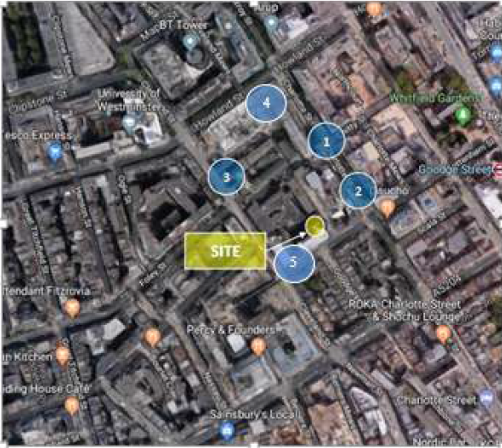

# Transport

**This section must be completed in conjunction with your principal contractor. If one is not yet assigned, please leave the relevant sections blank until such time when one has been appointed.**

Camden is a CLOCS Champion, and is committed to maximising road safety for Vulnerable Road Users (VRUs) as well as minimising negative environmental impacts created by motorised road traffic. As such, all vehicles and their drivers servicing construction sites within the borough are bound by the conditions laid out in the [CLOCS Standard.](http://www.clocs.org.uk/)

This section requires details of the way in which you intend to manage traffic servicing your site, including your road safety obligations with regard to VRU safety. It is your responsibility to ensure that your principal contractor is fully compliant with the terms laid out in the CLOCS Standard. It is your principal contractor’s responsibility to ensure that all contractors and sub-contractors attending site are compliant with the terms laid out in the CLOCS Standard.

Checks of the proposed measures will be carried out by the council to ensure compliance. Please refer to the CLOCS Standard when completing this section. Guidance material which details CLOCS requirements can be accessed [here](http://www.camden.gov.uk/ccm/cms-service/stream/asset?asset_id=3550016&), details of the monitoring process are available [here](http://www.camden.gov.uk/ccm/cms-service/stream/asset?asset_id=3550014&).

Please contact [CLOCS@camden.gov.uk](mailto:CLOCS@camden.gov.uk) for further advice or guidance on any aspect of this section.

**Please refer to the CLOCS Overview and Monitoring Overview documents referenced above which give a breakdown of requirements.**

**CLOCS Contractual Considerations**

17. Name of Principal contractor:

|  |  |
| --- | --- |
| **Name:** | Chris Lewis |
| **Organisation:** | 21 Construction |
| **Position:** | Team Director |
| **Address:** | 4th Floor, Boundary House, 91-93 Charterhouse Street, EC1M 6HR |
| **Email:** | Chris.Lewis@21.Construction |
| **Phone:** | 07725 544 7847 |

18. Please submit the proposed method for checking operational, vehicle and driver compliance with the CLOCS Standard throughout the duration of the contract (please refer to our [CLOCS Overview document](http://www.camden.gov.uk/ccm/cms-service/stream/asset?asset_id=3550016&) and [Q18 example response](http://www.camden.gov.uk/ccm/cms-service/stream/asset?asset_id=3550015&)).

The CMP will form part of the subcontractor orders, and a minimum of FORS Bonze accreditation will be a stipulation of their order.

Where FORS Bronze operators are appointed, written assurances will be requested from all contractors to ensure their commitment and compliance to CLOCS. This will include confirmation that all vehicles over 3.5 tonnes will be fitted with additional safety equipment to help protect vulnerable road users, such as Class V and VI mirrors, side under-run protection and audible left turn alerts. Proof that the drivers delivering to site have undertaken approved vulnerable road user training, such as a Safe Urban Driving course will also be sought.

The traffic marshals will carry out checks on all vehicles over 3.5t arriving on site, using the CLOCS Compliance Checklist. Any non compliant vehicles will be issued a non compliance notice and not allowed to return to site.

19. Please confirm that you as the client/developer and your principal contractor have read and understood the [CLOCS Standard](http://www.clocs.org.uk/wp-content/uploads/2015/05/CLOCS-Standard-v1.2-APRIL_15.pdf) and included it in your contracts. Please sign-up to join the [CLOCS Community](http://www.clocs.org.uk/links-to-partners/) to receive up to date information on the standard by expressing an interest online.

I confirm that I have included the requirement to abide by the CLOCS Standard in my contracts to my contractors and suppliers:

We confirm that I have and will continue to include the requirement to abide by the CLOCS standard in any contracts with our contractors and suppliers.

Chris Lewis – Team Director

Please contact [CLOCS@camden.gov.uk](mailto:CLOCS@camden.gov.uk) for further advice or guidance on any aspect of this section.

**Site Traffic**

**Sections below shown in blue directly reference the CLOCS Standard requirements. The CLOCS Standard should be read in conjunction with this section.**

**20. Traffic routing**: *“Clients shall ensure that a suitable, risk assessed vehicle route to the site is specified and that the route is communicated to all contractors and drivers. Clients shall make contractors and any other service suppliers aware that they are to use these routes at all times unless unavoidable diversions occur.”* (P19, 3.4.5)

Routes should be carefully considered and risk assessed, taking into account the need to avoid where possible any major cycle routes and trip generators such as schools, offices, public buildings,museums etc. Where appropriate, on routes that use high risk junctions (i.e. those that attract high volumes of cycling traffic) installing Trixi mirrors to aid driver visibility should be considered.

Consideration should also be given to weight restrictions, low bridges and cumulative impacts of construction (including neighbouring construction sites) on the public highway network. The route(s) to and from the site should be suitable for the size of vehicles that are to be used.

a. Please indicate routes on a drawing or diagram showing the public highway network in the vicinity of the site including details of how vehicles will be routed to the [Transport for London Road Network](http://www.lscp.org.uk/lrsu/engineering_tlrn.html) (TLRN) on approach and departure from the site.

The following is the proposed construction vehicle access and egress routes:

**Access Route**

1. Travel along the Euston Road A501
2. Take a left and travel down Gower street
3. Take a right turn down Torrington Place until reaching the junction at Tottenham Court road
4. Take a further left down Howland Street and then left down Charlotte Street
5. A final right turn onto Tottenham Street drive into Tottenham Mews and Pull up within the vehicle set down area

**Egress Route**

There are 2 options for departing site, both involve turning right out of Tottenham Mews onto Tottenham Street.

Via Riding House Street

1. At the end of Tottenham Street, turn right on to Cleveland Street.
2. Travel down Cleveland Street then take a left on to Riding House Street.
3. At the end of Riding House Street, turn right on to Portland Place and this road will lead to Marylebone Road .

**Via Maple Street**

1. At the end of Tottenham Street, then take a right on to Cleveland Street
2. Travel down Cleveland Street, then turn right into Maple Street
3. At the junction turn left onto Tottenham Court Road.
4. Traffic continues North until Euston Road where construction traffic can turn left for West London or right for East London.

**Figure 20.1: Proposed Vehicle Access Routes**: Red line shown below is TLRN

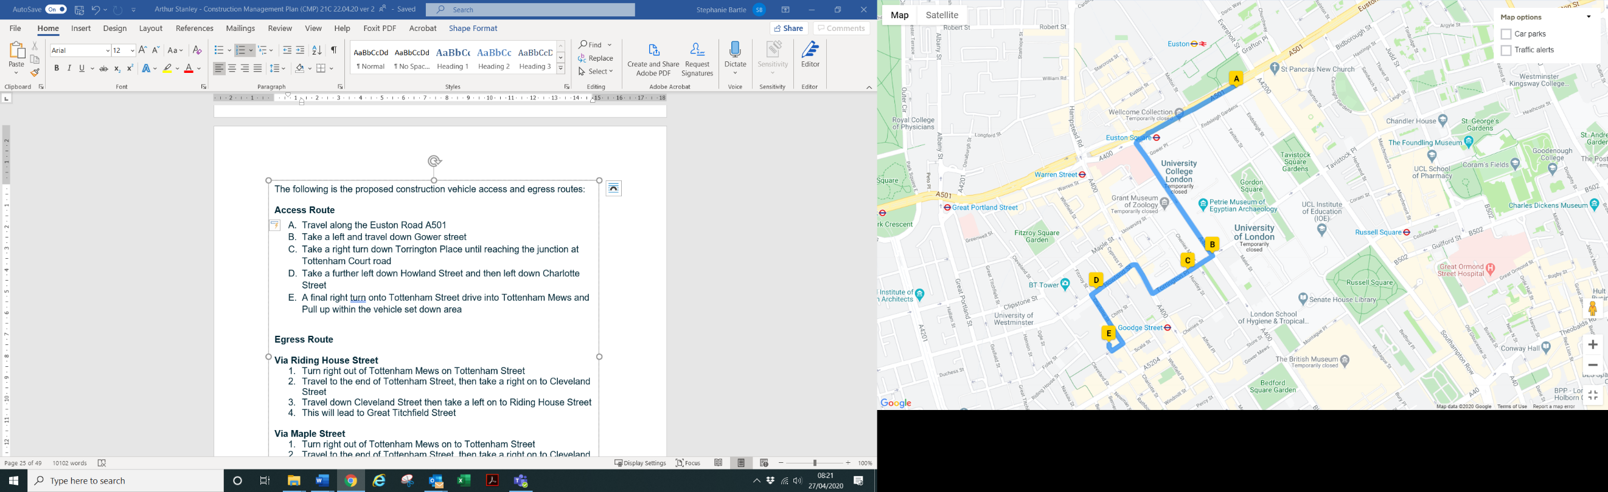

**Proposed Vehicle Egress Route**: Red Line below is TLRN

**Via Riding House Street**

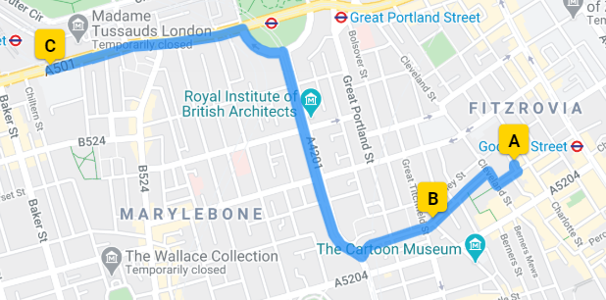

Proposed Vehicle Egress Route: Red Line below is TLRN

**Via Maple Street**

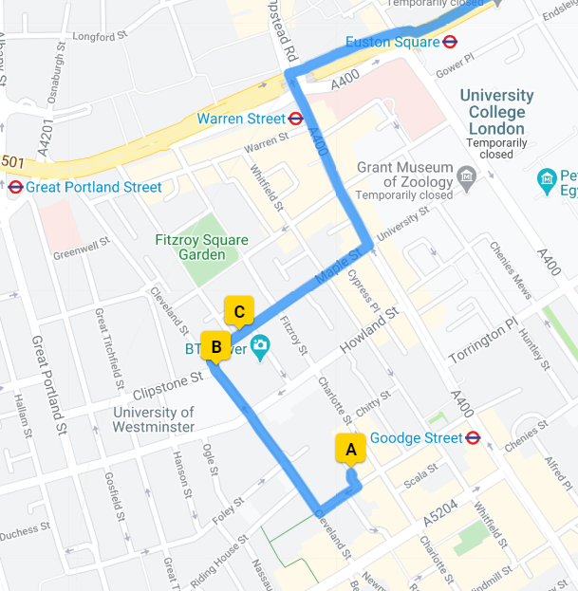

LANTRA (or similar) trained banksman will be present during all construction vehicle movements in order to ensure the safety of cyclists, pedestrians and other vulnerable road users.

In order to protect cyclists, pedestrians and other vulnerable road users all drivers of construction related vehicles will be made aware of the following points:

* Drivers will be informed that TCR will be shared with cyclists from Easter 2019.
* Additionally they will be informed that there is a partially segregated cycle lane in Howland Street
* Pedestrian crossing junctions with Charlotte and Tottenham Street

**Street Furniture, Highway & Pavements**

Existing services and street furniture are to be protected as directed by the LA. If any pavements or kerbs are damaged due to construction traffic they will be repaired or re-instated at the cost of the site, with pedestrian and highways areas remaining safe throughout.

Cycle Safety:

Figure 20.2 shows the location of TFL cycle docking stations in relation to site.



**Arthur Stanley House**

b. Please confirm how contractors, delivery companies and visitors will be made aware of the route (to and from the site) and of any on-site restrictions, prior to undertaking journeys.

All contractors and delivery companies will be sent a copy of our CMP along with their orders, prior to commencing on site and will be advised of the routes to and from site as detailed in Section 20 of this CMP.

**21. Control of site traffic, particularly at peak hours**: “*Clients shall consider other options to plan and control vehicles and reduce peak hour deliveries”* (P20, 3.4.6)

Construction vehicle movements are generally acceptable between 9.30am to 4.30pm on weekdays and between 8.00am and 1.00pm on Saturdays). If there is a school in the vicinity of the site or on the proposed access and/or egress routes, then deliveries must be restricted to between 9.30am and 3pm on weekdays during term time. (Refer to the [*Guide for Contractors Working in Camden*](http://www.camden.gov.uk/ccm/cms-service/download/asset?asset_id=799001)).

A delivery plan should ensure that deliveries arrive at the correct part of site at the correct time. Instructions explaining such a plan should be sent to all suppliers and contractors**.** Consideration should be given to the location of any necessary holding areas for large sites with high volumes of traffic. Vehicles must not wait or circulate on the public highway. Whilst deliveries should be given set times to arrive, dwell and depart, no undue time pressures should be placed upon the driver at any time.

a. Please provide details of the typical sizes of all vehicles and the approximate frequency and times of day when they will need access to the site, for each phase of construction.You should estimate the average daily number of vehicles during each major phase of the work, including their dwell time at the site. High numbers of vehicles per day and/or long dwell times may require vehicle holding procedures.

**Table 21.1 details the permitted hours for deliveries and collections**

|  |  |
| --- | --- |
| **Table 21.1** |  |
| Permitted Hours for Deliveries and collections: | |
| Monday – Friday (Outside Term Times/No School on Route | 08:00 – 18:00 |
| Monday – Friday (Inside Term Times/With School on Route) | 09:30 – 15:00 |
| Saturdays | 08:00 – 13:00 |
| Sundays & Bank Holidays | Not Permitted |

**Site Traffic Management**

The management of site logistics is key to the success of the project and the detailed traffic management plan has been developed to control and manage the site, all deliveries will be booked in with the Site Manager not less than 24 hours prior to arrival on-site.

Delivery vehicle movements will be monitored closely, the detailed traffic management and logistics plans put in place will make sure that delivery vehicle dwell time is kept to an absolute minimum, this will be achieved by ensuring that:

1. Construction related vehicles do not turn up ‘unannounced’
2. Construction staff are ready and waiting to receive deliveries, directly into site

Construction related vehicles will not be permitted to ‘circle’ the site or ‘lay up’ in local roads prior to attending site.

**Table 21.2 details of vehicle dimensions and approximate dwell times:**

|  |  |  |  |  |
| --- | --- | --- | --- | --- |
| **Table 21.3** |  |  |  |  |
| **Type** | **Vehicle Description** | **Length (M)** | **Width (M)** | **Approximate Dwell Time** |
| Type 1 | Delivery Lorries | 8 | 2.4 | 30 minutes |
| Type 2 | Muck-away Wagons | 9.5 | 2.5 | 40 minutes |
| Type 3 | Box Van | 6 | 2 | 40 minutes |

b. Please provide details of other developments in the local area or on the route.

Development by others in is progress at 24-32 Cleveland Street.

In addition following a search of the London Borough of Camden’s planning website, the projects detailed in table 21.6 have been identified as potential sites of interest:

|  |  |  |
| --- | --- | --- |
| **Table 21.6** |  |  |
| **Reference No.** | **Address** | **Description** |
| 2018/2095/P | 1. 80 Charlotte Street W1T 4DF | Demolish post war building |
| 2018/1716/P | 1. 77-79 Charlotte Street, W1T 4PW | Erection of 4 Storey extension |
| 2018/2163/P | 1. 44 Cleveland Street, W1T 4JT | Alterations to listed building |
| 2015/1139/P | Astor College, 99 Charlotte Street |  |
| 2016/7076/P | Noho House, 30 Cleveland Street |  |

**Figure 21.7: Potential sites of interest**

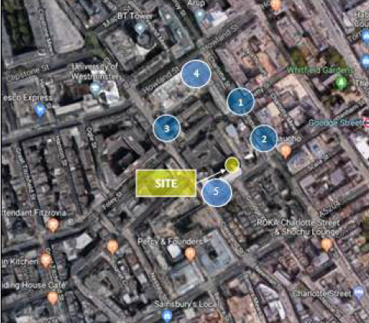

c. Please outline the system that is to be used to ensure that the correct vehicle attends the correct part of site at the correct time.

In accordance with section 5.2/c of the ‘Guide for Contractors Working in Camden’, construction vehicle routes, as much as practicable, have been designed to avoid sensitive receptors.

All supplier and contractors vehicles will attend site following the agreed route outlined within the CMP and Traffic Management Plan, a delivery programme will be prepared to manage the frequency and quantity of vehicles attending site.

A traffic marshal along with suitably qualified banksmen shall be present to coordinate the access and egress of construction vehicles.

All deliveries to site will be managed and staggered to prevent concurrent deliveries to both front of site and from Tottenham Mews.

Prior to construction vehicles attending site, contact will be made with the site logistics team to ensure that access is possible, communication shall be made to afford enough time so that vehicles are not required to wait on a circulate on the public highway.

d. Please identify the locations of any off-site holding areas (an appropriate location outside the borough may need to be identified, particularly if a large number of delivery vehicles are expected) and any measures that will be taken to ensure the prompt admission of vehicles to site in light of time required for any vehicle/driver compliance checks. Please refer to question 24 if any parking bay suspensions will be required for the holding area**.**

None yet required. All materials will be delivered on a ‘as required’ basis, either direct from factory or suppliers warehouses.

e. Please provide details of any other measures designed to reduce the impact of associated traffic (such as the use of [construction material consolidation centres](https://www.google.co.uk/url?sa=t&rct=j&q=&esrc=s&source=web&cd=2&cad=rja&uact=8&ved=0ahUKEwi5hKjPiLjRAhVqLcAKHQduC_gQFggkMAE&url=http%3A%2F%2Fcontent.tfl.gov.uk%2Fdirectory-london-construction-consolidation-centres.pdf&usg=AFQjCNFhB34aaqw3M3fmDpJYUUBw_PjbdA&sig2=KXhGnTR3slzf0kN4XMOcQg&bvm=bv.143423383,d.ZWM)).

None yet identified

**22. Site access and egress:** “*Clients shall ensure that access to and egress from the site is appropriately managed, clearly marked, understood and clear of obstacles.”* (P18, 3.4.3)

Vehicles entering and leaving the site should be carefully managed, using gates that are clearly marked and free from obstacles. Traffic marshals must ensure the safe passage of all traffic on the public highway, in particular pedestrians and cyclists, when vehicles are entering and leaving site, particularly if reversing.

Traffic marshals, or site staff acting as traffic marshals, should hold the relevant qualifications required for directing large vehicles when reversing. Marshals should be equipped with ‘STOP – WORKS’ signs (not STOP/GO signs) if control of traffic on the public highway is required. Marshals should have radio contact with one another where necessary.

a. Please detail the proposed access and egress routes to and from the site

Please refer to section 20 – Traffic Routing

b. Please describe how the access and egress arrangements for construction vehicles will be managed.

A list of all deliveries and collections will be distributed to all relevant parties including the qualified banksmen so that they are aware of the planned vehicle types, and the nature of the expected deliveries.

Three full time traffic marshals will be on site at all times. Two further relief traffic marshals will also be employed full time to provide adequate cover during break times and any other necessary times.

One traffic marshal will be dedicated to managing pedestrians and two marshals will be responsible for manoeuvring vehicles.

This approach will be kept under review and modified if necessary.

Traffic Marshals/Banksmen will be ready and waiting to receive vehicles and will manage the efficient movement of vehicles into the vehicle set down area. Regular checks will be made of drivers and marshals performance.

During all vehicle movements traffic marshals/banksmen will be present to ensure the safety of pedestrians, cyclists and other vulnerable road users.

c. Please provide swept path drawings for any tight manoeuvres on vehicle routes to and from the site including proposed access and egress arrangements at the site boundary (if necessary).

We will suspend the 3 parking Bays, 2 of which will be used for delivery’s and collections. Vehicles will drive into the bays, then reverse out of them to exit and continue down Tottenham Street. Should vehicles require access to Tottenham Mews, they will reverse into the Mews then exit the same way. See Figure 22.1

**Fig. 22.1 – Swept Path**

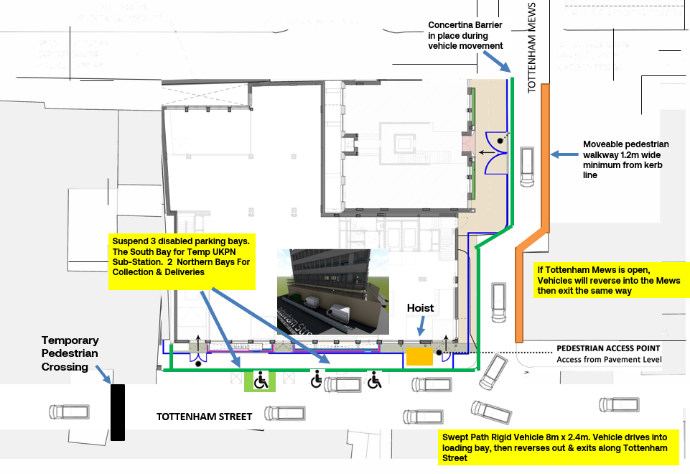

d. Provision of wheel washing facilities should be considered if necessary. If so, please provide details of how this will be managed and any run-off controlled.

No vehicles visiting the site will traverse over the site or any surfaces that will create the migration of dirty materials on to their wheels and therefore no wheel washing will be required. However, a jet washer will be kept on site in the event that any surface or wheel cleaning is required.

Should the need arise a road sweeper will be hired to carry out cleaning along the defined access route to ensure that material from the site is not left on the highway.

**23. Vehicle loading and unloading:** *“Clients shall ensure that vehicles are loaded and unloaded on-site as far as is practicable.”* (P19, 3.4.4)

If this is not possible, Traffic Marshalls must ensure the safe passage of pedestrians, cyclists and motor traffic in the street when vehicles are being loaded or unloaded.

Please provide details of the parking and loading arrangements for construction vehicles with regard to servicing and deliveries associated with the site (e.g. delivery of materials and plant, removal of excavated material). This is required as a scaled site plan, showing all points of access and where materials, skips and plant will be stored, and how vehicles will access and egress the site. If loading is to take place off site, please identify where this is due to take place and outline the measures you will take to ensure that loading/unloading is carried out safely. Please outline in question 24 if any parking bay suspensions will be required.

It is proposed that all vehicle loading and unloading is carried out within the suspended parking bays on Tottenham Street and via Tottenham Mews. Red and white Barriers will be set up by 21C around vehicles on Tottenham Street and Tottenham Mews to separate members of the public during loading and unloading of vehicles . See Fig. 22.1 Swept Path

Minimum 1.2m wide pedestrian walkway will be in place to protect pedestrians while vehicles are being loaded or unloaded on the Mews. 21C Traffic Marshals will move the walkway to allow HGV access/egress and use concertina barriers at each end to prevent access for pedestrians during this brief period.

Any vehicles requiring access to or from Tottenham Mews at these unloading times will be reasonably accommodated by moving the 21C delivery /collection lorry to suit. If the Mews is open during working hours, delivery lorries will contact the site logistics team prior to arrival on site to determine if their delivery location can be accessed without blocking existing Mews vehicles. Utilisation of the car parking bays on Tottenham Street enables 21C delivery vehicles to be relocated from the Mews to ensures access or egress for Mews delivery vehicles is not restricted.

A Traffic Marshall shall be present to coordinate the loading/unloading zone, during all vehicle movements trained banksmen will be in attendance to direct and oversee vehicle movements and to ensure that all vehicle movements are carried out safely.

**Highway interventions**

**Please note that Temporary Traffic Orders (TTOs) and hoarding/scaffolding licenses may be applied for prior to CMP submission but won’t be granted until the CMP is signed-off.**

**If the site is on or adjacent to the TLRN, please provide details of preliminary discussions with Transport for London in the relevant sections below.**

**24. Parking bay suspensions and temporary traffic orders**

Please note, parking bay suspensions should only be requested where absolutely necessary. Parking bay suspensions are permitted for a maximum of 6 months, requirement of exclusive access to a bay for longer than 6 months you will be required to obtain [Temporary Traffic Order (TTO)](http://camden.gov.uk/ccm/content/transport-and-streets/traffic-management/temporary-road-restrictions/) for which there is a separate cost.

Please provide details of any proposed parking bay suspensions and TTO’s which would be required to facilitate construction. **Building materials and equipment must not cause obstructions on the highway as per your Considerate Contractors obligations unless the requisite permissions are secured.**

Information regarding parking suspensions can be found [here.](http://www.camden.gov.uk/ccm/navigation/transport-and-streets/parking/parking-bay-suspensions/)

A TTO was applied for by McGee in relation to this project, namely the 3 disabled bays on Tottenham Street. Further consultation with LBS has been and will be carried out if required in relation to this proposal.

**21c intend on using the same tried and tested traffic management plan already in place by McGee and 21C will apply to suspend the 3 disabled bays on Tottenham Street.**

**25. Scaled drawings of highway works**

Please note that use of the public highway for storage, site accommodation or welfare facilities is at the discretion of the Council and is generally not permitted. If you propose such use you must supply full justification, setting out why it is impossible to allocate space on-site. You must submit a detailed (to-scale) plan showing the impact on the public highway that includes the extent of any hoarding, pedestrian routes, parking bay suspensions and remaining road width for vehicle movements. We prefer not to close footways but if this is unavoidable, you should submit a scaled plan of the proposed diversion route showing key dimensions.

a. Please provide accurate scaled drawings of any highway works necessary to enable construction to take place (e.g. construction of temporary vehicular accesses).

Vehicles will access the site delivery bay via Tottenham Street.

b.Please provide details of all safety signage, barriers and accessibility measures such as ramps and lighting etc.

All exterior site signage will comply with:

1. Chapter 8 of the New Roads & Street Works Act 1991
2. HSE Safety Signs & Signals Regulations 1996

As required, barriers and ramps will be used during deliveries and loading and unloading of materials, plant and excavated materials. The use of safety signage, barriers and ramps will be managed during vehicle movements by the traffic marshal. Barriers will be installed when required during construction hours as shown in the Logistics Drawings and will be removed out of hours to return to Tottenham Mews to its present condition.

Minimal 110V Lighting will be installed on the hoarding to illuminate the pavement, the lighting will be such as to provide illumination but not to adversely affect neighbours or road users.

All lighting will be designed and installed in accordance with section 7.7 of the ‘Guide for Contractors Working in Camden.

**26. Diversions**

Where applicable, please supply details of any diversion, disruption or other anticipated use of the public highway during the construction period (alternatively a plan may be submitted).

Please see figure 27.1 Logistics Plan

**27. VRU and pedestrian diversions, scaffolding and hoarding**

Pedestrians and/or cyclist safety must be maintained if diversions are put in place. Vulnerable footway users should also be considered. These include wheelchair users, the elderly, those with walking difficulties, young children, those with prams, the blind and partially sighted. Appropriate ramping must be used if cables, hoses, etc. are run across the footway.

Any work above ground floor level may require a covered walkway adjacent to the site. A licence must be obtained for scaffolding and gantries. The adjoining public highway must be kept clean and free from obstructions. Lighting and signage should be used on temporary structures/skips/hoardings etc.

A secure hoarding will generally be required at the site boundary with a lockable access.

a. Please provide details describing how pedestrian and cyclist safety will be maintained, including any proposed alternative routes (if necessary), and any Traffic Marshall arrangements.

During vehicle access and egress 2 traffic marshals and 1 pedestrian banksmen will be present to aid the vehicle driver and to ensure that cyclists and pedestrians do not enter whilst vehicle movements are being carried out. Concertina barriers will be placed to ensure pedestrians cannot access or exit The Mews during vehicle movements. A pedestrian walkway demarcated using water filled red and white barriers with metal railings fitted to the top at 1.2m wide minimum from the kerb edge will be in place during day time loading and unloading. These will be moved to allow vehicle movements to take place in and out of The Mews. The walkway will remain in place out of hours. Footpath Closed Ahead signs will be placed at the junction with Charlotte Street.

As required, vehicle movements will be stopped and every assistance will be provided to ensure the safe passage of cyclists, vulnerable footway users and pedestrians, especially the disabled and those using prams/pushchairs.

All delivery Companies and hauliers shall be contacted to confirm that all their vehicles have FORS compliant signage displayed including "Cyclists Do Not Pass on This Side" and are fitted with additional mirrors and reversing cameras.

All pedestrian routes will be managed in accordance win section 3.6 of the “Guide for Contractors Working In Camden”.

See Figure 27.1 Logistics Plan

b. Please provide details of any temporary structures which would overhang the public highway (e.g. scaffolding, gantries, cranes etc.) and details of hoarding requirements or any other occupation of the public highway.

The proposed scaffold gantry on Tottenham Street pavement requires full closure of the pavement along this elevation of the building.

SYMBOL IS FOR INTERNAL USE

**Fig 27.1 – Logistics Plan**

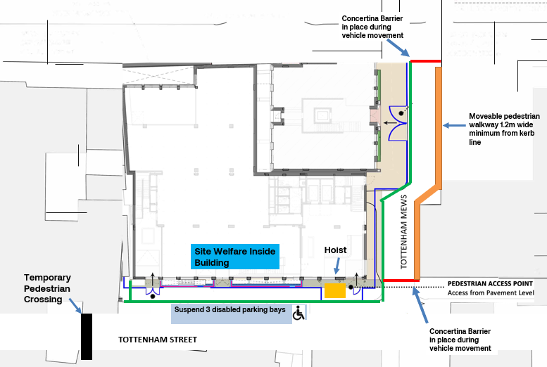



**Fig. 27.2 – Scaffold and Temporary Structure Plan**

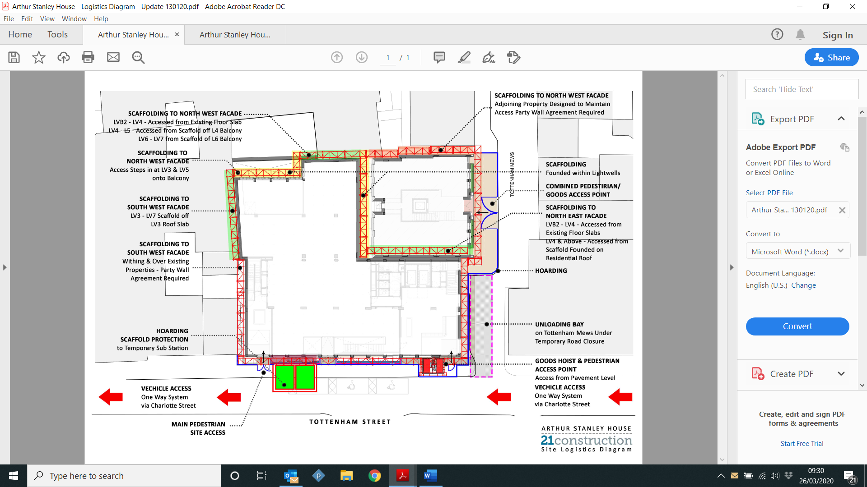



# 

# Environment

To answer these sections please refer to the relevant sections of **Camden’s Minimum Requirements for Building Construction (**[**CMRBC**](http://www.camden.gov.uk/ccm/cms-service/download/asset?asset_id=3257318)**).**

28. Please list all [noisy operations](http://www.camden.gov.uk/ccm/content/environment/environmental-health--consumer-protection/noise/reducing-noise/noise-from-construction-sites.en?page=2)  and the construction method used, and provide details of the times that each of these are due to be carried out.

21C will not be carrying out any structural works, these were being undertaken and have been completed by McGee.

We will be carrying out the fit out and façade works:

* Façade works will involve the cutting of bricks and blocks using a wet saw inside the building and not on the scaffold
* Fit out works will be done using small tools such as hammers and the use of percussion drilling into concrete.

29. Please confirm when the most recent noise survey was carried out (before any works were carried out) and provide a copy. If a noise survey has not taken place please indicate the date (before any works are being carried out) that the noise survey will be taking place, and agree to provide a copy.

McGee are currently on site completing the structure. 21C will be commencing the fit out works 18th May. It is our intention to carry out noise monitoring before commencing works.

Please see Appendix E – Baseline Noise, Vibration, Dust data Monitoring results

30. Please provide predictions for [noise](http://www.camden.gov.uk/ccm/content/environment/environmental-health--consumer-protection/noise/reducing-noise/noise-from-construction-sites.en?page=2) and vibration levels throughout the proposed works.

21C will be carrying out the fit out works which we be done using small tools such as hammers and the use of percussion drilling into concrete. The predicted noise out put from the hammer drill will be 114dB

31. Please provide details describing mitigation measures to be incorporated during the construction/demolition works to prevent noise and vibration disturbances from the activities on the site, including the actions to be taken in cases where these exceed the predicted levels.

The works are fit out works confined within the building. McGee have formed all necessary openings and carried out all structural alterations. The fit out works will only use small hand tools such as drills to fix into the structure to hang services and windows. The building will be scaffolded and enclosed in monarflex sheeting. Any drilling will be carried out during the noisy working periods and any cutting of bricks or blocks will be done within a cutting station internal to the building using a wet saw. 2 hours on 2 hours off will be followed for noisy works, we envisage this will mostly be from the use of hand drills for fixing in to the structure to hang services etc. Cutting stations will be set up within the footprint of the building and bricks and block wet cut to avoid noise and dust. The building will be fully encapsulated with scaffold and monarflex sheeting which will help reduce any noise breakout when drilling.

32. Please provide evidence that staff have been trained on BS 5228:2009

All of our project managers are trained on Environmental Management which includes the prevention of nuisance such as that caused by noise and vibration from construction works. Site specific inductions will cover the detail of projects and will brief all staff involved on working hours and other noise related limitations. Finally, regular toolbox talks will be undertaken (including noise and vibration) to ensure that all staff remain aware of the issue and any working constraints.

33. Please provide details on how dust nuisance arising from dusty activities, on site, will be prevented.

All dust nuisance will be managed in accordance with section 5 of the ‘Guide for Contractors Working In Camden’. Measures such as damping down and sheeting to scaffolds will be used.

34. Please provide details describing how any significant amounts of dirt or dust that may be spread onto the public highway will be prevented and/or cleaned.

The structural works have been completed and vehicles will always be on the highway. 21C will however ensure at all times footpaths and roads are swept clean and the site is presentable at all times.

Should the need arise a road sweeper will be hired to carry out cleaning along the defined access route to ensure that material from the site is not left on the highway.

35. Please provide details describing arrangements for monitoring of [noise](http://www.camden.gov.uk/ccm/content/environment/environmental-health--consumer-protection/noise/reducing-noise/noise-from-construction-sites.en?page=2), vibration and dust levels.

A hand held noise meter will be used to record noise 3 times per day to coincide with noisy and non noisy working hours. These records will be available at all times should anyone wish to review.

36. Please confirm that a Risk Assessment has been undertaken at planning application stage in line with the GLA policy. [The Control of Dust and Emissions During Demolition and Construction 2104 (SPG)](https://www.london.gov.uk/file/18750/download?token=zV3ZKTpP), that the risk level that has been identified, and that the appropriate measures within the GLA mitigation measures checklist have been applied. Please attach the risk assessment and mitigation checklist as an appendix.

We can confirm that this will be included within the Construction Dust Assessment.

37. Please confirm that all of the GLA’s ‘highly recommended’ measures from the [SPG](https://www.london.gov.uk/file/18750/download?token=zV3ZKTpP) document relative to the level of risk identified in question 36 have been addressed by completing the [GLA mitigation measures checklist.](https://www.london.gov.uk/what-we-do/planning/implementing-london-plan/supplementary-planning-guidance/control-dust-and)

We can confirm that this will be included within the Construction Dust Assessment.

38. If the site is a ‘High Risk Site’, 4 real time dust monitors will be required. If the site is a ‘Medium Risk Site’, 2 real time dust monitors will be required. The risk assessment must take account of proximity to sensitive receptors (e.g. schools, care homes etc), as detailed in the [SPG](https://www.london.gov.uk/file/18750/download?token=zV3ZKTpP). Please confirm the location, number and specification of the monitors in line with the SPG and confirm that these will be installed 3 months prior to the commencement of works, and that real time data and quarterly reports will be provided to the Council detailing any exceedances of the threshold and measures that were implemented to address these.

39. Please provide details about how rodents, including [rats](http://www.camden.gov.uk/ccm/content/environment/environmental-health--consumer-protection/pest-control/about-the-pest-control-service.en), will be prevented from spreading out from the site. You are required to provide information about site inspections carried out and present copies of receipts (if work undertaken).

A BPCA accredited contractor, Prime Pest Control, has carried out a survey and assessment of the site and their report is included in Appendix D.

The report concluded there is no evidence of rodents present or past and has made recommendations for preventions which will be acted upon by 21C.

These include installation of 30 baited boxes in the basement and ground floor levels which will be checked monthly.

Drainage pipes in the site have been sealed to prevent rodents leaving site. All pest control will be carried out in accordance with section 7.3 of the ‘Guide for Contractors Working in Camden’.

40. Please confirm when an asbestos survey was carried out at the site and include the key findings.

The most recent asbestos survey undertaken was issued on 12th June 2018, please refer to Appendix C– Asbestos Survey for further information.

Any asbestos containing materials have been removed under the previous contract however all operatives are briefed and told to remain vigilant at all times.

41. Complaints often arise from the conduct of builders in an area. Please confirm steps being taken to minimise this e.g. provision of a suitable smoking area, tackling bad language and unnecessary shouting.

We can confirm that 21C are a member of the Considerate Contractors Scheme and have registered this development with the Scheme. Documentation verifying this will be made available to Camden Council on request.

In accordance with the Considerate Contractors Scheme and section 1.3, table 1.1 (reproduced below) of the ‘Guide for Contractors Working In Camden’, 21C commits to working towards the standards outlined in table 41.1.

The conduct of all staff working in connection with this development will be measured against the standards detailed below, the site will be designed so that welfare facilities and smoking areas are located in positions least likely to cause disruption to local residents and businesses.

The expectations of staff conduct will be reiterated during regular toolbox talks and will be clearly displayed around the site.

Table 41.1 Code of Considerate Contractors Standards:

|  |  |  |  |
| --- | --- | --- | --- |
| **1** | **Considerate:** | **2** | **Environment:** |
|  | Consider the needs of everyone who is affected by the construction process and of its effect on the environment. You must give special attention to the needs of people with sight, hearing, or mobility difficulties |  | Be aware of the environment when choosing and using resources. You must pay particular attention managing waste, avoiding pollution, using local resources wherever possible, and keeping noise as low as possible. |
| **3** | **Cleanliness:** | **4** | **Good Neighbour** |
|  | Keep the site, footpaths and surrounding area affected by the work clear of mud, spillage, litter, and any unnecessary rubbish. Make sure that the site, hoardings, scaffolds, and other features are kept in a clean, tidy, and safe condition. |  | Consult with neighbours about site activity from before the work starts to the final handover. Provide site information and viewing facilities where practical. |
| **5** | **Respectful** | **6** | **Safe:** |
|  | Make sure that the site, hoardings, scaffolds, and other features are kept in a clean, tidy, and safe condition. |  | Make sure all construction work and vehicle movements are carried out with care for the safety of passers-by, neighbours, and site personnel |
| **7** | **Responsible** | **8** | **Accountable** |
|  | Be responsible for making sure everyone on site understands the scheme. |  | Be accountable (responsible for your actions) to the public by providing site contact details and being available to deal with their concerns and develop good local relations. |

42. If you will be using non-road mobile machinery (NRMM) on site with net power between 37kW and 560kW it will be required to meet the standards set out below. The standards are applicable to both variable and constant speed engines and apply for both PM and NOx emissions.

**From 1st September 2015**

**(i) Major Development Sites** – NRMM used on the site of any major development will be required to meet Stage IIIA of EU Directive 97/68/EC

**(ii) Any development site within the Central Activity Zone -** NRMM used on any site within the Central Activity Zone will be required to meet Stage IIIB of EU Directive 97/68/EC

**From 1st September 2020**

**(iii) Any development site -** NRMM used on any site within Greater London will be required to meet Stage IIIB of EU Directive 97/68/EC

**(iv) Any development site within the Central Activity Zone -** NRMM used on any site within the Central Activity Zone will be required to meet Stage IV of EU Directive 97/68/EC

Please provide evidence demonstrating the above requirements will be met by answering the following questions:

1. Construction time period (mm/yy - mm/yy ): 05/20 – 05/21
2. Is the development within the CAZ? (Y/N): Y
3. Will the NRMM with net power between 37kW and 560kW meet the standards outlined above? (Y/N): Y
4. Please provide evidence to demonstrate that all relevant machinery will be registered on the NRMM Register, including the site name under which it has been registered: We confirm that the site will register applicable plant on the NRMM register and that relevant plant will meet stage IIIA/IIIB of EU Directive 97/68/EC, as required
5. Please confirm that an inventory of all NRMM will be kept on site and that all machinery will be regularly serviced and service logs kept on site for inspection: We confirm that this will take place and that this requirement will be adhered to
6. Please confirm that records will be kept on site which details proof of emission limits, including legible photographs of individual engine plates for all equipment, and that this documentation will be made available to local authority officers as required: We confirm that this will take place and that this requirement will be adhered to

SYMBOL IS FOR INTERNAL USE

# Agreement

The agreed contents of this Construction Management Plan must be complied with unless otherwise agreed in writing by the Council. This may require the CMP to be revised by the Developer and reapproved by the Council. The project manager shall work with the Council to review this Construction Management Plan if problems arise in relation to the construction of the development. Any future revised plan must be approved by the Council in writing and complied with thereafter.

It should be noted that any agreed Construction Management Plan does not prejudice further agreements that may be required such as road closures or hoarding licences.

**Please notify that council when you intend to start work on site. Please also notify the council when works are approximately 3 months from completion.**



**Signed:** ………………………………………

**Date:** ……27.04.0………………………

**Print Name:** …………Chris Lewis…………

**Position:** ……Team Director………………

Please submit to: [planningobligations@camden.gov.uk](mailto:planningobligations@camden.gov.uk)

End of form.