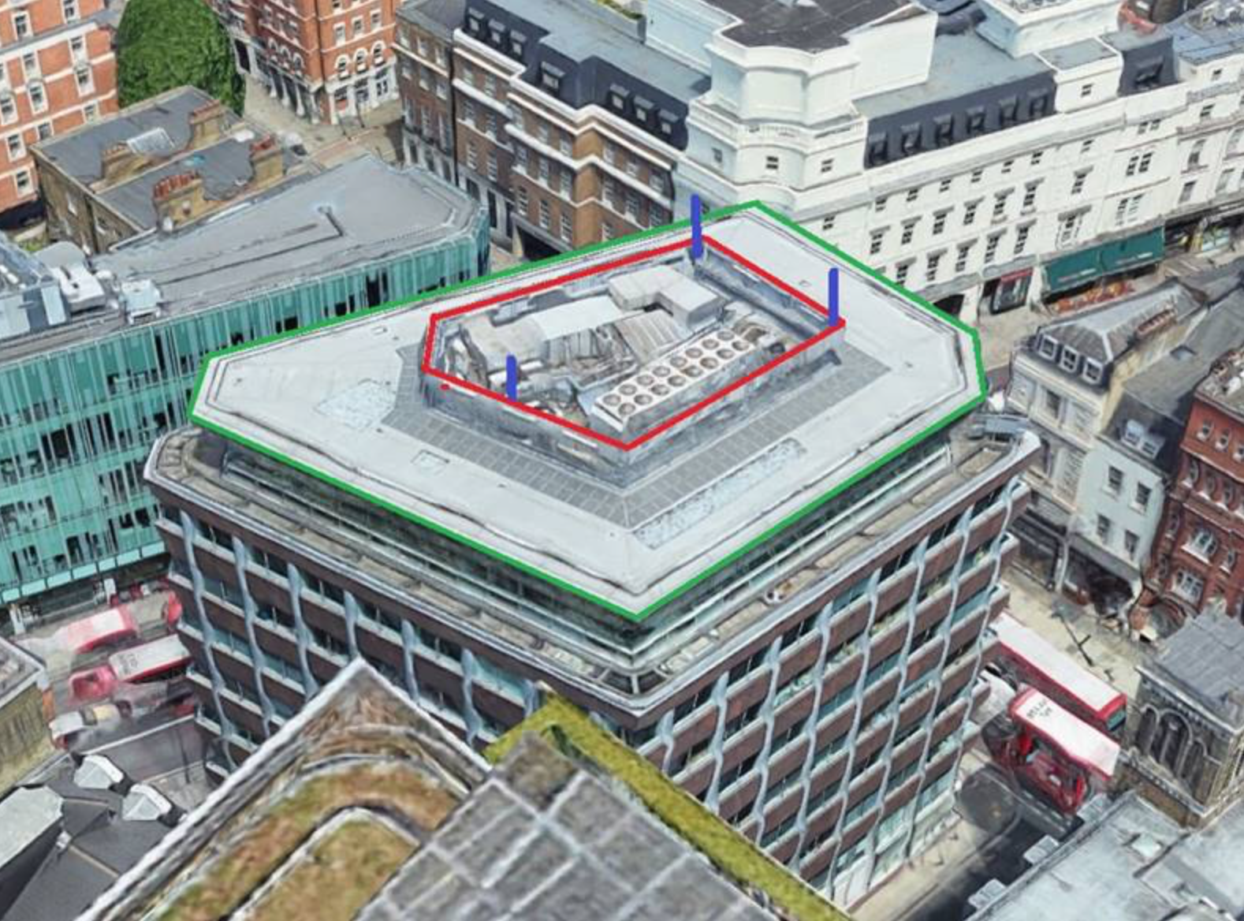

Figure A: Green lines illustrate the roof edge, Red the Extent of the screening, Blue is the antenna positions.

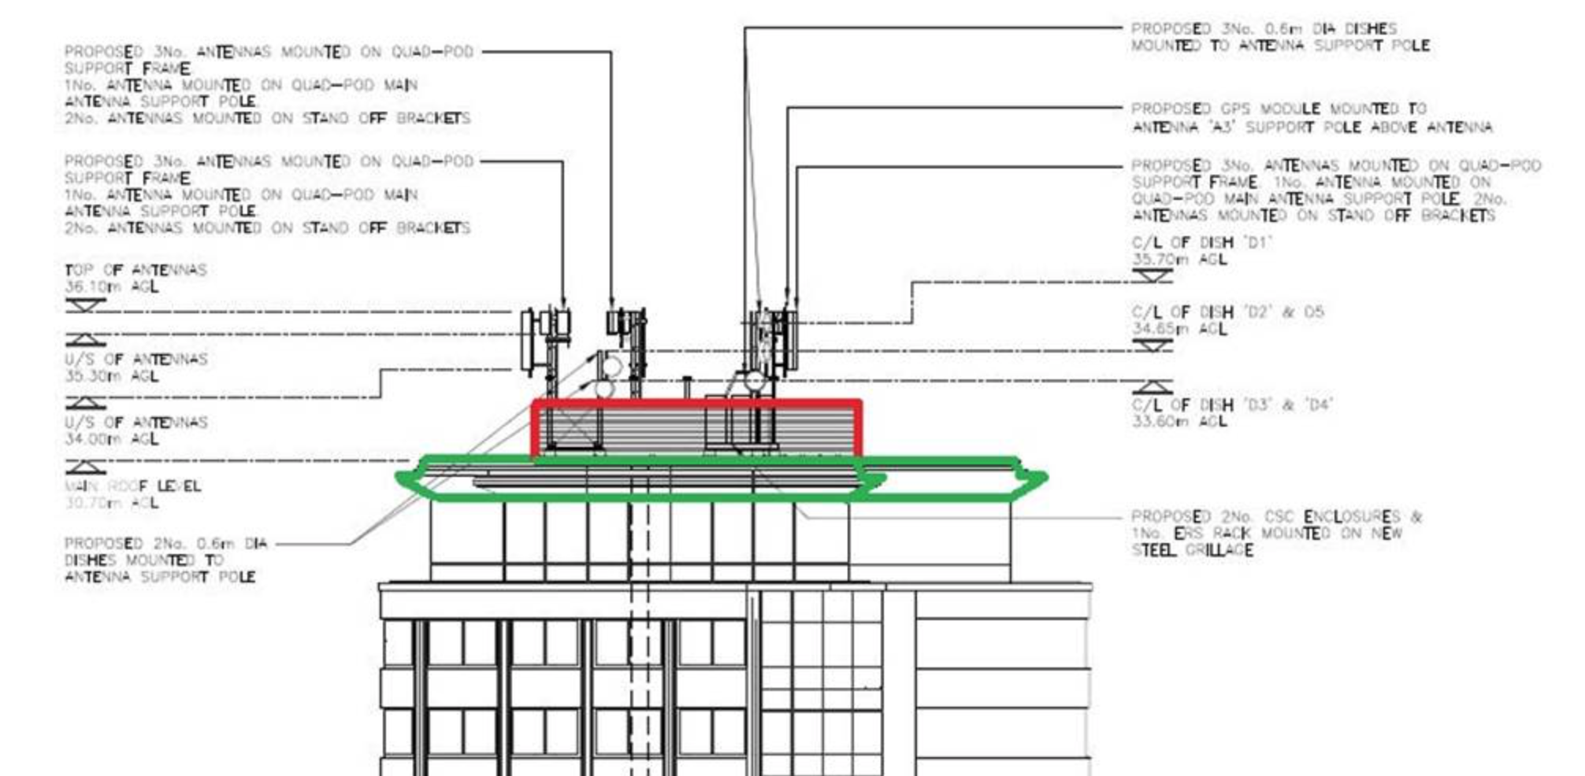

Figure B: Green lines illustrate the roof edge, Red the Extent of the screening

The antennas are located away from the roof edge. The main roof level at 30.70m AGL incorporates a high profile screen that surrounds the existing rooftop mounted plant / AC units. The proposed antenna support frames are positioned behind this screen effectively positioning the antenna 5.7m in from the roof edge in the shortest direction. As Indicated by the blue lines on Figure A above.