Enforcement Delegated Report |  |  | Receipt date: | 21.11.18
Officer |  | Enforcement Case
Raymond Yeung |  | EN18/0850
Breach Address |  | Photos & Other material
Flat 17 - Derby Lodge  Britannia Street  London  WC1X 9BP |  | See file

Authorised Officer Signature
Thursday, 30 July 202604/11/2019

Alleged Breach
Without planning permission, the use of the Property as ‘temporary sleeping accommodation’ (as defined by Section 25 of the Greater London (General Powers) Act 1973 and as set out in the ‘Explanatory Note’ below) for more than 90 nights in the same calendar year in breach of Section 25A (2)(a) and (b) of the Greater London Council (General Powers) Act 1973.
Recommendation(s): | That the Borough Solicitor be instructed to issue an Enforcement Notice under Section 172 of the Town & Country Planning Act 1990 as amended requiring, to cease the use of the property as short stay accommodation, and to pursue any legal action necessary to secure compliance and officers be authorised in the event of non-compliance, to prosecute under section 179 or appropriate power and/or take direct action under 178 in order to secure the cessation of the breach of planning control.
Priority: | P3

Site Description
The site comprises a 6-storey grade II listed property with communal main entrance ground level. The building fronts onto Britannia Street. The site is considered to be a town centre location with good access to public transport. The flat in question is no.17

Investigation History
- A case was opened on the 21st November 2018 following a report about short term letting, following a visit from environmental health officer, whom stated; Whilst the flat is not currently licensable, but did establish that the flat is being let on a short term business let basis to various clients.
- A Planning Contravention Notice was served on the 21st November 2018
- A 7 day warning letter was sent on 24th October 2019 to all with legal interest in the property advising that unless evidence was provided that the use had ceased formal action would be taken.
- No Reponses were received from the above
- The property continues to be available on booking.com.

Relevant policies / GPDO Category
National Planning Policy Framework (2019)

The London Plan (2017): policy 3.14 (C)

Camden Local Plan (2017)
H1 Maximising housing supply
H3 Protecting existing homes
H6 Housing choice and mix
H7 Large and small homes
A1 Managing the impact of development
A4 Noise and vibration
D1 Design
D2 Heritage

Camden Planning Guidance
CPG Housing
CPG Amenity

Assessment
Planning history: There is no relevant planning history in respect of the property
Issues: The Deregulation Act 2015 permits residents in London to short term let their properties for up to 90 days per calendar year. The property in question has been used for short term letting in excess of 90 days this calendar year, which is deemed to be an unlawful use of the property resulting in the loss of permanent housing within the borough.
Assessment:
Summary

The Council’s investigation of the Property, the subject of this notice, indicates that on the balance of probability the property has been used during the calendar year 2019 to provide temporary sleeping accommodation (otherwise known, informally, as ‘holiday letting’ or ‘short-term letting’) in breach of the Conditions set out in Section 25A of the Greater London Council (General Powers) Act 1973 (“the Act”) as amended by Section 44 of the Deregulation Act 2015. Specifically, the Council’s investigations indicate that, without the benefit of planning permission the Property has been used as temporary sleeping accommodation for more than 90 nights in the calendar year 2019.

The Council seeks to control the use of residential properties for temporary sleeping accommodation across the Borough for two main reasons. Firstly, the use of residential accommodation for short term letting goes beyond the scope permitted by law, reduces the stock of permanent housing available to people who wish to live in Camden. In a time of an acute housing shortage the Council cannot afford to lose private dwellings in this manner.
Secondly, the Council seeks to restrict short term letting because holiday-makers and others staying properties for short periods are less likely to treat their holiday flat in a manner that has respect for the peace and privacy of other, permanent, residents who live within the vicinity, and therefore residential amenity is often diminished through noise and disturbance.

On balance, the evidence suggests that there has been a breach of planning control. In these circumstances it is recommended that an Enforcement Notice is issued.
It is to be emphasised that the effect of the Enforcement Notice will be to prohibit the use of the Property as temporary sleeping accommodation in breach of the Conditions set out in Section 25A of the Act from the date that the requirements of the notice must be complied with. Use as temporary sleeping accommodation within the scope allowed by Section 25A of the Act will not be prevented.
Policy context and definition of ‘Temporary Sleeping Accommodation’ (Also known as ‘Short-Term Letting’ and ‘Holiday Letting’)

The London Plan recognises the importance of maintaining London’s housing stock. Policy 3.14C in particular specifically states:

“The loss of housing to short-term provision (lettings less than 90 days) should also be resisted.”

The London Plan (paragraph 3.81) advises that given the level of need, existing housing should be retained where possible and appropriate, except where there are acceptable plans for its replacement. It states that short-term lettings especially for holiday lets, can result in a serious loss of housing, and should be resisted.

Policy H3 ‘Protecting Existing Homes’ in Camden’s Local Plan seeks to protect ‘housing from permanent conversion to short-stay accommodation intended for occupation for periods of less than 90 days’

By virtue of Section 25 of the Greater London Council (General Powers) Act 1973, the use as ‘temporary sleeping accommodation’ of any residential premises in Greater London involves a ‘material change of use’ for the purposes of the definition of ‘development’ which appears at Section 55 of the Town and Country Planning Act 1990 (as amended).

Temporary sleeping accommodation is defined by Section 25 of the Greater London Council (General Powers) Act 1973 (as amended) as follows:

“Use as sleeping accommodation which is occupied by the same person for less than 90 consecutive nights and which is provided (with or without other services) for a consideration arising either by way of trade for money or money’s worth, or by reason of the employment of the occupant whether or not the relationship of landlord and tenant is thereby created”.

Extent of Use for Short-Term Letting Permitted by the Deregulation Act 2015

Prior to amendments to Section 25 of the Greater London Council (General Powers) Act brought in by Section 44 of the Deregulation Act 2015, the use of residential premises as temporary sleeping accommodation was not lawful (however intense or infrequent its occurrence within any particular ‘residential premises’) unless planning permission had been expressly granted for such use or unless a Lawful Development Certificate had been granted (i.e. on the basis that the use had been undertaken continuously for a sufficient period - 10 years – to acquire immunity from enforcement action
The amendments to Section 25 of the Greater London Council (General Powers) Act 1973 introduced Section 25A. Subsection (1) of Section 25A states that the use of residential accommodation within Greater London as ‘temporary sleeping accommodation’ does not involve a material change of use [and therefore does not require planning permission and is lawful] provided two Conditions are met.

The first of these two Conditions is set out in subsection (2)(a) and (b) of Section 25A, as follows:

‘The first is that the sum of –

(a)the number of nights of use as temporary sleeping accommodation, and

(b)the number of nights (if any) of each previous use of the premises as temporary sleeping accommodation in the same calendar year does not exceed ninety.’

The second of these two Conditions is set out in subsection (3) (a) and (b) of Section 25A as follows:

‘The second is that, in respect of each night which falls to be counted under subsection (2)(a) -

(a)the person who provided the sleeping accommodation was liable to pay council tax under Part 1 of the Local Government Finance Act 1992 in respect of the premises, or

(b)where more than one person provided the sleeping accommodation for the night, at least one of those persons was liable to pay council tax under Part 1 of that Act in respect of the premises.

Section 25A (4) advises that for the purposes of Section 25(A) 2 (b) it does not matter whether any previous use of the premises as temporary sleeping accommodation in the calendar year was by the same person.

Subject to this 90-night annual limitation, and the conditions in respect to the payment of Council Tax, the use of residential premises as ‘temporary sleeping accommodation’ is lawful in planning terms. Expressly stated, the use of a residential property as temporary sleeping accommodation even for one night requires planning permission if the person providing the temporary sleeping accommodation was not liable to pay Council Tax. However, where the person providing the temporary sleeping accommodation is liable to pay Council Tax the 90-night limit can be exercised in a variety of ways.

For example, this could be a single continuous episode of use of the residential premises as ‘temporary sleeping accommodation’ for a period of 90 successive nights which would be considered lawful. Alternatively the 90 night limit in a calendar year could be made of the aggregate of a number of separate stays spread sporadically across a calendar year.
In the case of this property, the Council alleges that there has been a breach of the first Condition, the requirements of which are set out in Section 25A (2) (a) and (b) of the Greater London Council (General Powers) Act 1973, and which restricts the use of a residential property as temporary sleeping accommodation to a maximum of 90 nights in a single calendar year.

Areas within Greater London exempt from the Deregulation Act 2015

The Property has not been exempted by the Secretary of State from the application of the Deregulation Act 2015 (i.e. using the powers made available by Section 44 (4) of that Act). On this basis, in accordance with the Deregulation Act 2015 short-term letting is permitted at the Property for a maximum of 90 nights in any one calendar year, subject to the remaining conditions set out in the foregoing.

Details of Short-Term Letting Investigation

A planning contravention notice was served on those with a legal interest in the land, a response was not received. If the owner later provides information that was requested in the PCN then this would demonstrate a wilful failure to respond to the PCN. The Council’s own leaseholder team are also investigating this matter as a breach of the leasehold agreement.

As mentioned above, the flat in question is no.17 .

The property is advertised [Accessed on 31.10.19];

Booking.com;

https://www.booking.com/hotel/gb/renovated-2-bed-in-kings-cross.en-gb.html?no_rooms=1&checkin=2019-10-31&checkout=2019-11-29&group_adults=2&group_children=0&req_children=0&req_adults=2&hp_refreshed_with_new_dates=1

There are currently 4 reviews The latest advert is September 2019, the earliest advert is June 2018;

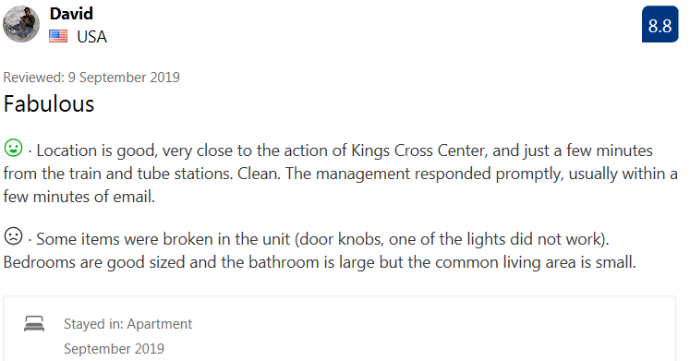
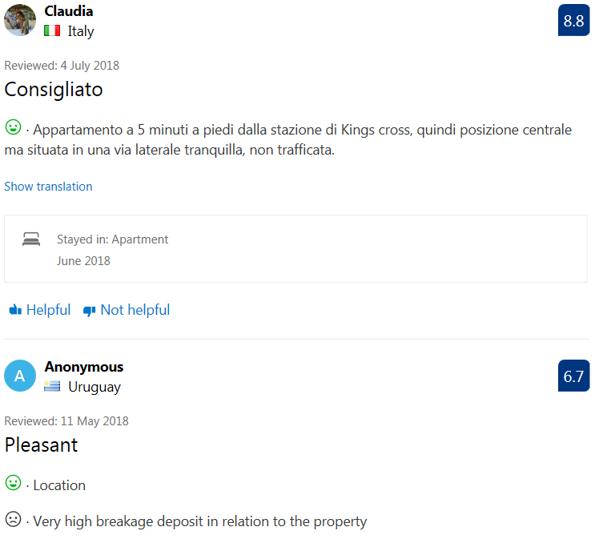
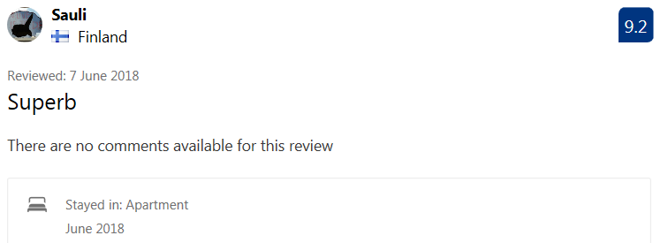
With all the above taken into consideration and due to the time period of the reviews from time period of; June 2018 to September 2019, which corroborates the timeframe the September 2018 visit from environmental health officer, whom stated that it was established that the flat is being let on a short term business let basis to various clients, it is considered that it appears that a breach of planning control has occurred. The property is booked out for the remainder of the calendar year and is clearly laid out as a full time short term let.
In taking enforcement action the Council as local planning authority has to show that it ‘appears’ to it that a breach of control has occurred. The onus is not to demonstrate beyond reasonable doubt that a breach has occurred as a matter of fact but to demonstrate that on the balance of probability a breach of planning control has occurred. In this case, the question is whether the evidence set out in this report would be regarded by a reasonable person as constituting grounds to allege that the Property has been used as temporary sleeping accommodation during the course of the calendar year 2019 in breach of one or both of the Conditions as set out in Section 25A of the Deregulation Act 2015. It is considered that the evidence set out above meets this test.
Recommendation: That the Borough Solicitor be instructed to issue an Enforcement Notice under Section 172 of the Town & Country Planning Act 1990 as amended requiring, to cease the use of the property as short stay accommodation, and to pursue any legal action necessary to secure compliance and officers be authorised in the event of non-compliance, to prosecute under section 179 or appropriate power and/or take direct action under 178 in order to secure the cessation of the breach of planning control.
The notice shall allege the following breaches of planning control:

Without planning permission, the use of the Property as ‘temporary sleeping accommodation’ (as defined by Section 25 of the Greater London (General Powers) Act 1973 and as set out in the ‘Explanatory Note’ below) for more than 90 nights in the same calendar year in breach of Section 25A (2)(a) and (b) of the Greater London Council (General Powers) Act 1973.

WHAT ARE YOU REQUIRED TO DO:
Discontinue the use of the premises as ‘temporary sleeping accommodation’ as defined at Section 25 of the Greater London Council (General Powers) Act 1973 except to the extent allowed by Section 25A (1) of that Act, which permits the use subject to Conditions, including Conditions set out at Section 25A (2) (a) and (b) which limit use as temporary sleeping accommodation to a maximum of 90 nights in any one calendar year

PERIOD OF COMPLIANCE: 1 Month
REASONS WHY THE COUNCIL CONSIDER IT EXPEDIENT TO ISSUE THE NOTICE:
- It appears to the Council that the above breach of planning control has occurred within 10 years

- The number of nights that the flat has been let on a short term basis has exceeded the conditions set by Section 25 of the Greater London Council (General Powers) Act 1973 except to the extent allowed by Section 25A (1) of that Act, which permits the use subject to Conditions, including Conditions set out at Section 25A (2) (a) and (b) limiting the use as temporary sleeping accommodation to a maximum of 90 nights in any one calendar year. In doing exceeding the 90 day limit this has resulted in the unacceptable loss of permanent residential accommodation in the Borough which is contrary to policies H1 (Maximising housing supply), and H3 (Protecting existing homes), of the Camden Local Plan (2017)

- The high turnover of occupiers has resulted in an increased incidence of noise and disturbance to the detriment of the neighbouring occupiers which is contrary to policy A1 (Managing the impact of development), of the Camden London Plan (2017)

