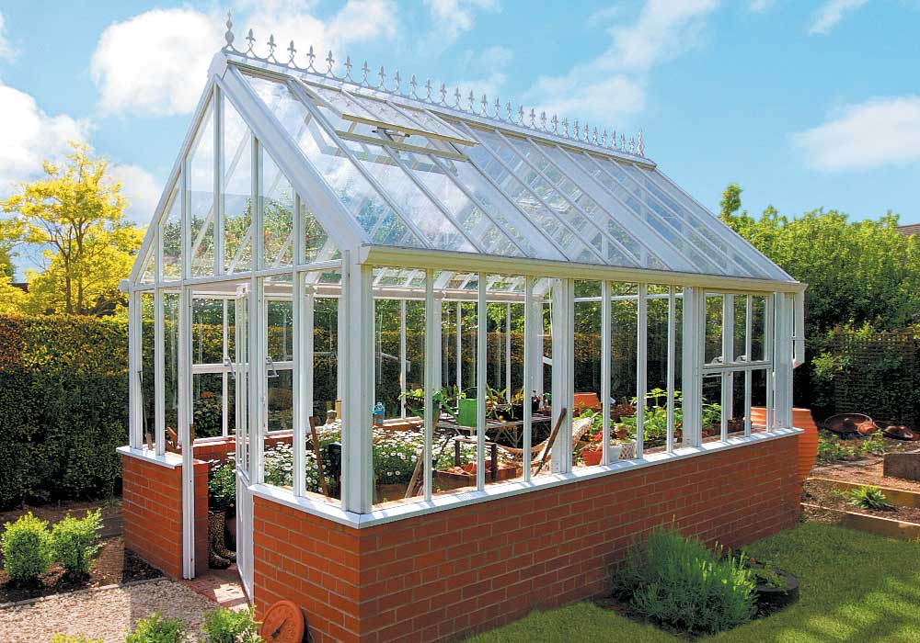

Glasshouse Design but not size proposed.