**LISTED BUILDING APPLICATION:**

**Current Site Photographs - of 4 Taviton Street, WC1H 0BT, the building proposed for a blue plaque to Noor Inayat Khan;**

**Front façade of 4 Taviton Street**

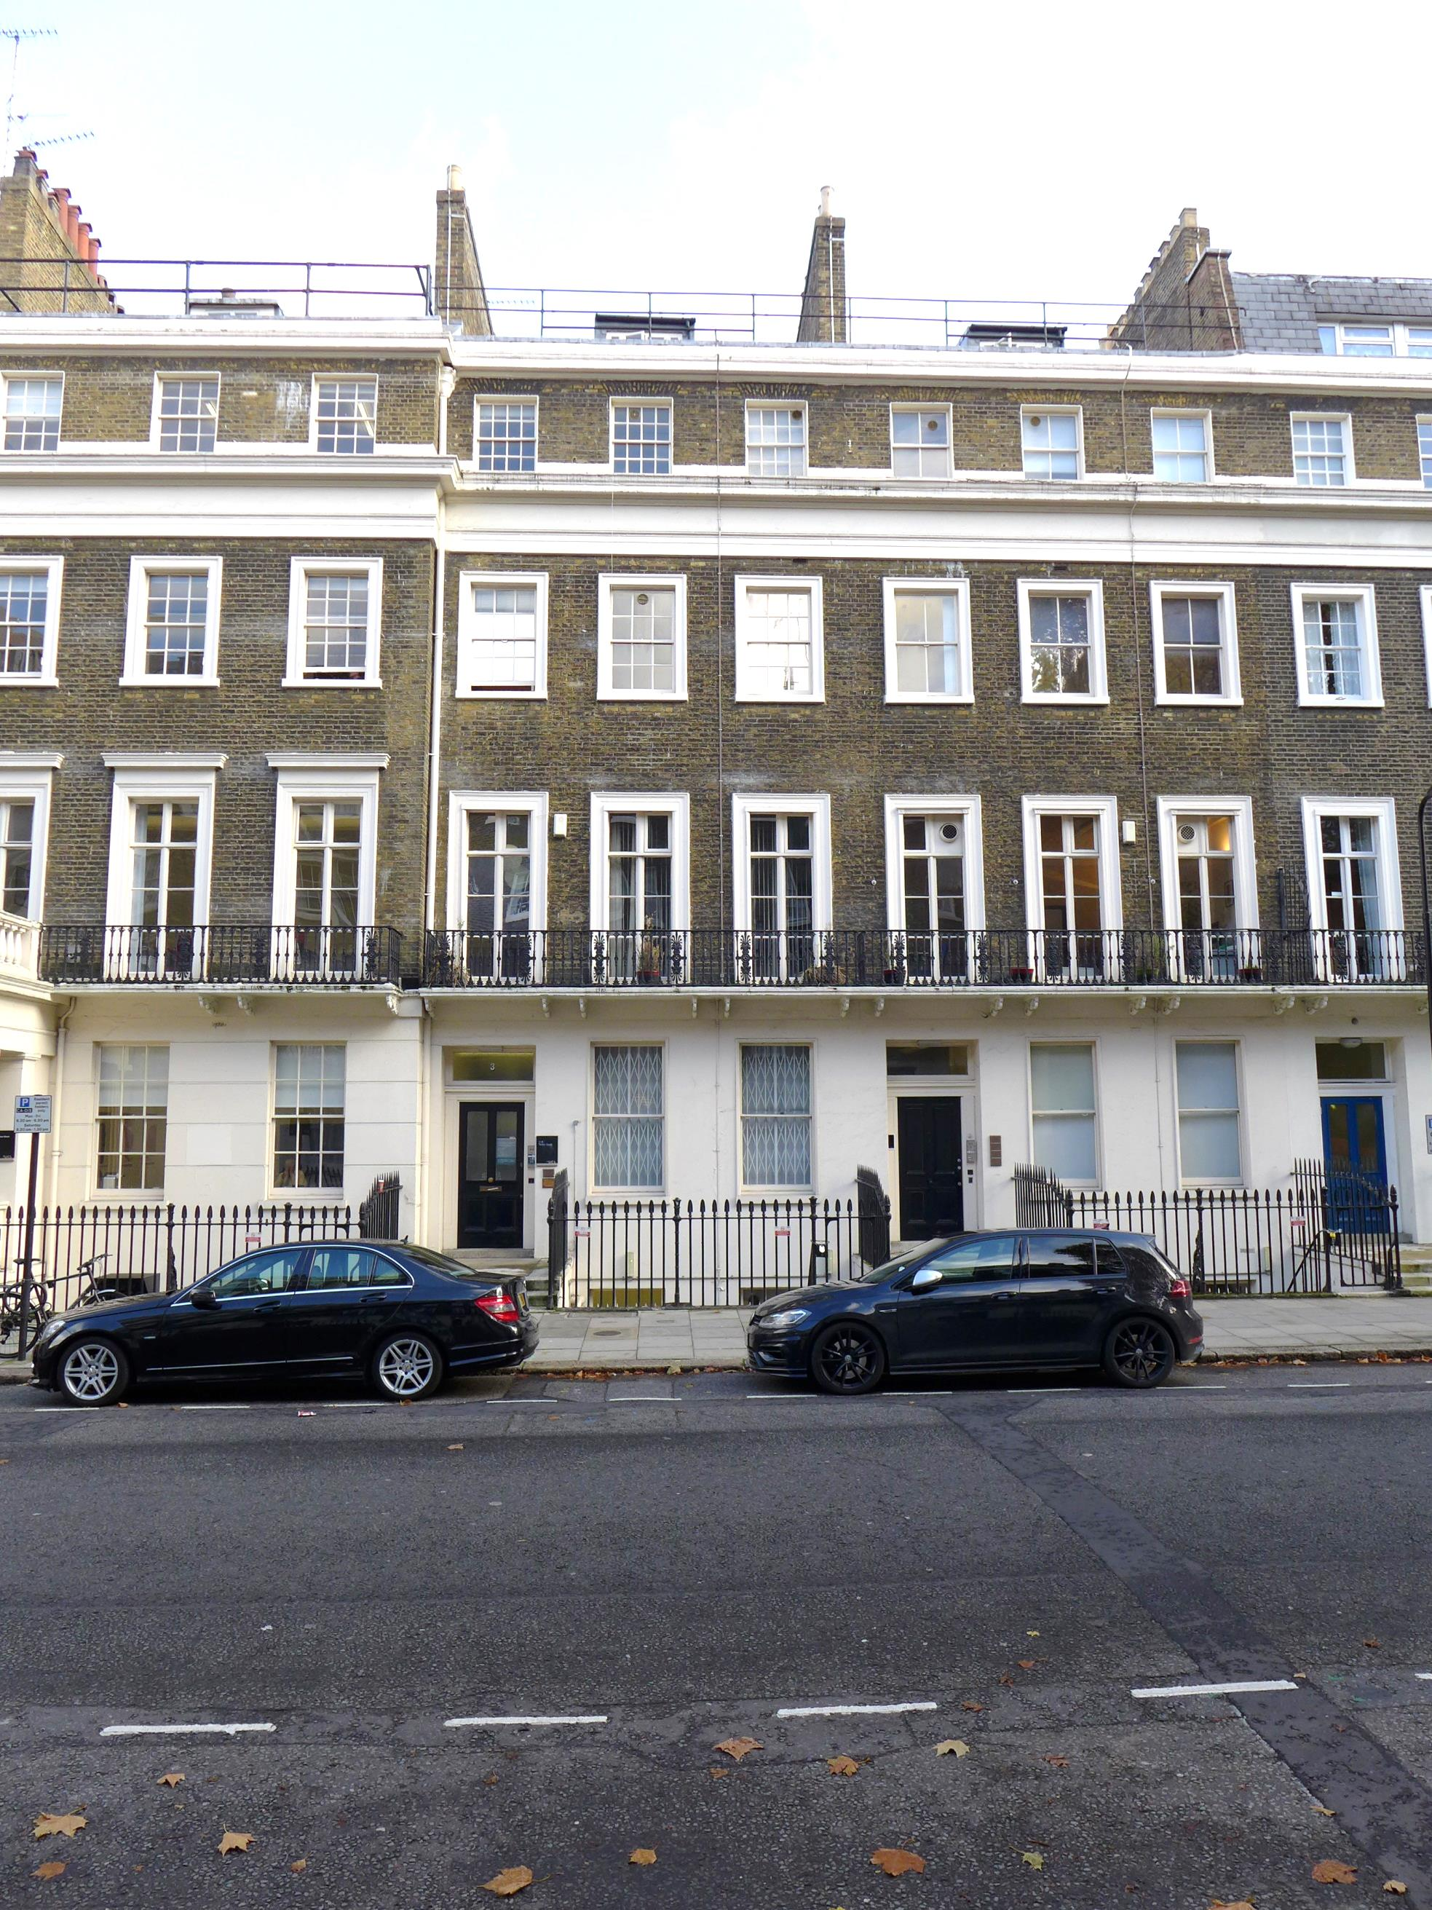

**Numbers 3 to 4 (left to right consecutive) Taviton Street**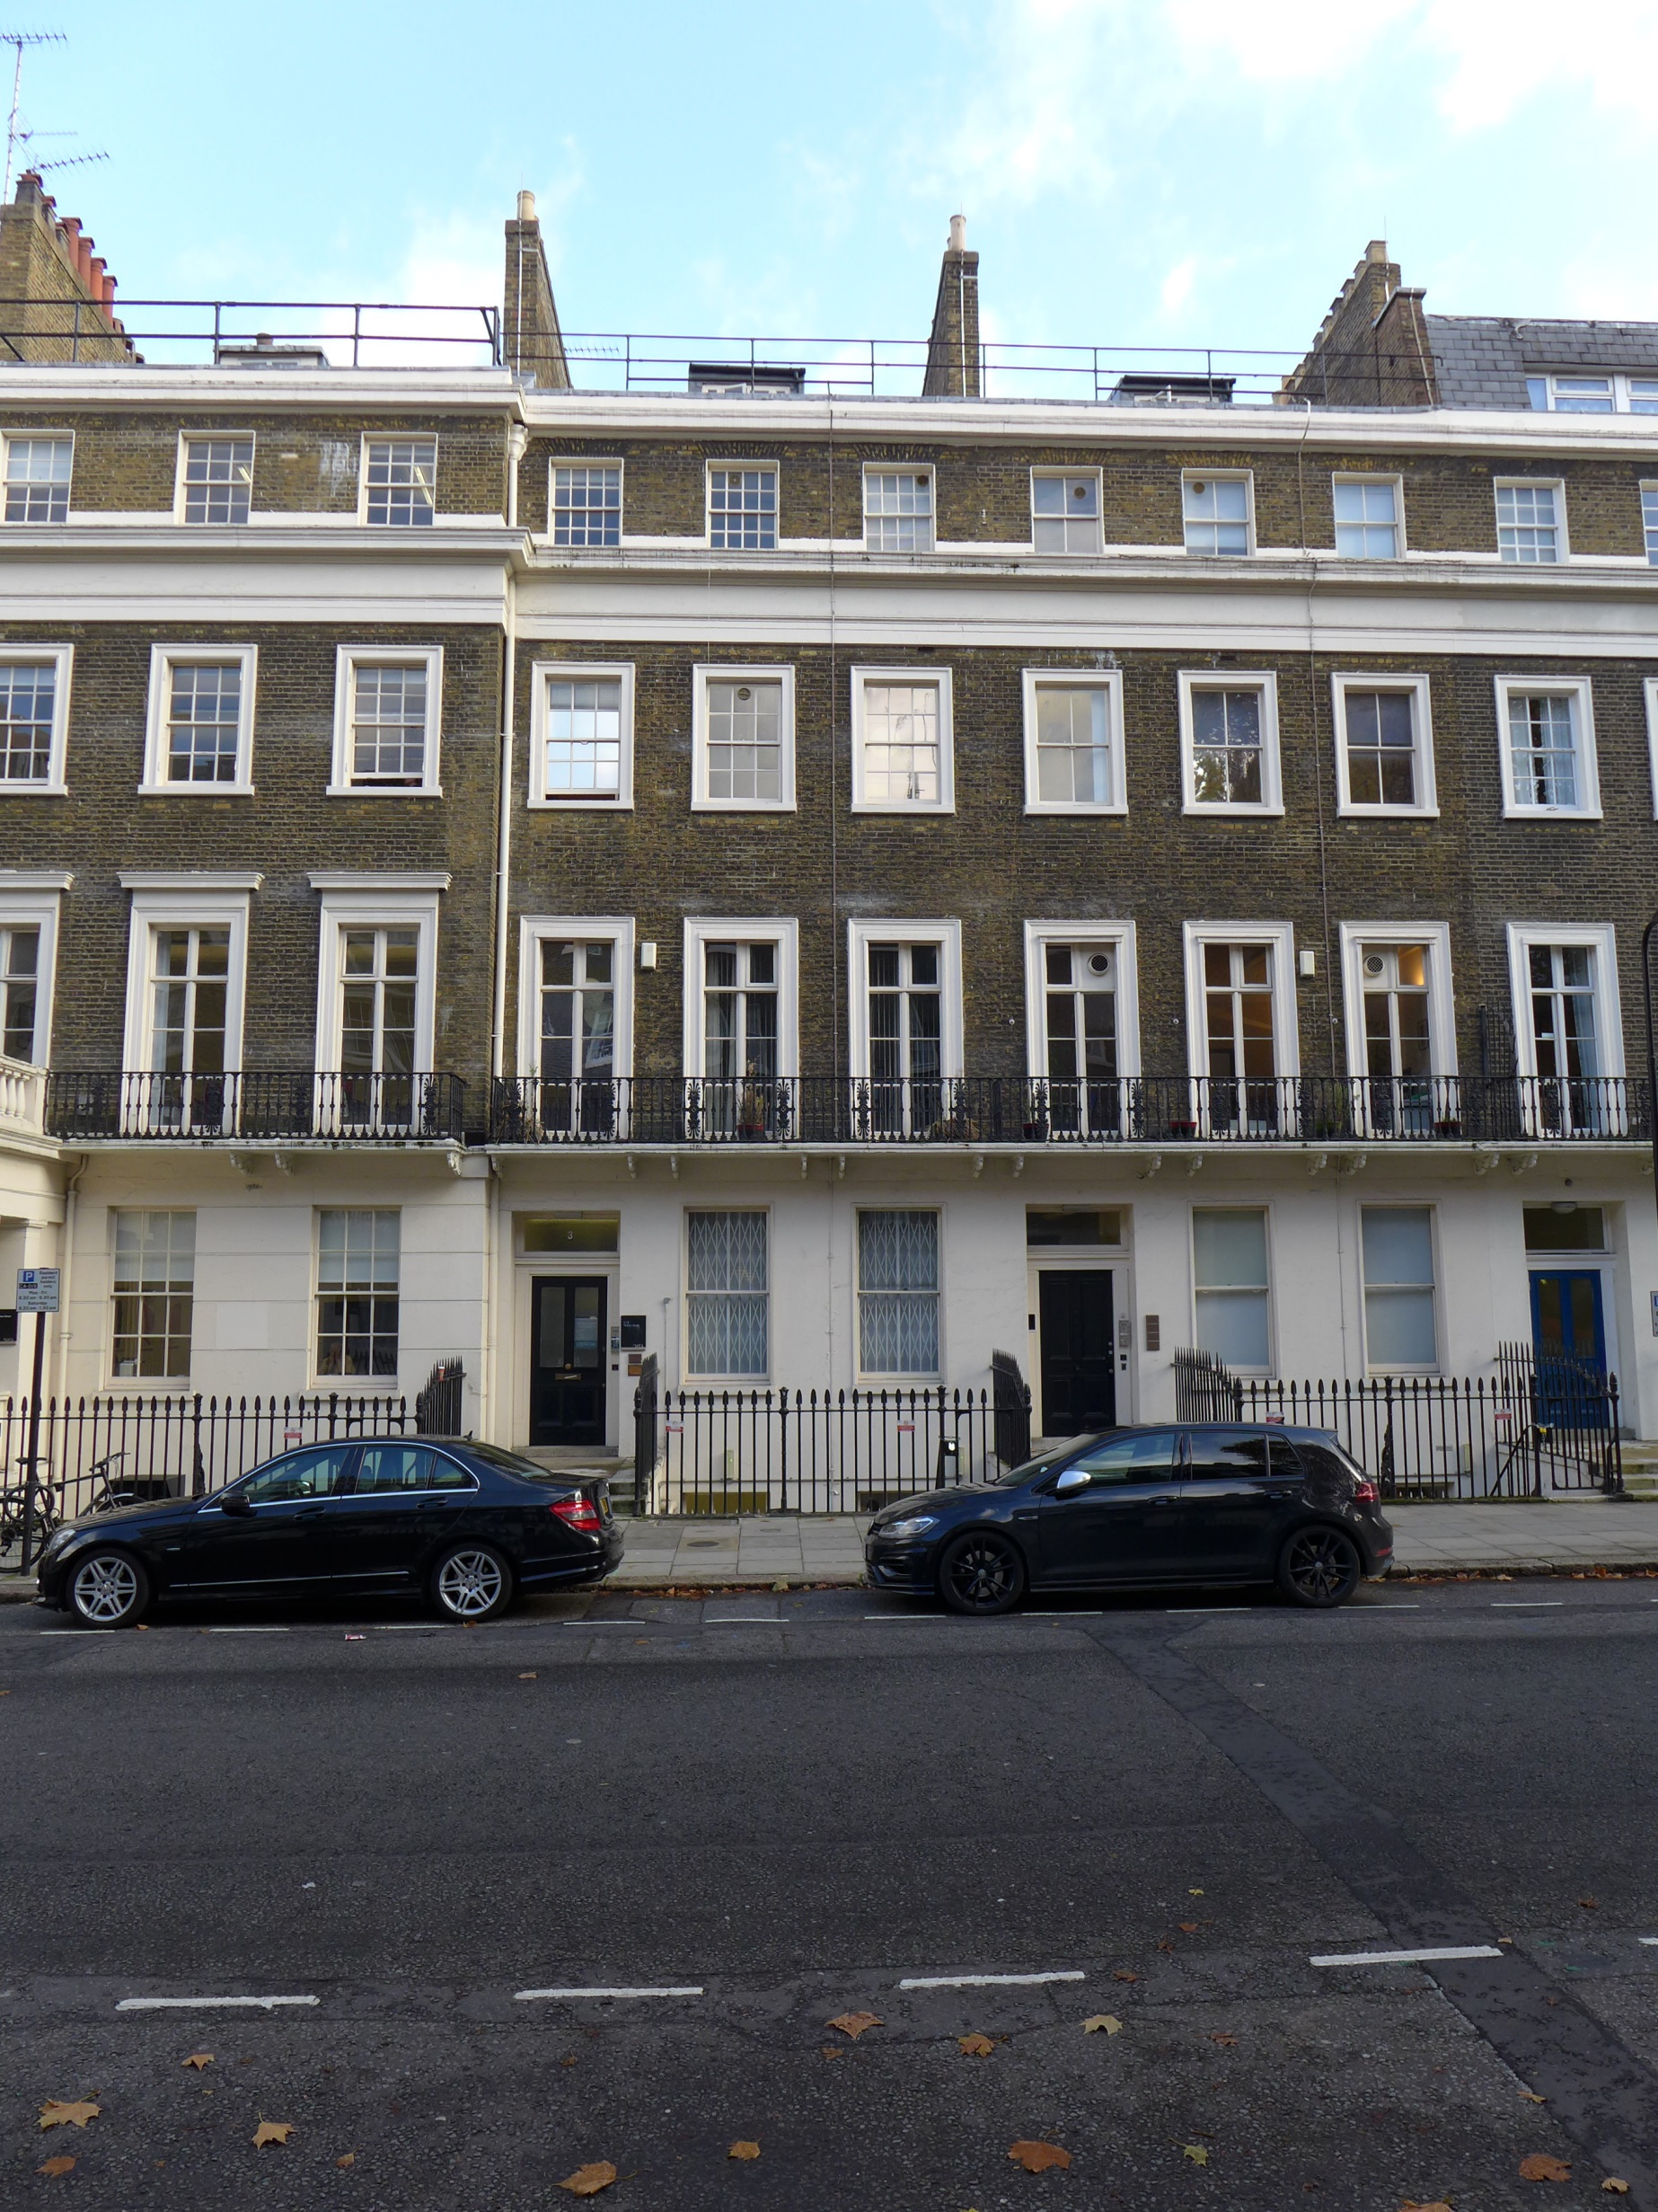

**Terrace (number 3 to 8, left to right consec), joined by running first-floor cast-iron balcony, cornice and parapet decorative details.**

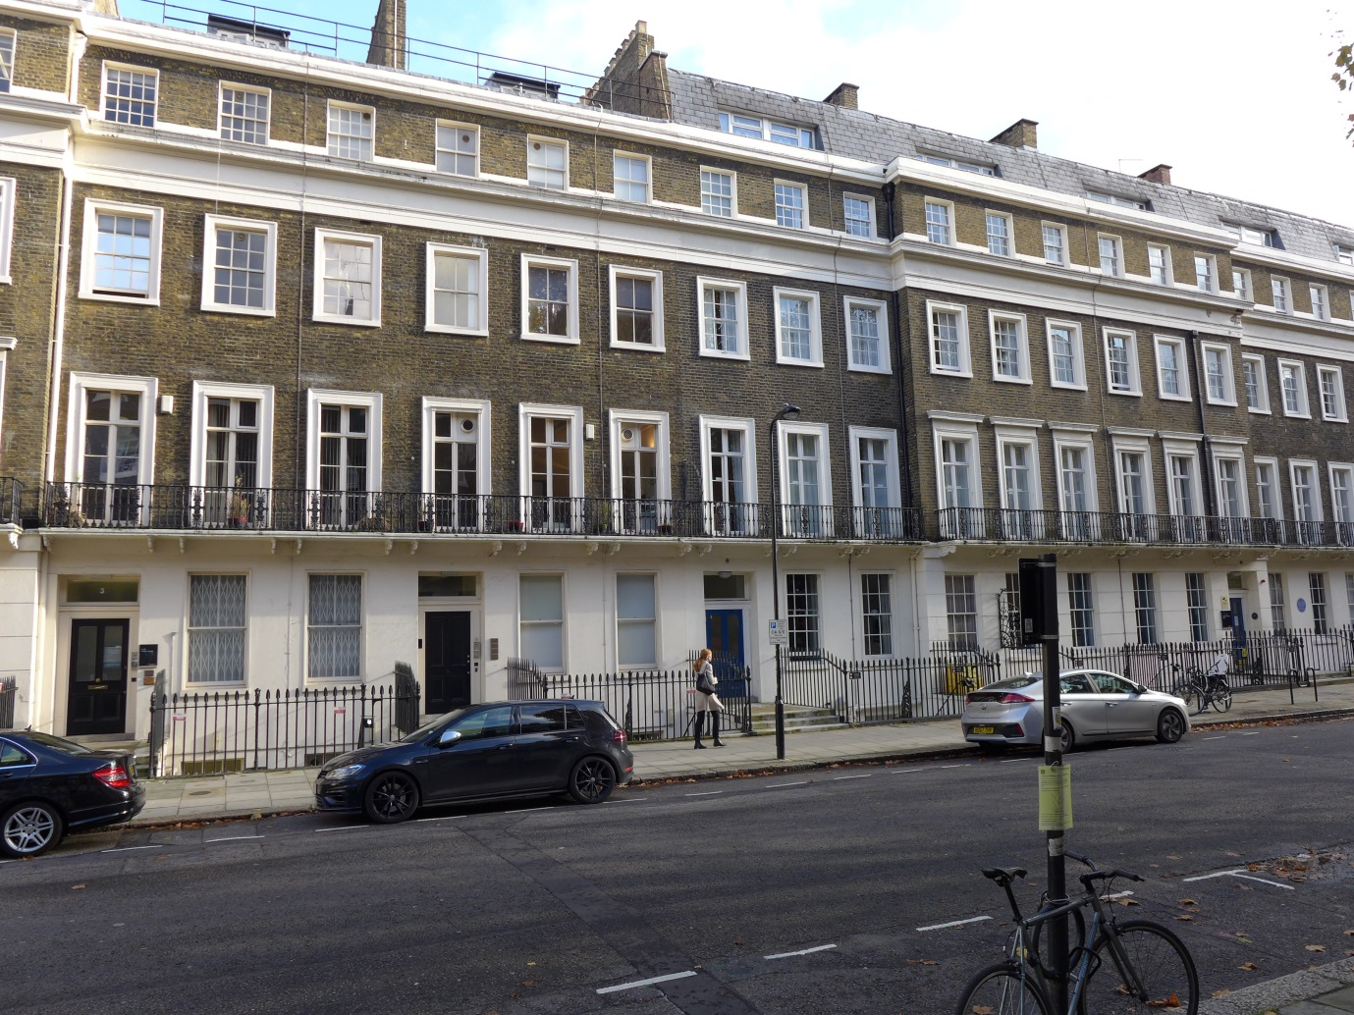

**Detail of ground floor level of 4 Taviton Street, showing current lightning cable that will be re-routed to fit neatly beside the window frame**

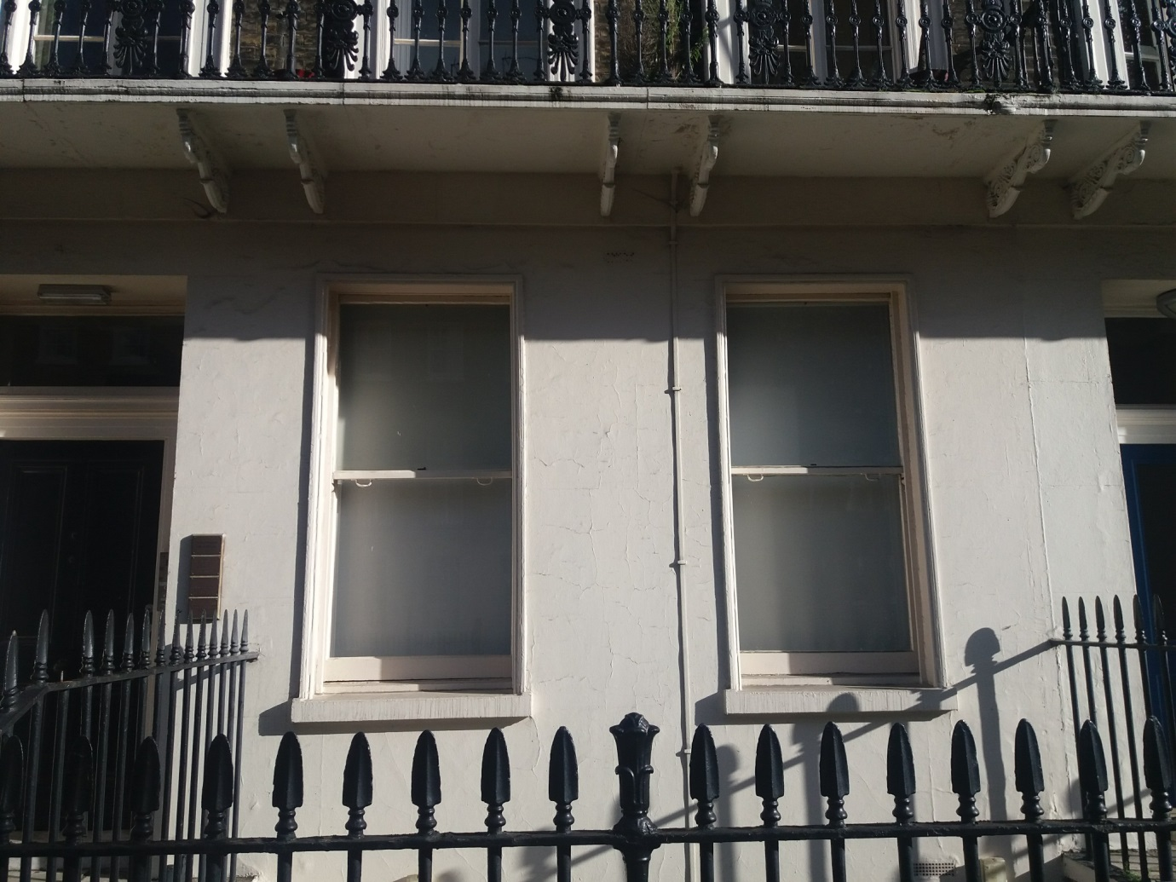

**Context photos showing existing blue plaque to Hugh Price Hughes at 8 Taviton Street, upper end of terrace to number 12 Taviton Street.**

