
Design and Access Statement

Title: 250 Grays Inn Road, London WC1X 8JR
Date: 25/03/2020
Project number: J9648
Site: 250 Grays Inn Road, London, WC1X 88JR
Applicant: KMK Ltd
Agent: Property Tectonics, Titan Court, 2nd Floor, 3 Bishop Square, Hatfield, AL10 9NA
Application: Planning Change of Use Application
Issue: One (March 2020)

Contents

1.0 Existing Site 3
2.0 Proposed Development 5
3.0 Proposed Materials 12
4.0 Scale…………………………………………………………………………………………………………………………………. 15
5.0 Access 15
6.0 Environment 16

Existing Site

The subject property comprises a four-storey mid-terrace period property of traditional construction, situated to the west facing side of Grays Inn Road, a very short distance from the junction with Wren Street.
The property is provided with solid load-bearing brick external walls, with a timber framed, typical London centre valley main roof, with flat and mono-pitch ground floor rear extension roofs, that are provided with a variety of different weatherings, including glass and slate.
Accommodation within the property comprises lower ground and ground floor retail unit, with residential accommodation at first and second floor level.
The retail unit comprises a ground floor kitchen and public seating area, with WC and storage at lower ground floor level.
Listed Building Consent, reference 2019/2200L received on 17th July 2019 for replacement of ground floor rear retail unit roof and for repairs and decorations to the shopfront.

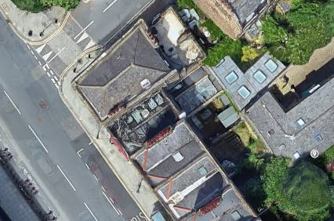

Photo No. 1 – Satellite View of Property

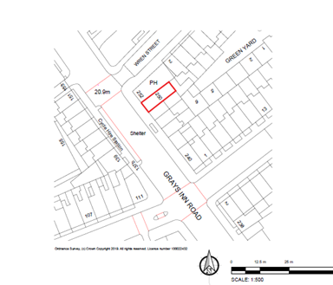

Fig. No. 1 – Site Plan

Proposed Development

The proposed development comprises the change of use to the upper parts to a one bedroom, two person self-contained flat.
The existing upper parts comprise currently unoccupied accommodation, typically comprising a room to the front elevation and a room to the rear at each floor level.
The accommodation would have been originally formed part of a single demise. The upper parts have been previously separated from the GF and LGF parts of the property.
The internal alterations to the property related to this Change of use, comprise the provision of new partitions to separate the front rooms from the rear areas and the upgrading of the fire separation between the GF and 1F parts of the property.

- Scale
The proposed works will not have any impact with regards to the existing mass or scale of the property.

4.0 Access
The proposed works do not have any impact on access to the property.

6.0 Environment
The proposed works do not have any impact upon any existing trees to the site.
The proposed works do not have any other environmental implications.
Working hours will be Monday to Friday 8.00am to 6.00pm and 9.00am to 1.00pm Saturday. There will be no Sunday working.

